FINAL REPORT FOR CDFA CONTRACT NUMBER 07-0177

A. PROJECT TITLE: Assessing the Post-Winter Threat of Glassy-winged Sharpshooter Populations

B. CDFA CONTRACT NO.: 07-0177

C. REPORTING PERIOD: Results reported here are from work conducted from 1 July 2007 through 31 December 2008.

D. PROJECT LEADERS:

Marshall W. Johnson  Dept. of Entomology  Univ. of California, Riverside  Kearney Agric. Ctr.  Parlier, CA 93648  mjohnson@uckac.edu | Kris Lynn-Patterson  GIS Academic Coordinator  UC Kearney Agric. Ctr  Parlier, CA 936348  krislynn@uckac.edu | Mark Sisterson  USDA-ARS, PWA  SJVASC  9611 S. Riverbend Ave  Parlier, CA 93648  msisterson@fresno.ars.usda.gov | Russell Groves  Dept. of Entomology  Univ. of Wisconsin  Madison, WI 53706  groves@entomology.wisc.edu

Cooperators:
Hannah Nadel  Department of Entomology  Univ. of California, Riverside  Kearney Agricultural Center  Parlier, CA 93648  hnadel@uckac.edu | Youngsoo Son  California Dept of Food and Agriculture  Mount Rubidoux Field Station  4500 Glenwood Drive, Building E  Riverside, CA 92501  yson@jps.net | David Morgan  California Dept of Food and Agriculture  Mount Rubidoux Field Station  4500 Glenwood Drive, Building E  Riverside, CA 92501  drmorgan@jps.net

ABSTRACT

Glassy-winged sharpshooter (GWSS), Homalodisca vitripennis, appears to be limited to discrete regions within the San Joaquin Valley where winter temperatures are mild and the temperature rarely drops below freezing. Prior research indicates that GWSS adults cannot feed at maximum daily temperatures below 10°C (= 50°F), thereby reducing its ability to survive cold winters. We verified the impact of cool temperatures on GWSS adults by exposing them to a regime of seasonal temperatures (within temperature cabinets) that reflect a variety of areas within the state. As expected, mortality rates varied greatly among sites tested, and it appears that mortality is related to both length of exposure as well as intensity of exposure over time (i.e., amount of cold endured). Using temperature records to calculate numbers of cooling degree days, we constructed ten GIS maps to delineate areas where post-winter GWSS mortality should be substantial, thereby providing a tool to estimate the springtime GWSS threat to different regions. However, estimates of post-winter GWSS mortalities were usually smaller (< 90%) than expected across much of the agricultural production areas of the Central Valley. However, the ten GIS maps suggest that most of the GWSS population in the Central Valley, except in the southwestern border portions, would have been decimated by cool temperatures during winters of two (1998-1999 and 2004-2005) of the ten years that climatic data were available. This may mean that even if GWSS can survive in the Central Valley, it probably would never become firmly established in most of the region. This somewhat reflects the population patterns that we see today.

INTRODUCTION

The initial arrival of glassy-winged sharpshooter (GWSS), Homalodisca vitripennis, into California’s Orange and Ventura Counties was predicted to dramatically change Pierce’s Disease (PD) epidemiology within infested areas (Varela et al. 2001). The insect soon spread into other southern California localities. PD devastated the wine grape industry in the Temecula Valley resulting in significant losses. First detected in Kern County in 1998, GWSS is now present in the San Joaquin Valley. However, the rapid population expansion first observed in southern California appears to be limited to discrete regions within the San Joaquin Valley coincident with citrus production areas where overwintering populations are highest and winter temperatures are relatively mild compared to locations elsewhere in the San Joaquin Valley. Additionally, persistent, localized GWSS populations are present within the urban areas of Fresno, Sacramento, and San Jose Counties where a range of perennial plant host types and slightly elevated daytime high and evening low temperatures might favor the survival and persistence of established populations.
Hoddle (2004) used the climate modeling program “CLIMEX” to estimate the potential worldwide distribution of GWSS. His reported estimates for California (when all localities received supplemental irrigation water) suggested that GWSS could establish reproducing populations along much of the California coast from San Diego north to the Eureka vicinity and within the Central Valley from Bakersfield north to the Redding vicinity. He did propose cold stress as a potential limitation to the establishment of GWSS in states north of California (i.e., Oregon, Washington). However, other observations and studies suggest that low winter temperatures may be the “bottleneck” that limits GWSS survival and distribution in the higher altitudes and northern regions of California (Pollard and Kaloostian 1961, Russell Groves et al., unpublished data from 2003).
Earlier CDFA-funded research showed that GWSS adults do not feed near or below 50°F (10.0°C), and that individuals will die if held below 50°F for long periods (e.g., 15 or more days) even in the presence of food and water (Johnson et al. 2006). Also of significant importance is that the overwintering adult cohort is responsible for producing the offspring in the spring, which may start as early as late-February in some southern California areas (Krugner 2007). Given this, if the daily maximum temperature infrequently surpasses the thermal activation threshold (50°F) necessary for GWSS ingestion, then GWSS survivorship may be curtailed by extended periods of cool temperatures in specific microclimatic regions of California. We experimentally showed this phenomenon using programmable, temperature cabinets to simulate fluctuating diurnal temperature regimes based on January temperatures in the locations of Riverside (Riverside County.), Oakville (Napa County), and Buntingville (Lassen County), CA. In our study, the Riverside temperature always exceeded 50°F (= 10°C), and about 20% of the test insects remained alive after 115 days; for Oakville it daily exceeded 50°F for 18 hours and only 10% of GWSS survived after 115 days; and for Buntingville the temperature never reached 50°F, and the entire test group died within 20 days (Youngsoo Son et al., unpublished data). We have applied the concept of cooling degree-days (CDD) to estimate the impact of cool temperatures on GWSS survival. The equation for CDD_{GWSS} may be expressed as:

Daily CDD_{GWSS} = 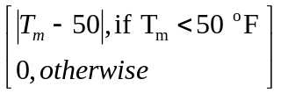

where T_{m} = daily mean temperature in a given locality, | T_{m} – 50 | = absolute value of difference between T_{m} and the feeding threshold of 50°F when the mean daily temperature is lower than 50°F. Daily CDD_{GWSS} equals zero if the daily mean temperature (T_{m}) is higher than 50°F. By summing the CDD_{GWSS} for each day over an extended period, one can estimate the cumulative CDD_{GWSS} over the specified time period for that locality. Using unpublished field data collected by Don Luvisi, Farm Advisor Emeritus, in 2001-2002, we plotted the relationship between cumulative CDD_{GWSS} and GWSS survival at various sites in the vicinity of Bakersfield (Kern County). Based on a curvilinear regression, GWSS survival dropped to 0% when about 321 CDD_{GWSS} in °F (or 178 in °C) were accumulated.
Because most of our previous CDFA-funded work on the impact of cool temperatures on GWSS feeding and survival was conducted using constant temperatures, it was necessary to validate our findings under actual fluctuating temperatures in the field. Prior efforts to field-validate the impact of cool winter temperatures on caged GWSS adults in the crop production areas of the San Joaquin Valley (e.g., east and west of Bakersfield, central Fresno and Merced Counties) and farther north (Napa and Sonoma Counties) were prevented due to concerns over potential escapes of GWSS individuals. Fortunately, we were permitted to establish one field test comparing GWSS adults caged in the urban area of Bakersfield versus caged GWSS in Riverside (UCR Citrus Experiment Station). The GWSS individuals died in a shorter amount of time at the cooler Bakersfield site than the Riverside site. However, only one field test of our hypothesis using fluctuating temperatures is inadequate. Therefore, we proposed to test the impacts of fluctuating temperatures on GWSS survival using programmable temperature cabinets as we have done for the study mentioned above. These additional studies would provide insights into the benefits of using cumulative CDD_{GWSS} to estimate GWSS survival. We also planned to analyze historical temperature data for various locations within the agricultural production areas of California to determine if winter conditions (e.g. November to March) would permit significant GWSS survival based on CDD_{GWSS} accumulation. The eventual product that we aim to produce from these efforts will be the production of GIS maps that estimate CDD_{GWSS} accumulation over the winter months to provide estimates of the ability of local GWSS populations to pose a substantial threat to local agriculture in the following growing season (i.e., a risk assessment). As resources for GWSS management dwindle, government agencies will be forced to make decisions on which regions should receive area-wide treatment to suppress GWSS populations. Our studies suggest that the presence of the GWSS threat may vary with the severity of local winter temperatures. An annual estimation of overwintering GWSS survival across agricultural regions will provide insights into where resources for GWSS suppression should be most effectively allocated.

OBJECTIVES

1) Verify impacts of winter temperatures on GWSS survival from selected California sites;

2) Quantify and compare variation in “cooling degree day” accumulation within and among selected California sites using historical temperature data; and

3) Construct Geographical Information Systems (GIS) maps that estimate GWSS survival during the winter period

METHODS, RESULTS AND DISCUSSION

Objective 1
Verify impacts of winter temperatures on GWSS survival from selected California sites

Dr. Hannah Nadel conducted experimental studies in temperature-controlled growth chambers at the University of California at Riverside. Laboratory studies were conducted because using live GWSS in field-cage studies was prohibited outside of the GWSS-infested areas of California. Cabinets were programmed to run various fluctuating, diurnal temperature patterns that were representative of historical patterns from selected sites within California’s agricultural regions. For nine CIMIS sites (i.e. Riverside, Santa Ynez, Porterville, Merced, Davis, Oakville, McArthur, Gerber, and Arvin), mean daily maximum and minimum temperatures were calculated for the months of November, December, January, February, and March. GWSS adults were caged under a given temperature regime (e.g., McArthur) for a five month period. In chronological order (November, December, January, February, and March), the temperature cabinets were programmed to simulate the average maximum and minimum temperature patterns for the individual months (i.e., 30 days for November, 31 days for December, 31 days for January, etc.). To avoid mortality due to freezing, the minimum temperature was set at 3°C.
Adult GWSS were collected by beat-netting from lemon trees at the UCR Agricultural Operations citrus orchard in Riverside, CA, between late October and early December 2007. They were held on potted sweet orange and prostrate acacia in mesh and vinyl cages in a greenhouse at 25 ± 4°C with natural light (supplemented with sodium vapor lamps L:D 12:12) for 4 – 7 days before use.
Two plant species were selected as winter hosts for the study, ‘Washington Navel’ orange (Citrus sinsensis [L.] Osbeck) grafted on trifoliate orange (Poncirus trifoliata [L.] Rafinesque) rootstock, and prostrate acacia (Acacia redolens Maslin cv ‘prostrata’). Grapevines were not used as originally planned because of difficulty locating nursery stock not treated with insecticides. Prostrate acacia is a leguminous evergreen shrub that is an overwintering host for GWSS (H. Nadel, personal observation). One orange (75 cm tall) (TreeSource Citrus Nursery, Exeter, CA) and one acacia (Parkview Nursery, Riverside, CA) were potted together in a 180 cm² (7-inch) pot and all plants were acclimated at least 1 month in a greenhouse before the study started. A 3.0 mm layer of white sand was placed over the potting medium to facilitate observation of insects on the soil. A 10-day study revealed that the nursery plants were apparently free of toxic residues.
Exposure of GWSS to simulated November temperatures began on the following dates: Riverside 11/9/07; Arvin 11/14/07; McArthur, Oakville and Merced 11/16/07; Porterville, Gerber and Davis 11/30/07; and Santa Ynez 12/6/07. Five male and five female GWSS were transferred in vials from holding cages to each experimental cage. Seven replicate cages were placed individually in water saucers in each temperature cabinet and the plants and insects allowed to acclimate at 18°C for 24 hours before winter temperature simulations began. Cabinets were lighted from 6:00 AM to 6:00 PM by four 32 W fluorescent tubes and two 15 W incandescent bulbs.
GWSS mortality was recorded weekly. Cages were removed from temperature cabinets only long enough to examine and remove dead insects, and were quickly returned (2-5 min). Insects that appeared to be dead were removed from cages, placed on paper under room temperature (20-21°C), and covered with a clear vial. Those that did not revive within two hours were recorded as dead; revived GWSS were returned to their respective cages. Examination of cages was done during the warmest hours of the simulated day, when the insects were likely to show movement. Dead insects were counted and sexed. The potting medium was kept moist with weekly or biweekly watering, as needed.
Numbers of live and dead individuals were sexed and counted weekly until all insects died or the 5-month study period ended. The cumulative CDD_{GWSS} were calculated for each location regime (e.g., Riverside, McArthur) based on temperatures recorded with HOBO recorders within the temperature cabinets (Table 1) and median mortality was compared among regimes using product-limit survival analysis (with survivor data designated as censored) (Table 2). The numbers of cumulative CDD_{GWSS} required to kill all GWSS individuals per cage was compared across location regimes to determine if the value to kill all test insects remains fairly constant across different diurnal temperature patterns. Mortality in all environments was > 97% at the end of the study (Fig. 1). Median GWSS mortality occurred significantly faster in MacArthur and Santa Ynez environments than in others, and occurred significantly later in the Porterville environment than in all but the Merced environment (Table 2). As expected, all GWSS died in the McArthur environment by early December, after exposure to temperatures below feeding threshold. All insects died in the Davis and Oakville environments before accumulated CDD reached the average predicted value for 100% mortality. Although the Riverside environment accumulated no CDD, ~ 98% of the insects died by the end of the study (Fig. 2). A modification of the planned analysis will therefore be necessary, possibly including a senescence function. A significant positive relationship was found between the rate of CDD accumulation and how quickly the insects died (Fig. 3). Data were fitted to a proportional hazards model and likelihood ratio tests of effects of measured variables showed that environment (site), weekly CDD, and minimum temperature significantly affected GWSS mortality (Table 3).

Objective 2
Quantify and compare variation in “cooling degree day” accumulation within and among selected California sites using historical temperature data

Daily maximum and minimum temperature data were downloaded for 10 recent winter periods (November through March for the years 1997 – 2007) from 20 CIMIS stations in several climatic regions of California, including areas expected to be suitable and unsuitable for GWSS winter survival. Eight stations were within or adjacent to known GWSS-infested areas (CDFA 2008). Two CIMIS stations, Merced and Porterville, were operative less than 10 years prior to 2007, and had only 8 and 7 years of data, respectively. CDD were calculated for each date and summed for each winter month, then averaged (Table 4). Most of the sites accumulated less than 300 CCDs (based on °C) through winter. Ten sites accumulated less than 200 CDDs. Five of the six sites that accumulated the least CDD are within the distribution of GWSS infestation. However, three sites in which GWSS occurs accrued more CDDs than our earlier model’s estimated threshold of 178 CDD to cause complete mortality. Among them, Porterville accrued the highest historical CDDs, ~ 260 per winter, while Shafter and Fresno State University accumulated 235 CDD and 227 CDD, respectively. Variation in mean CDD accumulation among sites was statistically significant within each month (November F = 38.7, df = 19, P < 0.0001; December F = 35.6, df = 19, P , 0.0001; January F = 21.5, df = 19, P < 0.0001; February F = 72.5, df = 19, P < 0.0001; March F = 21.2, df = 19, P < 0.0001), but only a few sites were statistically separable from all others (Table 2), notably the coldest, MacArthur, on the Northern Plateau and the warmest, Irvine, on the South Coast. Most sites were not statistically different from each other within each winter month, although they occur in a variety of geoclimatic regions. Analysis of variation across 10 winters within each site indicated non-significant differences in accumulated average CDD in all sites except Santa Rosa (ANOVA, F = 3.8, df = 9, P = 0.0017), which had an unusually cold winter in 2006-2007.

Objective 3
Construct Geographical Information Systems (GIS) maps that estimate GWSS survival during the winter period

We produced ten GIS maps that show estimates of post-winter mortality of GWSS populations (estimated as % mortality) in regions across California following the periods of November through March for each year from 1998-1999 to 2007-2008 (Figs. 4 through 8). These maps were based on temperature data collected during the target months of November through March by CIMIS and the Western Regional Climate Center (WRCC). We estimated the cumulative CDD_{GWWS} based on mean daily temperatures for about 340 temperature monitoring sites. One hundred percent mortality was achieved at 178 cumulative CDD_{GWWS} (based on °C). Spatial statistics techniques using ESRI ArcGIS® Geostatistical Analyst were used to create interpolated surface maps using an Inverse Distance Weighted Analysis with a standard search of 206 points using 15 neighbors (at least 10 were found for each search). Examination of the maps provided show very high estimated GWSS mortality (90-100%) in the Central Valley in the years 1998-1999 (Fig. 4A) and 2004-2005 (Fig. 7A) compared with much less mortality during the other years mapped.
Contrary to our initial assumptions, estimated post-winter mortality was not as high as we expected (i.e., 100%) in most of the agricultural areas of the state and was quite variable throughout the ten years examined. Within the Central Valley, estimated GWSS mortality resulting from cool temperatures (that inhibit normal feeding) usually varied from 80 to 95%. Based on these results, we now realize there is a need to be able to estimate the size of GWSS populations at the end of the winter months as well as the potential for increase in various areas based on climatic conditions. Small post-winter populations in cool areas (Merced) may not pose a threat to agriculture compared to large post-winter populations in warmer areas (e.g., Santa Ynez). Also of significant importance is the time when GWSS females initiate egg laying in the spring. Egg laying may start as soon as late February in Riverside compared to later dates farther north in cooler areas. The earlier in the spring that GWSS populations can initiate egg-laying, the less impact winter temperatures will have on them.

CONCLUSIONS

This project has generated significant new information regarding the impact of California winter temperatures on GWSS survival and also provides a practical tool to use in the decision making process for GWSS management. However, estimated post-winter GWSS mortality due to cold inhibition of feeding was smaller (< 90%) than expected across much of the agricultural production areas of the Central Valley in most of the winters for which maps were produced. In much of the Central Valley, mortality estimates ranged from 80 to 90%, which may be insufficient to prevent the initiation of threatening spring populations of the GWSS. However, occasionally estimates were as high as 90 to 99%. Another important factor is geographical location because GWSS populations in southern latitudes are typically able to initiate egg-laying earlier than populations farther north. More northern populations will suffer greater temperature-related mortality before they can initiate egg-laying activities.

REFERENCES CITED

California Department of Food and Agriculture. 2008. Glassy-winged sharpshooter and Pierce’s disease distribution. Available online at http://www.cdfa.ca.gov/pdcp/ images/Pierce’sDisease_distribution_v4.jpg. Accessed on February 5, 2009.
Hoddle, M.S. 2004. The potential adventive geographic range of glassy-winged sharpshooter, Homalodisca coagulata and the grape pathogen Xylella fastidiosa: implications for California and other grape growing regions in the world. Crop Prot. 23:691-699.
Johnson, M., K. Daane, R. Groves, E. Backus, & Y. Son. 2006. Spatial population dynamics and overwintering biology of the glassy-winged sharpshooter, Homalodisca coagulata, in California’s San Joaquin Valley, pp. 12-15. In M. A. Tariq, R. Medeiros, M. Mochel, and S. Veling [eds.], Proceedings, 2005 Pierce’s Disease Research Symposium, San Diego, CA, Nov 27-29, 2006.
Krugner, R. 2007. Population ecology of Homalodisca vitripennis (Germar) (Hemiptera: Cicadellidae) and host selection behavior of associated egg parasitoids. Ph.D. Dissertation, University of California, Riverside, CA. 132 pp.
Pollard, H. N., and Kaloostian, G. H. 1961. Overwintering habits of Homalodisca coagulata, the principal natural vector of phony peach disease. Journal of Economic Entomology 54: 810-811.
Varela, L.G., R.J. Smith, and P.A. Phillips. 2001. Pierce's Disease. Univ. California. Agric. & Nat. Res. Publ 21600.
PUBLICATIONS PRODUCED
Actual
Johnson, M., K. Lynne-Patterson, M. Sisterson, and R. Groves. 2007. Assessing the post-winter threat of glassy-winged sharpshooter populations, pp. 34-37. In T. Esser, P. Blincoe, D. West, M. Mochel, and S. Veling [eds.], Proceedings, 2007 Pierce’s Disease Research Symposium, San Diego, CA, Dec. 12-14, 2007.

Johnson, M., K. Lynne-Patterson, M. Sisterson, and R. Groves. 2008. Assessing the post-winter threat of glassy-winged sharpshooter populations, pp. 22-27. In T. Esser, P. Blincoe, D. West, S. Veling, R. Randhawa, and J. LeMasters [eds.], Proceedings, 2008 Pierce’s Disease Research Symposium, San Diego, CA, Dec. 15-17, 2008.
Pending
Son, Y., R. L. Groves, K. M. Daane, D. Morgan, and M. W. Johnson. Influences of temperature on Homalodisca vitripennis (Germar) (Hemiptera: Cicadellidae) survival under various feeding conditions. Submitted to Environmental Entomology (manuscript revised and submitted to editor for final decision). 37 pp.
In preparation
Nadel, H., Johnson, M., K. Lynne-Patterson, M. Sisterson, and R. Groves. Impact of cool winter temperatures on California glassy-winged sharpshooter populations. In Preparation for submission to Environmental Entomology.

CONTRIBUTIONS TO SOLVING THE GWSS THREAT TO CALIFORNIA

Using temperature records to calculate numbers of cooling degree days, we constructed ten GIS maps to delineate areas where post-winter GWSS mortality should be substantial, thereby providing a tool to estimate the springtime GWSS threat to different regions. However, estimates of post-winter GWSS mortalities were usually smaller (< 90%) than expected across much of the agricultural production areas of the Central Valley. However, the ten GIS maps suggest that most of the GWSS population in the Central Valley, except in the southwestern border portions, would be decimated by cool temperatures during winters of two (1998-1999 and 2004-2005) of the ten years that climatic data were available. This may mean that even if GWSS can survive in the Central Valley, it probably would never become firmly established in most of the region. This somewhat reflects the population patterns that we see today.
As resources for GWSS management dwindle, government agencies will be forced to make decisions on which regions should receive area-wide treatment to suppress GWSS populations. Our studies suggest that the presence of the GWSS threat may vary with the severity of local winter temperatures. An annual estimation of overwintering GWSS survival across agricultural regions will provide insights into where resources for GWSS suppression should be most effectively allocated.

FUNDING AGENCIES

Project funding was provided by 1) the CDFA Pierce’s Disease and Glassy-winged Sharpshooter Board and 2) an USDA ARS Special Cooperative Agreement with the senior P.I.
Table 1. GWSS adult mortality and total Cumulative Degree Days (CDD), based on a feeding threshold of 10°C, accrued to reach > 95% mortality.

CA Site | Accumulated CDD | Mortality (%) | Weeks elapsed
Riverside | 0 | 98.6 | 17
Arvin | 86 | 95.7 | 12
Oakville | 117 | 97.1 | 9
McArthur | 144 | 97.1 | 4
Davis | 145 | 97.1 | 11
Santa Ynez | 154 | 97.1 | 11
Porterville | 221 | 95.7 | 18
Merced | 236 | 97.1 | 21
Gerber | 237 | 96.7 | 16

Table 2. Quantiles for time to median (with 95% CI), 25%, and 75% mortality (product-limit survival analysis, JMP 7).

 | Quantiles of Weeks until Death
Site | Median Time | Lower 95% CI | Upper 95% CI | 25% Dead | 75% Dead
Arvin | 6 | 4 | 7 | 2 | 10
Davis | 5 | 3 | 6 | 2 | 7
Gerber | 7 | 6 | 8 | 4 | 9
McArthur | 2 | 2 | 2 | 1 | 3
Merced | 7 | 5 | 9 | 4 | 13
Oakville | 5 | 4 | 6 | 3 | 7
Porterville | 9 | 9 | 11 | 7 | 12
Riverside | 8 | 5 | 10 | 2 | 11
Santa Ynez | 2 | 2 | 3 | 1 | 5
Combined | 5 | 5 | 6 | 2 | 9

Table 3. Effect likelihood-ratio tests of variables monitored in the environmental chambers (proportional hazards model, JMP 7).

Source | DF | Chi-square | P > Chi-square
Site | 8 | 175.48 | < 0.0001
Sex | 1 | 1.35 | 0.2448
Maximum Temperature | 1 | 0.76 | 0.3829
Minimum Temperature | 1 | 54.33 | < 0.0001
Weekly CDD | 1 | 4.80 | 0.0285
P < 0.05 is considered significant.
Table 4. Average accumulated CDD during each winter month and over the whole winter period (November through March) over a 10-year period between 1997 and 2007 in 20 California sites.

Station | County | Geoclimatic region | Nov | Dec | Jan | Feb | Mar | Total Winter
McArthur | Shasta | Northern Plateau | 190.5ª | 284.9ª | 277.7ª | 207.0ª | 132.9ª | 1093.1
Camino | El Dorado | Sierra Foothills | 53.8 | 100.2 | 101.3 | 91.9 ^{b} | 64.3 ^{b} | 411.6
Santa Rosa | Sonoma | North Coast Valleys | 37.0 | 95.9 | 93.2 | 53.3 | 30.2 | 309.5
Merced | Merced | San Joaquin Valley | 33.0 | 91.8 | 101.5 | 40.0 | 13.7 | 280.0
Porterville* | Tulare | San Joaquin Valley | 33.7 | 86.1 | 95.9 | 33.5 | 10.2 | 259.4
Orange Cove | Fresno | San Joaquin Valley | 26.4 | 81.5 | 98.2 | 32.6 | 12.8 | 251.5
Shafter/USDA* | Kern | San Joaquin Valley | 25.5 | 93.6 | 85.9 | 23.3 | 6.8 | 235.1
Gerber | Tehama | Sacramento Valley | 25.3 | 79.4 | 79.7 | 32.4 | 15.3 | 232.1
Fresno State* | Fresno | San Joaquin Valley | 21.0 | 86.6 | 84.6 | 25.5 | 9.6 | 227.2
Davis | Yolo | Sacramento Valley | 19.7 | 76.5 | 80.8 | 30.1 | 12.2 | 219.3
King City-Oasis Rd. | Monterey | Monterey Bay | 19.2 | 63.3 | 61.4 | 30.8 | 17.4 | 192.0
Brentwood | Contra Costa | San Francisco Bay | 16.7 | 72.8 | 73.6 | 21.4 | 6.4 | 190.9
Oakville | Napa | North Coast Valleys | 19.3 | 59.0 | 62.6 | 28.2 | 16.3 | 185.3
Suisun Valley | Solano | Sacramento Valley | 18.6 | 67.8 | 66.9 | 20.0 | 9.3 | 182.6
Arvin-Edison* | Kern | San Joaquin Valley | 18.0 | 72.6 | 64.8 | 14.4 | 4.2 | 174.0
Fair Oaks* | Sacramento | Sacramento Valley | 14.6 | 61.3 | 66.5 | 20.2 | 8.8 | 171.4
Santa Ynez** | Santa Barbara | Central Coast Valleys | 19.7 | 58.8 | 50.6 | 27.3 | 12.3 | 168.8
De Laveaga | Santa Cruz | Monterey Bay | 11.3 | 37.4 | 46.3 | 21.9 | 16.0 | 132.9
U.C. Riverside* | Riverside | Los Angeles Basin | 1.7^{c} | 8.7^{c} | 10.5 | 5.7 | 4.1 | 30.6
Irvine* | Orange | South Coast Valleys | 0.4^{c} | 3.9^{c} | 4.3^{c} | 2.0^{c} | 1.4 | 11.9
Note: 178 CDD estimated for mortality when temperature measured in °C.
*Within or **adjacent to current GWSS and Pierce’s Disease distribution (California Department of Food and Agriculture 2008.)
ª Value is significantly higher than all others in this column (Tukey’s HSD test to separate means).
^{b} Value is significantly higher than all but ‘ ª ’ in this column (Tukey’s HSD test to separate means).
^{c} Value is significantly lower than all others in this column (Tukey’s HSD test to separate means).
Table 5. Mean accumulated cooling degree-days (CDD) and standard error of the means (SEM) during December and January over a ten-year period between 1997 and 2006 in 20 California sites.
December |  |  |  |  |  |  | January
Station |  | CDD | SEM | Means Separationª |  | Station |  | CDD | SEM | Means Separationª
McArthur |  | 285 | 12.7 | A |  | McArthur |  | 278 | 17.7 | A
Camino |  | 100 | 9.0 | B |  | Merced |  | 102 | 15.1 | B
Santa Rosa |  | 96 | 19.3 | B |  | Camino |  | 101 | 12.5 | B
Shafter / USDA |  | 92 | 11.1 | B |  | Orange Cove |  | 98 | 13.5 | B
Merced |  | 86 | 9.8 | B |  | Porterville |  | 96 | 15.0 | B
Fresno State |  | 81 | 9.6 | B |  | Santa Rosa |  | 93 | 18.0 | B
Porterville |  | 94 | 8.1 | BC |  | Shafter / USDA |  | 86 | 12.0 | B
Orange Cove |  | 79 | 7.2 | BC |  | Fresno State |  | 85 | 11.7 | B
Gerber |  | 87 | 7.3 | BC |  | Davis |  | 81 | 10.9 | B
Davis |  | 77 | 8.6 | BC |  | Gerber |  | 80 | 10.3 | B
Brentwood |  | 63 | 9.9 | BC |  | Brentwood |  | 74 | 10.9 | B
Arvin- Edison |  | 73 | 8.7 | BC |  | Suisun Valley |  | 67 | 10.1 | BC
Suisun Valley |  | 59 | 8.0 | BC |  | Fair Oaks |  | 66 | 10.4 | BC
King City-Oasis Rd. |  | 68 | 8.6 | BC |  | Arvin-Edison |  | 65 | 10.8 | BC
Fair Oaks |  | 73 | 8.4 | BC |  | Oakville |  | 63 | 10.1 | BCD
Oakville |  | 61 | 8.5 | BC |  | King City-Oasis Rd. |  | 61 | 11.7 | BCD
Santa Ynez |  | 59 | 6.3 | BC |  | Santa Ynez |  | 51 | 9.2 | BCD
De Laveaga |  | 37 | 7.3 | CD |  | De Laveaga |  | 46 | 8.7 | BCD
UC Riverside |  | 9 | 2.2 | D |  | UC Riverside |  | 10 | 3.2 | CD
Irvine |  | 4 | 1.1 | D |  | Irvine |  | 4 | 1.4 | D
Note: 178 CDD estimated for mortality when temperature measured in °C.
¹ Means followed by the same letter within a month are not significantly different (ANOVA, followed by Tukey’s HSD test to separate means).

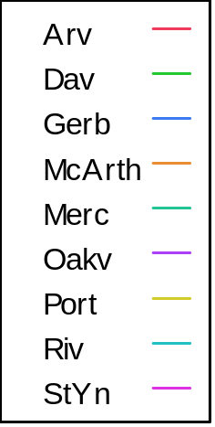
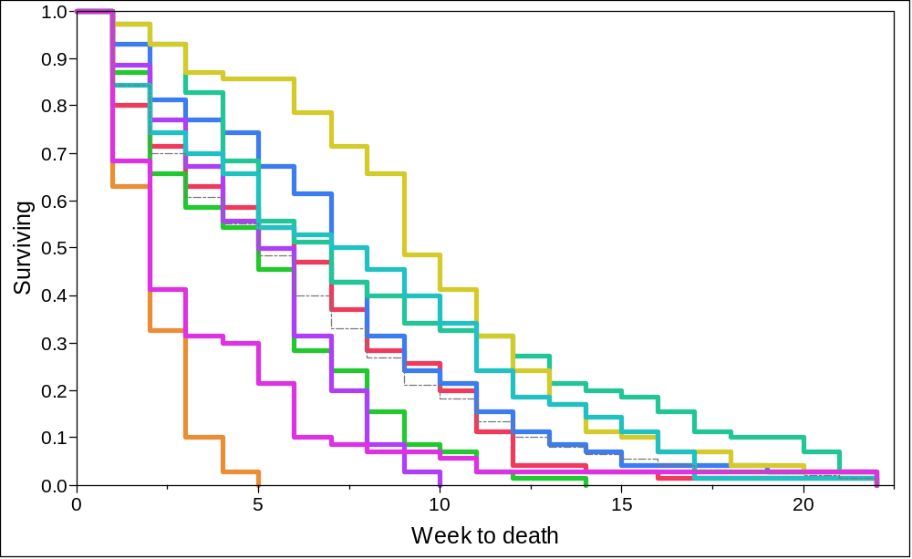

Fig. 1. Product-limit survival plot of GWSS subjected to simulated diurnal winter temperature cycles in nine California sites. The dashed line represents the combined plot.

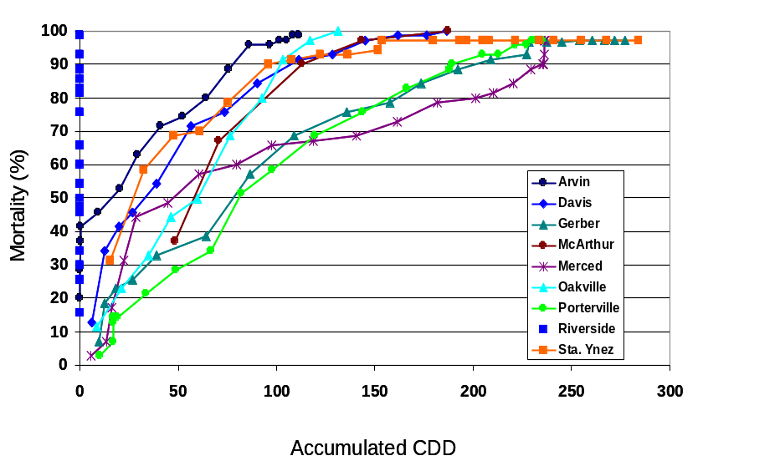

Fig. 2. Relationship between accumulated CDD (Based on °C) and GWSS mortality under simulated winter conditions for nine California sites. Points represent mean weekly mortality data.

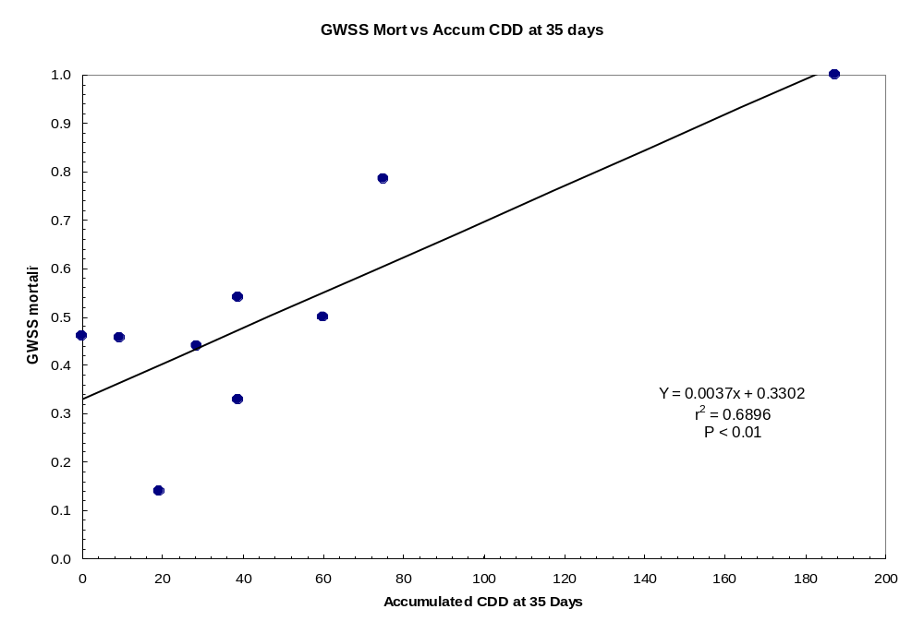

Fig. 3. Relationship between accumulated CDD (Based on °C) and GWSS mortality under simulated winter conditions for nine California sites. Points represent mean weekly mortality data.

A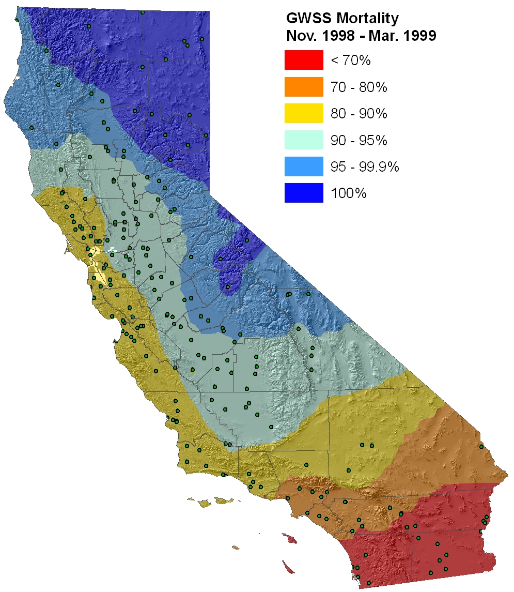 | B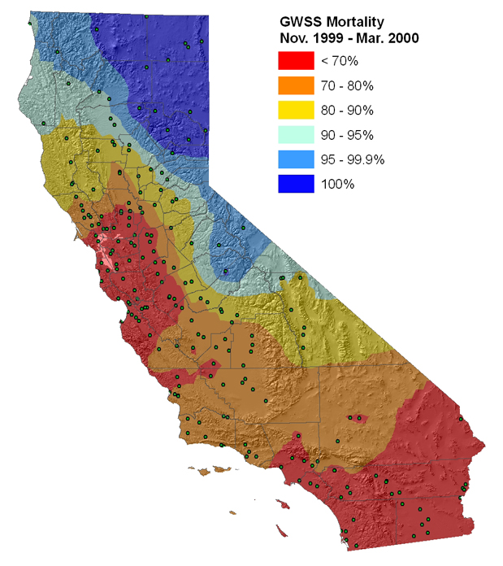
Fig. 4. Estimated percentage of cold-induced mortality of adult GWSS populations throughout California regions experiencing different levels of cumulative cooling day degrees (CCD) from A) November 1998 thru March 1999 and B) November 1999 thru March 2000. Dark blue represents 100% GWSS mortality (> 178 cumulative CDD based on ºC or > 321 cumulative CDD based on ºF) and red represents 0 to 69% GWSS mortality. Green circles indicate CIMIS weather stations.

A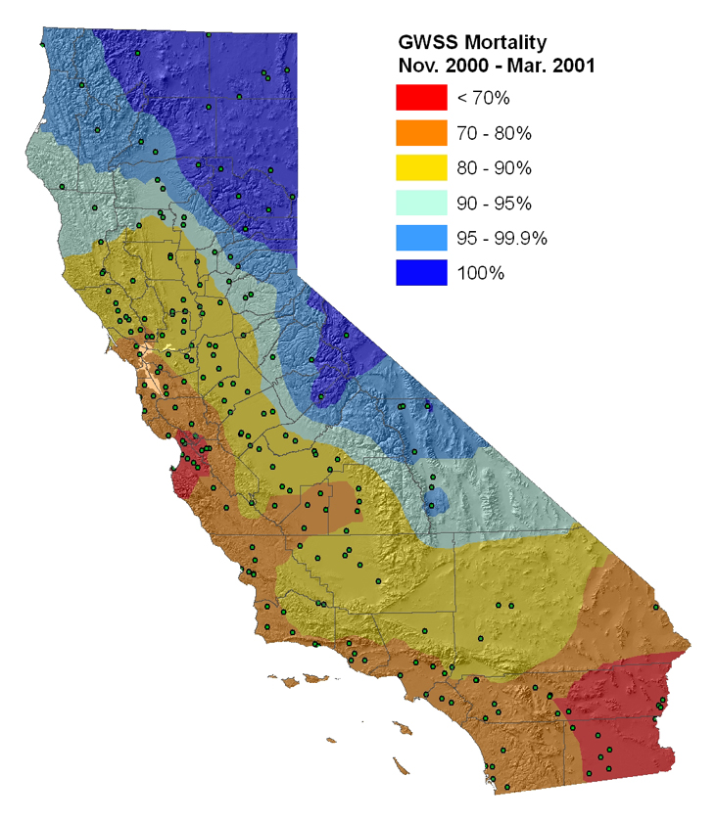 | B 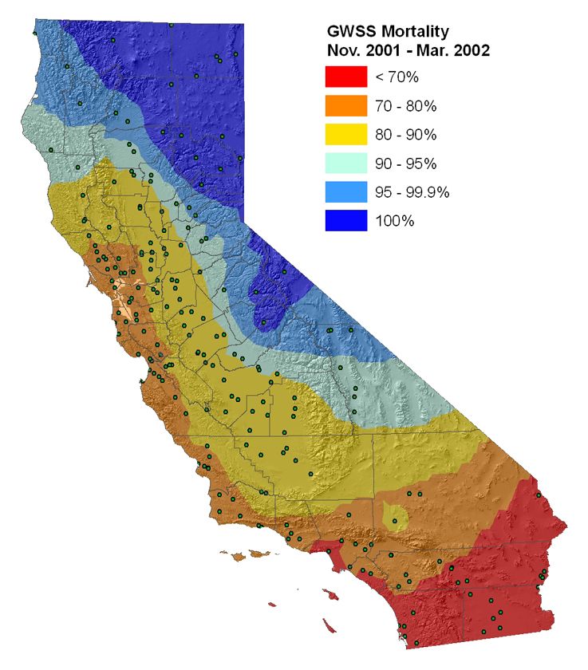
Fig. 5. Estimated percentage of cold-induced mortality of adult GWSS populations throughout California regions experiencing different levels of cumulative cooling day degrees (CCD) from A) November 2000 thru March 2001 and B) November 2001 thru March 2002. Dark blue represents 100% GWSS mortality (> 178 cumulative CDD based on ºC or > 321 cumulative CDD based on ºF) and red represents 0 to 69% GWSS mortality. Green circles indicate CIMIS weather stations.

A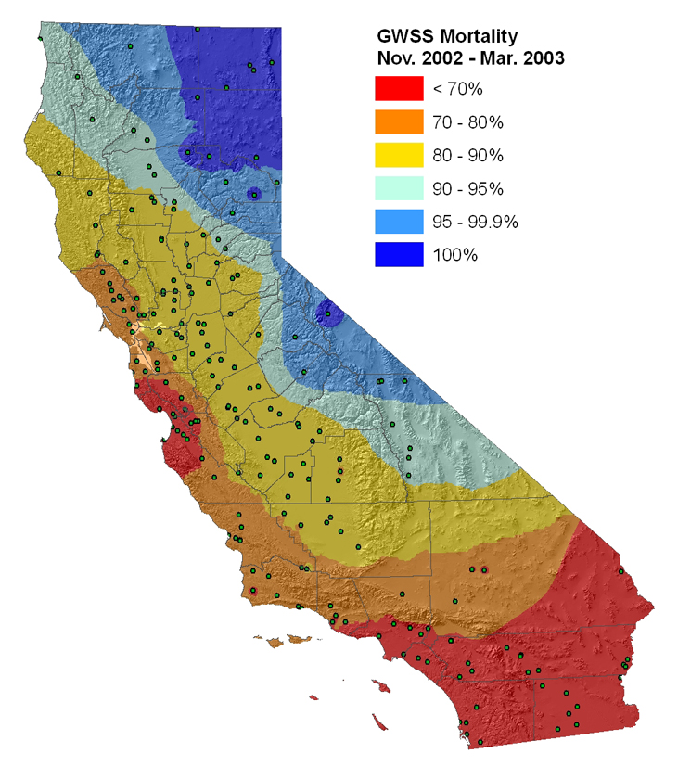 | B 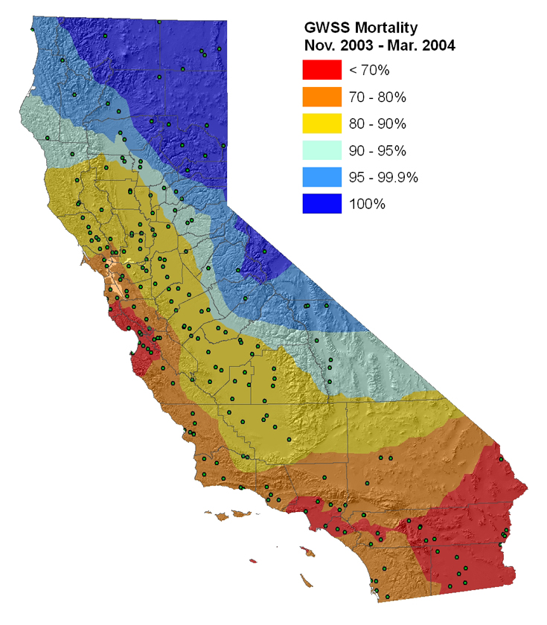
Fig. 6. Estimated percentage of cold-induced mortality of adult GWSS populations throughout California regions experiencing different levels of cumulative cooling day degrees (CCD) from A) November 2002 thru March 2003 and B) November 2003 thru March 2004. Dark blue represents 100% GWSS mortality (> 178 cumulative CDD based on ºC or > 321 cumulative CDD based on ºF) and red represents 0 to 69% GWSS mortality. Green circles indicate CIMIS weather stations.
A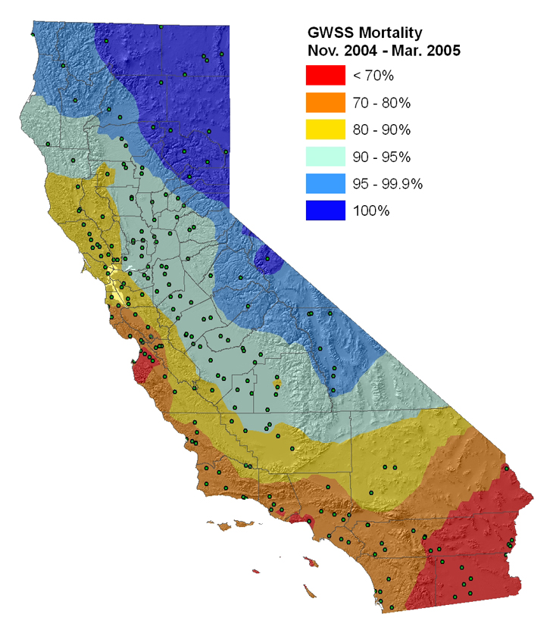 | B 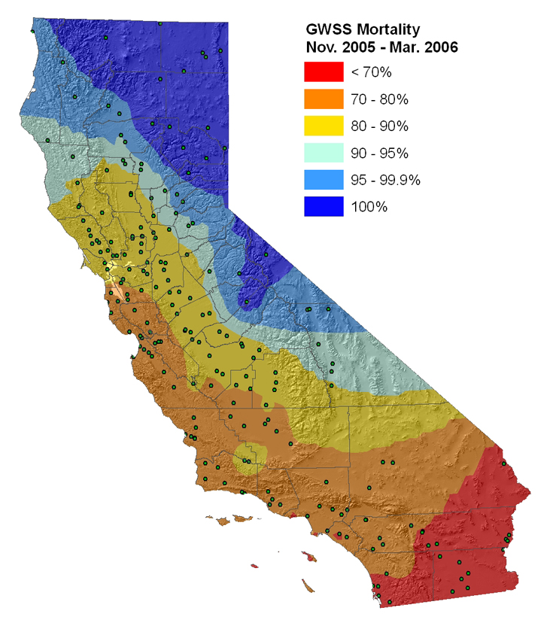
Fig. 7. Estimated percentage of cold-induced mortality of adult GWSS populations throughout California regions experiencing different levels of cumulative cooling day degrees (CCD) from A) November 2004 thru March 2005 and B) November 2005 thru March 2006. Dark blue represents 100% GWSS mortality (> 178 cumulative CDD based on ºC or > 321 cumulative CDD based on ºF) and red represents 0 to 69% GWSS mortality. Green circles indicate CIMIS weather stations.

A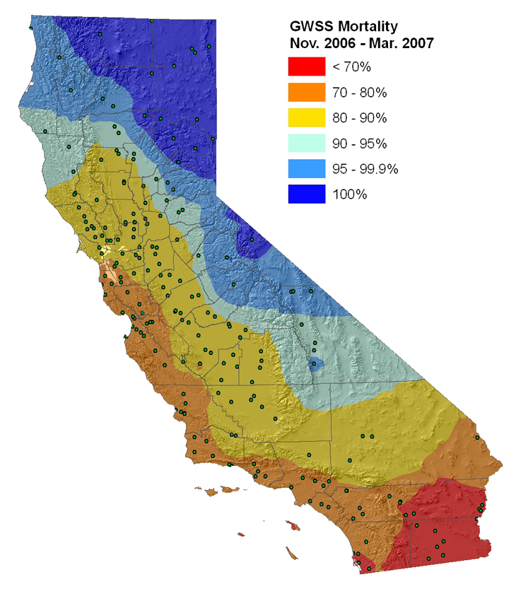 | B 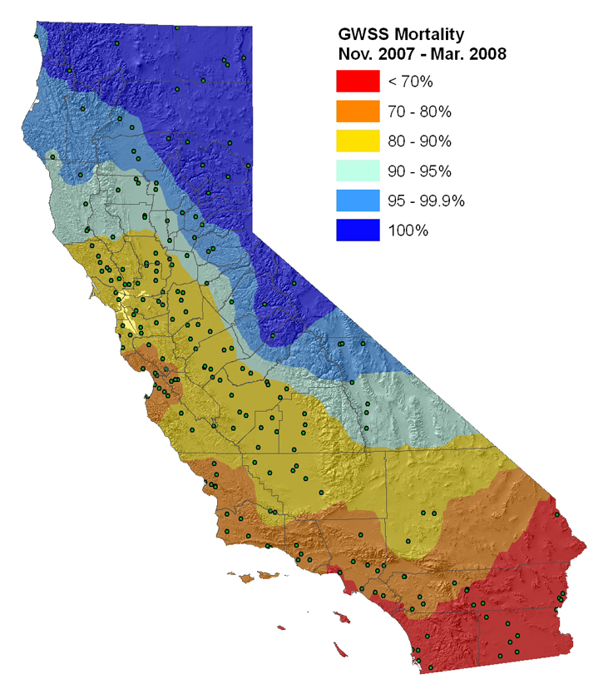
Fig. 8. Estimated percentage of cold-induced mortality of adult GWSS populations throughout California regions experiencing different levels of cumulative cooling day degrees (CCD) from A) November 1998 thru March 1999 and B) November 2007 thru March 2008. Dark blue represents 100% GWSS mortality (> 178 cumulative CDD based on ºC or > 321 cumulative CDD based on ºF) and red represents 0 to 69% GWSS mortality. Green circles indicate CIMIS weather stations.

