PROJECT TITLE
Identification of factors mediating cold therapy of Xylella fastidiosa-infected grapevines.

PRINCIPAL INVESTIGATOR AND COOPERATOR
Bruce C. Kirkpatrick and Melody M. Meyer, University of California, Davis.

THIS REPORT COVERS RESEARCH CONDUCTED: 3/2009-7/2009

LIST OF OBJECTIVES AND DESCRIPTION OF ACTIVITIES CONDUCTED TO ACCOMPLISH EACH OBJECTIVE
Objective 1: Develop an experimental, growth chamber temperature regime that can consistently cure Pierce’s Disease affected grapevines without causing unacceptable plant mortality.
The results described in previous reports showed that our field plants and cold chamber plants had lower disease ratings and higher curing rates in the colder temperature treatments. In 2005-2007 sites, vine mortality was minimal due to better cold acclimation of the grapevines prior to establishing the plots in the fall.
The data collection for the field and cold chamber studies have been completed (Tables 1 and 2, respectively) and the analysis of the data to determine the critical temperature thresholds for cold curing has begun. We are collaborating with Heiner Lieth from the Plant Sciences department at UC Davis to generate a cold temperature model to determine if vineyards in cold boundary areas (i.e., foothills of the Sierra and northern-most California) are at risk for developing PD. The information obtained from these models could provide data that could be used by grape growers for risk assessment and management purposes.
Field Experiment Results:
The results for our field plots showed lower disease ratings and higher curing rates in the colder temperature treatments (Table 1). This is consistent with the results we obtained in previous field seasons. This information will be used to make a model that will help predict what areas are most likely to experience cold curing and not expected to have PD problems.
Table 1: 2006-2007 Field Results
PD-free vines^{x}/ X.fastidiosa-inoculated grapevines that survived until 2007 | Davis | Hopland | McLaughlin | Foresthill
Pinot Noir | 3/11 | 9/11 | 8/11 | 8/11
Cabernet Sauvignon | 1/11 | 8/11 | 7/11 | 10/11
Mean Disease Ratings after  cold treatments^{y} | Davis | Hopland | McLaughlin | Foresthill
Pinot Noir | 1.6 | 0.6 | 1.0 | 0.3
Cabernet Sauvignon | 2.3 | 1.0 | 1.1 | 0.1
Vine Mortality^{z} | Davis | Hopland | McLaughlin | Foresthill
Pinot Noir | 0% | 0% | 0% | 0%
Cabernet Sauvignon | 0% | 0% | 0% | 0%
^{x.} Vines that were inoculated with X. fastidiosa and tested (+) by IC-PCR in Fall 2006 that no longer tested (+) in Fall 2007..
^{y.} Disease ratings for Pierce’s Disease 0-5 (no disease to most severe disease).
^{z.} Total mortality of inoculated and control vines.

Cold Room Experimental Results:
The results of the cold room experiments showed disease recovery and mortality trends that were similar to the field plots. The coldest treatments had the highest rate of recovery from PD, but also the highest mortality (Table 2).

Table 2: 2006-2007 Cold Chamber Results
PD-free vines^{x}/ X. fastidiosa-inoculated grapevines that survived until 2007 | +5ºC | 2.2ºC | 0ºC | -5ºC
Pinot Noir | 3/9 | 3/10 | 4/10 | 6/6
Cabernet Sauvignon | 0/9 | 4/10 | 5/10 | 7/7
Mean Disease Ratings after  cold treatments^{y} | +5ºC | 2.2ºC | 0ºC | -5ºC
Pinot Noir | 1.4 | 2.1 | 1.1 | 0.0
Cabernet Sauvignon | 2.1 | 2.2 | 0.6 | 0.0
Vine Mortality^{z} | +5ºC | 2.2ºC | 0ºC | -5ºC
Pinot Noir | 10% | 0% | 0% | 40%
Cabernet Sauvignon | 10% | 0% | 0% | 30%
^{x.} Vines that were inoculated with X. fastidiosa and tested (+) by IC-PCR in Fall 2006 that no longer tested (+) in Fall 2007..
^{y.} Disease ratings for Pierce’s Disease 0-5 (no disease to most severe disease).
^{z.} Total mortality of inoculated and control vines.

Objective 2: Analyze chemical changes such as pH, osmolarity, total organic acids, proteins and other constituents that occur in the xylem sap of cold-treated versus non-treated susceptible and less susceptible Vitis vinifera varieties.
Xylem sap was extracted from vines from each field location and cold chamber treatment using the pressure bomb. The samples were then tested for potential changes in pH, osmolarity, protein profiles, total phenolics, total sugars, and calcium and magnesium concentrations in xylem sap. The final statistics for all these analyses are being completed and a manuscript is being prepared to be submitted for publication.
The pH for each sample was measured using a Corning pH meter 140 with a MI-710 Micro-combination electrode (Microelectrodes, Inc., Bedford, NH). The results reported in previous reports show that the pH of Cabernet sauvignon (CS) xylem sap was significantly higher than Pinot noir (PN) sap overall.
The osmolarity for each sample was measured using a Wescor 5500 vapor pressure osmometer. These results have been reported in previous progress reports and posters.
Xylem sap protein profiles were analyzed for the 2005-2007 samples. The sap proteins were concentrated with acetone precipitation and the proteins were electrophoresed in a 12% Tris-HCl 1-dimensional polyacrylamide gel (PAGE). Protein profiles of the PAGE gels were compared for each treatment. Unique protein bands that were found in the cold treated plants were cut from the gel, and end terminally sequenced by the UCD Molecular Structure Facility. The remaining bands on the gel were also sequenced to determine the identity of some of the other major plant proteins that are present in grapevine xylem sap. Sequencing identified proteins that had high sequence homology with stress proteins that are produced by Cabernet Sauvignon berries under water deficit stress conditions, proteins that are similar to proteins produced in Pinot Noir roots, tryptase inhibitors, thaumatin-like protein which is reported to have anti-fungal properties, transaldolase, peroxidase, hydrolase, extracellular chitinase, and beta 1,3 glucanase.

Figure 1: Protein profile of grapevine xylem sap. 150 uL of xylem sap was precipitated with cold acetone. Proteins were resuspended in 30 uL of SDS-loading buffer and loaded in to a BioRad 12% Tris-HCl gel. Figure 3: Protein profile of grapevine xylem sap.

. 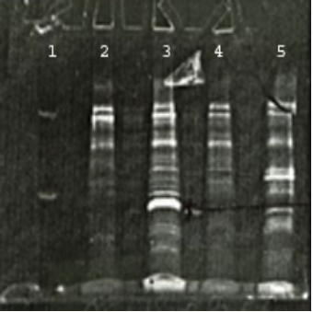
Lane 1: Dual Color SDS-ladder.
Lane 2: CS +5ºC xylem sap from control vines.
Lane 3: CS -5ºC xylem sap from control vines.
Lane 4: CS +5ºC xylem sap from inoculated vines. Lane 5: CS -5ºC xylem sap from inoculated vines.

Arrow indicates a protein whose sequence had high homology with a Vitis vinifera thaumatin-like protein

Total phenolics were measured using the Folin-Ciocalteu procedure which is a colorimetric assay for measuring phenolic and polyphenolic compounds. Results for the 2005-2006 and 2007-2008 xylem sap samples from Pinot Noir and Cabernet Sauvignon showed significantly higher amount of total phenolics in the cold treated sap than the warm sap (Figure 2).

Figure 2: Total phenolics of grapevine xylem sap.
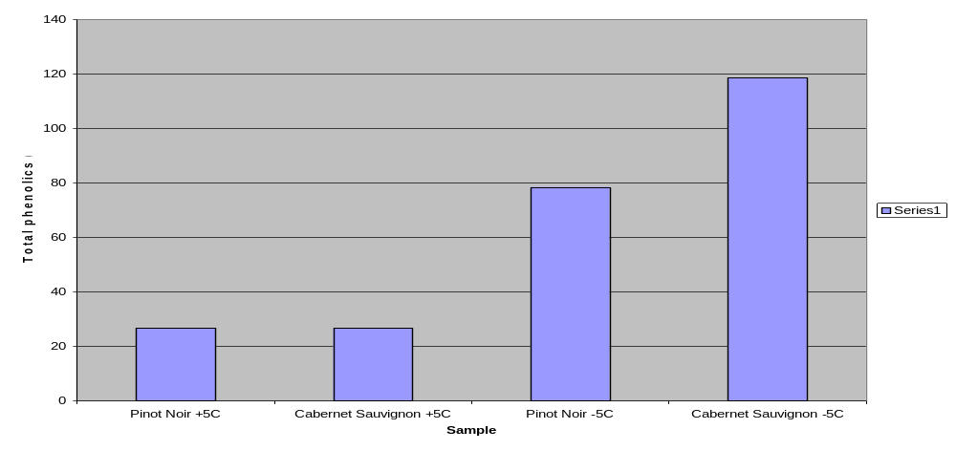
ABA concentrations in the spring xylem sap collections were the lowest in the coldest field locations. ABA levels were higher in the late winter sap collections than in the spring collections for the field locations.
Sugar and select ion concentration analysis of CS grapevines showed greater amounts of glucose and fructose in –5ºC cold chamber vines, whereas Ca⁺ levels were greater in the warmest treatments. Osmolarity was greatest in the coldest treatments and decreased with increasing temperature. Conversely, in PN grapevines, glucose and fructose levels were the lowest in the coldest treatments. Ca⁺ levels showed a similar trend with CS vines, with increased Ca⁺ levels in the warmer temperature treatments. Temperature appeared to have a less direct effect on osmolarity in Pinot Noir grapevines.

Figure 3: Fructose, glucose, Ca+ and Mg+ concentrations from cold room treated Cabernet Sauvignon grapevines plotted against osmolarity of xylem sap.
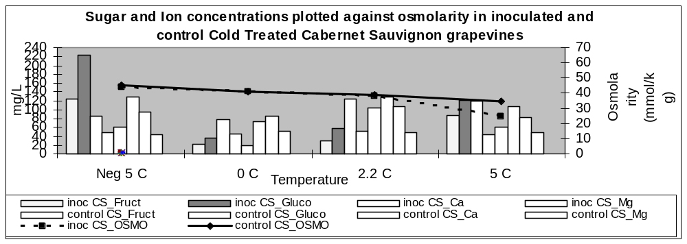

Figure 4: Sugar (fructose and glucose) and ion (Ca+ and Mg+) concentrations in xylem sap from cold treated Pinot Noir grapevines compared to osmolarity.
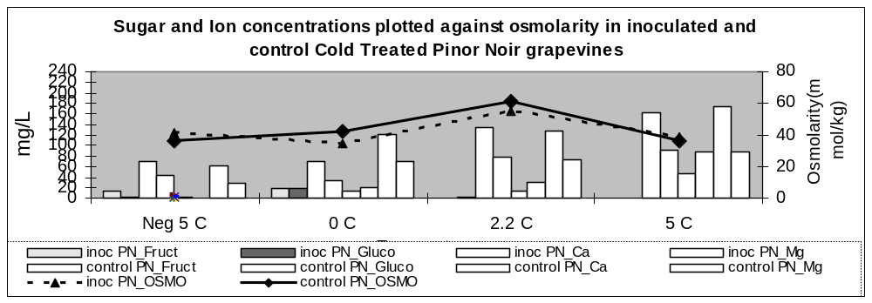

Objective 3: Assess the viability of cultured X. fastidiosa cells growing in media with varying pH and osmolarity and cells exposed to xylem sap extracted from cold- and non-treated grapevines.
The solutions used for these viability experiments included: water, extracted V. vinifera (‘Pinot Noir’ and ‘Cabernet Sauvignon’ varieties) xylem sap, PD3 medium, HEPES, sodium and potassium phosphate buffers. All buffers and PD3 medium were adjusted to pH 6.8. X. fastidiosa cells suspended in the various buffers and media were exposed to various temperatures (28ºC, 5ºC, 2.2ºC, 0ºC, -5ºC, -10ºC and -20ºC). Potassium phosphate buffer at various pH values (5.0-6.8) was also used to determine the effects of pH on the survival of X. fastidiosa. A suspension of 10⁸ X. fastidiosa cells was determined using a spectrophotometer (Thermo Spectronic; Rochester, NY USA) and once the desired cell concentration was made, portions of the solutions were plated and counted seven days post plating to confirm the correlation between OD reading and viable colony forming units (CFUs).
The results of these experiments were reported in detail in the 2007 progress report. Currently, this data is being prepared for publication.
To summarize the results, these experiments indicate that X. fastidiosa can survive at 28ºC in most media except water. The mortality rate was the lowest in PD3 medium in the 5˚C and 2.2˚C temperature treatment. The deionized water treatment had the highest mortality rate followed by potassium phosphate at pH 6.2. The highest survival at 0˚C occurred with PD3 media and in xylem sap collected from grapevines growing in a cold climate (Placer County, CA). Survival was the lowest in deionized water and potassium phosphate at pH 6.2. These experiments showed that X. fastidiosa can survive at -5ºC in all buffers at pH 6.8, media and xylem sap for at least 4 days. No cultivable X. fastidiosa was recovered from any of the media, buffers or xylem sap after 24 hours at -10˚C or at -20˚C.
Determining the survival of X. fastidiosa over an hourly progression in various medias/buffers/sap could help determine the viability of cells for other experiments that require high X. fastidiosa viability such as plant inoculations and flow chamber experiments.
Every hour, for 24 hours, samples were dilution plated out onto solid PD3 and grown for seven days. After seven days, colonies were counted to determine the effect each treatment had on the viability of X. fastidiosa cells. This experiment showed that X. fastidiosa does best in PD3 and xylem sap over a short time span.

Figure 5: Hourly buffer, media and xylem sap effects on X. fastidiosa over a 24 hour period.
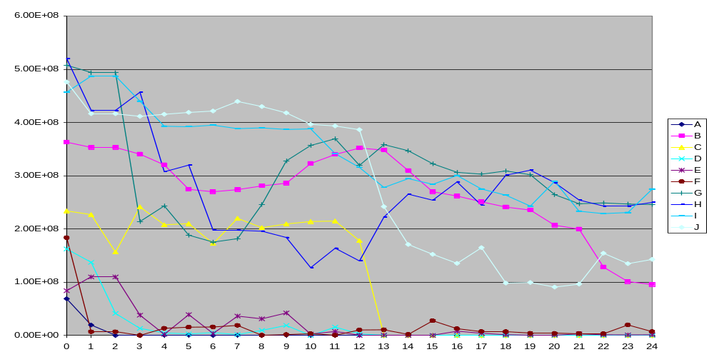

Objective 4: Determine the effect of treating PD-affected grapevines with cold-induced plant growth regulators, such as abscisic acid (ABA), as a possible therapy for PD.
We contacted Valent Bioscience Corporation who develops plant growth regulators, such as ABA, for agricultural use. In November of 2005, 2006, 2007 and 2008, healthy and X. fastidiosa-inoculated Cabernet Sauvignon and Pinot Noir vines were sprayed with solutions of ABA.
The results of these experiments indicate that ABA has a curing effect on Vitis vinifera ‘Pinot Noir’ when applied as a drench. In the 2005-2006 season the most effective treatment was the 10ppm VBC-30030 drench treatment which resulted in 100% curing in ‘Pinot Noir’. The 100ppm VBC-30054 also had significant more curing than the control vines. In the 2006-2007 none of the treatments were significantly different from the control. In the 2007-2008 season, the 100ppm VBC-30054 drench treatment, the 10ppm VBC-30030 drench and the 100ppm VBC-30030 spray were significantly different from the control. Disease ratings for both drench treatments (VBC-30030 and VBC-30054) decreased after application of drench treatments (Figure 6).

Figure 6:
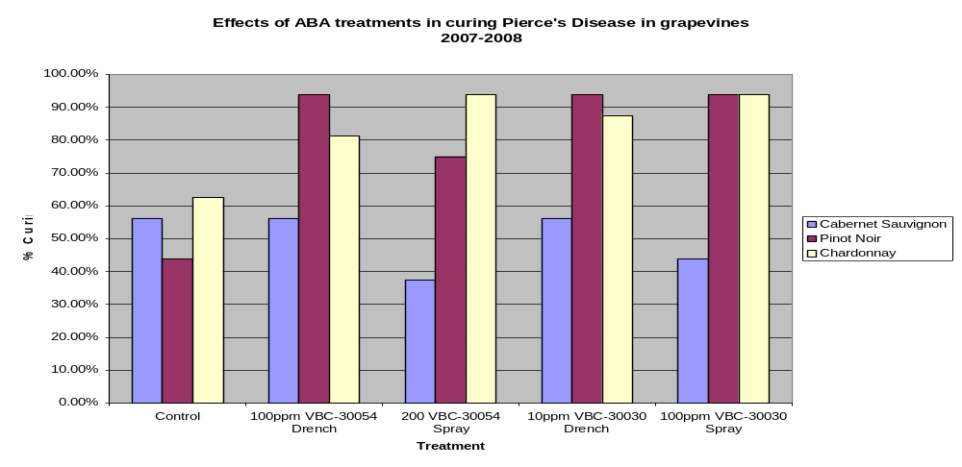
The xylem sap of the grapevines was extracted using a pressure bomb four days after the application of the ABA treatments. To examine the proteins produced when grapevines are exposed to ABA, protein profiles were made of each treatment. The 150 ul of xylem sap was precipitated with cold acetone to concentrate the proteins. The proteins were resuspended in 30 uL of SDS-loading buffer and electrophoresed in a BioRad 12% Tris-HCl gel. Some of the proteins sequences in the ABA treated vines are similar to those found in our cold treated vines.
As a continuation of objective 2, from the results of the analysis of xylem sap proteins, we determined that we should further characterize the potential biological properties of the thaumatin–like protein (TLP). TLP proteins were also up regulated in the ABA treated grapevine xylem sap, making TLP a protein of potential interest in the cold curing phenomenon.
Other plant TLPs have been shown to have anti-microbial activity and TLP is found in the xylem of plants. To investigate this further, we cloned and expressed TLP in an E.coli expression vector. The crude TLP protein preparation appeared to have some anti-Xf activity. I have tried purifying the protein with a His-column but did not get biologically active protein off the column. I am currently attempting to use a FPLC to purify functional protein.

Publications or reports resulting from the project:
2009 American Phytopathological Society Meeting Abstract
2008 Pierces Disease Research Symposium Report; Pacific Division American Phytopathological Society Meeting 2008 Abstract;
2007 Pierces Disease Research Symposium Report; 2007 American Phytopathological Society Meeting Abstract; 2007 National Viticulture Research Conference Abstract
2006 Pierces Disease Research Symposium Report
2005 Pierces Disease Research Symposium Report
2004 Pierces Disease Research Symposium Report.

Presentations on Research:
2009 American Phytopathological Society Meeting; Seminar at UC Riverside (6/16/09); Seminar at UC Davis (4/27/09)
2008 Pierces Disease Research Symposium; Pacific Division American Phytopathological Society Meeting 2008; 2008 National Viticulture Research Conference
Pierces Disease Research Symposium; 2007 American Phytopathological Society Meeting; 2007 National Viticulture Research Conference
2006 Pierces Disease Research Symposium; 2006 American Phytopathological Society Meeting; 2005 Pierces Disease Research Symposium;
2004 Pierces Disease Research Symposium.

Research Relevance Statement:
PD is currently found in many regions of California and the southern United States. One factor that has been shown to be associated with the observed limited geographical distribution of PD in North America is the severity of winter temperatures in those regions. For example, PD does not occur in New York, the Pacific Northwest or at high altitudes in South Carolina, Texas and California where the winter temperatures on average drop below zero degrees Celsius (Hopkins & Purcell, 2002). Purcell (1977, 1980) and Feil’s (2002) research suggested that some factor(s) expressed in the intact plants helps eliminate X. fastidiosa from grapevines.
To elucidate the mechanism(s) of the “cold curing” phenomenon, it is necessary to determine the cold curing temperature threshold that maximizes PD recovery and minimizes vine mortality. This research should also allow us to generate projection maps to determine if vineyards in cold boundary areas (i.e., foothills of the Sierra and northern-most California) are at risk for developing PD. The information obtained from these experiments will facilitate basic research on mechanisms causing cold therapy and provide data that could be used by grape growers for risk assessment and management purposes.
It has been well documented that xylem sap contains many metabolites such as phenolics, mono- and disaccharides, organic acids, plant growth regulators, proteins and other organic compounds (Andersen et al., 1989; Bollard, 1960; Pate, 1976; Wormall, 1924; reviewed by Seyedbagheri & Fallahi, 1994). Though it is well known that these compounds are in the sap, little is known about the effects of cold temperatures on the synthesis or quantity of these compounds in sap. Also, little is known about the effect of cold temperatures on factors such as pH and osmolarity of xylem sap and how these factors may be contributing to the cold curing phenomenon. Assessing the effect of pH and osmolarity on the viability of X. fastidiosa cells in vitro, could provide insight into the factors that contribute to the cold curing phenomenon.
Previous research has shown that herbaceous and woody plants exposed to sub-lethal cold conditions have significantly elevated levels of plant hormones, such as abscisic acid (ABA), which induce the synthesis of a number of cold shock proteins (Guy, 1990; Bravo, et al., 1998; Thomashow, 1998). Kuwabara et al. (2002) elicited cold-shock proteins at 23°C in winter wheat using an exogenously applied 100ppm ABA solution. ABA treated plants elicited proteins that were able to inhibit fungal growth when exposed to exogenous applications of ABA. The application of ABA could lead to a potentially novel approach for managing Pierce’s Disease.

Lay Summary of Current Years Results:
The results of our field and cold chamber experiments show lower disease ratings and higher curing rates in the colder temperature treatments. The coldest treatments had the highest rate of recovery from PD, but also the highest grapevine mortality.
The analysis of the biochemical factors in sap revealed that the pH of CS xylem sap was significantly higher than PN sap overall. Sugar and select ion concentration analysis of CS grapevines showed greater amounts of glucose and fructose in –5ºC cold chamber vines, whereas Ca⁺ levels were greater in the warmest treatments. Osmolarity was greatest in the coldest treatments and decreased with increasing temperature. Conversely, in PN grapevines, glucose and fructose levels were the lowest in the coldest treatments.
Ca⁺ levels showed a similar trend with CS vines, with increased Ca⁺ levels in the warmer temperature treatments. Temperature appeared to have a less direct effect on osmolarity in Pinot Noir grapevines.
ABA concentrations in the spring xylem sap collections were the lowest in the coldest field locations and coldest cold chambers. ABA levels were higher in the late winter sap collections than in the spring collections for the field locations.
Total phenolics results for the 2005-2006 and 2007-2008 xylem sap samples from Pinot Noir and Cabernet Sauvignon show significantly higher amount of total phenolics in the cold treated sap than the warm sap.
PAGE protein profile analysis showed that most of the proteins we found were similar for the various temperatures, but a few unique proteins were found in the cold stressed and/or X. fastidiosa-inoculated plants. Sequencing results of xylem proteins from cold-treated vines showed many different proteins. The protein that is most interesting is a thaumatin-like protein, which has been reported to have anti-microbial activity in other plant-microbe interactions. This protein appears to be produced in greater quantities under the coldest conditions.
The in vitro culture experiments indicate that X. fastidiosa can survive at 28ºC in most media except water. At 28˚C the survival rate was the highest in PD3 media followed by potassium phosphate at pH 6.8, sodium phosphate, and xylem sap. At the coldest temperatures, the highest survival at 0˚C occurred with PD3 media and in xylem sap collected from grapevines growing in a cold climate (Placer County, CA), whereas survival was the lowest in deionized water and potassium phosphate at pH 6.2. Interestingly, X. fastidiosa can survive at -5ºC in all buffers at pH 6.8, media and xylem sap for at least 4 days. No cultivable X. fastidiosa was recovered from any of the media, buffers or xylem sap after 24 hours at -10˚C or at -20˚C. X. fastidiosa in potassium phosphate buffers with pH values at 5.0, 5.4 and 5.8 died rapidly at all temperatures. The hourly sampling for 24 hours shows that X. fastidiosa does best in PD3 and xylem sap over a short time span.
The results the ABA application experiments in the 2005-2006 season indicate that ABA appears to have a curing effect when applied as a drench. The synthetic ABA had the most interesting result with 100% curing in Pinot Noir vines. Disease ratings for both drench treatments decreased or were eliminated after application of drench treatments.
In 2006-2007 this experiment was replicated with some modifications to the 2005-2006 treatments. Curing rates were not as high as what we saw in the 2005-2006 treatments. The only treatment that seemed to have more curing than the control treatment was the VBC-30030 drench in Pinot Noir grapevines. The difference observed in the 2006-2007 ABA application could possibly be due to a rain event that occurred a few hours after the ABA application, possibly diluting, washing off, or leaching out the applied ABA. We are repeating the ABA experiment this season to determine if ABA could be a possible tool in the management of Pierce’s Disease.

Status of Funds: Approximately ¾ of the 2 years of funding allocated for this project has been spent.

Summary and status of intellectual property produced during this research project:
No intellectual property has been produced during this research period.

