Project Title: Inhibition of Xylella fastidiosa polygalacturonase to produce
Pierce’s disease resistant grapevines.

CDFA number: 07-0299

Research conducted: 3/1/09 to 6/31/09

Principle Investigator and Cooperators: Professor Bruce Kirkpatrick, Jeremy Warren, and Dr. Paul Feldstein, Department of Plant Pathology, University of California, Davis.

Objective 1: Isolate a sufficient amount of biologically active Xylella fastidiosa (Xf) polygalacturonase (PG) enzyme to conduct phage panning and PG-inhibition assays.

The method we described previously for generating active Xf PG remains the method that delivers the most protein in active form, however we would still like to obtain greater amounts of active Xf PG. The biggest problem we have had with expressing Xf PG in E. coli is that recombinant Xf PG aggregates in inactive, insoluble, inclusion bodies. We have been able to overcome the solubility problem of expressing Xf PG in E.coli and can now produce large quantities of purified soluble Xf PG. We were able to first solubilize recombinant protein in a denaturing buffer. The Xf PG was then loaded onto a FPLC and bound to a metal affinity column (Ni²⁺). While the Xf PG was bound to the column we slowly renatured it using buffer exchange to remove the denaturant. Once all of the denaturant was removed we eluted purified soluble Xf PG (Fig 1). We have not been able to detect polygalacturonase activity in assays of the FPLC solubilized and purified Xf PG thus far, however because the protein is soluble we are continuing our efforts to detect activity using this preparation. We are also currently using this solubilized Xf PG in panning experiments with the Tomlinson I and J recombinant phage libraries.

Additionally, we are using a Pichia pastoris yeast expression system in a new approach to produce enzymatically active PG. The Pichia pastoris expression system has a few advantages; it can form disulfide bonds in the cytoplasm unlike E.coli and it is able produce glycosolated proteins which an E. coli expression system cannot. Additionally, Pichia pastoris is able to secrete recombinant proteins into the medium making the following protein purification and activity assays steps easier. We are currently preparing constructs for electroporation into Pichia pastoris and hope to have positive transformants soon to use in our activity assays.

As was reported previously we feel confident that the reducing sugar assays that we are using to detect Xf PG activity dinitrosalicylic acid (Wang et al. 1997) and 3-Methyl-2-benzothiazolinonehydrazone methods (Anthon and Barrett 2002) will be suitable for the PG-inhibition assays.

Figure 1
A 1 10 B 1 10

←

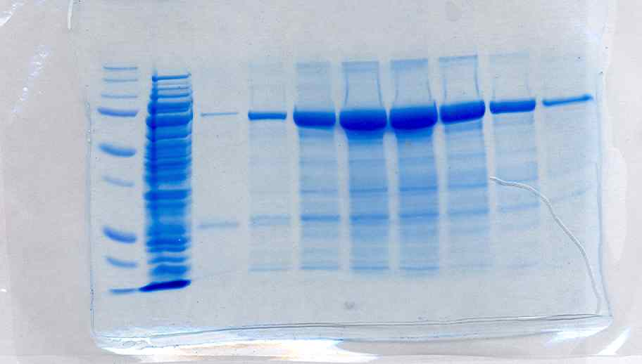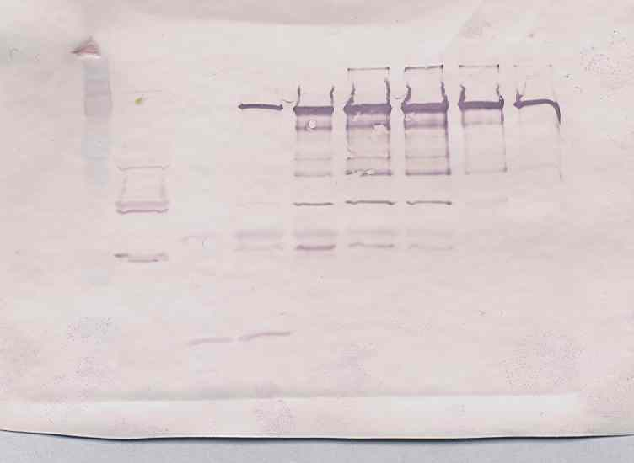
Figure 1. A: Coomassie stained polyacrylamide gel electrophoresis of purified, soluble Xf PG fractions from FPLC refolding/ purification experiments, arrow denotes correct Xf PG band size. Lane 1 Bio-rad dual color protein ladder, lane 2 column flow through, lanes 3-10 soluble Xf PG fractions B: Western blot analysis of purified, soluble Xf PG fractions from FPLC refolding/purification experiment using Xf PG polyclonal antibodies. Lane 1 Bio-rad dual color protein ladder, lane 2 column flow through, lanes 3-10 soluble Xf PG fractions

Objective 2: Isolate M13 phage that possess high binding affinities to Xf PG from a M13 random peptide library.

We have done extensive in silico analyses of the enzymatically active sites of several phytopathogenic bacterial and fungal PGs such as Pectobacterium carotovora ssp. carotovora and Aspergillus aculeatus (Pickersgill et al 1998, Cho et al 2001). The PGs from these other microbes have been well studied and structural studies have shown that the active site amino acids, consisting of roughly 8 amino acids and the tertiary structure of the PGs are highly conserved across all fungal and bacterial PGs (Pickersgill et al 1998, Cho et al 2001, Shimizu et al 2002, Abbott and Boraston 2007). Furthermore, previous research using phage display technologies showed that many of the phage that bound to a variety of enzymes also bound to and inactivated the enzyme (Hyde-deRuyscher et al, 1999).
Having a very good idea of where the Xf PG active site may be located on the protein, and which amino acids are involved in catalysis and substrate binding, we had synthesized two 14mer peptides derived from the Xf PG sequence, one which will target the active site directly and a second that will target an area providing entry into the active site (Fig. 2).

Figure 2
Peptide Sequence
Peptide 1 DSPNSNGLQMKSDAC
Peptide 2 STGDDHVAIKARGKC

Fig 2. Sequences of synthesized peptides.

Additionally, these peptides were injected into rabbits to create polyclonal antibodies. These polyclonal antibodies were used in a western blot that confirmed that the antibodies created against each 14-mer peptide could also recognize full length Xf PG (Fig. 3).

Figure 3
1 2 ladder 1 2 ladder
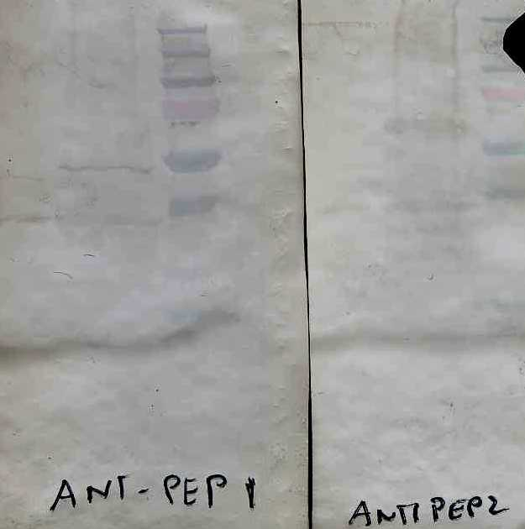←
←

Fig 3. Lane 1 is E.coli lysate containing no XF PG. Lane 2 is E. coli lysate containing recombinant Xf PG. Arrow represents location of Xf PG band.

We have completed the phage panning procedure for peptide 2 using the Tomlinson I and J scFv libraries. At the end of the third round of selection a polyclonal ELISA with BSA conjugated peptide 2 as the target was run which showed that each library (I and J) of scFvs showed a higher binding affinity to BSA conjugated peptide 2 than to BSA alone, or to the wells of the plate. With this knowledge 90 individual colonies from each library were picked from the third round phage pool and used in a monoclonal ELISA to determine which monoclonal scFvs had the highest binding efficiencies. The eight clones from each library (I and J) providing the highest ELISA absorbance readings were chosen for sequencing. We have currently only sequenced the heavy chain variable portion of the scFv and although none of the eight clones from each of libraries shared the exact same sequence they did have similarities to each other. We are in the process of sequencing the light chain portion of these clones.
The eight monoclonal phages from each library (I and J) were then used individually as the primary antibodies in a western blot to confirm that monoclonal phage raised against the 14-mer peptide 2 conjugated to BSA would also be able to indentify full length recombinant PG (Fig. 4) (Tanaka et al 2002).
Additionally, we have finished phage panning against the commercially available Aspergillus aculeatus PG. We are currently screening the monoclonal phages for their specificity to Aspergillus aculeatus PG and Xf PG. Once we confirm specificity for either target we will use these phages in PG inhibition assays.

Figure 4

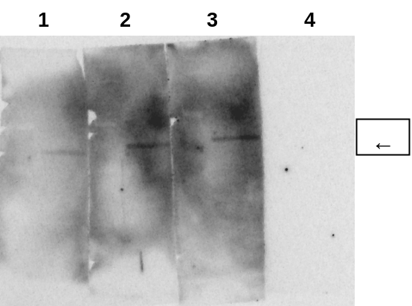

Fig 4. Western blot analysis of 3 representative monoclonal scFv phages(J-library).Lanes 1-3 are E. coli lysate containing recombinant Xf PG each membrane strip was reacted with a single monoclonal phage from the third round of panning . Arrow represents location of Xf PG band. Molecular weight markers are on the left side of each gel strip. Lane 4 is a conjugate control that was not reacted with any monoclonal phage.

Objective 3: Determine if selected M13 phage and the gp38 M13 protein which mediates phage binding to Xf PG can inactivate PG activity in vitro.

We have sequenced the heavy chain variable regions of the 16 candidate monoclonal phage and although none of the eight clones from each of libraries shared the exact same sequence they did have similarities to each other. Once we obtain enough active Xf PG we will use the monoclonal phages in Xf PG inhibition assays. Once a candidate phage is found that can inhibit Xf PG in vitro we will then express the scFv protein alone and determine if the protein itself can also inhibit Xf PG activity in vitro. We will then be able to clone the anti-Xf PG protein into an Agrobacterium binary vector and provide this construct to the UCD Plant Transformation facility to produce transgenic SR1 tobacco and Thompson Seedless grapevines. Once we have transgenic plants we will be able to complete objectives 5 and 6.

Objective 4: Clone anti-Xf PG gp38 protein into an Agrobacterium binary vector and provide this construct to the UCD Plant Transformation facility to produce transgenic SR1 tobacco and Thompson Seedless grapevine.

Once suitable inhibitory phage peptides are discovered in objective 3 we can begin objective 4.

Objective 5: Determine if anti-Xf PG gp38 protein is present in xylem sap of transgenic plants.

Objective 4 needs to be completed before work on objective 5 can begin.

Objective 6: Mechanically inoculate transgenic plants with Xf and compare Pierce’s disease development with Xf-inoculated non-transgenic control plants.

All previous objectives must be completed before we can start Objective 6.

Publications or reports resulting from the project:
2008 Pierce’s Disease Research Symposium Report
Presentations on Research:
2008 Pierce’s Disease Research Symposium

Research Relevance
Xylella fastidiosa (Xf) is a xylem-limited, gram-negative bacterium that causes Pierce’s Disease (PD) in grapevines. In order to cause disease the bacterium must multiply and colonize xylem elements of a susceptible plant host such as Vitis vinifera. In order to move from one xylem element to another Xf must degrade xylem pit membranes that separate adjacent elements. Pit membranes (primary cell walls) are composed of cellulose and hemi-cellulose microfibrils and pectic polymers that mediate the porosity of the pit membrane (Baron-Epel, et al. 1988; Buchanan et al. 2000; Zwienecki et al. 2001)). The primary enzyme that is needed to degrade pectic polymers in the xylem pit membrane is polygalacturonase (PG). Dr. Caroline Roper showed that if the gene encoding Xf PG was disrupted the resulting PG-mutant was completely non-pathogenic in grapevines (Roper, et al, 2007). This result suggests that if grapevines expressed sufficient amounts of a “factor”, such as a peptide or protein in xylem sap that could inactivate Xf PG, then Xf cells introduced by insect vectors could not move and subsequently cause PD. Additional evidence supporting this hypothesis was provided by Aguero, et al., (2005) who produced transgenic grapevines that expressed a pear fruit polygalacturonase-inhibiting protein (PGIP). Following mechanical inoculation with virulent strains of Xf, the transgenic vines had reduced leaf scorching, lower Xf titers and better re-growth after pruning than untransformed controls. They also found that PGIP was detected and functional in non-transformed grapevines that were grafted onto transgenic PGIP vines that served as rootstocks. This suggests that the constructs they used could deliver an anti-PG protein through the graft union and into a commercial grape scion variety; an observation that suggests transformed rootstocks could be developed while leaving the horticultural properties of wine varieties unchanged. While the PGIP transgenics were not completely immune to Xf the significant reduction in disease severity, coupled with the PG knockout experiments performed by Roper, provides strong support for identifying additional molecules that can effectively knock out the enzymatic function of Xf PG. We propose to identify unique peptides or single chain fragment variable (scFv) antibodies (Nissim, et al, 1994) expressed on the surface of gp38 protein that mediate binding of M13 to E. coli using commercially available library kits. Recombinant gp38 proteins expressing anti-PG activity will then be expressed in transgenic grapevine rootstocks using vectors similar to those used by Aguero, et al, 2005. Transgenic plants will then be inoculated with Xf and disease progression compared with Xf-inoculated non-transgenic controls. The ultimate goal of this project is to provide a novel form of resistance against Pierce’s disease that can be expressed in grapevine rootstocks and provide disease protection to grafted, fruit-bearing cultivars.

Lay Summary of Current Years Results:

This period we have again made progress on Objectives 1-3. We have been able to overcome the solubility issues with expression of Xf PG in E. coli using FPLC techniques. We now are able to produce large quantities of soluble purified Xf PG. We also hope that the Pichia pastoris expression system we are currently using will provide us with enzymatically active Xf PG. Additionally, we have completed the panning procedure for peptide 2 and the commercially available Aspergillus aculeatus PG. We have shown that the antibodies raised against peptide 2 can bind to full length Xf PG, and thus have produced our first candidate monoclonal phage to use in the inhibition assays. We hope to soon have enough active Xf PG to test these phages in inhibition assays.

Summary and status of intellectual property produced during this research project:
No intellectual property has been produced during this research period.

Literature Cited:
1) Abbott, D. Wade; Boraston, Alisdair B. The structural basis for exopolygalacturonase activity in a family 28 glycoside hydrolase Journal of Molecular Biology 368 (5) : 1215-1222 May 18 2007.

2)Aguero, C.B., S.L. Uratsu, C. Greve, A.,L.T. Powell, J.M. Labavitch, C.P. Meredith and A. M. Dandekar, 2005. Evaluation of tolerance to Pierce’s disease and Boytrytis in transgenic plants of Vitis vinifera expressing the pear PGIP gene. Molecular Plant Pathology 6: 43-51.

3) Anthon, G.E. and Barrett, D. E., 2002. Determination of reducing sugars with 3-methyl-2-
benzothiazolinonehydrazone. Anal. Biochem. 305:287-289.

4) Baron-Epel, O., P.K. Gharyal, and M. Schindler. 1988. Pectins as mediators of wall porosity in soybean. Planta 175:389-395.

5) Buchanan, B.B., W. Gruissem, and R.L. Jones. 2000. Biochemistry and Molecular Biology of Plants. American Socirty of Plant Physiologists. Maryland. Chapter 2: The cell wall. 52-100.

6) Cho, S., Lee, S., Shin, W.The X-ray structure of Aspergillus aculeatus polygalacturonase and a modeled structure of the polygalacturonase-octagalacturonate complex Journal of Molecular Biology 311 (4) : 863-878 24 August, 2001.

7) Lindbo, J., High-efficiency protein expression in plants from agroinfection-compatible Tobacco mosaic virus expression vectors. BMC Biotechnology 7 : Article No.: 52 Aug 27 2007.

8) Nissim, A., H.R. Hoogenboom, I.M. Tomlinson, G. Flynn, C. Midgley, D. Lane and G. Winter. 1994. Antibody fragments from a ‘single pot’ phage display library as immunochemical reagents. EMBO 13:692-698.

9) Pickersgill, R., Smith, D., Worboys, K., Jenkins, J. 1998. Crystal structure of polygalacturonase from Erwinia carotovora ssp. Carotovora. Journal of Biological Chemistry 273: 24660-24664.

10) Roper, M. C., Greve, L.C., Warren, J. G., Labavitch, J. M., and Kirkpatrick, B. C. 2007. Xylella fastidiosa requires polygalacturonase for colonization and pathogenicity in Vitis vinifera grapevines. MPMI 20:411-419.

11) Shimizu, Tetsuya; Nakatsu, Toru; Miyairi, Kazuo, et al.Active-site architecture of endopolygalacturonase I from Stereum purpureum revealed by crystal structures in native and ligand-bound forms at atomic resolution. Biochemistry 41 (21) : 6651-6659 May 28, 2002.

12) Tanaka T, Ito T, Furuta M, Eguchi C, Toda H, Wakabayashi-Takai E, Kaneko K. 2002. In situ phage screening. A method for identification of subnanogram tissue components in situ. J Biol Chem 277:30382–30387.

13) Wang, G., Michailides, T. J., Bostock, R. M. 1997. Improved detection of polygalacturonase activity due to Mucor piriformis with a modified dinitrosalicylic acid reagent. Phytopathology 87:161-163.

14) Zwieniecki, M.A., P.J. Melcher and N.M. Holbrook. 2001. Hydrogel gel control of xylem hydraulic resistance. Science 291: 1059-1062.

