PROGRESS REPORT

I. Project title
Which grape varietals are sources of Pierce’s disease spread? Decoupling resistance, tolerance and glassy-winged sharpshooter discrimination

II. Principal Investigators and Cooperators
Rodrigo Almeida, Principal Investigator
Department of Environmental Science, Policy, and Management
University of California, Berkeley, CA 94720, e-mail: rodrigoalmeida@berkeley.edu

Matthew Daugherty, Cooperator
Department of Entomology
University of California, Riverside, CA 92521, e-mail: matt.daugherty@ucr.edu

III. Researcher:
Arash Rashed (Hiring date: Feb 16th 2009)
Department of Environmental Science, Policy, and Management
University of California, Berkeley, CA 94720, e-mail: arashed@berkeley.edu

IV. List of objectives and description of activities
The bacterium Xylella fastidiosa causes Pierce’s Disease (PD) in a wide range of economically valuable grapevines. We aim to quantify infection level, PD symptom severity, and GWSS host-choice for infected versus healthy plants, for several wine, table and raisin grape varietals. Our specific objectives are:

Objective 1. To measure the relative levels of both resistance and tolerance for important California grape varietals
Objective 2. To measure GWSS discrimination against infected vines and X. fastidiosa spread for different grape varietals
Objective 3. To quantify within host plant feeding site preference of GWSS and its correlation with X. fastidiosa transmission

V. Summary of research progress for each objective

In order to quantify the level of resistance and tolerance we obtained and planted dormant cuttings of 18 different commonly used varieties of Vitis vinifera in March 2009.

We mechanically inoculated X. fastidiosa into 22 plants of each variety in two different time blocks within 24 hrs. All plants were inoculated at the base of the main shoot.
Inoculated plants were quantified for symptoms on the weeks eight and 12 post- inoculation, following Guilhabert and Kirkpatrick (2005). Initially, PD symptom development appeared to be most aggressive for the varieties Flame Seedless, Red Globe, Crimson Seedless, Cabernet Sauvignon and Syrah consistently across the two time blocks. The varieties Chardonnay, Red globe, and Chenin Blanc showed the least symptom development compared to the other tested varieties (see Figure 1).
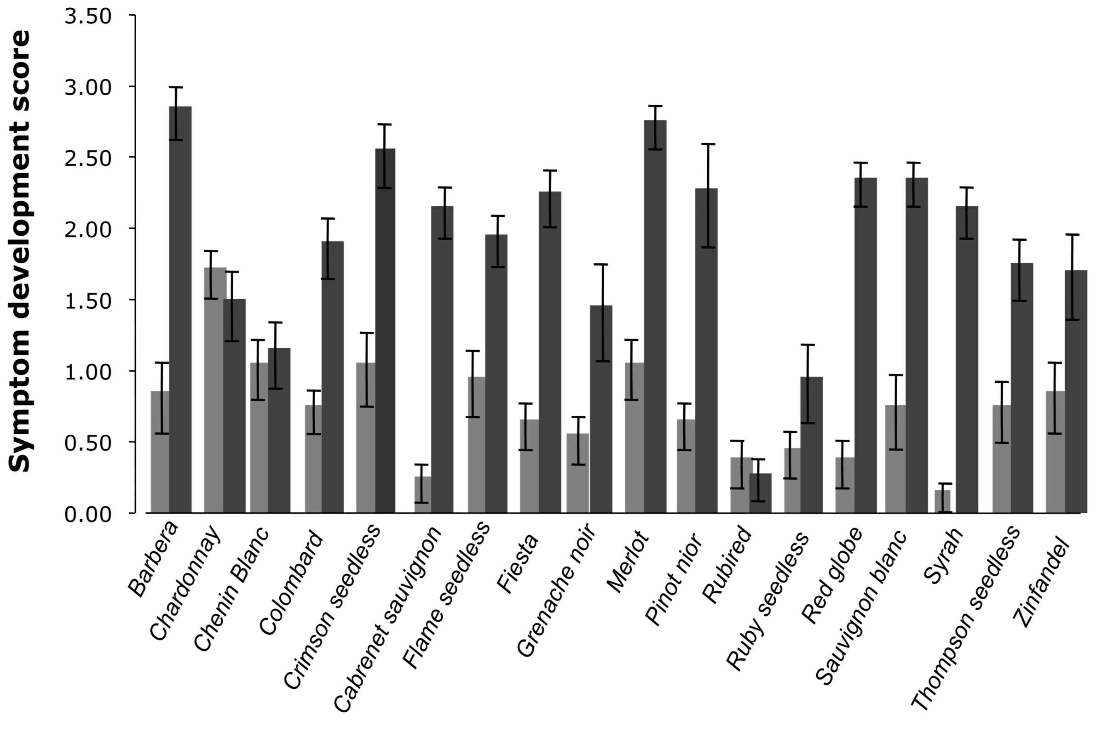
Figure 1: Symptom development scores for all tested grape varieties following a 0 to 5 scale a) time block 1; n= 10, b) time block 2; n= 12. Light-gray fill marks the symptom development score on week 8 and dark-gray marks the symptom development score on week 12.

b
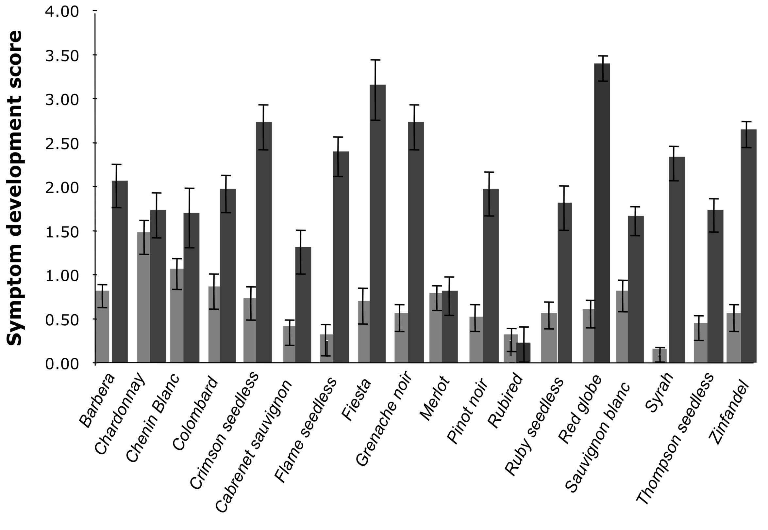

Because of pruning requirements, much of the new plant tissue had asymptomatic leaves during the second symptom evaluation. This made it difficult to obtain accurate symptom quantification on week 16. In addition, the new soil mix may have potentially influenced the extent of visual symptoms. To investigate this possibility we have repeated the artificial inoculation with 10 commonly used varieties (Barbera, Thompson seedless, Red globe, Crimson seedless, Syrah, Cabernet sauvignon, Chardonnay, Chenin blanc, Flame seedless, and Fiesta) with a range of susceptibility as determined in the first test. For this time block each pot is filled with a mixture of 50% super soil, 25% sand, and 25% perlite. Twenty plants per variety were mechanically inoculated in late December and will be quantified for symptoms every 4 weeks following week 8 post-inoculation. We expect that the new potting soil facilitate the symptom development, and therefore, ease our visual comparisons.

We are now quantifying bacterial population growth with quantitative real-time PCR. We just finished extraction from our samples on week 8 (~400 petiole samples from our 18 tested varieties) and soon will quantify bacteria population growth in week 12 (see below). Therefore, we will be able to compare the bacterial population growth and movement (petiole samples on week 12 are obtained from 2 points each 50 cm apart) among the tested varieties.

Our ongoing winter block, combined with our previous season results should provide an accurate classification of susceptible, tolerant and resistant varieties. This would be possible by contrasting visual symptoms and within plant bacterial population quantifications. Tolerance and resistance are used as relative terms within V. vinifera among its varietals.

In order to confirm our findings, these experiments will also be repeated this upcoming summer. Plant material has already been ordered from the Foundation Plant Services, UC Davis.

No-choice transmission experiments

i) Insect colonies
A greenhouse population of GWSS was established, from approximately 200 field-collected individuals from Riverside, CA.

ii) Experimental design
We caged the insects individually on the 22 mechanically inoculated plants of each variety for a 48-hour acquisition access period. After acquisition period, we moved the insects to healthy host of the same variety for a 6-day inoculation access period. We are using the culturing method to confirm transmission events. This step will be conducted after the initial PCR screening for positive bacteria on the source plants to eliminate replicates where the sources were X. fastidiosa-negative. Transmission rates will be calculated and compared among varieties.

Feeding behavior of GWSS - choice experiments

i Host choice behavior
Morphological, physiological and nutritional changes in plants due to pathogen infection have been suggested to influence insect vector choice of the host plant (Hammond and Hardy 1988). Parallel to this, Marucci et al. (2005) showed that sharpshooter vectors, Dilobopterus costalimia and Oncometopia facialis (Hemiptera: Cicadellidae) both prefer to feed on healthy asymptomatic plants rather than symptomatic plants infected by the pathogenic X. fastidiosa. Anecdotal observations have suggested a similar host choice pattern in GWSS. Based on these observations GWSS is expected to choose healthy hosts more frequently compared to a symptomatic plant. However, this proposed behavior has never been quantitatively tested.

Since our inoculated plants did not produce extensive symptoms suitable for choice experiments, we postponed the GWSS choice experiment for the upcoming season. However, because PD symptoms to some degree mimic those of water stress, we tested GWSS’s response to water stress symptoms as a part of our second objective. The method we used is explained in the previous progress report and here we will present the additional results addressing this question.

In the initial 20 replications, GWSS did not discriminate against water stressed plants (Sign test (two-tailed): P = 0.66). In these replicates, water stressed plants possessed 3-4 scorched leaves on a fresh stem in addition to 1-2 healthy looking leaves. In our most recent trial of 12 replicates we only used plants that were severely water stressed. This means that all leaves were ‘crispy dry’ for the treatment plant while the control plant was well watered. Out of 12 replicate only one GWSS chose the treatment plant (Two-tailed sign test: P=0.006). These findings, although preliminary, are suggestive of the effect of the degree of water stress on GWSS host choice. However, the lack of a significant discrimination against plants with moderate water stress symptoms may indicate a potential random host choice prior to severe disease symptoms.

This year, in a similar choice experiment, we will test GWSS's choice for infected versus uninfected host-plants.

ii Feeding site preference

It is conceivable that within-host feeding site influences the acquisition efficiency of an insect vector if there is a nonrandom pattern in within-plant pathogen distribution. Vectors feeding on plants tissue with greater bacterial populations may have a greater probability of acquiring X. fastidiosa compared to insects feeding on tissues with lower pathogen populations. We have shown this to be the case for sharpshooter transmission of X. fastidiosa from alfalfa plants (Daugherty et al. in press). On the other hand, because of its relative immobility during feeding, the feeding-site choice in H. vitripennis may be driven by other ecological/evolutionary factors that are linked to predation avoidance strategies, in particular background matching.

To test for this possibility we presented individual sharpshooters with grape cuttings, Vitis vinifera (var Cab Sauv), 20-30 cm in length and with equal proportions of green and brown colors (to the experimenter eye). Our experimental data showed that GWSS prefers to feed on the lower and brownish-colored parts of the stem (sign-test (two-tail): P=0.011; n=20). This is a finding that has been previously observed by the research community under laboratory and field conditions.

To confirm the existence of background color preference, rather than just tissue preference, we also introduced individual GWSS into a 30x30x30 cm cage covered with paper sheets of brown and green checkers. We showed that insects chose to alight on brown checkers first (sign-test (two-tail): P=0.04; n=30), and that they spend significantly more time on brown compared to the green squares (Wilcoxon brown-green: Z= -2.407; n=30; P=0.015).

Exploring the potential link between GWSS background/feeding-site preference and pathogen acquisition rate is significantly important because: i) cane color in grapevine changes in response to X. fastidiosa infection (Krivanek et al 2005) and ii) different grape varieties may vary in their time of cane maturation and the amount of brown pigmentation on the stem.

To evaluate whether feeding site preference within host plant influences the acquisition rate of bacteria by GWSS, we caged 50 adult GWSS on leaves (and petiles-all green in color) and 50 GWSS on the woody stems (brown in color) of 5 infected grapevies (100 insects in total; 20/plant). Following a 24hrs acquisition access period insects were collected and their heads were removed. We extracted the DNA from the heads and detected the presence and quantity of the bacteria in the GWSS's foregut by qPCR.

Our results indicate that the acquisition rate (acquisition vs no acquisition) of X. fastidiosa by GWSS is not influenced by the feeding location (chi-square: X²= 0.05, df=1, P= 0.814). Our comparisons for the exact number of cells acquired in different feeding locations indicated that sharpshooters acquired more cells when feeding on petioles and leaves, compared to when they feed on the woody stem (mean number of cells acquired: leaf, 8350; stem, 5248), although this tendency was not statistically significant (ANOVA (stepwise): F_{1, 24}= 2.71, P = 0.11; Figure 2).
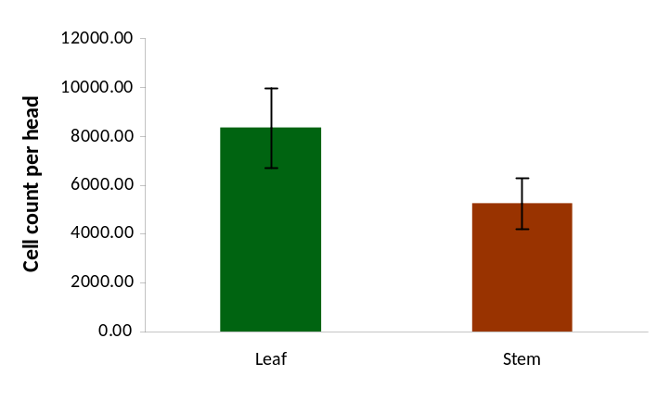

Figure 2: Number of X. fastidiosa cells in insect heads following a 24 hour acquisition access period on leaves and stems of infected plants.

We interpret out results as a consequence of evolved anti-predatory behaviors such as background matching, which would explain the within-host plant feeding-site preference, with indirect effects on vector transmission efficiency. This may also explain observed differences in transmission efficiencies among GWSS sharpshooters, which prefer to feed on stem tissue, compared to blue green sharpshooters, which prefer leaves and petioles as their feeding sites.

In summary, we have ongoing experiments addressing the Objectives originally proposed. Monitoring and sampling of field experiments is also ongoing. In addition, we ran a few additional tests to address questions directly associated with those Objectives related to GWSS feeding tissue preference and color attraction within hosts and explored the link between this behavior and their acquisition efficiency of the pathogen.

VI. Publications or reports resulting from the project
Almeida R.P. P. and Rashed A. 2009. Which grape varietals are sources of Pierce’s disease spread? Decoupling resistance, tolerance, and glassy-winged sharpshooter discrimination. Pierce’s Disease Research Symposium Proceedings, pp 57-61.

VII. Presentations on research
Almeida RPP. 2009. Xylella fastidiosa transmission: how did it become so complicated? Department of Entomology and Plant Pathology, Auburn University, Auburn, AL. April 6, 2009.
Almeida RPP. 2009. Xylella fastidiosa transmission by vectors – from molecules to models. Annual Meeting of the American Phytopathological Society, Portland, OR. August 1-5, 2009.
Almeida RPP. 2009. Xylella fastidiosa transmission and population ecology. I’institut National de la Recherché Agronomique, Bordeaux, France. September 7, 2009.
Almeida RPP. 2009. Xylella fastidiosa transmission and population ecology. I’institut National de la Recherché Agronomique, Montpellier, France. September 9, 2009.
Almeida RPP. 2009. Ecologia de Xylella fastidiosa. ESALQ/Universidade de Sao Paulo, Brazil. October 15, 2009.
Daugherty MP Lopes JRS and Almeida RPP. 2009. Vector within-host feeding preference mediates transmission of a heterogeneously distributed pathogen. Annual Meeting of the Pacific Branch of the Entomological Society of America, San Diego, CA. March 31, 2009.
Rashed A, Kwan J and Almeida RPP. The relationship between color pattern and feeding behavior in three species of leafhoppers Entomological Society of America annual meeting, Indianapolis, IN, Dec 2009.
Rashed A and Almeida RPP. Which grape varietals are sources of Pierce’s disease spread? Decoupling resistance, tolerance, and glassy-winged sharpshooter discrimination. Poster, Pierce’s Disease Symposium, Sacramento, CA, Dec 2009.

VIII. Research relevance statement
The GWSS is an important vector of Xylella fastidiosa, the etiological agent of Pierce’s disease. Grape cultivars differ in Pierce’s disease severity, suggesting there is variability among cultivars in tolerance or resistance to X. fastidiosa. Quantifying the relative levels of tolerance among different varietals is critical because each may impact GWSS spread of Pierce’s disease in different ways. Tolerant varietals, especially, may act as X. fastidiosa sources. We are evaluating the feasibility of using existing Vitis vinifera cultivars to control Pierce’s disease spread by quantifying resistance, tolerance, and GWSS behavior for several important table and wine grape varietals. This work will provide recommendations to growers in high risk Pierce’ disease areas on which varietals to use to minimize spread.

IX. Lay summary of current year’s results
We have quantified GWSS feeding site preference with in host plant and explored its link to pathogen acquisition, and thus its link to the disease spread. We are currently analyzing the results of out transmission experiments from previous year. We sat up winter experiments to evaluate symptom development in different varieties and are planning a second large-scale block for the upcoming field season. Symptomatic plants of upcoming large-scale experiment will be used for the study of the winter recovery of infected grapevines. Our results provide valuable data GWSS behavior and the tolerance/resistance of different existing grape varieties. Quantifying the vector behavioral interaction combined with the plant response to pathogen help to contain the disease spread throughout the field season.

X. Status of funds
No present funding problems for this project.

XI. Summary and status of intellectual property produced during this research project
None expected.

References
Almeida R.P.P., Purcell A.H. 2003. Biological traits of Xylella fastidiosa strains from grapes and almonds. Applied and Environmental Microbiology 69: 7447-7452.
Daugherty, M.P., Lopes, J.R.S., Almeida, R.P.P. Vector within-host feeding preference mediates transmission of a heterogeneously distributed pathogen. Ecological Entomology in press.
Hammond A.M., Hardy T.N. 1988.Quality of diseased plants as hosts for insects. In: Plants stress- insect interactions (ed. E.A. Heindrichs). Wiley, NY.
Krivanek A.F., Stevenson JF, Walker MA. 2005. Development and comparision of symptom indecies for quantifying grapevine resistance to Pierce’s disease. Phytopathology 95: 36-43.
Marucci R.C., Lopes J.R.S., Vendramim J.D., Corrente J.E. 2005. Influence of Xylella fastidiosa infection of citrus on host selection by leafhoppers. Entomologica Experimentalis et Applicata 117: 95-103.

