**Progress Report for CDFA PD/GWSS Contract number --------**

**PROJECT TITLE:** Map-based cloning and functional characterization of *Xylella fastidiosa* resistance gene(s) in a range of *V. arizonica*.

**Principal Investigator and Cooperating Staff**: Andrew Walker (PI) and Summaira Riaz, Dept. of Viticulture and Enology, University of California, Davis, CA 95616; awalker@ucdavis.edu

**Reporting period:** The results reported here are from work conducted March 2011 to July 2011

**List of Objectives and description of activities:**

**Objective 1**. Characterize and refine the PDresistance locus on chromosome 14 by genetically mapping in four populations that derive resistance from *V. arizonica/candicans* b43-17 and its *V. rupestris* x b43-17 progeny F89090-08 (*PdR1b*) and F8909-17 (*PdR1a*): 04190 (*V. vinifera* F2-7 x F8909-08), 9621 (D8909-15 x F8909-17), 04191 (F2-7 x F8909-17), and 04373 (*V. vinifera* F2-35 x *V. arizonica/candicans* b43-17).

In the March 2011 progress report, we described the genetic mapping of the 04191 population, which was being done to identify QTLs other than the *PdR1a* locus. *PdR1a* was identified using the 9621 population (D8909-15 x F8909-17) whose female parent (D8909-15) is also resistant to PD, but its multigenic resistance may have a confounding effect on fine-scale mapping efforts. Thus, the 04191 population (*V. vinifera* F2-35 x F8909-17) was a better choice and critical for the identification of minor genes that might contribute to PD resistance. Briefly, a total of 139 SSR markers representing all 19 chromosomes were added to the set of 153 seedlings, of which 141 were greenhouse screened for resistance. Mapping analysis was carried out with 150 genotypes after eliminating three seedlings that were off-types. A genetic map was constructed with 5.0 LOD and 0.40 recombination frequency. 136 markers were grouped on 19 chromosomes. QTL analysis was carried out with the natural log of the ELISA values. Two different methods of QTL detection were performed: Kruskal-Wallis and Interval mapping. We reconfirmed a major locus *PdR1a* on chromosome 14 and identified a minor QTL explaining 7% phenotypic variation on chromosome 19 that peaks at marker CB918037.

In last three months, we have identified five SSR markers that are positioned on the arm of chromosome where we detected locus for PD resistance by using information gathered by comparison to the other reference maps. These five markers (UDV0023, Chr19a, VVIu09, VMC5h11, VVIn74) were tested on the small set of parents and progeny and three polymorphic markers were added to the 04191 progeny. Mapping and QTL analysis was carried out on the new data set. We refined the distance between the markers from 12 cM to 8 cM on one side and from 5 cM to 3 cM on the other side of the locus from the previous report. This minor locus explained 7% phenotypic information.

Fig. 1. Updated interval mapping analysis of the PdR2 locus on LG 19.

In last three months, we have also completed a BLAT comparison of the markers VMC5e9, CB918037, and VVIp17b marker sequences to the Pinot noir 12X PN40024 genome (4,000 Kb on the physical sequence based on the alignment of the markers to PN40024).

|  |  |  |  |  |
| --- | --- | --- | --- | --- |
| Table 1. List of new SSR markers developed from the PN40024 sequence to refine the distance between markers and *PdR2* locus. | | | | |
| Name | Primer sequence | Product size | Repeat | Position 12X Pn40024 |
| SC14-001-F | tgatcataccatatttcacaacatacc | 194 | 17 TA | 2489805 |
| SC14-001-R | ccctattggtattaacacatcgt |  |  |  |
|  |  |  |  |  |
| SC14-002-F | atggccttgactttgtctccta | 248 | 13 AGAGAGG | 2596242 |
| SC14-002-R | tgctttgacttgactcatggac |  |  |  |
|  |  |  |  |  |
| SC14-003-F | ccccaaaagcaaagtataatgc | 217 | Complex AGGG | 2746426 |
| SC14-003-R | gatatgggacacctttttcctg |  |  |  |
|  |  |  |  |  |
| SC14-004-F | ggtcaaaccagtgacgtcataa | 336 | 19 AT | 3306106 |
| SC14-004-R | ctactacgccccctttcctatt |  |  |  |
|  |  |  |  |  |
| SC14-005-F | gaactgtactgcgtggatttga | 324 | Complex CT | 3500506 |
| SC14-005-R | gcaccttttgttagctccagat |  |  |  |
|  |  |  |  |  |
| SC14-006-F | tttgagctgtctcccctgttat | 237 | Complex CT | 3899266 |
| SC14-006-R | atcccaaccaaaaattacctga |  |  |  |
|  |  |  |  |  |
| SC14-007-F | ccaggtttacatgtacccaaaaa | 145 | 23 GA | 4096126 |
| SC14-007-R | ttttcccatatgatgaatactctttc |  |  |  |
|  |  |  |  |  |

These markers are tested for polymorphism and application on the entire population of 150 seedlings. Seedlings with missing or equivocal phenotypic data and key recombinants will be greenhouse tested a second time.

Fig. 2. The distribution of the greenhouse ELISA screen of 04191 genotypes was as follow:

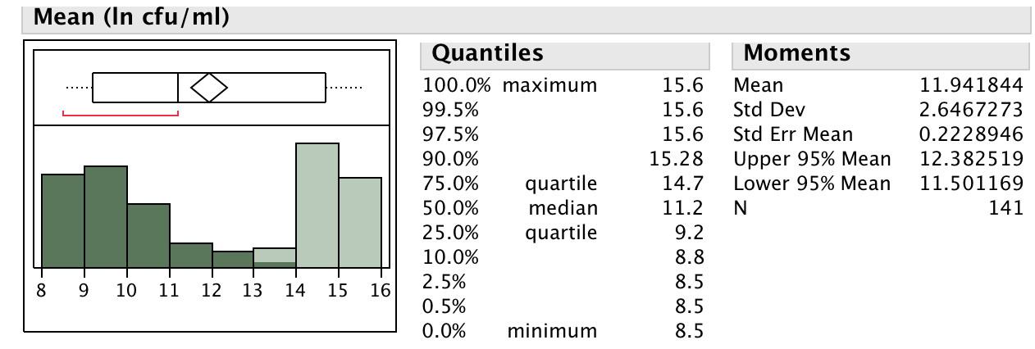

In order to test, if the QTL on LG19 has an additive effect to the *PdR1a* locus, we carried out analysis based on the resistant and susceptible genotypes via least square means and developed a plot with SAS Jump program for both LG 14 and LG 19 (Fig 3a)

Fig. 3.

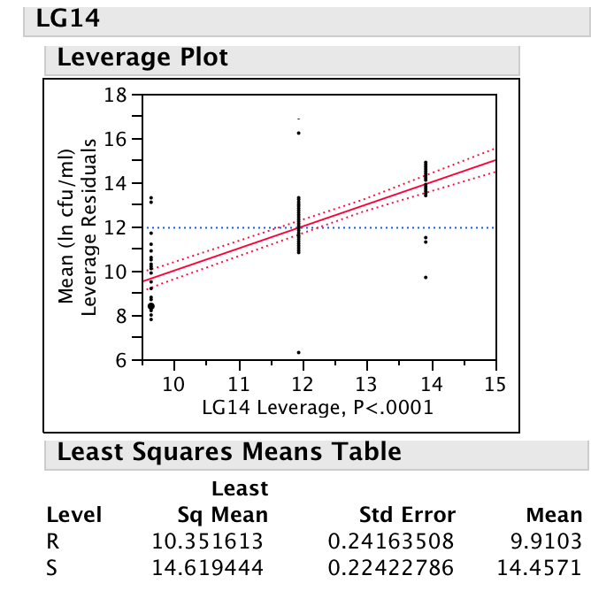

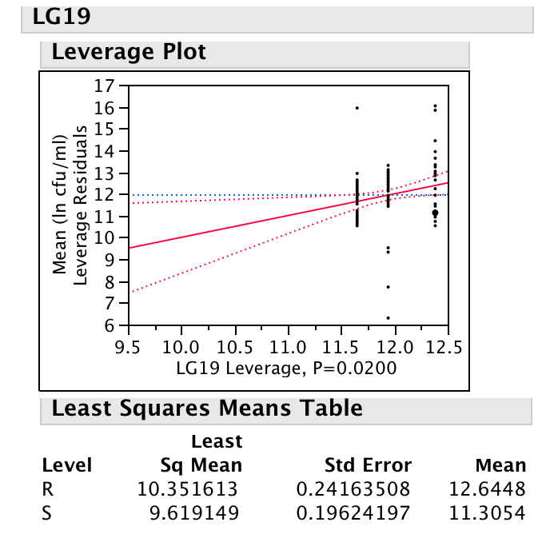

It was clear that both loci work independently of each other and do not have an additive impact. The mean ELISA values of resistant and susceptible plants with the *PdR1a* locus were very different, however, the mean values of resistant and susceptible for *PdR2* locus were higher for the resistant plants.

In addition, the 04190 population (F2-7 x F8909-08) will also be genotyped with markers from chromosome 19 to determine if the F8909-08 haplotype also carries this minor QTL. We have observed that F8909-17 based genotypes tend to have lower *X. fastidiosa* levels. More work is required to validate and understand the complete genetic basis of PD resistance from the b43-17 background, and how and if minor genes play a role.

**Objective 2.** Genetically map PD resistance from other forms of *V. arizonica*: b42-26 (*V. arizonica/girdiana*) and b40-14 (*V. arizonica*).

The goals of this objective are to identify additional resistance sources, genetically map them and use tightly linked molecular markers to pyramid resistance from different backgrounds into a single line. We are pursuing two other resistant *V. arizonica* forms: b42-26 *V. arizonica/girdiana* from Loreto, Baja California, and b40-14 *V. arizonica* from Chihuahua, Mexico. Although they are morphologically different than b43-17, they both posses strong PD resistance and greatly suppress *X. fastidiosa* levels in stem tissue after greenhouse screening.

Greenhouse screening data indicate that resistance from b42-26 is quantitative. A small breeding F1 population 05347 (*V. vinifera* F2-35 x b42-26) was produced in 2005. A subset of 48 genotypes was greenhouse screened – 35 were resistant and 13 were susceptible. A total of 337 SSR markers were tested on the parents and a few progeny. Results found a high level of homozygosity for b42-26 – only 113 markers were polymorphic, 184 markers were homozygous for b42-26, and 40 markers did not amplify. We remade this cross in 2008 and 2009 to increase the population size, and now have 239 seedlings in the field. Sixty-four of these have been greenhouse screened, these tests are underway on 100, and the final 75 will be screened by the end of 2011.

We completed preliminary QTL analysis with the 64 greenhouse screened genotypes with data from 71 SSR markers. A framework genetic map of all chromosomes was not possible with this limited amount of marker data, so we conducted Kruskal-Wallis analysis that allows association of each marker to the phenotypic trait. Because we know the chromosomes the markers reside on, we can get a rough map from this analysis. The results indicated that markers from chromosome 10 and 14 (and to a lesser extent 2 and 11) are associated with PD resistance. This allows us to focus mapping efforts on markers known to exist on these chromosomes, which will greatly accelerate the identification of genomic regions responsible for b42-26’s resistance.

We are now mapping with the complete set of 239 seedlings with 30 to 50 markers on chromosomes 2, 10, 11 and 14, and 4 or 5 on the remaining chromosomes. As stated above, b42-26 is extremely homozygous, which means many of the SSR markers are homozygous and not useful for mapping. Thus, we developed 71 new SSR markers from clone sequences generated from the Vitis Microsatellite Consortium (the original source of SSR markers for grape). These clones had been discarded as not useful for marker development because of the presence of microsatellite repeats at the beginning or end of the sequence, leaving no room for primer design. A total of 238 of these clone sequences were compared to the nearly homozygous 12X Pinot noir genome in order to obtain additional flanking sequences. There were good matches for 71 of the clones and primers were designed for them; 69 of the newly designed primers amplified and 67 of them generated a clean banding pattern with *V. vinifera* DNA samples. We also acquired primer sequences of an additional 200 markers that have not been tested with b42-26. Marker testing on small set of parents and progeny is underway. We are also adding markers to develop a framework map for the entire population.

Resistance in *V. arizonica* b40-14 seems to be controlled by a single homozygous dominant gene. As mentioned in previous reports 40 F1 progeny from a cross of *V. rupestris* x b40-14 were resistant to PD, while three progeny had intermediate responses. Two resistant siblings were used to develop the 07388 (R8918-02 x *V. vinifera*) and 07744 (R8918-05 x *V. vinifera*) populations. A summary of the genetic mapping and QTL analysis for the 07744 population is presented below: 227 markers were polymorphic for one of the parents; 152 were analyzed on the entire set of 122 plants; a framework map of R8918-05 was produced with MAP QTL (4.0) and the Kruskal-Wallis approach was used to complete the preliminary analysis. PD resistance mapped only on chromosome 14 – the same chromosome where *PdR1a* and *PdR1b* mapped. PD resistance from b40-14 (which we have named *PdR1c*) also maps in the same general region between flanking markers VVCh14-77 and VVIN64 and within 1.5 cM. The LOD threshold for the presence of this QTL was 33 and 82% of the phenotypic variation was explained (Fig. 2). In 2009, crosses were made with resistant F1 selections from 07744 population.

Fig. 4. Interval mapping of *PdR1* indicating a peak at LDD 34.0 with the 95% confidence interval. The X-axis indicates the position of the markers; LOD values are plotted on the Y-axis.

**Objective 3 and 4.** Develop a BAC (bacterial artificial chromosome) library for the homozygous resistant genotype b43-17 (parent of F8909-08, and F8909-17) and screen the library with closely linked markers. Complete the physical mapping of *PdR1a* and *PdR1b* and initiate the sequencing of BAC clones that carry *PdR1a* gene candidates.

Two BAC libraries were created from the homozygous resistant b43-17. Screening of the library with markers VVCh14-10, VVCh14-56 and VVCh-58, which are closely linked to *PdR1*, identified 41 positive clones – 4 of the clones were positive with VVCh14-10, VVCh14-56 markers (H23-P13, H34-B5 and H64-M16 and H45-J22) and 5 of them were positive with the VVCh14-56 and VVCh14-58 marker. Two clones were selected for sequencing with an overlap of 60Kb and a spanned region of 340Kb. A shotgun library of BAC clone H64M16 was Sanger sequenced. Clone H69J14 was selected for 454 sequencing. A total of 42,000 sequences were generated and two different programs were used to assemble the sequence. However, the sequenced region was highly enriched with repetitive elements, which complicated the assembly. In order to generate longer sequence fragments, a shotgun library was constructed for clone H69J14; 384 sequences were generated in both directions to develop paired ends in order to fill the gaps between the contigs from the 454 sequence data. We then masked the repetitive region from all the sequences (both H69J14 and H64M16 clones) to allow assembly with the MIRA assembler program. These steps improved the assembly, but the contig number was still too high for primer walking. Moreover, all the major contigs had masked repetitive regions on both ends indicating that the primer design effort would not generate sequence specific results capable of bridging the gaps. To overcome the repetitive elements and produce longer sequences, a Fosmid library was generated with an insert size of 35-40Kb. The assembled sequence (454 reads, shotgun reads, and fosmid library reads) produced more than 80 contigs. A search was carried out to identify the genes on all of them using program sequence builder module and confirmed by blasting with NCBI database. We have identified 6 copies ranging from 2Kb to 3.1Kb in the resistance region. Copies 1 thru 4 are 97-99% similar and differ in size (potentially tandam repeats of one gene), they were up to 78% similar to the four copies of genes on the PN40024 sequence (Fig. 5).

Figure 5.

Detailed analyses based on the NCBI protein search identified four tandem repeats of serine threonine protein kinase with a leucine-rich repeat domain gene family in the resistance region. The four genes in this region have large introns indicating that they may carry transposable element-like sequences. We utilized CENSOR software to screen query sequences against a reference collection of repeats to generate a report classifying all detected repeats. All four genes carry DNA transposons as well as LTR retrotransposons confirming the complexity of the region.

A direct comparison of the H69J14 clone sequence to the PN40024 sequence is not possible due to major re-arrangement of repetitive elements between the two genomes. When the b43-17 resistance region sequences were matched to scaffold 68 of the Pinot noir sequence, they matched to multiple sites and the level of similarity was reduced. These results suggest that the *PdR1* region of the b43-17 genome is divergent from PN40024 and that transposable elements may play a major role in these sequence differences. Our main emphasis is assembling the complete region in order to make comparisons to the susceptible sequence. This will help us understand the causes of sequence divergence and the evolution of the PD resistance gene family. Previous studies have indicated that the sequence of chromosome 14 is known to carry members of 13 different families of DNA transposons and retrotransposon (Moisy et al. 2008).

Fig 6. Alignment tree of the six candidate PD genes separately and with four genes of Pinot noir. 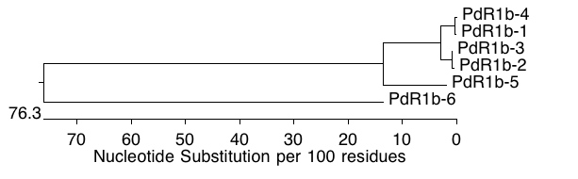

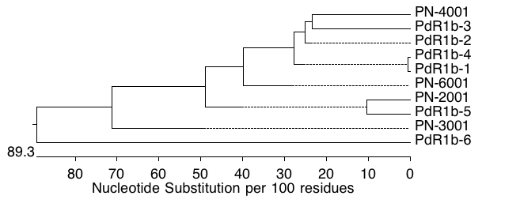

We utilized different tools from [www.expasy.org/tool/](http://www.expasy.org/tool/) to conduct pattern and profile searches of the PD resistance genes. There is very strong evidence of a LRR region in five of the candidate genes. Figure 7 displays the 16 LLR regions in the *PdR1b-1* gene.

There is no signal sequence in the protein sequence, which indicates that the resistance gene product is not secreted. There is also no indication of a coiled-coil, which suggests that the PD resistance gene is not a member of the CC-NB-LRR class of resistance proteins. The protein sequences do carry transmembrane domains, however they lack the kinase domain. Interestingly, the PdR1b-6 gene candidate that was very different from the other candidates that have a protein Kinase domain.

Fig 7. Interpro scan results of the PdR1b-1 gene.

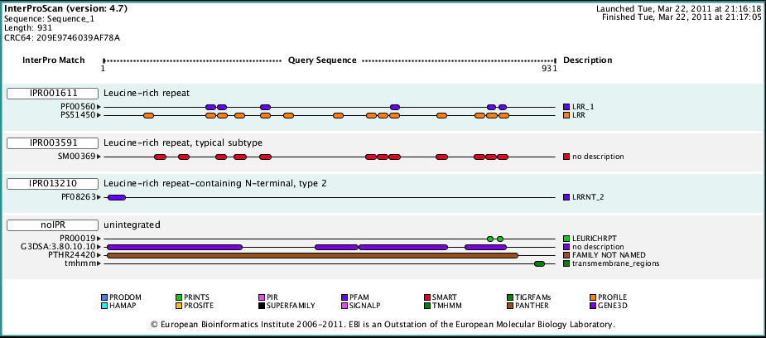

Currently we have cloned and verified the sequence of copy 1 and copy 6 candidate genes and are developing constructs for transformation experiments to determine which of these gene candidates confers resistance to PD. (See companion report “Molecular characterization of the putative *Xylella fastidiosa* resistance gene(s) from b43-17 (*V. arizonica*)).

**Intellectual Property**: The resistance genes identified in this research will be handled by PIPRA, UC Davis.

**LAYPERSON SUMMARY**

Genetic mapping from two different forms of *V. arizonica* has identified a region on chromosome 14 that is responsible for PD resistance, which we termed *PdR1*. We have mapped two forms of *PdR1* from *Vitis arizonica/candicans* b43-17, and have mapped a third form, *PdR1c*, that originated from *V. arizonica* b40-14. These forms are single dominant genes for PD resistance. Recently, we discovered a minor gene on chromosome 19 that is associated with *PdR1* and may be important in its regulation. We are also examining another resistance *V. arizonica/girdiana* b42-26, which is controlled by multiple genes. Fine-scale mapping is underway to determine if markers are tightly enough linked to these multiple resistance genes to be used for marker-assisted selection. At this point we have identified quantitative trait loci (QTLs) on chromosomes 10 and 14 and to a lesser extent on 2 and 11. We plan to combine these multiple resistance sources in our breeding program to ensure broad and durable resistance to PD. Genetic markers to these forms of resistance will make this possible and allow the confirmation and tracking of interbred progeny. These mapping efforts are also essential to physically locating and characterizing PD resistance genes. At present, the chromosome region where *PdR1* exists has been sequenced and the pieces of sequence were arranged and compared to the Pinot noir genome sequence. This comparative analysis indicates that the susceptible Pinot region carries 4 genes. The Pinot noir region was compared to the sequences we have from the resistant b43-17 and we identified 6 candidate resistant genes. These candidates appear to be members of typical resistance gene families and we preparing them for transformation experiments to test whether they induce PD resistance in susceptible Chardonnay.

This project provides the genetic markers critical to the successful classical breeding of PD resistant wine, table and raisin grapes. Identification of markers for PdR1 has allowed us to reduce the seed-to-seed cycle to 2 years and attain the 97% vinifera PD resistant level. These markers have also led to the identification of 6 genetic sequences that house the PD resistance gene, which we will soon be testing to verify their function. These efforts will help us better understand how these genes function and could also lead to PD resistance genes from grape that would be available to genetically engineer PD resistance in *V. vinifera* cultivars.

**REFERENCES**

Moisy C., Garrison K.E., Meredith C.P., Pelsy F. 2008. Characterization of ten novel TyI/copia-like retrotransposon families of the grapevine genome. BMC Genomics 9:469

Riaz, S., S. Vezzulli, E.S. Harbertson, and M.A. Walker. 2007. Use of molecular markers to correct grape breeding errors and determine the identity of novel sources of resistance to *Xiphinema index* and Pierce’s disease. Amer. J. Enol. Viticult. 58:494-498.

Riaz, S, A.C. Tenscher, B.P. Smith, D.A. Ng and M.A. Walker. 2008. Use of SSR markers to assess identity, pedigree, and diversity of cultivated muscadine grapes. J. Amer. Soc. Hort. Sci. 133:559-568

Riaz, S., A.C. Tenscher, J. Rubin, R. Graziani, S.S. Pao and M.A, Walker. 2008. Fine-scale genetic mapping of two Pierce’s disease resistance loci and a major segregation distortion region on chromosome 14 of grape. Theor. Appl. Genet. 117:671-681

Riaz, S., A.C. Tenscher, R. Graziani, A.F. Krivanek and M.A. Walker. 2009. Using marker-assisted selection to breed Pierce’s disease resistant grapes. Amer. J. Enol. Viticult. 60:199-207.

**PUBLICATIONS:**

Yang, L., H. Lin, Takahashi, Y., Chen, F., Walker, M.A. and Civerolo, E. 2011. Proteomic analysis of grapevine stem in response to *Xylella fastidiosa* inoculation. Physiological and Molecular Plant Pathology 75:90-99.

Riaz, S., A.C. Tenscher, D.W. Ramming and M.A. Walker. 2011. Using a limited mapping strategy to identify major QTLs for resistance to grapevine powdery mildew (*Erysiphe necator*) and their use in marker-assisted breeding. Theoretical and Applied Genetics 122: 1059-1073.

Viana, A.P., S. Riaz and M.A. Walker. 2011. Evaluating genetic diversity and optimizing parental selections in a segregating table grape population. American Journal of Enology and Viticulture 62: (In press).

**PRESENTATIONS ON RESEARCH:**

Walker Breeding and RMI tour. National Clean Plant Network, UC Davis tour, March 1, 2011.

Walker breeding program. California Grape Rootstock Improvement Commission, Monterey, CA, March 12, 2011.

Walker breeding program and RMI tour. Early Academic Outreach Program, parents and kids, UC Davis, March 15, 2011.

Walker breeding program PD, powdery mildew and rootstocks. Lodi Woodbridge Winegrape Commission, UC Davis, March 18, 2011.

Vineyard site analysis and dealing with pests and diseases. Wine Executive Program, UC Davis, March 22, 2011.

Sustainable viticulture and the role of breeding. UC Berkeley Hass Business School Professional School, Mondavi Winery, Oakville, CA, April 9, 2011.

Walker breeding program. UC Cooperative Extension group meeting, UC Davis, April 13, 2011.

Walker rootstock breeding program (PD rootstocks discussed). CDFA Improvement Advisory Board Meeting, UC Davis, April 21, 2011.

Tasting of Walker PD wines. CDFA PD Board Meeting, Sacramento, CA, April 25, 2011.

Breeding for pest and disease resistance. University of Vienna BOKU (Natural Resources and Life Science) Austria, June 13, 2011.

Pierce’s disease resistant winegrapes are approaching wine quality and field testing. American Society of Enology and Viticulture 62nd Annual Meeting, Monterey, CA, June 22, 2011.