- Title of Report: Interim progress report for CDFA agreement number 10-278

- Project title: Tools to Identify PGIPs transmitted across grapevine grafts

- Principal Investigators:

Ann L.T. Powell
Dept. of Plant Sciences
University of California
Davis, CA 95616
alpowell@ucdavis.edu

Abhaya Dandekar
Dept. of Plant Sciences
University of California
Davis, CA 95616
amdandekar@ucdavis.edu

John M. Labavitch
Dept. of Plant Sciences
University of California
Davis, CA 95616
jmlabavitch@ucdavis.edu

- Reporting Period: March 2012 to August 2012

- Introduction:
Pierce’s Disease (PD) incidence has been associated in several studies with the spread of the causal agent, Xylella fastidiosa (Xf), throughout the xylem vasculature of infected grapevines. The spread of bacteria from one vessel to the next utilizes bacterial cell wall modifying enzymes to degrade the pit membranes separating adjacent vessels (Pérez-Donoso et al., 2010). One enzyme that degrades the polysaccharide portion of pit membranes is a polygalacturonase (XfPG), a well characterized PD virulence factor (Roper et al., 2007). Several previous projects have analyzed the effectiveness of PG-inhibiting proteins (PGIPs) in minimizing the damage caused by pathogens and pests on plants (Powell et al., 2000), including damage caused by Xf in PD. Two currently funded projects use pear fruit PGIP (pPGIP) to restrict Xf movement: “Optimizing grape rootstock production and export of inhibitors of X. fastidiosa PG activity” (PI Labavitch) and “In planta testing of signal peptides and antimicrobial proteins for rapid clearance of Xylella” (PI Dandekar).
This project was designed to generate a monoclonal antibody that specifically recognizes the pPGIP protein. The monoclonal antibody is a necessary tool for both aforementioned research projects and the related project “Field evaluation of grafted grape lines expressing PGIPs” (PI Powell) and will allow for detection and quantification of pPGIP without cross-reactive interference from the native PGIP. Plants can, therefore, be more efficiently screened for the presence of the pPGIP protein, whether directly produced in, or transported to the plant tissue of interest from grafted rootstocks.
- Objectives:
- Using existing fresh pear flesh, prepare pPGIP protein and provide it to Antibodies, Inc. to develop mouse hybridoma lines expressing monoclonal antibodies against the pear PGIP.
- Calibrate the antibodies produced by the hybridoma clones to determine effective dilutions for use in detecting the pPGIP protein.
- Use the antibody to detect transgenic pear PGIP in xylem sap of own-rooted and grafted grapevines.

- Summary of activities and accomplishments for each objective:
Objective 1: Purification of pear PGIP from transgenic Arabidopsis leaves and pear fruit.
This was documented in the previous report. During this period we have contacted a firm (Ab-mart) that proposes to generate multiple monoclonal antibodies for the pear fruit (p)PGIP protein. To do this they will divide the protein into smaller peptides and then develop monoclonal antibodies to each peptide. The advantage of this approach is that it is possible that antibodies recognizing unique epitopes of pPGIP as well as antibodies that recognize common features among PGIPs should be generated. The cost of doing this is about the same as developing a single monoclonal antibody through Antibodies Inc. We have provided the pPGIP amino acid sequence to Ab-mart and they are currently selecting regions of the protein to target. They will synthesize the peptides and generate the antibodies. If their progress is not acceptable we will revert to our previous plan. This opportunity is a good opportunity to leverage the CDFA-GWSS support to generate more resources for the community.
From previous reports about the original objective:
The generation of a monoclonal antibody requires purified protein to be used as the antigen. The project “Optimizing grape rootstock production of and export of inhibitors of Xylella fastidiosa (Xf) polygalacturonase (PG) activity” (PI Labavitch) generated transgenic Arabidopsis thaliana plants expressing the pPGIP protein fused to a C-terminal histidine tag for purification. Leaves from these transgenic plants yielded a small amount of pPGIP protein, as determined by Bradford assays. Work to refine the purification of pPGIP protein from these plants is ongoing.
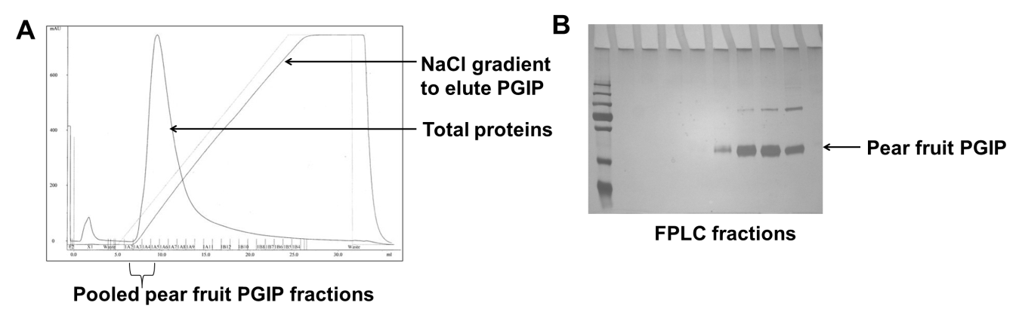
pPGIP protein extraction was done using fresh pear fruit and the protocols in Stotz et al. (1993) and Abu-Goukh et al., (1983) with modifications as described in previous reports. Figure 1 shows the fractions from the FPLC separation which were pooled. In Figure 2, the purity of the protein from the pooled fractions is shown. The yield of purified pPGIP protein is 1.7 mls (in 20 mM NaAcetate) of 115 μg/ml or a total of 195 μgs protein, which should be sufficient for the generation of the monoclonal antibody.
Figure 2. Silver stained SDS-PAGE gel showing pPGIP collected from cation exchange column fractions. Loading dye containing β mercaptoethanol causes a reduction of, presumably, multimeric PGIP proteins (90 kDa). The 90 kDa band in the absence of β mercaptoethanol, in the presence of β mercaptoethanol is resolved into the 45 kDa pPGIP bands. Differences in glycosylation may account for PGIP sub-bands around 45 kDa. Chemical deglycosylation of the pear PGIP was done but not evaluated on a gel.

Figure 1. (A) FPLC analysis of pPGIP preparation. Proteins eluted from ConA column were applied to a cation exchange column and eluted by FPLC in 50 mM NaAceteate pH 4.5 and a 0-500 mM NaCl gradient. (B) Silver stained SDS-PAGE gel showing relative purification of PGIP. Lanes 2-10 contain various fractions from the FPLC separations. PGIP band corresponding to a molecular weight of 45 kDa is seen. A band corresponding to 90 kDa is also visible and corresponds to the molecular weight of a PGIP dimer.

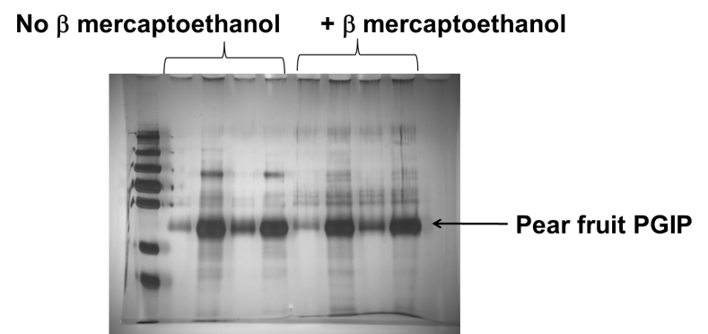
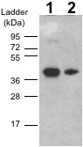
A western blot showing the pear PGIP (pPGIP) band using polyclonal anti-pPGIP antibody is shown in Figure 3. The pPGIP band corresponds to a molecular weight of approximately 45 kDa, which is the expected size for pPGIP.
Figure 3. Immunoblot analysis of pPGIP. Lane 1: 80 ng protein after ammonium sulfate precipitation (50-100% fraction). Lane 2: 10 ng protein after the ConA purification step. Molecular weight ladder is indicated on the left. Proteins were separated on a SDS-PAGE (10%) gel and probed using pPGIP antiserum.

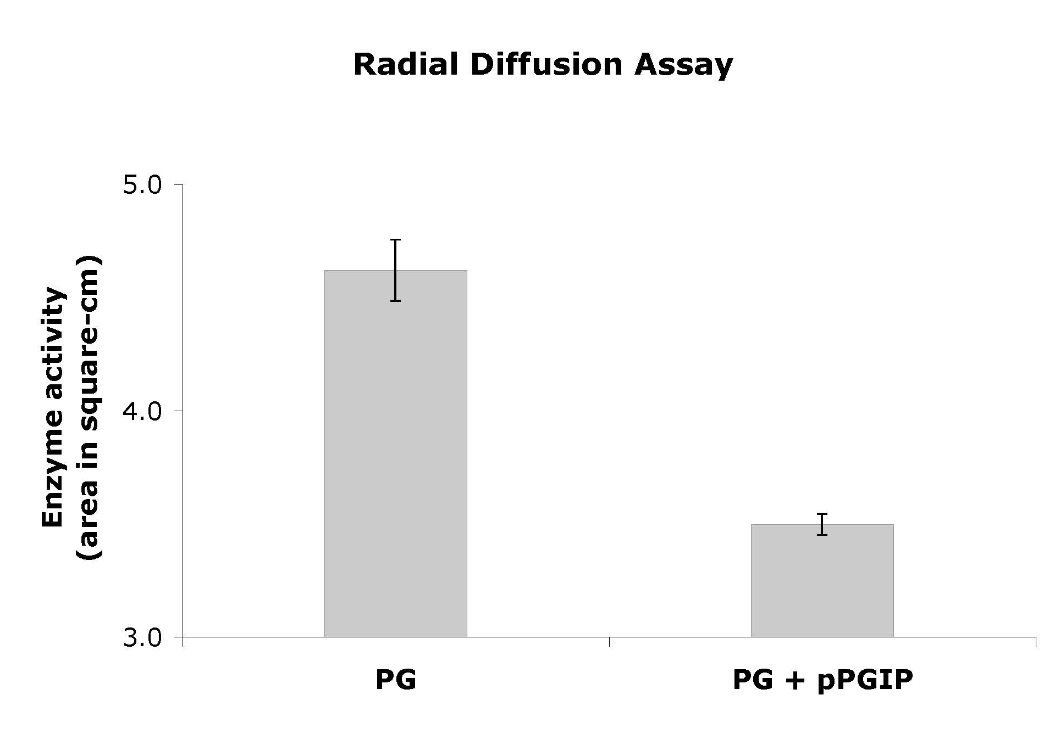
Inhibitor activity the pPGIP protein was measured throughout purification by radial diffusion assays (Taylor and Secor, 1988). Samples of the initial pear homogenate inhibited a PG (BcPG) mixture from Botrytis cinerea culture filtrates. The pPGIP purification preparations after ammonium sulfate precipitation and subsequent dialysis resulted in a 75% reduction in BcPG activity in the assay (Figure 4).
Figure 4. Results of a radial diffusion assay to determine the amount of pPGIP in a protein preparation from pear fruit.
Objective 2 - Calibrate the antibodies produced by the hybridoma clones to determine effective dilutions for use in detecting the pPGIP protein.
Will commence once the antibody has been generated.
Objective 3 - Use the antibody to detect transgenic pear PGIP in xylem sap of own-rooted and grafted grapevines.
Will commence once the antibody has been generated.
References cited:
Abu-Goukh AA, Greve LC Labavitch JM 1983. Purification and partial characterization of “Bartlett” pear fruit polygalacturonase inhibitors. Plysiological Plant Pathology 23:111-122.
Pérez-Donoso AG, Sun Q, Roper MC, Greve LC, Kirkpatrick B, Labavitch JM. 2010. Cell wall-degrading enzymes enlarge the pore size of intervessel pit membranes in healthy and Xylella fastidiosa-Iinfected hrapevines. Plant Physiol. 152: 1748-1759.
Powell ALT, van Kan JAL, ten Have A, Visser J, Greve LC, Bennett AB, Labavitch JM. 2000. Transgenic expression of pear PGIP in tomato limits fungal colonization. Mol. Plant Microbe Interact. 13: 942-950.
Roper MC, Greve LC, Warren JG, Labavitch JM, Kirkpatrick BC. 2007. Xylella fastidiosa requires polygalacturonase for volonization and pathogenicity in Vitis vinifera grapevines. Mol. Plant Microbe Interact. 20: 411-419.
Stotz HU, Powell ALT, Damon SE, Greve LC, Bennett AB, Labavitch JM. 1993. Molecular characterization of a polygalacturonase inhibitor from Pyrus communis L. cv Bartlett. Plant Physiol. 102: 133-138.
Taylor RJ and Secor GA. 1988. An improved diffusion assay for quantifying the polygalacturonase content of Erwinia culture filtrates. Phytopathology. 78: 1101-1103.

- Publications:
Report for the December 2011 PD-GWSS Annual Meeting (Powell, Ann L.T., Dandekar, Abhaya, Labavitch, John M., Barabote, Ravi D., Chestnut, Zachary. 2011. “Tools to identify PGIPs transmitted across grapevine grafts.” 2011 Pierce’s Disease Research Symposium, Pgs.158-161)

- How this work will contribute to solving the PD problem in California:
The CDFA Pierce’s Disease and Glassy-winged Sharpshooter Board’s Research Scientific Advisory Panel review in 2007 and subsequent RFPs have given top priority to delivery of PD control candidates, including polygalacturonase-inhibiting proteins (PGIPs), from grafted rootstocks. Four currently funded projects (two research projects and two field trials) use expression of PGIPs as a control strategy to limit the spread of X. fastidiosa in the xylem network and thereby limit PD symptom progression in infected vines. A monoclonal antibody recognizing pear fruit PGIP (pPGIP), the protein expressed in the grape lines in the four projects, is needed to detect, quantify, and observe the localization of the protein in transformed grapevines and in grafted vines with transformed rootstocks. Authentic pPGIP protein from pear fruit is needed to prepare this monoclonal antibody which can be maintained in perpetuity as a cell culture. Production of the monoclonal antibody by Antibodies, Inc. will begin now that sufficient quantities of properly glycosylated, active PGIP have been purified. The monoclonal antibody will allow comparison of the approaches from different research groups and will allow accurate assessments of the potency of pPGIP for limiting PD symptoms.
- Layperson summary of project accomplishments:
X. fastidiosa (Xf), the bacteria that causes Pierce’s Disease (PD) in grapevines, utilizes a key enzyme, polygalacturonase (XfPG), to spread from one grapevine xylem vessel to the next, eventually leading to the development of PD symptoms because the bacteria multiply and interrupt the flow of nutrients and water through the vessels in the plant. Plant proteins called PG-inhibiting proteins (PGIPs) selectively inhibit PGs from bacteria, fungi, and insets. Our work has identified a PGIP from pear fruits that at least partially inhibits the XfPG and we demonstrated reduced PD symptom development in grapevines expressing the pear fruit PGIP. Current projects, including field trial evaluations, require a monoclonal antibody specifically recognizing the pear fruit PGIP protein in order to detect, quantify, and characterize the PGIP protein delivered to the scion portion of grafted plants from rootstocks expressing the pear fruit PGIP. The monoclonal antibody allows the researchers to compare the amounts of the PGIP protein at different times and places and thereby determine the protein’s role in XfPG inhibition in grapevines. We have purified active pear PGIP green pear fruit for commercial antibody production to meet the needs of the collaborating groups.

- Summary and status of intellectual property associated with the project:
Not part of this project.

