California Department of Food and Agriculture PD/GWSS
Final Report

Report title: Final Report for CDFA Agreement Number 10-0277
Project Title: Molecular and functional characterization of the putative Xylella fastidiosa resistance gene(s) from b43-17 (V. arizonica).

Principal Investigator and Cooperating Staff: M. Andrew Walker, Cecilia Agüero, and Summaira Riaz, Dept. of Viticulture & Enology, University of California, One Shields Ave., Davis, CA 95616-8749, awalker@ucdavis.edu, 530-752-0902

Cooperator: Abhaya M Dandekar, Dept. of Plant Sciences, University of California, One Shields Ave., Davis, CA 95616-8749, amdandekar@ucdavis.edu, 530- 752-7784

Reporting period: July 1, 2010 to June 30, 2013

INTRODUCTION
New cultivars bred to resist Xylella fastidiosa infection and subsequent expression of PD symptoms will provide long-term sustainable control of PD. Disease resistant cultivars can be obtained by conventional breeding through the introgression of resistance from Native American species into elite vinifera wine and table grapes. Another approach is “cisgenesis” – the transformation of elite V. vinifera varieties with grape resistance genes and their native promoters, cloned from disease resistant American Vitis species. The cisgenic approach may have a more limited impact on the genome of the elite V. vinifera parent since single genes from the Vitis species genome would be added to the elite parent, thus limiting the impact on its fruit and wine quality while making it PD resistant. The cisgene approach in grapes is similar to the natural clonal variation that exists in many winegrape cultivars. This linkage-drag-free approach is attractive, and also allows the opportunity to stack additional resistance genes from other Vitis sources, even if these genes originate from the same chromosomal position in different species or accessions (Jacobsen and Hutten 2006). The physical mapping of the resistance region from V. arizonica/candicans b43-17, PdR1, allowed the identification of potential candidate resistance gene(s). Preliminary comparisons indicated that the PdR1 region contains multiple tandem repeats of Serine Threonine Protein Kinase with a LRR domain (STPK-LRR) gene family. This category of genes belongs to a group involved in plant resistance. Their defense mechanism is based on compounds involved in the recognition of microbe-associated molecular patterns (MAMP) like compounds, which initiate a defense response (Bent and Mackey 2007). In order to gain insight and to verify the function of resistance gene(s), cloning and functional characterization is required. In this report, we present the progress on the cloning and testing of five candidate resistance genes.

OBJECTIVES
- Cloning, structural analysis and gene annotation via comparison of the PdR1b locus to the susceptible Pinot noir genome sequence using the assembled sequence of the BAC clone H64J14.
- Expression studies of candidate genes.
- Complementation tests of candidate gene(s) to test their function using:
- Agrobacterium-mediated transformation of the susceptible Vitis cultivars (Chardonnay and Thompson Seedless, and the rootstock St. George). b) Transformation of tobacco.

DESCRIPTION OF ACTIVITIES / SUMMARY OF ACCOMPLISHMENTS
Objective 1. Cloning, structural analysis and gene annotation via comparison of the PdR1b locus to the susceptible Pinot noir genome sequence using the assembled sequence of the BAC clone H64J14 –
A refined genetic map of chromosome 14, which contains the PD resistance locus, was generated from three grape mapping populations derived from V. arizonica/candicans b43-17. The resistance locus segregates as a single dominant gene and mapped as PdR1a in the F1 selection 8909-17 and as PdR1b in its sibling F8909-08. Clone H69J14 from a b43-17 BAC library, containing both markers flanking the PdR1b resistance locus, was sequenced using 454 sequencing. Further detailed analysis of the assembled, and unassembled sequences, revealed the presence of a high number of transposable elements (TE). Chromosome 14 is known to have the second largest number of TEs in the sequenced grape genome (Moisy et al. 2008). Transposable elements play a key role in the diversification of disease resistance genes through a process termed TE-induced gene alteration (Michelmore 1995). Considering the complexity of this region due to the large number of TE tandem repeats, a Fosmid library was generated with an insert size of 35-40kb from the H69J14 BAC clone. The second round of sequencing was performed using fosmid end-sequencing as well as shotgun reads.

The first assembly generated 10 contigs, with a portion of the sequence remaining unassembled. Analysis of assembled and unassembled sequences revealed the presence of four candidate genes, PdR1b.1–4, which appear to be receptor-like proteins, a class of resistance proteins. PdR1b.1-2 and 4 were cloned into a pGEM-T easy vector (Promega) and subcloned into vector pDE00.0113 containing the 35S promoter and ocs3’ terminator (Figure 1). The second assembly allowed the identification of two new candidate genes and showed that PdR1b.1 was longer than previously found. As a consequence, we repeated the amplifications from BAC H69J14, using primers that hybridize to regions flanking the open reading frames (ORFs). So far, we have re-amplified and confirmed the sequences of PdR1b.1, PdR1b.2, PdR1b.5 and PdR1b.6. We have sublconed PdR1b.1 and PdR1b.6 into binary vectors pCAMBIA-1303 (www.cambia.org) and pDU99.2215 (Figure 1). PdR1b.1 is the largest gene, sharing a high degree of homology with PdR1b.2, 3, 4, and 5.. PdR1b.6 is significantly different from the rest. It has a kinase domain, which suggests it might be involved in PD resistance in combination with PdR1b.1 or one of the other candidates. pCAMBIA-1303 was included in the experiments because it carries a hygromicin resistance gene that improves the selection of transformants (D. Tricoli, pers. comm.). An additional advantage is that it allows the subcloning of the gene in one step, by replacing the gus gene with the gene of interest. The resulting plasmids were used for transformation via Agrobacterium tumefaciens of Chardonnay, Thompson Seedless, St. George and tobacco SR1. A similar procedure will be followed with the remaining 4 genes.

The first assembly generated 10 contigs, with a portion of the sequence remaining unassembled. Analysis of assembled and unassembled sequences revealed the presence of four candidate genes, PdR1b.1 – 4, which appear to be receptor-like proteins, a class of resistance proteins. The second assembly allowed the identification of two new candidate genes and showed that PdR1b.1 was longer than the sequence previously found. As a consequence, we repeated the amplifications from BAC H69J14, using primers that hybridize to regions flanking the ORFs. We have re-amplified and confirmed the sequences of all six candidate genes PdR1b.1 - 6. PdR1b.1 is the largest gene, sharing a high degree of homology with PdR1b.2, 3, 4, and 5. PdR1b.6 is significantly different from the rest (Table 1). It has a kinase domain that suggests it might be involved in PD resistance in combination with PdR1b.1 or one of the other candidates.

Sequence analysis and alignments to identify introns and exons on the PdR1b.1 gene was performed using the GeneQuest module of Lasergene v 8.1, which facilitates the prediction of coding regions using the Borodovsky's Markov method and predicts intron/exon boundaries using species-specific patterns by aligning to known genes. We also utilized the GeneMark (http://exon.biology.gatech.edu/) program using both Arabidopsis thaliana and Medicago truncatula settings. By using both systems, we identified two small introns from position 1-168 and position 3128-3191 that are 167bp and 361bp, respectively. With A. thaliana as the model system, the size of predicted protein was 976 amino acids, and with M. truncatula it was 964 amino acids. It is interesting to note that all four genes from the 12X assembly of PN40024 carry large introns. We plan to make sequence comparisons and identify protein domains for other putative candidate genes. Experiments continue with specific primers to amplify these regions of the genes using total RNA extracted, then clone and sequence the DNA to make sequence comparisons among Pinot noir and 5 different genotypes used for RNA extraction.

Table 1. Size and degree of homology between PdR1b candidate genes

 | Size (bp) | % Homology with PdR1b.1 | % Homology with PdR1b.1  over-lapping region
PdR1b.1 | 3198 | - | -
PdR1b.2 | 2946 | 87% | 95%
PdR1b.3 | 2787 | 83% | 95%
PdR1b.4 | 2580 | 80% | 98%
PdR1b.5 | 2235 | 53% | 77%
PdR1b.6 | 2052 | 21% | -

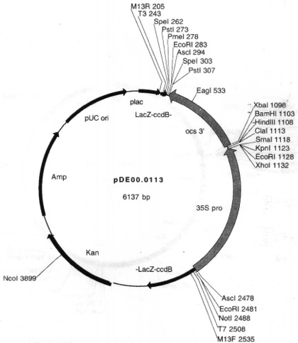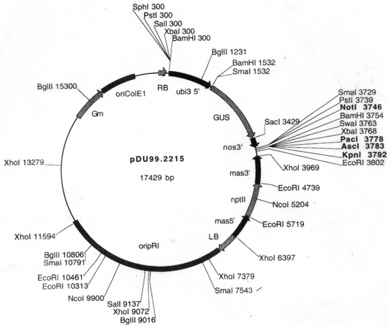
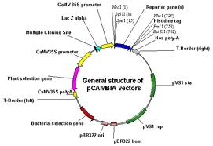

Figure 1. Vectors used in genetic transformation with PdR1b candidate genes. PdR1b.1 was subcloned into pDE00.0113 and then the expression cassette was moved into the binary plasmid pDU99.2215. PdR1b.1 and PdR1b.6 were also subcloned directly into the binary plasmid pCAMBIA 1303 in the place of the reporter gene. Because the two binary plasmids have different plant selection genes, it is possible to co-transform tobacco with both genes.

Objective 2. Expression studies of candidate genes –
Expression studies of the candidate genes were conducted on the susceptible vinifera control (Chardonnay), resistant and susceptible parents (b43-17 and V. rupestris A. de Serres) and two resistant F1 selections (F8909-08 and F8909-17). Stem and leaf tissues were used for the total RNA from both resistant and susceptible genotypes using a cetyltrimethylammonium bromide (CTAB)-based RNA extraction protocol as described previously (Iandolino et al., 2004). Two other methods were tested to get better yield and quality of total RNA with less genomic DNA. The best yield of total RNA was obtained by the procedure described by Reid et al. 2006.

A time course analysis was used to evaluate expression and to determine when the resistance gene(s) is activated. Total RNA was extracted from the leaves and stem tissue of un-inoculated plants, and from plants 1, 3 and 5 weeks after inoculations with the X. fastidiosa. ELISA screening was carried out after 12 weeks to quantify the amount of X. fastidiosa in tissues. Figure 2 presents the results of RNA extracted from the young leaves of the four genotypes before the bacterial inoculations and stem tissue two weeks after inoculations. First-strand cDNA synthesis will be performed with SuperScript III reverse transcriptase (Invitrogen, Carlsbad, CA). We tested three different genes to act as housekeeping gene controls (actin, chitinase and B-actin). The actin gene (F-actgctgaactggaaattgt; R- acggaatctctcagctccaa) as described Vasanthaiah et al. 2008 worked very well in our system. We designed specific primers for quantitative PCR from two of our candidate genes (PdR1.1 and PdR1.6) and carried out test comparative RT-PCR to check the effectiveness of the primers and the whole setup. We observed differences in the level of expression of the genes indicating that our RT-PCR system is working. Experiments that are more detailed are underway to monitor the gene expression of all six candidate PD resistant genes.

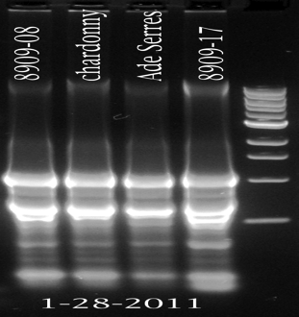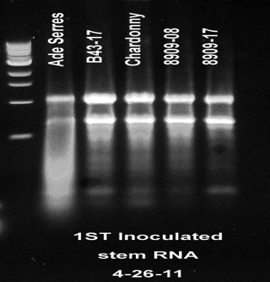
Figure 2. Total RNA extracted from the leaves and stem tissue of susceptible control and resistant plants

Objective 3. Complementation tests of candidate gene(s) to test their function.

Once the gene constructs are completed, they must be tested to see if they contain the resistance genes. This is done by inserting the genes into a susceptible plant and testing to see if the insertion results in resistant plants. Currently, the most widely used method for the production of transgenic/cisgenic grapes is based on Agrobacterium transformation followed by regeneration of plants from embryogenic callus. We have established cultures of pre-embryogenic callus derived from anthers of V. vinifera Thompson Seedless and Chardonnay and the rootstock V. rupestris St. George that have been used for transformation (Agüero et al. 2006).

PdR1b candidate genes were amplified using Phusion high-fidelity DNA polymerase (Finnzymes), cloned into pGEM-T easy vector (Promega) and sequenced at UC Davis Sequencing Facility. After sequence verification, genes were subcloned into binary vector pCambia 1303 (www.cambia.org) containing the 35S cauliflower mosaic virus promoter, the nopaline synthase terminator and an hptII-selectable marker gene. PdR1b.1 was also subcloned into binary vector pDU99.2215 containing an ntpII selectable marker gene. The resulting plasmids were transformed into disarmed A. tumefaciens EHA105 pCH32 by electroporation and used for transformation of Chardonnay, Thompson Seedless, and St. George.

Pre-embryogenic calli of Thompson Seedless, Chardonnay and St George transformed with 5 candidate genes were selected in medium with antibiotics, then subcultured to germination medium for plant regeneration. The presence of the genes was checked in some callus through PCR and tested again in plants transferred to the greenhouse. For each gene, we expect to produce, at least 10 independent lines that will be subsequently propagated clonally to 6 plants per line and tested under greenhouse conditions. Table 2 shows the number of independent lines that have been obtained at present. P2 binary plasmid was the last to be constructed, but many P2 embryogenic callus have developed in selection medium and are now growing in germination medium. Chardonnay has the highest number of transgenic lines, some of which have been acclimated to greenhouse conditions and multiplied through green cuttings. Genomic DNA was isolated from these plants with DNeasy Plant Mini Kit (Qiagen). A primer that binds the CaMV 35S promoter and a primer that binds the coding region of each PdR1b candidate were used in combination for PCR amplification to verify the presence of the transgene. Candidate genes have amplified successfully in all the plants transferred to the greenhouse (Figure 3). No phenotypic differences have been observed with control plants obtained from non transformed embryo cultures. These plants will be cut back in August and inoculated with Xylella in September. PD resistance analysis will be performed through symptom screening (leaf scorch and uneven cane maturation) and ELISA (Krivanek and Walker 2005).

Table 2. Number of independent lines produced until July 2013; lines in the greenhouse is shown in parentheses.
 | Chardonnay | Thompson Seedless | St George
P1 pDU 99.2215 | 4 (3) | 0 | 0
P1 pCambia1303 | 14 (5) | 1 | 13
P2 pCambia1303 | 0 | 0 | 0
P3 pCambia1303 | 20 (4) | 0 | 4
P4 pCambia1303 | 13 (6) | 1 | 2
P5 pCambia1303 | 17 (4) | 7 | 1

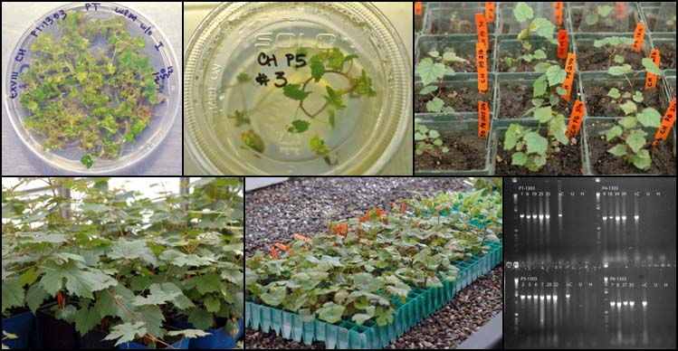
Figure 3. Clockwise from top left: Chardonnay embryos growing in germination medium, regenerated plantlets growing in vitro, in vitro plants transferred to substrate in greenhouse, mother plants for green cuttings, green cuttings in mist bed, transgene detection through PCR.

Tobacco transformation

To speed the functional analysis, we have also transformed the tobacco variety SR1, which was recently demonstrated to be a susceptible host for X. fastidiosa and is much easier and quicker to transform and test (Francis et al. 2008). Transgenic tobacco plants carrying each candidate gene (9-10 independent lines per gene) have been produced at the UC Davis Transformation Facility and multiplied in vitro in our lab. Genomic DNA was isolated from plants of each line for PCR amplification to verify the presence of the transgene as described previously. All candidate genes amplified successfully with exception of PdR1b.1 sublcloned into pDU99.2215.

Preliminary experiments conducted to establish the best screening method for tobacco showed that pin prick inoculation of the stem was best when compared to inoculations on the base of leaves, either through pin prick or incision. Plants are pin prick inoculated two times, one week apart. Each time, 20 μl of a water suspension of the Beringer strain (OD600=0.25), are inoculated on the second or third node on both sides of the stem. Symptoms are scored on a 5-point scale and stem tissue is collected and analyzed through ELISA every 4 weeks.

Transgenic tobacco plants have been acclimated to greenhouse conditions for testing against X. fastidiosa. Figures 4 and 5 show the results obtained from the testing of 4-5 lines of all 5 candidate genes, using 5 replicants per line. Two additional plants / line were inoculated with water. Untransformed plants were subjected to the same treatments. No significant differences were observed in stem Xf counts between untransformed controls and transformed plants 12 weeks post inoculation (Fig. 4). However, candidate genes PdR1b.1 and PdR1b.5 appear to have significantly lower symptoms compared to the untransformed controls (Fig 5 and 6). Other candidate genes did not show significant differences with the untransformed control (Fig. 5). Mock inoculated plants displayed dried leaves at the base of the plant that were scored as PD symptoms although this could be a consequence of the water restriction imposed on the plants to facilitate the development of PD.

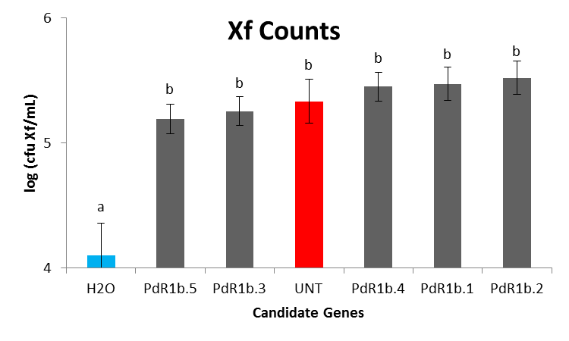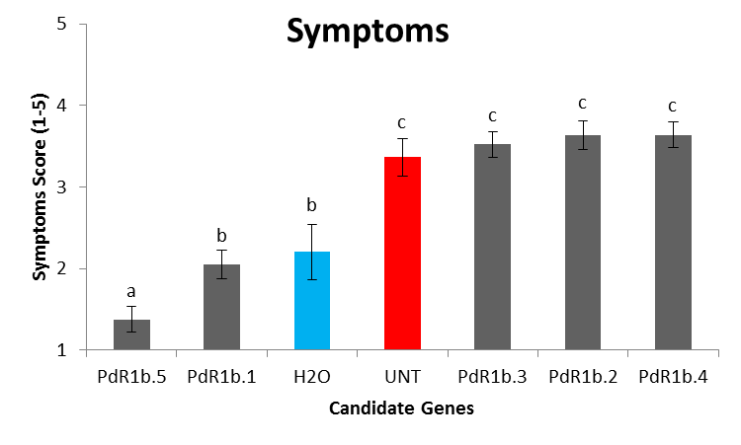
Figure 4. ELISA results for transformed candidate genes as well as negative controls (H2O) and positive controls (UNT). Samples were stem sections collected aprox. 50 cm above the POI.
Figure 5. Symptom results for transformed candidate genes as well as negative controls (H2O) and positive controls (UNT).

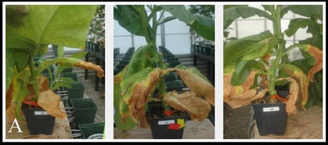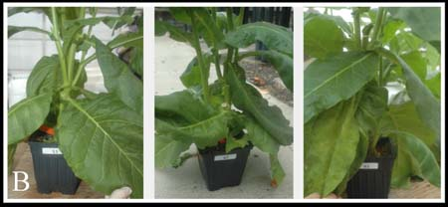

Figure 6. Symptoms 12 weeks post -inoculation for untransformed controls (A) and for plants transformed with PdR1b.5 (B).

Genetic transformation via organogenesis

Inoculation with A. tumefaciens of meristematic bulks (MB) is being tested as an alternative transformation technique via organogenesis to reduce the time needed to produce transgenic grapes (Mezzetti et al. 2002). In our lab, transgenic plants of Thompson Seedless expressing GFP were produced in 3 months using MB and kanamycin as the selective agent. Based on these results, it was decided to focus on testing the production of St. George and Chardonnay MB, which was partially successful. Consequently, PhD student Xiaoqing Xie is testing different hormone ratios and cytokinins to adapt the protocol to these cultivars. She will also compare the effect of kanamycin and hygromicin as selective agents.

Thompson Seedless and Chardonnay MB were inoculated with A. tumefaciens carrying PdR1b.5 in pCAMBIA 1303 using 3 initial levels of hygromicin: 5, 10 and 15 ug/ml but MB didn’t grow with any of the concentrations tested. Subsequently, experiments assaying 0 ug /ml in the first subculture after inoculation, followed by 2.5 ug /ml hygromicin were initiated last January on T.Seedless MB inoculated with A. tumefaciens carrying PdR1b.2. This lower hygromicin concentration allowed the growth of 2 MB out of 50 initial explants that have not produce plants yet.

Transformation of pre-embryogenic cultures or MB has been performed with A. tumefaciens EHA105 pCH32, carrying binary plasmids with PdR1b coding sequences. Overnight cultures of the bacteria in LB medium + antibiotics are diluted to 10⁸ cells·ml⁻¹ using liquid co-cultivation medium. Pre-embryogenic calli are placed on a sterile glassfiber filter (GFF) overlaid on co-cultivation medium. The Agrobacterium culture is poured over the callus and excess is blotted with sterile filter paper after 5 min. MB slices are dipped in bacteria suspension for 10 minutes. Pre-embryogenic calli or MB are then transferred onto fresh co- cultivation medium. After 48 h in the dark, MB or callus pieces, sub-divided into clumps of about 2 mm in diameter, are cultured on selection medium containing 100 ug /ml kanamycin or 0-15-25 ug /ml hygromicin for pre-embryogenic callus; or 0-2.5 ug/ml hygromicin for MB.

PUBLICATIONS/Abstracts
Bistue C., Agüero C.B., Riaz S., and Walker M.A. 2013. Testing Vitis arizonica candidate genes for Pierce’s disease resistance in Nicotiana tabacum /SR-1. ASEV 64th National Conference. Monterey, California.
Riaz, S., Tenscher, A., and Walker, M.A. 2013. Phylogeographic analysis of resistance to Pierce’s disease in North American and Mexican species with SSR markers and identification of novel resistance sources. ASEV 64th National Conference. Monterey, California.
Agüero C.B., Riaz S., Hwang C-F, He R., Hu R., Bistue C., Walker M.A. 2012. Map-based cloning of Pierce’s disease and Xiphinema index resistance genes from Vitis arizonica. ASEV 63nd National Conference. Portland, Oregon, 6/18-22/2012.
Walker M.A., Riaz S., Agüero C., Bistue C. 2012. Molecular characterization of the putative Xylella fastidiosa resistance gene(s) from b43-17 (V. arizonica/candicans). Poster presentation Pierce’s Disease Research Symposium. Sacramento, 12/13-15/2012
Walker M.A., Riaz S., Agüero C., Bistue C. 2011. Molecular characterization of the putative Xylella fastidiosa resistance gene(s) from b43-17 (V. arizonica/candicans). Poster presentation Pierce’s Disease Research Symposium, Dec. 13-15, Sacramento.

RESEARCH RELEVANCE
This research is focused on demonstrating whether PD resistance genes developed from genetic and physical mapping efforts function when transformed into susceptible host plants. These transformations are underway in tobacco (an easily used model system) and susceptible grape (Chardonnay, Thompson Seedless and St. George). These studies will lay the foundation to understanding how these resistance genes work, and may provide a tool to genetically engineer cisgenically resistant grapevines.

LAYPERSON SUMMARY
We maintain and characterize many populations while breeding PD resistant wine grapes, some of which have been used to develop genetic maps. These maps have been used to identify genetic markers that are tightly linked with PD resistance, which have allowed classical breeding to be greatly expedited through marker-assisted selection. Genetic maps allow the construction of physical maps to identify resistance genes (Riaz et al. 2008; Riaz et al. 2009). The physical map of the b43-17 resistance region allowed us to identify candidate genes responsible for PD resistance. Comparisons with plant genomes indicated that multiple tandem repeats of the disease resistance gene family Receptor-like proteins with LRR domains were present in the resistance region. This category of genes is involved in the recognition of microbes and in the initiation of defense responses (Bent and Mackey 2007). We completed the cloning of five candidate genes: PdR1b.1, 2, 3, 4 and 5 and confirmed their sequence. We also developed embryogenic callus cultures of PD susceptible Chardonnay and Thompson Seedless and rootstock St. George for genetic transformation to verify candidate PD resistance gene function. PdR1b.1, 2, 3, 4 and 5 have been used in transformation of tobacco and grape. Transgenic tobacco plants have been tested against Xylella in the greenhouse and promising results have been obtained with 2 candidate genes. Transgenic grape plants have been acclimated to greenhouse conditions and will be ready for Xylella testing in several months. Although the current transgenic grape plants were produced using the traditional procedure we are also testing another technique to speed the development of transgenic tissue from meristematic bulks that will allow PdR1 gene candidates to be tested faster.

Status of Funds: These funds have been allocated.

Intellectual Property: The resistance genes identified in this research will be handled by PIPRA, UC Davis.

LITERATURE CITED
Agüero CB, Meredith CP, Dandekar AM (2006) Genetic transformation of Vitis vinifera L. cvs Thompson Seedless and Chardonnay with the pear PGIP and GFP encoding genes. Vitis 45:1-8
Bent AF and Mackey D (2007) Elicitors, effectors, and R genes: the new paradigm and a lifetime supply of questions. Ann. Rev. Phytopath. 45, 399–436
Dutt M, Li ZT, Dhekney SA, and Gray DJ (2007) Transgenic plants from shoot apical meristems of Vitis vinifera L. ‘Thompson seedless’ via Agrobacterium-mediated transformation. Plant Cell Rep. 26: 2101-2110
Francis M. Civerolo E.L., Bruening, G. (2008) Improved bioassay of Xylella fastidiosa using Nicotiana tabacum Cultivar SR1. Plant Disease 92:14-20.
Iandolino AB, Goes Da Silva F, Lim H, Choi H, Williams LE, and Cook DR (2004) High-quality RNA, cDNA, and derived EST libraries from grapevine (Vitis vinifera L.). Plant Molec. Biol. Rep. 22: 269-278.
Jacobsen J and Hutten R (2006) Stacking resistance genes in potato by cisgenesis instead of introgression breeding. In: N.U. Haase and A.J. Haverkort, Editors, Potato Developments in a Changing Europe, Wageningen Academic Publishers (2006), pp. 46–57
Mezzetti B, Pandolfini T, Navacchi O and Landi L (2002) Genetic transformation of Vitis vinifera via organogenesis, BMC Biotechnol. 2:18
The French-Italian Public Consortium for grapevine Genome Characterization (2007) The grapevine genome sequence suggests ancestral hexaploidization in major angiosperm phyla. Nature 449: 463-467
Riaz S, Tenscher AC, Rubin J, Graziani R, Pao SS and Walker MA (2008) Fine-scale genetic mapping of Pierce’s Disease resistance loci (PdR1a and PdR1b) and identification of major segregation distortion region along Chromosome 14 in grape. Theor. Appl. Genet. 117:671-681.
Riaz S, Tenscher AC, Graziani R, Krivanek AF, Walker MA (2009) Using marker assisted selection to breed for Pierce’s disease resistant grapes. Am. J. Enol. Viticult. 60:199-206.

