Interim Progress Report for CDFA Agreement Number 12-0116-SA

Title of Project
Blocking Xylella fastidiosa transmission

Principal Investigator
Rodrigo Almeida, Associate Professor
Dept. Environmental Science, Policy and Management
University of California, Berkeley
Berkeley, CA, 94720

Time Period Covered by the Report
December 2013- March 2014

Introduction

The goal of this project is to develop a technology to block the vector transmission of Xylella fastidiosa to plants. The approach focuses on the disruption of X. fastidiosa-vector interactions, so that the transmission of X. fastidiosa from one plant to another is affected. Our work has demonstrated that this approach is feasible and that we can disrupt sharpshooter transmission of X. fastidiosa to grapevines using generic molecules to block bacterial access to insect receptors (Killiny and al. 2012). The specific goal of this proposal is to identify and test X. fastidiosa candidate proteins that can be used as specific transmission-blocking molecules, so that this strategy can be tested under field conditions in the near future. This report describes results achieved since December 2013. In the previous report we summarized our efforts to search for proteins implicated in the transmission of X. fastidiosa, including work conducted on the identification of optimized chitin-binding peptides and the characterization of a chitinase mutant. In this interim report we focus on novel results obtained in the last three months.

List of Objectives – as in the approved research proposal

Objective 1. Continue efforts to identify additional targets implicated in X. fastidiosa transmission by insects.
Objective 2. Test specific and efficient molecules to disrupt vector transmission.

Description of activities

OBJECTIVE 1

- X. fastidiosa chitinase is important for insect colonization and plant to plant transmission

The work we developed on the characterization of a chitinase (ChiA) allowed us to better define the role of its enzyme in X. fastidiosa transmission. Details of this research have already been detailed in the previous report (Almeida and Labroussaa 2013, PD/GWSS Research Symposium). A paper covering those results is being drafted and will summarize the main findings on the role of X. fastidiosa ChiA. We showed that:
- X. fastidiosa is able to grow when only chitin is present as the main carbon source; a chiA mutant is not able to grow on such medium.
- The X. fastidiosa chiA mutant is not able to adequately colonize its insect vector and, consequently, its vector transmission to plants is reduced.
- More surprisingly, the chiA mutant is not able to colonize grapevines in comparison to a wild-type strain. When mechanically inoculated to a plant, the chiA mutant is only recovered near the inoculation site. In addition, the mutant is not able to induce symptoms.
- In vitro binding assays also allowed us to determine that ChiA was not able to directly bind to chitin or related insect polysaccharides. No chitin-binding domains (CBMs) are present on its sequence. ChiA requires X. fastidiosa chitin-binding proteins that ensure the link between ChiA and its substrate, necessary for its catalytic activity.

- Identification of additional peptides implicated in X. fastidiosa transmission

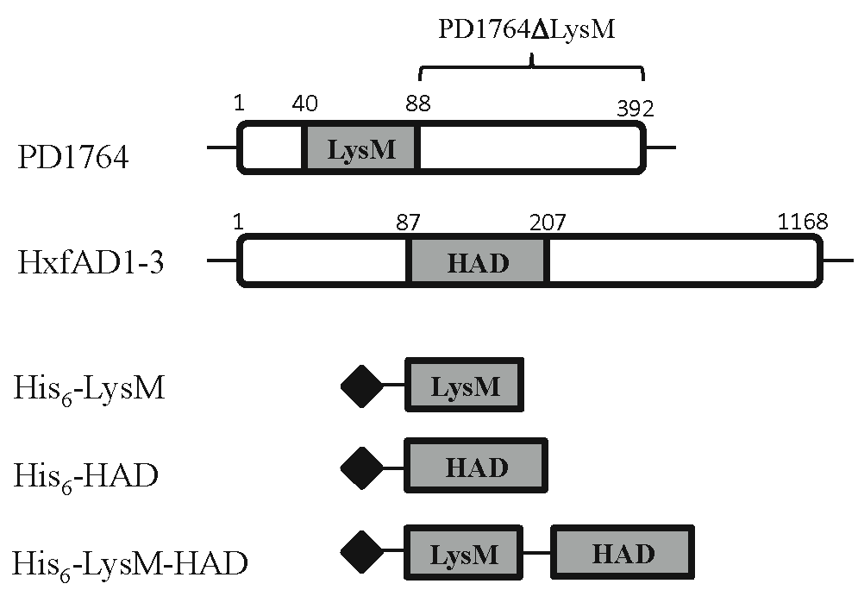
We previously reported our recent results obtained with PD1764 and the hemagglutinin-like protein HxfB (HxfAD1-3; PD1792). We successfully demonstrated that a strategy using those proteins as transmission-blocking proteins could result in a significant reduction or even a complete disruption of X. fastidiosa transmission by its insect vector. Results of this research are also being compiled in a paper. Based on those results and in silico analyses, we designed three additional peptides corresponding to the sequences of domains potentially having the blocking activity (see previous report for details in the identification and the construction of those peptides).
This figure summarizes the location of the first two domains, LysM and HAD, on each protein but also the construction of a fused peptide including both domains.

Efforts are still ongoing to identify additional X. fastidiosa proteins involved in transmission. In particular, successful results obtained with PD1764 using the proteomic-based pipeline reinforce our idea that this strategy will allow to identify other candidates that will enrich our understanding on X. fastidiosa transmission but also our pool of transmission-blocking peptides.

OBJECTIVE 2. Test specific and efficient molecules to disrupt vector transmission.

- Binding of optimized transmission-blocking peptides to insect-related polysaccharides

We used those 3 candidate peptides in a binding assay to assess or confirm their ability to bind to chitin or other related insect polysaccharides. Protocol for this assay has already been described with other candidates (see previous report for details). The figure below shows results obtained. PD1764, PD1764ΔLysM and HxfAD1-3 proteins have been retested again as references for us to be able to compare results obtained with the optimized peptides.

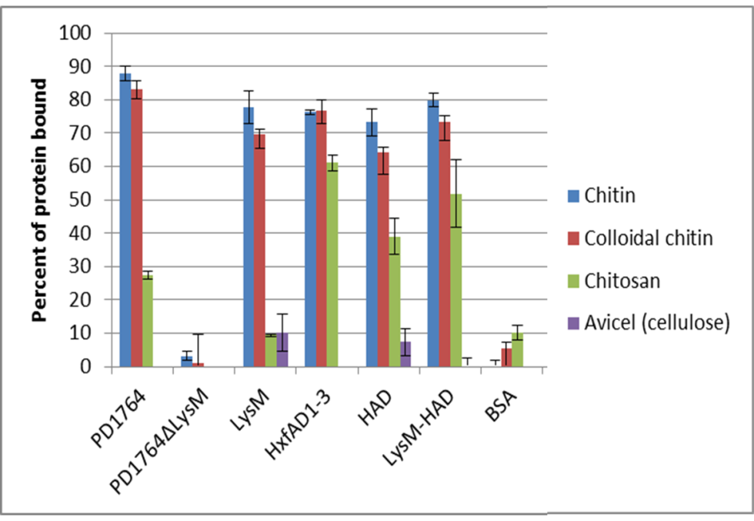
As previously found using this assay PD1764 and HxfAD1-3 strongly interact with chitin and colloidal chitin. Again, no interaction was found with PD1764ΔLysM. Before going into details for the three peptides, it is important to notice that all of them interact with at least two of the substrates tested indicating that their heterologous expression in E.coli had no or little significant impact on their binding capacity.

First, results obtained for the LysM peptide are in accordance with binding obtained for the full-length PD1764. LysM strongly interacts with chitin and colloidal chitin (78% and 69% respectively). However, only weak percentages of binding are obtained with chitosan and cellulose. Percentages for those two substrates are comparable with those acquired for BSA, used in this assay as a negative control. The HAD domain is also able to interact with chitin and colloidal chitin but as HXfAD1-3, it is also able to significantly bind to chitosan even if its binding percentage is lower (39% vs 61% for HxfAD1-3). This is of importance because it confirms that acetyl residues are playing an important role in the binding of PD1764 or LysM domain on chitin-related polysaccharides whereas it doesn’t seem to be a requirement for HxfAD1-3 or HAD interaction on such molecules.

The LysM-HAD construct seems to be able to interact with all the substrates but cellulose. It is of a great interest to notice that this peptide, constructed with the two previous cited domains, seems to harbor characteristics from those two components. It binding to chitin and colloidal chitin matches those obtained with LysM peptide, being slightly higher than affinity of HAD domain for those substrates. On the other hand, it affinity for chitosan match better with the affinity calculated for HAD domain (39% versus 51% in comparison to 10% of interaction obtained with the LysM domain).

Our main hypothesis for the construction of a fused domain was based on the idea that X. fastidiosa uses several proteins to bind to different receptors on insect cells to ensure an efficient colonization of its vector (Killiny and Almeida 2014). The construction of peptides made with several chitin-binding domains could allow the blocking of several of those receptors using only one transmission-blocking peptide. Data acquired from this binding assay seems to confirm that binding characteristics of each individual domain can be conserved in a fused domain.

- Blocking X. fastidiosa transmission using those optimized peptides

It is now important to confirm the binding characteristic of the fused LysM-HAD domain in a transmission assay using our diet-feeding system. Briefly, insects were allowed to acquire X. fastidiosa and proteins from an artificial diet system for 4 hours, and were then transferred to healthy grapevines for a 24h-inoculation access period. X. fastidiosa suspension was adjusted to 10⁸ cells/ml and different concentrations of the three optimized peptides (25, 100 and 250µM) were mixed with bacteria cells. Those peptide concentrations have been selected in accordance with previous experiments testing the effect of full-length candidates. In those experiments, 100µM was the minimal concentration having a significant effect on X. fastidiosa transmission, if an effect was detected. This experiment was conducted to better define the effect of each peptide but also to determine if the concentration needed to impact X. fastidiosa could be lower for the optimized peptide in comparison to the full-length candidates. Results are presented in the figure above. These results are preliminary as the experiment has been conducted only once.
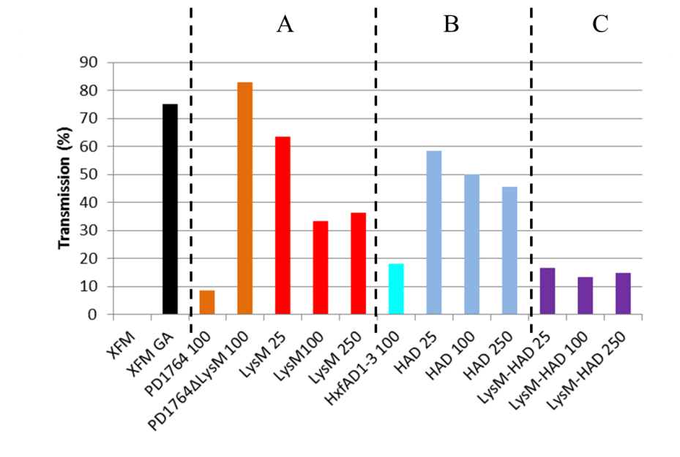
We confirmed the effect of 100 µM of PD1764 in blocking X. fastidiosa transmission, even if in this experiment 1 plant out of 12 has been tested positive whereas the disruption was total in previous experiments. The implication of the LysM domain was confirmed because i) no effect (83,3% of transmission) was obtained using the PD1764ΔLysM protein at that same concentration and ii) this LysM domain was able to reduce X. fastidiosa transmission whatever the concentration tested. However, the reduction obtained with the LysM domain was also less significant than the full-length PD1764. Indeed, 33,3% and 36,4% of transmission were respectively obtained using 100 and 250µM (8,6% of transmission for 100µM PD1764). The effect is even less obvious with the lowest concentration (25µM; 63,6%). The same trend was also obtained for the HAD domain. Whatever the concentration considered, HAD domain had a lower impact on X. fastidiosa transmission than HxfAD1-3 (>40% versus 18,2% of transmission).

Different issues, shared for both peptides, could explain these trends. First, even if we tested the binding of those peptides on different insect-related polysaccharides, we did not yet study their affinity parameters (Kd and Bmax). It is possible that even if their capacities to bind polysaccharides are comparable to their respective full-length proteins, their interactions over time are different. If the interaction does not occur sufficiently rapidly, it is possible that some cells have the opportunity to bind first. Second, because we don’t know the exact composition of the insect cuticle, it is possible that the spatial conformations of the full-length proteins non-specifically cover adjacent receptors.

More promising results were obtained using the LysM-HAD peptide. Indeed, whatever the concentration used, a significant reduction of the transmission was achieved. Only 2 plants out of 12, 15 and 13 respectively for 25, 100 and 250µM have been found infected. This result is close related to the diminution of the transmission obtained with 100µM of PD1764 and the reduction rates are definitively better that those obtained with any of the two other peptides. In addition, there is no noticeable difference regarding X. fastidiosa transmission among the three concentrations used for this fused domain. Additional experiments are needed now to test the different problems encountered with LysM and HAD domains but also to determine optimal parameters for the promising LysM-HAD domain.

- Blocking X. fastidiosa transmission using transgenic plants expressing full-length HxfB and HxfAD1-3 proteins

The last goal of our project is to develop a technology using transgenic grapevines expressing transmission-blocking molecules directly into the xylem. Based on the results obtained with PD1764, we started the construction of transgenic grapevines expressing PD1764 full-length protein but also PD1764ΔLysM and LysM domain. Constructions are currently being transformation into A. tumefaciens. Those constructions will be then sent to the Ralph M. Parsons Plant Transformation Facility at University of California, Davis. It is possible that, taking into account the results described previously with the LysM-HAD peptide, we will include such construction in our project.

In the meantime, plants expressing full-length HxfB protein but also HxfAD1-3, both containing the HAD domain, have been produced by Bruce Kirkpatrick (UC Davis). This is of great interest because HxfAD1-3 was responsible for a partial but significant decrease in the transmission of X. fastidiosa.

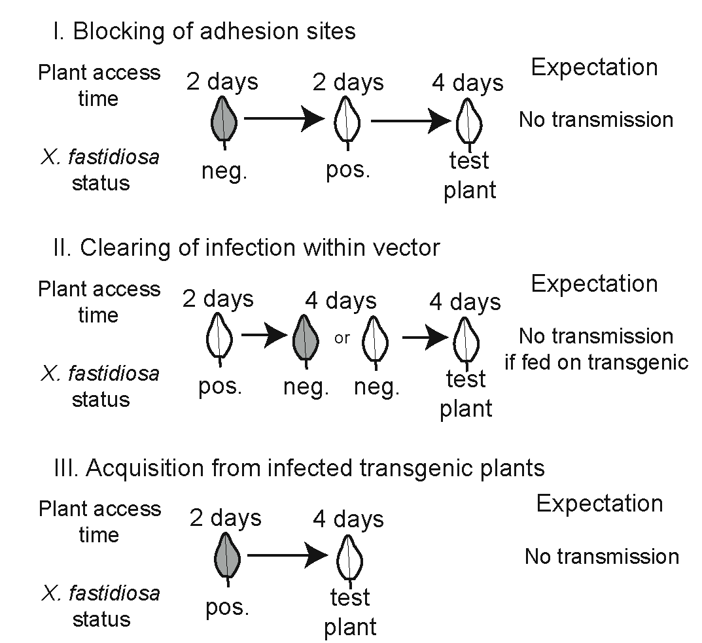
Each transgenic line was subjected to three experiments, shown on left. Shaded leaves represent transgenic plants. Twelve independent replicates were used per treatment, and each replicate used three insect vectors (G. atropunctata) for X. fastidiosa transmission. Final results of these experiments are pending and will be available for our next report.

PUBLICATIONS PRODUCED AND PENDING, AND PRESENTATIONS

Publications (2012-present)
Labroussaa, F. and Almeida, R.P.P. LysM domain blocks the transmission of a non-circulative vector-transmitted plant pathogen. In preparation.
Labroussaa, F. and Almeida, R.P.P. A Xylella fastidiosa chitinase is essential for plant and insect colonization, and vector transmission between host plants. In preparation.
Killiny, N. and Almeida, R.P.P. 2014. Factors affecting the initial adhesion and retention of the plant pathogen Xylella fastidiosa in the foregut of an insect vector. Applied and Environmental Microbiology 80: 420-426.
Baccari, C., Killiny, N., Ionescu, M., Almeida, R.P.P. and Lindow, S.E. 2014. Diffusible signal factor-repressed extracellular traits enable attachment of Xylella fastidiosa to insect vectors and transmission. Phytopathology 104: 27-33.
Killiny, N., Hernandez-Martinez, R., Dumenyo, C.K., Cooksey, D.A. and Almeida, R.P.P. 2013. The exopolysaccharide of Xylella fastidiosa is essential for biofilm formation, plant virulence and vector transmission. Molecular Plant-Microbe Interactions 26: 1044-1053.
Almeida, R.P.P., Killiny, N., Newman, K.L., Chatterjee, S., Ionescu, M. and Lindow, S.E. 2012. Contribution of rpfB to cell-cell signal synthesis, virulence, and vector transmission of Xylella fastidiosa. Molecular Plant-Microbe Interactions 25: 453-462.
Killiny, N., Rashed, A. and Almeida, R.P.P. 2012. Disrupting the transmission of a vector-borne plant pathogen. Applied and Environmental Microbiology 78: 638-643.

Presentations on research related to this award (2013-present)

02/2014 Instituto de Ciencias Agrarias, Madrid, Spain.
12/2013 CNRS-Strasboug/France.
11/2013 University of Bari, Italy.
11/2013 Université Montpellier 2. Montpellier, France.
11/2013 University of Stellenbosch and University of Cape Town. Cape Town, South Africa.
10/2013 Department of Plant Pathology, University of Zagreb, Croatia.
10/2013 USDA-ARS European Biological Control Laboratory, Montpellier, France.
09/2013 CIRAD/INRA/CNRS-UMR BGPI. Montpellier, France.
08/2013 International Symposium of Insect Vectors and Insect-Borne Pathogens. Taichung City, Taiwan.

RESEARCH RELEVANCE STATEMENT

This research is based on a novel concept to control Pierce’s disease spread, through which spread of the pathogen is expected to be reduced, rather than plant colonization (the basis of most other approaches). We have now identified one X. fastidiosa protein with transmission blocking activity (in vitro and in the greenhouse), effort to generate transgenic plants is ongoing. We have also showed that additional constructs are able to block transmission. In addition, work has focused on a recently-identified chitinase. We have shown that it is essential for X. fastidiosa colonization of both plant and insect hosts, in addition to being important for vector transmission. Lastly, related projects on the characterization of mutants have led to new insights through a series of papers looking at X. fastidiosa-vector interactions.

LAYPERSON SUMMARY

The research project is proceeding very well; conclusions summarized here are specific to this report period. We have identified specific proteins/domains that have vector transmission-blocking activity under greenhouse conditions, which is well correlated with biochemical in vitro assays. In addition, we have showed that fusions of domains from different proteins also have strong blocking activity. Constructs with these domains are now being used to generate transgenic plants. Furthermore, we have developed a protocol and started testing Hxf-expressing transgenic plants generated by Bruce Kirkpatrick’s group at UC Davis. Results are pending, but we believe that this protocol is a realistic pipeline to test transgenic lines, in addition to providing information on the potential mechanism involved in blocking transmission.

STATUS OF FUNDS

Funds will end when project ends – salary/benefits liens budgeted for until June 2014.

SUMMARY AND STATUS OF INTELLECTUAL PROPERTY ASSOCIATED WITH THE PROJECT

UCB Office has been contacted, they are checking to determine if the technology is patentable.

LITERATURE CITED

Almeida, R. P. P. and F. Labroussaa. 2013. “Blocking Xylella fastidiosa transmission.” In Proceedings of the Pierce’s Disease Research Symposium, 177–84. Sacramento, CA.
Killiny, N. and R. P. P. Almeida. 2014. “Factors affecting the initial adhesion and retention of the plant pathogen Xylella fastidiosa in the foregut of an insect vector.” Applied and Environmental Microbiology 80 (1): 420–26.
Killiny, N., Arash R. and R. P. P. Almeida. 2012. “Disrupting the transmission of a vector-borne plant pathogen.” Applied and Environmental Microbiology 78 (3): 638–43.

FUNDING AGENCIES

Funding for this project was provided by the CDFA Pierce’s Disease and Glassy-winged Sharpshooter Board.

