Interim Progress Report for CDFA Agreement Number 12-0130-SA.

Title of Project:
Building a next generation chimeric antimicrobial protein to provide rootstock-mediated resistance to Pierce's disease in grapevines

Principal investigator (PI)
Abhaya M. Dandekar, Plant Sciences Department, UC Davis, Davis, CA 95616
Phone: 530-752-7784; fax: 530-752-8502; email: amdandekar@ucdavis.edu

Co-Principal Investigator (Co-PI)

Cooperators
Hossein Gouran, Plant Sciences Department, UC Davis, Davis, CA 95616
Phone: 530-752-5325; fax: 530-752-8502; email: hgouran@ucdavis.edu

My Phu, Plant Sciences Department, UC Davis, Davis, CA 95616
Phone: 530-752-5325; fax: 530-752-8502; email: mlphu@ucdavis.edu

Sandeep Chakraborty, Plant Sciences Department, UC Davis, Davis, CA 95616
Phone: 530-752-5325; fax: 530-752-8502; email: sanchak@ucdavis.edu

B.J. Rao, Biological Sciences Department, Tata Institute of Fundamental Research, Mumbai India 400005. Phone: 011-91-2222-78-2606, fax: 011-91-2222-80-4610; email: bjrao@tifr.res.in

Ana M. Ibáñez, Plant Sciences Department, UC Davis, Davis, CA 95616
Phone: 530-752-5325; fax: 530-752-8502; email: amibanez@ucdavis.edu

Time period:
Five months (10/01/2014 to 02/28/2015)

Introduction
Xylella fastidiosa (Xf), the causative agent of Pierce’s disease (PD), has a complex lifestyle requiring colonization of plant and insect. Its growth and developmental stages include virulence responses that stimulate its movement in planta and its ability to cause disease in grapevines (Chatterjee et al. 2008). Resistance to this pathogen must be multifaceted to block the pathogen at different stages of its complex lifestyle. A key issue is the reservoir of bacterial inoculum already present in California that poses an immediate threat in the presence of a significant insect vector like the GWSS. Chemical pesticides are now used to suppress the GWSS population, which is effective but does not reduce this inoculum reservoir. Resistance mechanisms capable of degrading the reservoir could prevent further spread of the disease. It is critical to know whether any resistance mechanism under consideration can clear Xf and if so, by what mechanism. The resistance mechanism must limit spread and movement of the bacterium in planta and block transmission of the disease by insect vectors. We have previously shown that Xf exposed to xylem fluid from resistant lines expressing NE-CB shows significant mortality. Our group has successfully designed and tested a NE-CB chimeric protein that specifically targets Xf in plant xylem (the site of infection), rapidly clears the pathogen, and blocks infection (Dandekar et al. 2009, 2012; Kunkel et al. 2007). The protein contains two separate domains. A surface binding domain recognizes outer membrane proteins; we have previously shown that it recognizes and cleaves mopB, a major Xf outer membrane protein (Dandekar et al. 2012). This surface recognition domain is encoded by a synthetic gene derived from the human innate defense protein neutrophil elastase (NE) (Dandekar et al. 2012, Kunkel et al. 2007). The second, CB domain is a clearance domain, connected via a flexible linker to the C-terminal of NE. This domain is a synthetic gene that encodes an antimicrobial peptide, cecropin B (CB), that specifically lyses Gram-negative bacteria like Xf (Andrès and Dimarcq 2007). The two domains work in tandem to recognize and lyse Xf. Our current hypothesis for the mode of action is that NE binds to the surface of Xf via its mopB outer membrane protein, bringing the cecropin B peptide close to the bacterial surface where it can lyse and kill the pathogen. Transgenic expression of this protein in tobacco and grape has provided phenotypic evidence of bacterial clearance and biochemical evidence of mopB degradation by NE (Dandekar et al. 2012). A major concern is that the presence of a protein of human origin in grapevines is potentially controversial to groups opposed to GMOs. Therefore, substituting NE and CB proteins derived from plants, ideally from grapevine, would be less controversial.

List of objectives
The goal of this project is to redesign our existing therapeutic NE-CB CAP, replacing the human NE and insect CB domains with plant/grapevine orthologs, and to validate the efficacy of the new CAP components in providing resistance to PD in grapevines. We are now following the goals, objectives and activities as stated in the revised proposal submitted last year (2013) and approved for two years.

Goal: Redesign the NE-CB chimeric antimicrobial with a plant elastase and plant-derived lytic domain and test its efficacy to combat PD in transgenic tobacco and grapevines.

Objective 1: Redesign the chimeric antimicrobial protein by substituting a plant counterpart (plant elastase or PE) for the human neutrophil elastase (NE) component and demonstrate its efficacy for bacterial clearance.

Activity 1: Identify a suitable plant elastase candidate that is comparable to human neutrophil elastase in active site structure using the CLASP computational tool.

Activity 2: Construct vectors and test in planta-produced protein for efficacy in killing Xf in culture.

Activity 3: In planta efficacy testing: construct binary vectors (PE-CB), transform grapevine and tobacco, and test transgenic tobacco and grapevine for clearance of Xf and resistance to PD symptoms.

Objective 2: Redesign the chimeric antimicrobial protein by substituting a plant/grapevine counterpart (plant lytic domain or PLD) for the insect-derived Cecropin B (CB) component in the lytic domain and demonstrate its efficacy for bacterial clearance.

Activity 4: Identify a suitable PLD candidate that is comparable to insect-derived Cecropin B in primary and secondary structure using CLASP and other computational tools.

Activity 5: Test synthetic PLD protein for efficacy in killing Xf in culture.

Activity 6: In planta testing of the efficacy of grape-derived CAP components using transient expression.

Objective 3: Construct and test a fully plant-derived CAP (PE-PLD) and test its ability to confer resistance to PD in grapevine rootstocks.

Activity 7: Construct a PE-PLD binary vector, transform grapevine and tobacco, and evaluate Xf resistance and PD development.

Description of activities conducted to accomplish each objective, and summary of accomplishments and results for each objective

Objective 1: Redesign the chimeric antimicrobial protein by substituting a plant counterpart (plant elastase or PE) for the human neutrophil elastase (NE) component and demonstrate its efficacy for bacterial clearance.

Since the CAP components work synergistically, we will replace them one at a time, maintaining the other original component. In this time period, we focused our efforts in replacing the human neutrophil elastase (NE) with a plant/grapevine version of NE (PE). To do this, we need to discover an appropriate protein in plants and possibly more appropriately in grapevine that has the same activity as NE.

Activity 1: Identify a suitable plant elastase candidate that is comparable to human neutrophil elastase in active site structure using the CLASP computational tool.

This activity has been successfully accomplished. A plant PE candidate protein was identified using the CLASP (Chakraborty et al. 2011) package (http://www.sanchak.com/clasp/). Details of the protocol and workflow used to make this selection have been described (Chakraborty et al. 2013). The P14a from Solanum lycopersicum (tomato) was the protein of choice because we found similar, highly conserved proteins from other plant species, including grapevine. Additionally, the PR superfamily is widely distributed in animals, plants, and fungi. From several matching criteria, we chose the P14a from Vitis shuttleworthii (Vs), as this species is resistant to PD (Walker, personal communication). More recently, 21 different PR-1 genes from grapevine, including those from Vs, were characterized and shown to confer resistance to bacterial disease (Li et al. 2011).

Activity 2: Construct vectors and test in planta-produced protein for efficacy in killing Xf in culture.

To test the efficacy of VsP14a in clearing Xf, we codon-optimized and chemically synthesized VsP14a after adding a 3 x Flag purification tag (Sigma Aldrich) and cloned it into an expression vector, pEAQ-HT, and into a binary vector for transient protein expression in tobacco (N. benthamiana; Sainsbury et al. 2009). Total protein was extracted using an apoplastic wash method and tested for the ability inhibit growth of E. coli and Xf. After four hours, the extract from the plant expressing the empty vector showed E. coli growth, while growth of bacteria exposed to VsP14 was completely inhibited. VsP14a also inhibited growth of Xf while protein obtained from the empty vector did not. By 50 minutes, 50% of the population was killed, but mortality reached a plateau at ~ 60% mortality. These results are encouraging and indicate that we have found the desired replacement for NE.

Activity 3: In planta efficacy testing: construct binary vectors (PE-CB), transform grapevine and tobacco, and test transgenic tobacco and grapevine for clearance of Xf and resistance to PD symptoms.

We have completed construction of two binary vectors, one for expressing VsP14a by itself (Fig 1) and another that links the VsP14a sequence to CB. This recreates the original CAP protein, but with the SRD domain replaced by the P14a protein. In the first construct, the P14a coding sequence was fused to a signal peptide from the Ramy3D protein which is cleaved upon expression in the plant. Next to the signal peptide cleavage site and at the N-terminal of P14a is a 3 X FLAG sequence to improve immune detection of the P14a protein. In the second construct, the coding sequence is fused to the CB sequence via the four-amino acid flexible linker sequence used in the original CAP design (Dandekar et al. 2012). Both coding regions have a TMV omega sequence in the 5’ non-coding region to improve translation efficiency. The regulatory sequence in both constructs is a double CaMV35S promoter. The binary vectors have been introduced into a disarmed Agrobacterium strain to reconstitute a functional plant transformation system. Both vectors are being used to transform grapevine rootstock and SR1 tobacco to evaluate the efficacy of these two constructs.

Objective 2: Redesign the chimeric antimicrobial protein by substituting a plant/grapevine counterpart (plant lytic domain or PLD) for the insect-derived Cecropin B (CB) component in the lytic domain and demonstrate its efficacy for bacterial clearance.

The goal of this objective is to identify a CB-like protein in plants to replace the lytic domain of CAP described earlier (Dandekar et al. 2012). Unlike the search for the HNE, where the focus was the congruence of the active site (spatial and electrostatic), a similar approach cannot be used for CB, as it has no enzymatic function and thus no active site. The approach to finding a CB-like protein in plants focused instead on the highly structured nature of CB.

Activity 4: Identify a suitable PLD candidate that is comparable to insect-derived Cecropin B in primary and secondary structure using CLASP and other computational tools.

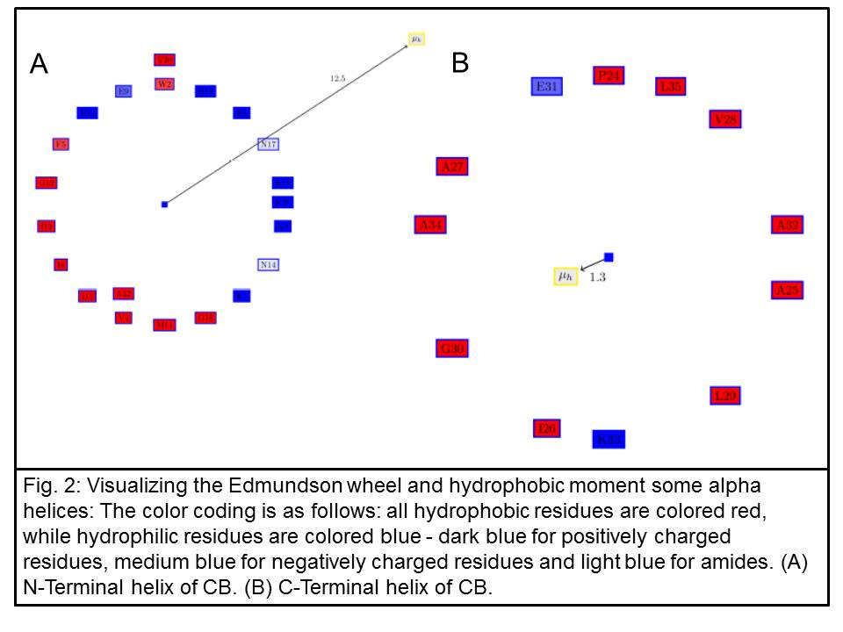
Initially, we used an approach similar to that described above in Activity 1 to identify a replacement component for CB. However, instead of comparing the reactive atoms as was done for the NE matching algorithm, we sought matches for the Cα atoms of the four Lys residues, Lys10, Lys11, Lys16 and Lys29, as the input motif (PDBid:2IGR), allowing Lys to matched by Lys, Arg or His. As indicated in our last report, this strategy revealed several good candidate proteins. We are now focusing on VvHAT52, a 52-amino acid segment of the HAT protein from Vitis vinefera, whose structure matches very well with the CB. However, we have refined our approach and focused instead on the alpha-helical structure itself to generate a greater diversity of replacement candidates for our previously described CAP (Dandekar et al. 2012). To better understand the functionality of the alpha-helical domains of CB, we developed two new computational tools, PAGAL (Chakraborty et al. 2014a) and SCALPEL, to better predict antimicrobial activities in portions of existing proteins. PAGAL (Properties and corresponding graphics of alpha helical structures in proteins) is open source software that implements previously known and established methods for evaluating the properties of alpha-helical structures, providing very useful information on the amphipathicity, hydrophobicity and charge moments within these structures. A key feature of lytic peptides is the distribution of hydrophobic and charged residues on the surface of the protein. To find proteins like cecropin that have an alpha-helical structure, we used PAGAL to evaluate CB. CB contains two alpha helixes (AHs) joined by a short stretch of random coil. The Edmundson wheel and hydrophobic moment of the two AHs show this structure (Fig 2). The N-terminal AH has a large hydrophobic moment and a specific positive charge distribution. This can also be seen in a Pymol rendering of the peptide surface (Fig 3). The Pymol script for this rendering is automatically generated by PAGAL. In contrast, the C-terminal AH of CB has neither of the above two properties.
We then developed the second program, SCALPEL, to search for alpha-helical structures of a particular type. We searched for the smallest peptide with a large hydrophobic moment and a high proportion of positively charged residues on the hydrophilic side. Here, we identified a 20-aa region of the protein PPC from Vitis vinefera, a key enzyme in the C4-photosynthetic carbon cycle from grapevine that we call PPC20 (Fig 4A). We also searched for the smallest peptide with a large hydrophobic moment and a high proportion of negatively charged residues on the hydrophilic side and identified a 15-aa region of isoprene synthase from grapevine that we call ISS15 (Fig 4B). Both of these proteins have a very large hydrophobic moment. A PYMOL rendering shows the highly hydrophobic surface of PPC20 and the positively charged surface, with the exception of a single Asp that is the only negative residue in a positive surface (Fig 5A and B). A PYMOL rendering shows the highly hydrophobic protein surface of ISS15 and the negatively charged surface (Fig 5C and D).
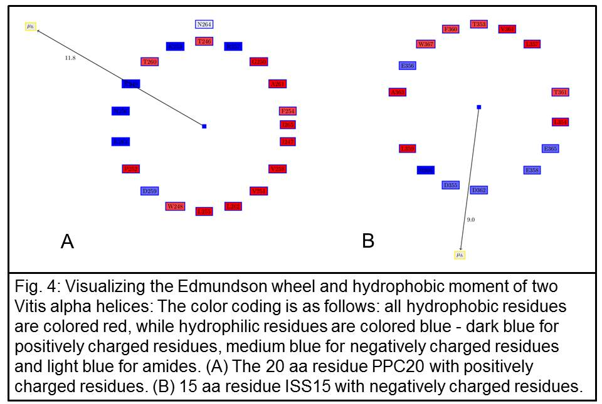

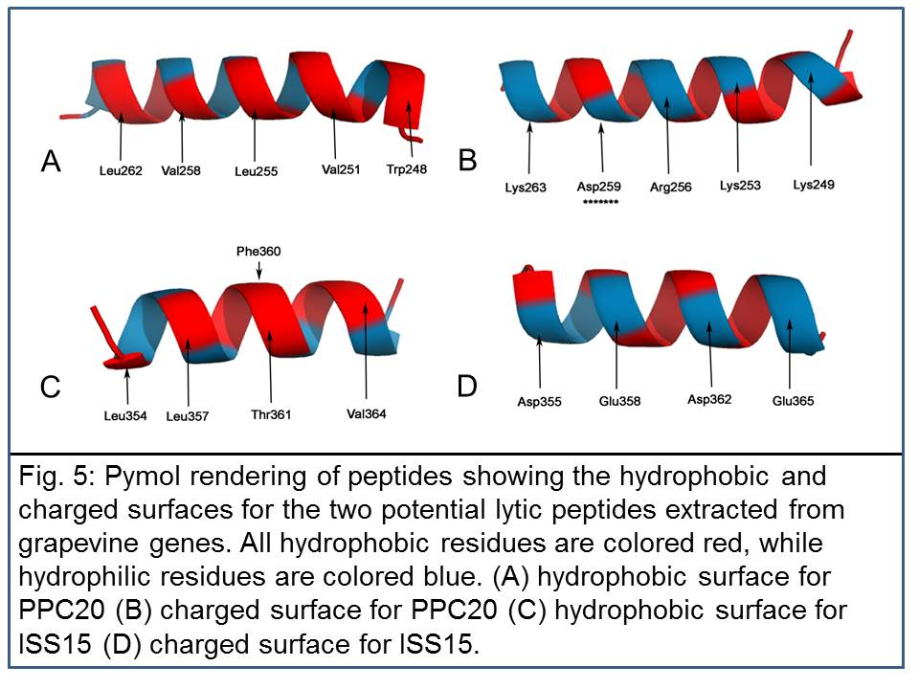
Activity 5: Test synthetic PLD protein for efficacy in killing Xf in culture.

We used our recently developed bioinformatics tools PAGAL and SCALPEL to conduct a phase 1 search and identified three potential grapevine candidate proteins to replace the CecB lytic peptide domain of our previously described chimeric antimicrobial protein (CAP; Dandekar et al. 2012). Using the same tools, we further refined our search within these particular proteins to identify a smaller segment that was then chemically synthesized and tested for antimicrobial activity. The following grapevine proteins were chemically synthesized: a 22-aa version of HAT (VvHAT22; a 52-aa segment of this protein was previously identified), a 15-aa segment of ISS (VvISS15), and 20-aa segment of PPC (VvPPC20). These proteins were successfully tested for antimicrobial activity using to the Temecula strain of Xf and a strain of Xanthomonas arbicola (Xa) that was more sensitive than Xf. Using the same search criteria, the search flagged a 22-aa N-terminal segment of the 34-aa Cecropin B (CBNT22) protein and a 12-aa segment of cathaylecitin (CATH15); these proteins with known antimicrobial activity served as a positive control for our bioassays. VvHAT22 and VvPPC22 inhibited Xf growth at levels comparable to CBNT22 and CATH15; however, VvISS15 displayed no detectable antimicrobial activity.

Table 1: Minimum inhibitory concentration of peptides tested
Indicator Bacteria | CecB | CBNT21 | PPC20 | CHITI25 | ISS15
Xylella fastidiosa | 100 μM | 200 μM | 150 μM | 100μM | >300 μM
Xanthomonas arbicola | 25 μM | 25 μM | 50 μM | 150 μM | >300 μM

We have successfully validated our Vv peptide candidates described above using plating spot assays (Table 1, Fig 6). CecB lytic peptide was used as a control and was the most potent peptide tested, displaying a minimum inhibitory concentration (MIC) of 25μM for Xa and 100μM for Xf. Interestingly, CBNT21 has a slightly lower MIC value, indicating and validating the need for the C-terminal alpha helix of CecB, which is comprised mostly of hydrophobic residues. This result corroborates a plausible mechanism suggested by others in which the anionic membrane of bacteria is targeted by the cationic N-terminal, followed by the insertion of the C-terminal AH into the hydrophobic membrane, creating a pore. PPC20 and CHITI25 have comparable potencies to CECB and CBNT21, although Xa appears to be slightly more resistant to CHITI25. Finally, the anionic peptide used as a negative control shows no effect on any of these pathogens.
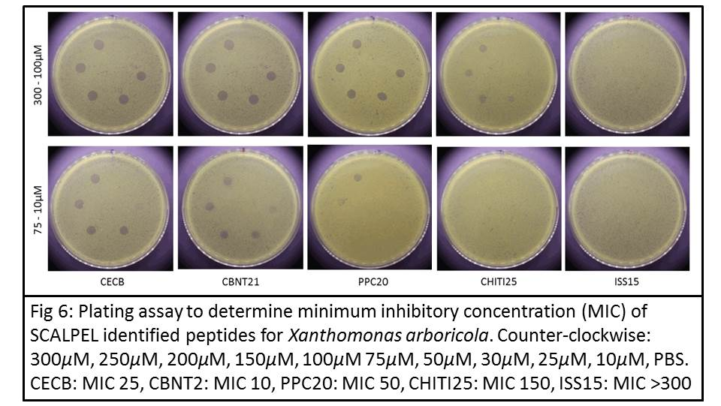

Activity 6: Conduct in planta efficacy testing of the grape-derived CAP components using transient expression.

We have successfully completed construction of all binary vectors for expression of VsP14a, VsP14a-CecB, VsP14a-VvHAT52 and VsP14a-VvPPC20, to test the efficacy of these proteins. We are currently infiltrating tobacco plants to isolate and purify proteins so that their efficacy can be tested as described above (Activity 5).

Objective 3: Construct and test a fully plant-derived CAP (PE-PLD) for the ability to confer resistance to PD in grapevine rootstocks.

Activity 7: Construct a PE-PLD binary vector, transform grapevine and tobacco, and evaluate Xf resistance and PD development.
We have developed four binary vectors (Fig 7) that are currently undergoing plant transformation to create transgenic tobacco and 110-14 grapevine rootstocks. The first two are controls. pDP13.35107.02 is designed to express the P14a protein domain by itself and pDP13.36122.02 will express the P14a domain as a CAP, linking it to the previous lytic domain CB to test whether it enhances lysis of Xf more than P14a by itself. The next two vectors, pDM14.0708.13 and pDM14.0436.03, will express the Vitis-derived CAPs VsP14a-VvHAT52 and VsP14a-VvPPC20. These will be tested for their efficacy against the original CAP NE-CB and against the controls described above.
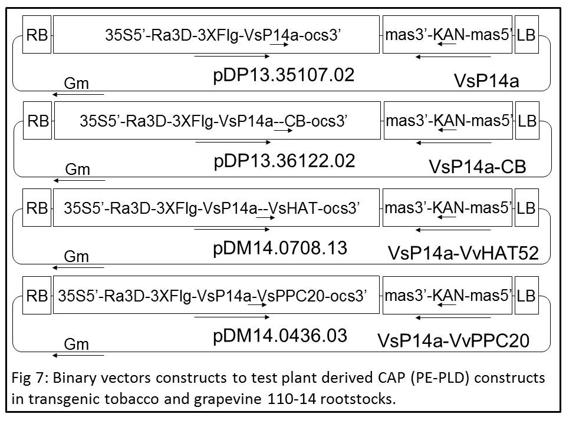
Publications produced and pending, and presentations made that relate to the funded project.
Dandekar, A.M., A.M. Ibanez, H. Gouran, M. Phu, B.J. Rao and S. Chakraborty. 2012. Building the next generation chimeric antimicrobial protein to provide rootstock-mediated resistance to Pierce’s Disease in grapevines. Pierce’s Disease Research Reports, December 2012, pp. 89-93.
Chakraborty, S., R. Minda, L. Salaye, A.M. Dandekar, S.K. Bhattacharjee and B.J. Rao. 2013. Promiscuity-based enzyme selection for rational directed evolution experiments. In Enzyme Engineering: Methods and Protocols. J. Samuelson (ed.), Springer, New York. Methods in Molecular Biology 978:74-78.
Dandekar, A.M., H. Gouran, S. Chakraborty, M. Phu, B.J. Rao and A.M. Ibanez. 2013. Building the next generation chimeric antimicrobial protein to provide rootstock-mediated resistance to Pierce’s Disease in grapevines. Proceedings of the Pierce’s Disease Research Symposium held December 16-18, 2013, in Sacramento, California. pp. 89-94.
Chakraborty, S., B.J. Rao and A.M. Dandekar. 2014a. PAGAL - Properties and corresponding graphics of alpha helical structures in proteins. F1000Res. 3:206 (In Press)
Chakraborty. S., M. Phu, B. Rao, B. Asgeirsson and A. Dandekar. 2014b. The PDB database is a rich source of α-helical anti-microbial peptides to combat disease causing pathogens [v1; ref status: awaiting peer review. F1000Res. 3.
Dandekar, A.M., H. Gouran, S. Chakraborty, M. Phu, B.J. Rao and A.M. Ibanez. 2014. Building the next generation chimeric antimicrobial protein to provide rootstock-mediated resistance to Pierce’s Disease in grapevines. Proceedings of the Pierce’s Disease Research Symposium held December 15-17, 2014, in Sacramento, California. pp. 99-105.
Research relevance statement, indicating how this research will contribute towards finding solutions to Pierce’s disease in California.
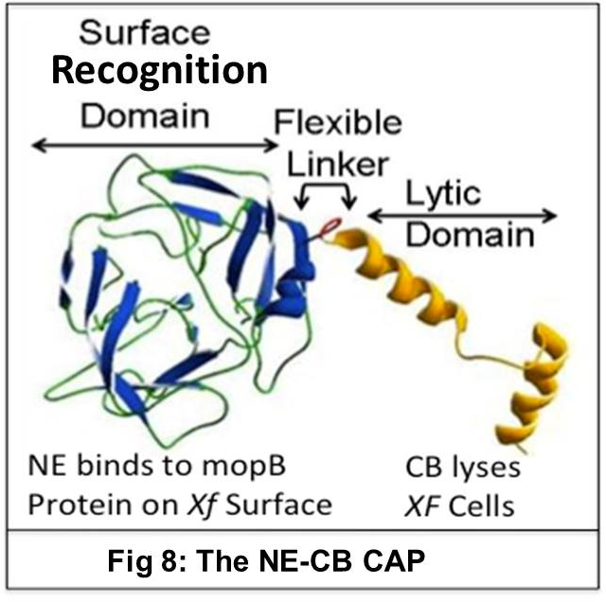
Xf, the causative agent of PD, has a complex lifestyle requiring colonization of plant and insect. Its growth and developmental stages include virulence responses that stimulate its movement in planta and its ability to cause disease in grapevines (Chatterjee et al. 2008). Thus, any control or resistance measure must by necessity be multifaceted to block this pathogen at different stages of its complex lifestyle. A key issue for the industry is the reservoir of bacterial inoculum already present in California that poses an immediate threat in the presence of a significant insect vector like the glassy-winged sharpshooter (GWSS). Chemical pesticides are currently used to suppress the GWSS population, which is effective but does not reduce this reservoir of bacterial inoculum. Resistance mechanisms must be directed to degrade this inoculum and prevent further disease spread. It is critical to know whether any resistance mechanism under consideration can clear Xf and if so, by what mechanism. The resistance mechanism must limit spread and movement of the bacterium in planta and block transmission of the disease by insect vectors. We have previously shown that Xf exposed to xylem fluid from resistant lines expressing NE-CB shows significant mortality (Dandekar et al. 2012). Transgenic grapevine lines expressing the NE-CB chimeric protein show very reduced or no PD symptoms: less xylem blockage and leaf scorching. Currently, some of these lines are being field tested in two locations, one with natural PD pressure due to an abundant supply of GWSS and one without GWSS but field-inoculated with Xf bacteria. In this proposal, we seek to swap the human NE domain and insect CB domains with an equivalent protein from grapevines which we have successfully identified and tested. We will test these by expression in plants to confirm whether these grapevine-derived protein replacements function as effectively as the human- and insect-derived proteins. This addresses concerns about expressing a human- and insect-derived protein in grapevines.

Layperson summary of project accomplishments
We have successfully investigated the replacement of the surface recognition domain (SRD) and lytic domain (LD) of our NE-CB chimeric antimicrobial protein (Fig. 8) with proteins from grapevine using recently described computational tools CLASP (Chakraborty et al. 2011), PAGAL (Chakraborty et al. 2014a) and SCALPEL (Chakraborty et al. 2014b). To replace the human SRD domain NE, we identified the VsP14a protein from grapevine Vitis shuttleworthii based on its structural and conformational similarity to the active site of the human neutrophil elastase (NE domain) (Chakraborty et al. 2013). The pure proteins P14a, HAT22 and PPC20 were tested against Xf cultures and shown to cause lysis of the bacteria. To verify the biological activities of these proteins in planta, we have constructed a gene cassette to express VsP14a by itself and as the CAP constructs VsP14a-CB, VsP14a-HAT52 and VsP14a-VvPPC20 in transgenic tobacco and grapevine rootstock plants. This step has also been accomplished and we were able to make this protein in tobacco.

Status of funds.
All funds for the second year of this project are on track to be spent by June 30, 2015.

Summary and status of intellectual property associated with the project
We have made intellectual property disclosures as UC Case No. 2014-776-1 for “Computational methods developed to identify alpha helical peptides that contain anti-microbial properties encoded in any specified genome. This invention provides the source code, and an example flow for choosing alpha helical anti-microbial peptides from plant genomes”.

Literature cited
Andrès, E., and J.L. Dimarcq. 2007. Cationic antimicrobial peptides: from innate immunity study to drug development. Med. Mal. Infect. 37:194-199.

Chakraborty, S., R. Minda, L. Salaya, S.K. Bhattacharjee and B.J. Rao. 2011. Active site detection by spatial conformity and electrostatic analysis-unravelling a proteolytic function in shrimp alkaline phosphatase. PLoS ONE 6:e28470. Doi:10.1371/journal.pone.0028470.

Chakraborty, S., and B.J. Rao. 2012. A measure of the promiscuity of proteins and characteristics of residues in the vicinity of the catalytic site that regulates promiscuity. PLoS ONE 7:e32011.

Chakraborty, S., R. Minda, L. Salaye, A.M. Dandekar, S.K. Bhattacharjee and B.J. Rao. 2013. Promiscuity-based enzyme selection for rational directed evolution experiments. In Enzyme Engineering: Methods and Protocols. J. Samuelson (ed.), Springer, New York. Methods in Molecular Biology. 978: (In Press).

Chakraborty. S., B.J. Rao and A.M. Dandekar. 2014a. PAGAL - Properties and corresponding graphics of alpha helical structures in proteins. F1000Res. 3:206 (In Press)
Chakraborty, S., M. Phu, B. Rao, B. Asgeirsson and A. Dandekar. 2014b. The PDB database is a rich source of α-helical anti-microbial peptides to combat disease causing pathogens [v1; ref status: awaiting peer review. F1000Res. 3.

Chatterjee, S., R.P.P. Almeida and S.E. Lindow. 2008. Living in two worlds: the plant and insect lifestyles of Xyllela fastidiosa. Ann. Rev. Phytopathol. 46:243-271.

Dandekar, A.M., H. Gouran, A.M. Ibanez, S.L. Uratsu, C.B. Agüero, S. McFarland, Y. Borhani, P.A. Fieldstein, G.E. Bruening, R. Nascimento, L. Goulart, P.E. Pardington, A. Choudhary, M. Norvell, R. Civerolo and Goutam Gupta. 2012. An engineered innate immune defense protects grapevines from Pierce’s Disease. Proc. Nat. Acad. Sci. USA 109:3721-3725.

Kunkel, M., M. Vuyisich, G. Gnanakaran, G.E. Bruening, A.M. Dandekar, E. Civerolo, J.J. Marchalonis and G. Gupta. 2007. Rapid clearance of bacteria and their toxins: Development of therapeutic proteins. Crit. Rev. Immunol. 27:233-245.

Li, Z.T., S.A. Dhekney and D.J. Gray. 2011. PR-1 gene family of grapevine: a uniquely duplicated PR-1 gene from Vitis interspecific hybrid confers high-level resistance to bacterial disease in transgenic tobacco. Plant Cell Rep. 30:1-11.

Sainsbury, F., E.C. Thuenemann and G.P. Lomonossoff. 2009. pEAQ: versatile expression vectors for easy and quick transient expression of heterologous proteins in plants. Plant Biotechnol J. 7:682-693.

