California Department of Food and Agriculture PD/GWSS

Interim Progress Report

July 2015

Report Title: Interim Progress Report for CDFA Agreement Number 14-0137-SA

Project Title: Molecular breeding support for the development of PD resistant winegrapes.

Principal Investigator, Collaborator and Cooperating Staff: M. Andrew Walker (PI), Dario Cantu (Collaborator), Summaira Riaz and Cecilia Agüero. Dept. Viticulture & Enology, University of California, Davis, CA 95616 awalker@ucdavis.edu 530-752-0902

Reporting period: March 2015 to June 2015

INTRODUCTION
Identification, understanding and manipulation of novel sources of resistance are the foundation of a successful breeding program. This project evolved from two previously funded projects: 1) Genetic Mapping – “Genetic mapping of Xylella fastidiosa resistance gene(s) in grape germplasm from the southern United States”; and 2) Functional Characterization – “Molecular and functional characterization of the Xylella fastidiosa resistance gene(s) from b43-17 (V. arizonica)”. Both of these projects supported the PD resistance grape breeding project – “Breeding Pierce’s disease resistant winegrapes”. Genetic markers linked to X. fastidiosa resistance from the former two projects were used to perform marker-assisted selection (MAS) to accelerate our PD resistant winegrape and the table and raisin grape breeding of David Ramming in the past. Outcomes from these projects include BAC libraries of the highly resistant V. arizonica accessions, b43-17 and b40-14. The b43-17 BAC library was used to physically map the PdR1 locus and several candidate genes were identified. Five genes were cloned and constructs were developed to transform tobacco, Chardonnay, Thompson Seedless and St George that are being tested for function.

The new merged project has five key objectives: to identify novel sources of PD resistance for use in broadening genetic base of resistance; to utilize improved sequencing technology to facilitate and accelerate marker discovery and the identification of new and unique resistance genes; to clone and characterize unique DNA sequences (promoters) that regulate the expression of candidate PD resistant grape genes cloned from the PdR1b locus; and to evaluate and compare lines transformed with native and 35S promoters. To broaden the genetic base of PD resistance breeding, we surveyed over 250 accessions of Vitis species growing in the southern US and Mexico to identify new PD resistant accessions. Analysis using population genetics methods allowed us to better understand gene flow among resistant species and their taxonomic and evolutionary relationships. PD resistance in southeastern Vitis spp. seems to be different than the resistance in Vitis from the southwest and Mexico. We have identified new PD resistant accessions that are genetically and phenotypically different, were collected from different geographic locations, and have different maternal inheritance. We are continuously developing and expanding breeding populations from new promising resistant lines. These populations will be tested to study the inheritance of resistance. Then next generation sequencing will be used on the recently identified resistant accessions to expedite marker discovery and confirm that they are unique. Then genetic maps will be developed to identify genomic regions associated with resistance, and genetic markers will be used for the stacking of multiple resistance genes to breed winegrapes with durable PD resistance.

The identification and characterization of resistance genes and their regulatory sequences will help determine the basis of resistance/susceptibility in grape germplasm. In addition, these genes and their promoters can be employed in production of ‘cisgenic’ plants. Cisgenesis is the transformation of a host plant with its own genes and promoters (Holmes et al. 2013). Alternatively, other well characterized vinifera-based promoters; either constitutive (Li et al. 2012) or activated by X. fastidiosa (Gilchrist et al. 2007) could be utilized. Development of V. vinifera plants transformed with grape genes and grape promoters might mitigate concerns about transgenic crops harboring genetic elements derived from different organisms that cannot be crossed by natural means. Proven resistance gene constructs could be transformed into a broad array of elite V. vinifera cultivars.

Objectives
The overall goal of this project is to provide molecular genetic support to the PD resistant winegrape breeding program. These efforts include discovering new sources of PD resistance; identifying functionally unique loci or genes with the help of population genetics and comparative sequence analysis; creating genetic maps with SSR and SNP markers to tag resistance regions; and providing genes and sequences to validate and characterize the function of candidate PD resistance genes. These genes under the control of promoters derived from grape will then be transformed into elite V. vinifera cultivars.

The specific objectives of this project are:
1. Provide genetic marker testing for mapping and breeding populations produced and maintained by the PD resistance breeding program, including characterization of novel forms of resistance.
2. Complete a physical map of the PdR1c region from the b40-14 background and carry out comparative sequence analysis with b43-17 (PdR1a and b).
3. Employ whole genome sequencing (WGS) (50X) of recently identified PD resistant accessions and a susceptible reference accession; use bioinformatics tools to identify resistance genes, perform comparative sequence analysis and develop SNP markers to be used for mapping.
4. Clone PdR1 genes with native promoters.
5. Compare the PD resistance of plants transformed with native vs. heterologous promoters.

Results and discussion

Objective 1. Provide genetic marker testing for mapping and breeding populations produced and maintained by the PD resistance breeding program, including characterization of novel forms of resistance.

We completed a survey of over 250 southwestern US, northern Mexico Vitis, which included accessions collected from multiple collection trips from States bordering Mexico or that were previously acquired from Mexico. Both SSR and chloroplast markers were used to evaluate genetic diversity and establish relationships with known sources of resistance currently being used in the breeding program (Riaz and Walker 2014). A set of 32 SSR and 14 chloroplast markers were added to the data set, and analysis of additional genotypes continues to be added to the previous data set to make it ready for population studies. Genotypes that were added to the project in Fall 2014 are in the process of being tested with greenhouse-based screen for the resistance to PD. The complete results will be presented in the next reporting cycle.

In Spring 2015, we provided molecular support to the companion PD resistance grape breeding project by marker testing a total of 1,237 seedlings from 17 crosses to determine PD resistant and susceptible genotypes. Most of these crosses were crosses designed to stack resistance from b42-26 and PdR1b as well as to develop advanced breeding lines with PdR1c (the b40-14 background).

Table 1 presents the breeding populations that were developed with new resistance sources (For details, see previous reports). In Spring 2015, we completed propagation of 4-5 replicates for the subset of crosses mentioned in Table 1. Plants from rooted green cutting were transferred to 2” pots first and then 4” pots to acclimatize to greenhouse conditions. These plants will be ready for inoculations with Xylella fastidiosa by the end of August and the results of the assay will be available in Fall.

Cross ID | Female Name | Male Name | Seedlings tested
14-360 | F2-35 | DVIT 2236.2 (V. nesbittiana) | 90
14-367 | F2-35 | 12340-13 | 50
14-321 | Rosa Minna | 12305-55 | 28
14-308 | Rosa Minna | 12305-55 | 19
14-364 | Rosa Minna | A28 | 19
14-347 | Rosa Minna | A28 | 23
14-322 | Rosa Minna | 12305-56 | 15
14-313 | A14 | Colombard | 53
14-324 | F2-35 | 12305-56 | 47
14-340 | ANU71 | Grenache blanc | 38
14-303 | C23-94 | Nero d'Avola | 64
14-362 | F2-35 | ANU67 | 31
14-363 | F2-35 | SAZ 7 | 52
14-368 | F2-35 | 12340-14 | 35
14-336 | F2-35 | 12305-83 | 14
Total |  |  | 578

Objective 2. Complete a physical map of the PdR1c region from the b40-14 background and carry out comparative sequence analysis with b43-17 (PdR1a and b).

We have completed a genetic map and identified a major PD resistance locus, PdR1c, on chromosome 14 frmthe V. arizonica b40-14 background (see previous reports for details). PD resistance from b40-14 maps in the same region as PdR1a and PdR1b between flanking markers VVCh14-77 and VVIN64 and within 1.5 cM. The allelic comparison of SSR markers within the 20cM region including the PdR1c locus revealed that PdR1c locus is unique and sequences and genomic features are distinct from those in b43-17 (the sources or PdR1a and PdR1b). A total of 305 seedlings were also tested with markers to identify unique recombinants. We also developed new SSR markers using the b43-17 sequence generated in this study for comparative sequence analysis. Two of the SSR markers, SSR82-1b4 and ORF18-19-3 were tested on the combined set of recombinant plants (Table 2) to tighten the genetic window. We found four recombinants between Ch14-81 and VVIn64 on one side and one recombinant between the Ch14-77 and Ch14-27 markers. With the help of these markers we confined the PdR1c locus to 325 Kb based on the sequence of b43-17.

Table 2. Positioning of genetic markers in relationship to PD resistance in V. arizonica b40-14.
Genotype | 14-29 | 14-27 | VVCh14-77 | SSR82-1b4 | ELISA  Results | ORF18 to 19-3 | 14-81 | VVIn64 | UDV025 | VVIp26
09367-35 | + | + | + | + | R | + | + | + | + | +
09367-37 | + | + | + | + | R | + | + | + | + | +
09367-38 | + | + | + | + | R | + | + | + | + | -
09367-41 | - | - | - | - | S | - | - | - | +
12325-78 | + | + | + | + | R | + | + | + | - | -
12326-18 | + | + | + | + | R | + | + | - | - | -
12327-54 | - | - | - | - | S | - | - | + | + | +
09367-26 | - | - | - | - | S | - | - | + | +
09367-30 | - | - | - | - | S | - | - | + | + | +
09367-07 | - | - | + | + | R | + | + | + | + | +
09367-12 | + | - | - | - | S | - | - | - | - | -
09367-40 | + | + | + | + | R | + | + | + | + | +
09367-43 | + | + | + | + | R | + | + | + | + | +

We developed a BAC library from b40-14 genomic DNA (see details in previous reports). BAC library screening was completed with probes that amplify a single amplicon of 600-650 bp using b40-14 genomic DNA. We identified 30 BAC clones by using two probes, Ch14-56 and Ch14-58. Six clones were positive with both probes. BAC clones that represent PdR1c were separated from the other haplotype based on the SSR markers that are polymorphic for the resistant selection b40-14. At the final stage, we selected two BAC clones VA29E9 and VA57F4 that overlap with each other, and are ~ 200Kb in size. The selected BAC clones were cultured to generate a large amount DNA, and purified DNA was sent to UCI genomics high through put facility for PAC BIO RS II sequencing (see previous report).

We have completed assembly of two BAC clones (Figure 1a). Each clone was assembled separately with anchor markers to assess quality and then assembled together. Both clones provide 192 Kb coverage of the genomic sequence with 160Kb overlap. Comparative sequence analysis to PdR1b region (from b43-17) revealed major differences between the two genetic backgrounds (Figure 1b)
Figure 1a. Assembly of two BAC clones with reference probes. The cumulative length of the assembled contig is 192 Kb. We identified four open reading frames (ORF) of genes, three of them are disease resistance related and one is a protein kinase.
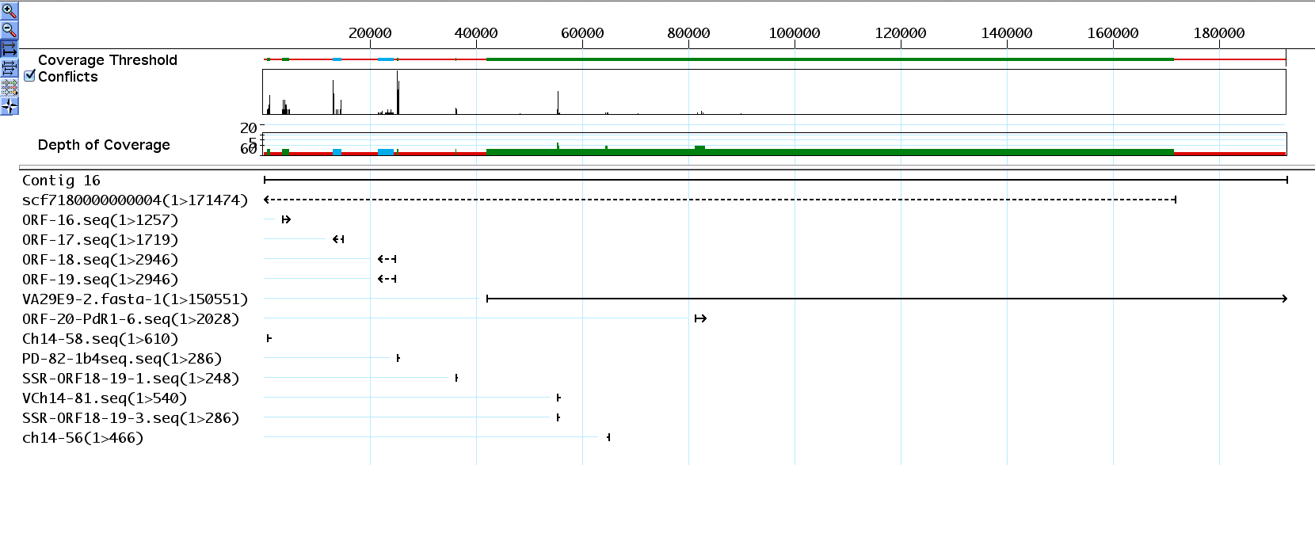

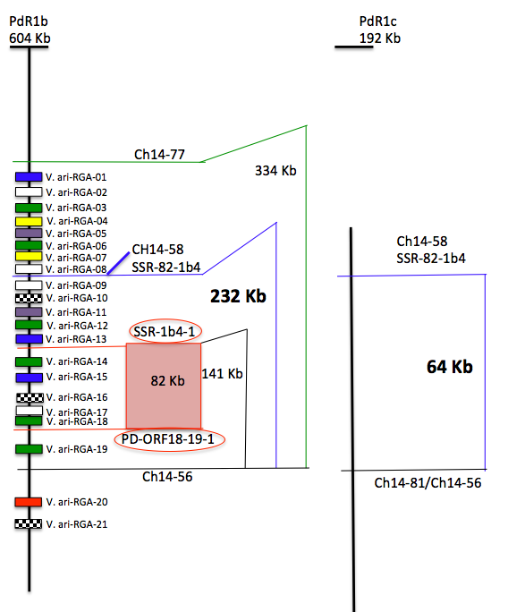
Figure 1b. Comparative sequence analysis of the PdR1b and PdR1c regions. The region between the two probes Ch14-58 and Ch14-56 was ~170 Kb greater in PdR1c with large number of repetitive elements and it is also reflected with the large number of RGA (11) in this region. In PdR1c, we identified a total of only 3 RGA and the sequence between the corresponding probes is only 64 Kb.

In order to expand the region beyond probe 14-58, we selected a third BAC clone that was positive with probe 14-58 and 14-59, isolated and purified the DNA and sent it for sequencing. Sequencing results are expected in August. A third clone would allow us to complement and expand the assembled region and provide confidence that we have not over looked any potential candidate genes that are not represented in the current assembled sequence of PdR1c region.

We also completed assembly of H43-I23 from the b43-17 BAC library that represents the PdR1a haplotype (F8909-17). The length of assembled sequence was 206Kb. Figure 2 provides details of the assembled region. The open reading frames (ORF) of the PdR1b region and the BAC clone H69J14 were used to make comparisons. There was complete homology between the over lapping BAC clone sequences that reflect two different haplotypes. The BAC clone H43I23 has ORF16 to ORF20 and all five ORFs have identical sequences to the PdR1b haplotype (Figure 2). Based on these results, we conclude that there is complete sequence homology between haplotype a, and b of the PdR1 locus; therefore cloning and functional characterization of genes from any one haplotype will be sufficient for future work. Complete sequence homology also reflects that the parents of b43-17 must be closely related and may have a first-degree relationship and acquired resistance from shared parents. This also explains why we observed complete homozygosity of SSR markers for the PdR1 locus in the resistant accession b43-17.

Figure 2. Assemblies of BAC clone reflecting the PdR1a haplotype.

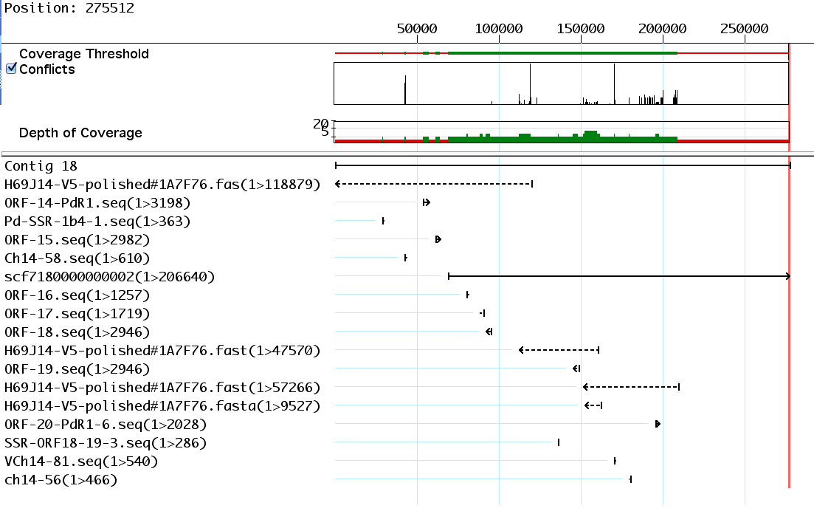

Objective 3. Employ whole genome sequencing (WGS) (50X) of recently identified PD resistant accessions and a susceptible reference accession; use bioinformatics tools to identify resistance genes, perform comparative sequence analysis and develop SNP markers to be used for mapping.

We identified multiple new PD resistant accessions that were used to develop small breeding populations in 2012 and 2013. More crosses were made in 2013 and 2014 to expand existing, and make new, breeding populations (see final report). Our focus is now on two new highly resistant accessions, b46-43 and T03-16. Both have shown very low bacterial levels in repeated greenhouse screens. Resistant accession b46-43 is homozygous resistant to PD. Crosses to develop BC1 populations were made in 2014. We have extracted DNA of the F1 population to test it with markers to ensure all the progeny are from the correct cross. Our approach of traditional bi-parental mapping populations has played an important role in gene discovery and understanding of PD resistance in North American Vitis species, and both bi-parental and multi-parental breeding populations remain the foundation of our breeding program. In this project, we want to combine our traditional SSR marker system with next generation sequencing to carry out SNP discovery and potential SNP markers will be developed. We will pursue the WGS (whole genome sequencing) approach only on those resistant lines for which we have strong greenhouse screen information, heritability of the PD resistance, and potential screening of the population using the limited mapping strategy. The BC1 populations with the b46-43 and T03-16 backgrounds are under testing and will be ready for WGS in Fall 2015.

Objective 4. Cloning of PdR1 genes with native promoters.

We have completed assembly of a 604 Kb region with four BAC clones for the PdR1b haplotype (see previous reports for details). We identified multiple ORFs (open reading frames)of the Leucine-Rich Repeat Receptor Kinase gene family that regulates a wide variety of functions in plants including stem cell maintenance, hormone perception, and defense and wounding response for both host as well as non-host specific defense. With the help of molecular markers, we have limited the genetic region that carries the five ORF to 82 Kb – these ORFs are associated with disease resistance and other plant functions described above. There are multiple ORF’s that are outside this genetic region and have 99% sequence similarity to the candidate genes. We have also acquired binary vectors pCLB1301NH and pCLB2301NK (Feechan et al. 2013) that have been optimized to carry large DNA sequences, thus allowing us to insert candidate genes plus surrounding sequences. Two ORFs V.ari-RGA14 and V.ari-RGA18, within the resistant region boundaries, are the most likely candidates for PdR1b. The other 3 sequences, V.ari-RGA15, 16 and 17 are shorter and contain a large number of transposable elements (TE).

In order to include native promoters and terminators in constructs for future genetic transformations, we have verified sequences upstream and downstream of V.ari-RGA14 and 18, the two most likely PdR1b candidates. Sequence verification for V.ari-RGA14 has been completed up to 3.75 kb in the upstream region and 1 kb in the downstream. We have designed a set of 11 primer pairs that generate overlapping amplified products to verify 6kb upstream and 1.5 Kb downstream genomic sequence of RGA-18 (see detail in previous report). Both RGA14 and 18 are very similar in the sequence profile with the exception that RGA-18 is 2946bp in size and lacks the first 252 bp of sequence that is part of RGA14. Functional analysis of the protein sequence of both RGA revealed that RGA-14 lacks a signal peptide in the initial part of the sequence. This was further verified by using 3’RACE to specifically amplify RNA from grapevines transformed with V.ari-RGA14 under the 35s promoter. The results found that mature mRNA does not contain a signal peptide, necessary for proper membrane localization, at the beginning of the sequence.

We have also initiated a large experiment of resistant and susceptible plants with multiple replicates, and time points for control (mock or un-inoculated) and inoculated plants (see details in previous report). Table 3 details the time points and number of genotypes in the study set

Table 3. List of genotypes that are part of a candidate gene expression study. Stem samples will be collected at 7 time intervals from both mock and Xf inoculated plants for RNA extractions. All plants are maintained in the same greenhouse.
 |  | No. of plants | Day 1 | Day 4 | Day 8 | Day 16 | Day 23 | Day 30 | Day 44
 |  |  |  |  | Week1 | Week2 | Week3 | Week4 | Week6
Inoculated | A de Serres | 28 | 4 | 4 | 4 | 4 | 4 | 4 | 4
 | b43-17 | 28 | 4 | 4 | 4 | 4 | 4 | 4 | 4
 | F8909-08 | 28 | 4 | 4 | 4 | 4 | 4 | 4 | 4
 | F8909-17 | 28 | 4 | 4 | 4 | 4 | 4 | 4 | 4
 | U505-01 | 28 | 4 | 4 | 4 | 4 | 4 | 4 | 4
 | U505-22 | 28 | 4 | 4 | 4 | 4 | 4 | 4 | 4
 | U505-35 | 28 | 4 | 4 | 4 | 4 | 4 | 4 | 4
 | Chardonnay | 28 | 4 | 4 | 4 | 4 | 4 | 4 | 4
Mock | A de Serres | 28 | 4 | 4 | 4 | 4 | 4 | 4 | 4
 | b43-17 | 28 | 4 | 4 | 4 | 4 | 4 | 4 | 4
 | F8909-08 | 28 | 4 | 4 | 4 | 4 | 4 | 4 | 4
 | F8909-17 | 28 | 4 | 4 | 4 | 4 | 4 | 4 | 4
 | U505-01 | 28 | 4 | 4 | 4 | 4 | 4 | 4 | 4
 | U505-22 | 28 | 4 | 4 | 4 | 4 | 4 | 4 | 4
 | U505-35 | 28 | 4 | 4 | 4 | 4 | 4 | 4 | 4
 | Chardonnay | 28 | 4 | 4 | 4 | 4 | 4 | 4 | 4

To date, we have completed RNA extractions from 230 samples in the above-mentioned experiment. We have also designed primers and determined primer efficiency for the gene expressions studies for both RGA14 and RGA18. Two different primer pairs with an efficiency of greater than 90% were selected to carry out preliminary analysis with mock and inoculated samples of Chardonnay and F8909-17. Preliminary results with samples from six time points indicates that the expression level of both RGA14 and RGA18 in F8909-17 increases after day 8 in comparison to mock inoculated, peaks at day 23 and then decreases. Mock and inoculated susceptible Chardonnay did not show any expression. Gene expression analysis will be carried out on complete data sets when we have processed all the RNA samples.

Objective 5. Comparing the PD resistance of plants transformed with native vs. heterologous promoters.

Once the gene constructs are completed, they must be tested to see if they confer resistance. This is done by inserting the genes into a susceptible plant and testing to see if the insertion results in resistant plants. We are using Agrobacterium transformation followed by regeneration of plants from embryogenic callus. We have established cultures of pre-embryogenic callus derived from anthers of V. vinifera Thompson Seedless (TS) and Chardonnay (CH) and the rootstock V. rupestris St. George (SG) (Agüero et al. 2006). We have transformed these varieties with five candidate genes containing the 35S cauliflower mosaic virus promoter, the nopaline synthase terminator and an hptII-selectable marker gene (see previous reports for details). We completed the test of a set of 5 candidate genes. Transgenic plants did not show PD tolerance. However, expression of V.ari-RGA19 and 20 produced some lines with dwarf phenotypes. Results are in accordance with the latest assembly obtained using PAC BIO SRII system and 3 additional overlapping BAC clones. They show that only one of the sequences tested, V.ari-RGA14, lays within the more refined resistance region of 141 kb defined by the two recombinants we recently obtained. We used 3’RACE to specifically amplify RNA from grapevines transformed with V.ari-RGA14. The results showed that mature mRNA does not contain a signal peptide, necessary for proper membrane localization, at the beginning of the sequence.

Defense related genes and over-expression of V.ari-RGA 20.
Figure. 3A) Shoot growth (gray) and expression levels relative to un-transformed CH of V.ari-RGA20 (black). 3B) Expression levels of PAL, LOX and PR1 relative to un-transformed CH in three transgenic lines of CH.

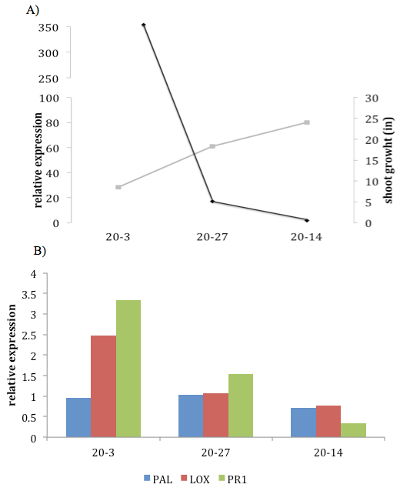
As previously reported, transgenic plants transformed with V.ari-RGA 20 under the control of 35S CaMV promoter exhibited an altered phenotype characterized by stunted growth. Transgene expression levels showed an inverse correlation with shoot growth, with line 20-3 showing highest expression and lowest growth. Although V.ari-RGA 20 has been excluded from the region that contains PdR1b, it codes for a protein with a kinase domain that suggests a possible involvement in PD resistance in combination with PdR1b. Based on the fact that over-expression of a defense-related gene often causes abnormal plant growth, relative expression of defense-related genes PAL, LOX, and PR1 was analyzed in 3 uninfected transgenic lines by qRT-PCR using primer sets selected by Dufour et al. (2013). Expression of PR1, which represents a marker for salicylic acid signaling, was 1.5-3 times higher in lines 20-3 ad 20-27.

CONCLUSIONS and Layperson summary
The development of breeding and mapping populations with the two new PD resistance sources, b46-43 and T03-16, is proceeding. These two accessions support the lowest levels of bacteria of any we have tested. They are geographically isolated from b43-17 and genetically different based on a recent genetic diversity study of over 250 accessions from the southern US and northern Mexico. We have started the screening of F1 and BC1 populations with these two backgrounds. Marker testing and a limited mapping strategy will proceed in Summer 2015. The results from this work will allow us to use markers to facilitate stacking of these resistance sources with PdR1 from b43-17 – the incorporation of multiple resistance should make resistance more durable. We have completed the genetic mapping of PD resistance from b40-14 and named it PdR1c. This resistance source maps within the PdR1b locus, and may be an alternative gene within this complex replicated locus. We are physically mapping this gene to improve our understanding of the locus. Finally, we have been sequencing the PdR1 locus to better define the 2 candidate genes and prepare them for complementation tests. This effort is also identifying their promoters so that we can avoid the use of constitutive non-grape promoters like CaMV 35S. We have tested versions of the PdR1 candidate genes with 35S and they have not worked. We hope that the sequencing efforts we have employed recently to fine-tune these gene candidates and the addition of PdR1’s native promoter will allow one of more of the 2 gene candidates to confer resistance in transformed Chardonnay.

TALKS AT GROWER MEETINGS (EXTENSION/OUTREACH)
Walker grape breeding program. Napa Valley Grape Growers, UC Davis, February 8, 2013.
Grape breeding. Napa Valley Vintners. UC Davis, Feb. 27, 2013.
The vineyard of the future. Wine Executive Program, UC Davis, March 28, 2013.
Breeding PD resistant wine grapes (including new PD rootstocks). Santa Rosa Winegrape Association Meeting, Santa Rosa, CA, April 5, 2013.
Sustainable Viticulture. Haas Business School, DNV Top Tech Program, Mondavi Winery, Oakville, CA, April 20, 2013
Pest and disease threats: Decisions and the future of farming. Napa Valley 2030 – Ahead of the Curve, Napa Valley Grape Growers, Napa, May 7, 2013
Walker grape breeding program. Chilean Winegrowers Meeting, UC Davis, May 7, 2013
Grape Improvement: breeding, genetics, genomics, ‘omics’. International Table Grape Symposium, Ica, Peru June 19, 2013.
Marker-assisted selection to optimize grape breeding. Grape Genetics Research Coordination Network. UC Davis, July 11, 2013.
PD resistant wine tasting. Temecula Wine Association, Temecula, CA, July 17, 2013.
PD resistant wine tasting. Healdsburg/Dry Creek Growers and Wineries, Clos du Bois, Healdsburg, CA, July 31, 2013.
Walker lab grape breeding projects. North American Grape Breeder’s Meeting, Fayetteville, AR, Aug14, 2013
Breeding PD resistant winegrapes and tasting. Napa Valley Wine Expo, November 13, 2013
Breeding PD resistant winegrapes and tasting. Martini / Gallo Winemakers, UC Davis, November 14, 2013
PD resistant winegrapes nearing release. PD/GWSS Board Annual Meeting, Sacramento, CA December 13, 2013
PD resistant winegrapes coming soon. Current Wine and Winegrape Research Conference / Unified Grant Management, UC Davis, February 12. 2014
Breeding resistant grapes. Diageo Central Coast Growers Meeting, Asilomar, CA, July 24, 2014.
Industry show and tell tasting of PD resistant selections at the UCD vineyard. August 28, 2014
Walker grape breeding program. Department Seminar October 3, 2014
Not only do they resist PD, they look like winegrapes, taste like winegrapes, make very good wines, and they are getting ready for release” FPS Annual Meeting November 20, 2014
Not only do they resist PD, they look like winegrapes, taste like winegrapes, make very good wines, and they are getting ready for release”, Current Issues in Vineyard Health, UC Davis, December 2, 2014
Walker breeding program. Gallo Lab Tech Team, UC Davis, December 5, 2014
PD resistant winegrapes nearing release. PD/GWSS Annual Meeting, Sacramento, CA December 16, 2014
Molecular genetics ready to launch a golden age of winegrape breeding. The Conversation. January 7, 2015 https://theconversation.com/molecular-genetics-ready-to-launch-a-golden-age-of-winegrape-breeding-35464
Walker grape breeding program. Flash talk for NGWI, UC Davis, January 26, 2015
Releasing PD resistant winegrapes. Viticulture and Enology Research Conference, UC /Davis February 9
Breeding for powdery mildew resistance using lessons from PD breeding. Napa Valley Grape Growers, March 4, 2015
Tasting of 2014 Vintage PD resistant wines, UC Davis, March 12, 2015
Breeding PD and powdery mildew resistant grapes. Diageo Winemaking Team, UC Davis, April 23, 2015
Breeding new wine varieties ... PD, PM and beyond. PD wine tasting included. Constellation Winery Meeting, Napa, CA April 7, 2015
A Look to the Future. What's in Store for California Vineyards? Anderson Valley Wine Technical Conference, Philo, CA May 15, 2015
Breeding new wine varieties ... PD, PM and beyond. PD wine tasting included. Daniel Roberts Clients Meeting, Santa Rosa, July 10, 2015
Breeding new wine varieties ... PD, PM and beyond. Sonoma County Winegrape Commission, Forestville, CA July 31, 2015
Progress in Developing PD Resistant Winegrapes — Tasting Small Scale Wines. California Alliance of Family Farms, Ramona Valley Winegrape Growers, Valley Center, CA August 7, 2015

PAPERS AND PRESENTATIONS AT SCIENTIFIC MEETINGS
Grape Improvement: breeding, genetics, genomics, ‘omics’. International Table Grape Symposium, Ica, Peru June 19, 2013.
Riaz, S. and Walker, M.A. 2013. Using marker-assisted selection to optimize grape breeding. Grape Research Coordination Network Meeting, UC Davis, Davis, CA, July 11, 2013.
Walker, A. 2013. Walker lab grape breeding. North American Grape Breeders Meeting, Fayetteville, AR, August 15, 2013.
Walker, M.A. 2013. Grape breeding at UC Davis, Seminar at Missouri State University, Springfield, MO, August 10, 2103.
Walker, M.A. 2013. Optimizing grape improvement with molecular tools. University of Missouri, Colombia, MO, August 11, 2013.
Grape breeding at UC Davis. Viticulture and Enology Seminar, UC Davis, Oct. 4, 2013.
Agüero, C., Bistué, C., Riaz, S. and Walker, A. 2013. Molecular characterization of the putative Xylella fastidiosa resistance gene(s) from b43-17 (V. arizonica/candicans). 2013. Pierce’s Disease Research Progress Reports. Sacramento, CA, December 16-18, 2013. http://www.cdfa.ca.gov/pdcp/Research.html
Walker, A., A.C. Tenscher and S. Riaz. 2013. Breeding Pierce’s disease resistant winegrapes. Pierce’s Disease Research Progress Reports. Sacramento, CA, December 16-18, 2013.
Riaz, S., R Hu and M.A. Walker. 2013. Genetic mapping of Xylella fastidiosa resistance gene(s) in grape germplasm from the southern United States. Pierce’s Disease Research Progress Reports. Sacramento, CA, December 16-18, 2013.
Walker, A. 2014. Disease resistance in perennial crops: classical and molecular approaches using grape as an example. International Plant Breeding and Genetics Conference, Campos dos Goytacazes, November 4, 2014
Walker, A. 2014. PD resistant winegrapes nearing release. Pierce’s Disease Research Symposium, Sacramento, CA, December 18.
Walker, A. 2015. Molecular genetics ready to launch a golden age of winegrape breeding. The Conversation. January 7, 2015. (https://theconversation.com/molecular-genetics-ready-to-launch-a-golden-age-of-winegrape-breeding-35464)

ABSTRACTS
Bistue C., Agüero C.B., Riaz S., and Walker M.A. 2013. Testing Vitis arizonica candidate genes for Pierce’s disease resistance in Nicotiana tobacum /SR-1. ASEV 64th National Conference. Monterey, California.
Riaz, S., Tenscher, A., and Walker, M.A. 2013. Phylogeographic analysis of resistance to Pierce’s disease in North American and Mexican species with SSR markers and identification of novel resistance sources. ASEV 64th National Conference. Monterey, California.
Agüero, C. B., S. Riaz, A. Tenscher, X. Xie and M. A. Walker. 2014. Functional analysis of Pierce’s disease resistance genes from Vitis arizonica. 65th ASEV National Meeting, Austin, TX
Riaz, S., R. Hu, A. Tenscher and M. A. Walker. 2014. Comparative sequence analysis of the Pierce’s disease resistance locus PdR1. 65th ASEV National Meeting, Austin, TX
Walker, A. , A. Tenscher and S. Riaz. 2014. Breeding Pierce’s disease resistant winegrapes. Proceedings of the 2014 Pierce’s Disease Research Symposium, Sacramento, Dec. 15-17 pp 220- 226
Walker, A., S. Riaz, and C. Agüero. 2014. Map-based identification and positional cloning of Xylella fastidiosa resistance genes from known sources of Pierce’s disease resistance in grape. Proceedings of the 2014 Pierce’s Disease Research Symposium, Sacramento, Dec. 15-17 pp 227- 239.
Walker, A., C. Agüero, and S. Riaz. 2014. Molecular and functional characterization of the putative Xylella fastidiosa resistance gene(s) from b43-17 (Vitis arizonica). Proceedings of the 2014 Pierce’s Disease Research Symposium, Sacramento, Dec. 15-17 pp 240-248.
Walker, A., D. Cantu and S. Riaz. 2014. Molecular breeding support for the development of Pierce’s disease resistant winegrapes. Proceedings of the 2014 Pierce’s Disease Research Symposium, Sacramento, Dec. 15-17 pp 249 – 255

PUBLICATION
Sun, Q., Y. Sun, M.A. Walker and J.M. Labavitch. 2013. Vascular occlusions in grapevines with Pierce’s disease make disease symptom development worse. Plant Physiology 161:1529-1541.

RESEARCH RELEVANCE
The goal of this research is to understand the genetics of PD resistance and provide genetic support to our PD resistance breeding of wine, table and raisin grapes. We successfully mapped the resistance genes from a form of V. arizonica and used the linked markers to greatly expedite our breeding program. We are now searching for additional forms of PD resistance in other species from a variety of geographic locations across the southern US and Mexico, with the goal of combining resistance from several species together to ensure durable long-lasting resistance.

Status of Funds: The funds are scheduled to be spent by the end of the grant.

Intellectual Property: PD resistant varieties will be released from Innovation Access of the University of California, Davis.

LITERATURE CITED
Agüero CB, Meredith CP, Dandekar AM (2006) Genetic transformation of Vitis vinifera L. cvs. Thompson Seedless and Chardonnay with the pear PGIP and GFP encoding genes. Vitis 45:1-8
Dufour, M. C., Lambert, C., Bouscaut, J., Mérillon, J. M. and Corio-Costet, M. F. (2013), Benzothiadiazole-primed defence responses and enhanced differential expression of defence genes in Vitis vinifera infected with biotrophic pathogens Erysiphe necator and Plasmopara viticola. Plant Pathology, 62: 370–382.
Gilchrist D., and Lincoln J. (2008) Functional testing and characterization of Pierce’s disease-induced promoters from grape. Proceedings of the Pierce's Disease Research Symposium.
Holmes IB, Wendt T, and Holm PB (2013) Intragenesis and cisgenesis as alternatives to transgenic crop development. Plant Biotech. J. 11:395–407
Krivanek, AF and Walker, MA (2005) Vitis resistance to Pierce’s disease is characterized by differential Xylella fastidiosa populations in stems and leaves. Phytopathology 95: 44-52
Li ZT, Kim KH, Jasinski JR, Creech MR, and Gray D. (2012) Large-scale characterization of promoters from grapevine (Vitis spp.) using quantitative anthocyanin and GUS assay systems. Plant Sci. 196:132-142
Riaz, S., A.F. Krivanek, K. Xu and M.A. Walker. 2006. Refined mapping of the Pierce’s disease resistance locus, PdR1, and Sex on an extended genetic linkage map of Vitis rupestris x V. arizonica. Theoretical and Applied Genetics 113:1317-1329.
Riaz, S., A.C. Tenscher, J. Rubin, R. Graziani, S.S. Pao and M.A, Walker. 2008. Fine-scale genetic mapping of two Pierce’s disease resistance loci and a major segregation distortion region on chromosome 14 of grape. Theoretical and Applied Genetics 117:671-681.
Riaz, S., A.C. Tenscher, R. Graziani, A.F. Krivanek, D.W. Ramming and M.A. Walker. 2009. Using marker-assisted selection to breed Pierce’s disease resistant grapes. American Journal of Enology and Viticulture 60:199-207.
Riaz S, Hu R, and Walker MA . 2012. A framework genetic map of Muscadinia rotundifolia. Theoretical and Applied Genetics 125:1195-1210
Riaz, S and M.A. Walker. 2013 Phylogeographic analysis of resistance to Pierce’s Disease in North American and Mexican species. 64th Annual Meeting of the American Society for Enology and Viticulture, Monterey, CA 4.
Walker, A. and A. Tenscher. 2014. Breeding Pierce’s disease resistant winegrapes. Proceedings of the CDFA Pierce’s Disease/Glassy-winged Sharpshooter Board, Sacramento, CA, December 15-17. Pp. 192-199.
Walker, A. and S. Riaz. 2014. Map-based identification and positional cloning of Xylella fastidiosa resistance genes from know sources of Pierce’s disease resistance in grape. Proceedings of the CDFA Pierce’s Disease/Glassy-winged Sharpshooter Board, Sacramento, CA, December 15-17. Pp. 227 – 239.
Walker, A., C. Agüero and S. Riaz. 2014. Molecular and functional characterization of the putative Xylella fastidiosa resistance gene(s) from b43-17 (Vitis arizonica). Proceedings of the CDFA Pierce’s Disease/Glassy-winged Sharpshooter Board, Sacramento, CA, December 15-17. Pp. 240 – 248.
Walker, A., D. Cantu, S. Riaz and C. Agüero. 2014. Molecular breeding support for the development of Pierce’s disease resistant winegrapes. Proceedings of the CDFA Pierce’s Disease/Glassy-winged Sharpshooter Board, Sacramento, CA, December 15-17. Pp. 249 – 255.

