Title of report: Renewal Progress Report for CDFA Agreement Number 15-0217-SA

Title of project: Assessing Pierce’s disease spread in grape lines with novel defensive traits

Principal Investigator:
Rodrigo Almeida
Dept. Environmental Science, Policy and Management
University of California, Berkeley
Berkeley, CA 94720
rodrigoalmeida@berkeley.edu

Cooperators:
M. Andrew Walker Steven Lindow
Dept. Viticulture and Enology Dept. Plant and Microbial Biology
University of California Davis University of California Berkeley
Davis, CA 95616 Berkeley, CA 94720

Reporting Period: The results reported here are from work conducted between July 2015 and January 2016

Introduction
This proposal expands on previous work funded by this program to develop PD-resistant grape lines. Previous projects have successfully developed grapevine lines with promising traits conferring resistance against X. fastidiosa, including plants expressing the rpfF gene, the PdR1 major locus, and the HxfB protein (Meredith et al 2000; Walker and Tenscher 2014; Lindow et al 2014). All these grape lines exhibit low symptom severity when inoculated with X. fastidiosa. We propose to expand upon previous work by testing the potential of PD-defended grapevine lines to reduce the spread of X. fastidiosa using a multi-disciplinary combination of transmission experiments and mathematical modeling. Using this approach and HxfB-producing plants as a case study, we found that while HxfB plants are unlikely to eliminate PD in the field, spread would nonetheless be significantly reduced. Further study will allow us to assess the impacts of these reductions on large-scale and long-term PD spread in resistant grape lines.

Objectives
The overall goal of this project is to assess the potential for novel defensive traits in grapevine lines to reduce the transmission of X. fastidiosa by insect vectors and the prevalence of Pierce’s disease (PD) within and among heterogeneous vineyards. We will assess PD epidemiology in two defended lines: transgenic grapevine lines expressing the rpfF gene (Lindow et al 2014) and conventionally bred grapevine lines with the PdR1 dominant locus (Walker and Tenscher 2014). The research consists of three specific objectives:
- Estimate transmission of Xylella fastidiosa and vector feeding behavior on novel PD-defended grapevine lines.
- Assess large-scale and long-term PD prevalence in defended grapevine vineyards.
- Inform vineyard managers on the efficacy of novel PD defenses.

Objective 1. Estimate transmission of Xylella fastidiosa and vector feeding behavior on novel PD-defended grapevine lines.
We successfully tested if transmission of X. fastidiosa by Graphocephala atropunctata (BGSS) differed between transgenic rpfF grape and wild-type control grapevine plants (cv. ‘Freedom’). Nine weeks after needle-inoculating rpfF and WT plants, we caged two BGSS adults on each plant—one just above the point of inoculation and one ~60 cm above the point of inoculation along the main stem. Both vectors were caged on healthy petioles. The vectors were allowed to acquire for four days and then were placed on test plants (all WT) for four additional days. We cultured X. fastidiosa from source plants and test plants 10 weeks after initial infection. We are currently quantifying X. fastidiosa populations in the experimental vectors using qPCR. We obtained sample sizes of 42 and 37 for vectors caged on rpfF and WT plants, respectively.
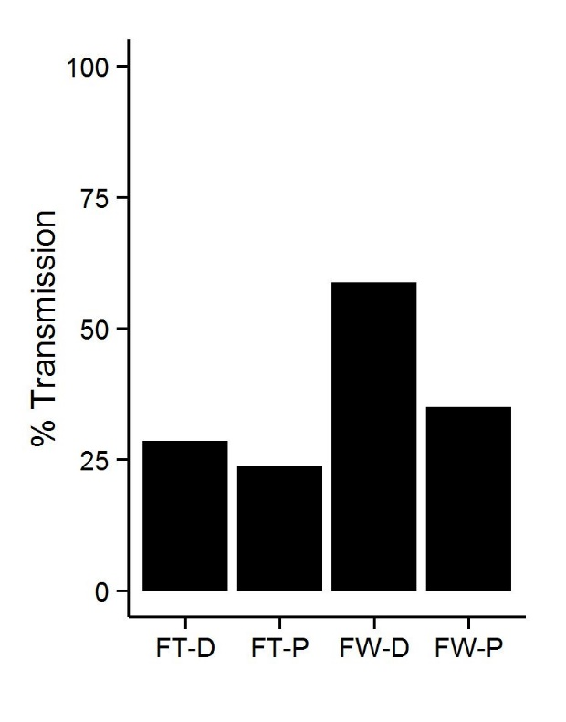
Overall, transmission to test plants was greater when the source plant was WT (Figure 1). However, the difference between genotypes was not statistically different (Z = 0.779, P = 0.436). We found no significant relationship between populations of X. fastidiosa in the source plant and transmission (Z = -1.14, P = 0.151). We also found no significant relationship between distance from inoculation point and the probability of transmission to the test plant (Z = 0.86, P = 0.390). Unexpectedly, we found a trend toward increasing probability of transmission with distance; we had predicted the opposite, with transmission being greater from vectors who had fed closer to point of inoculation (Figure 2).
Figure 2. Probability of transmission from WT (black circles, solid line) and transgenic (green triangles, dashed line) plants, over distance from inoculation point. Points show raw transmission data; fitted lines represent the predicted (i.e., marginal) probability of transmission from a generalized linear mixed-effects model.
Figure 1. Percent transmission of X. fastidiosa from Freedom WT (FW) and Freedom transgenic (FT) plants, depending on if the vector was caged proximally (P) or distally (D) to the point of inoculation.

Objective 2. Assess large-scale and long-term PD prevalence in defended grape vineyards
Our closer study of the biology of X. fastidiosa in rpfF-expressing plants suggests that the spatial distribution of X. fastidiosa within a plant and among plants in a vineyard will be critical for determining transmission and spread. As such, we have begun developing spatially-explicit epidemic models, based on the work described by Webb et al. (2007). While motivated by our work with rpfF plants, such a model could also be valuable for our future work with PdR1 plants. Model development is still in progress.

Objective 3. Inform vineyard managers on the efficacy of novel PD defenses
We will begin work on objective 3 when we have more results from Objectives 1 and 2.

Publications and Presentations
As we are in the early stages of the project, no publications or presentations have been made for our results.

Project Relevance
While plants expressing rpfF and PdR1 genes show great promise for alleviating Pierce’s disease in infected plants, it remains unclear whether these traits reduce the spread of X. fastidiosa within and among vineyards. By investigating the epidemiological effects of these novel defensive traits, we will provide critical information on the efficacy to reduce the spread of X. fastidiosa and the potential role that defended plants could play in integrated disease management. Our work will also provide a general framework through which the efficacy of other novel plant defenses can be assessed.
In addition to the direct significance of our proposed work to PD management, the work will inform fundamental and long-standing questions in the field: (1) What are the epidemiological consequences of different forms of host defense against pathogens? (2) What are the most important components of the X. fastidiosa transmission process for determining the PD prevalence, and does this depend on the dominant vector species? (3) How can plant defense and vector management complement each other to reduce pathogen spread?

Lay Summary
The Pierce’s disease (PD) research community has developed grapevines that exhibit novel and promising defenses against Xylella fastidiosa and have the potential to reduce crop damage from PD. Yet it remains unknown if these novel defensive traits will increase or decrease large-scale spread of PD within and among vineyards, which is a critical dimension of sustainable disease management. We are conducting transmission experiments with important insect vectors of X. fastidiosa and using data from these experiments to explore pathogen spread using mathematical models. We will assess the efficacy of defenses by comparing simulated spread in defended and susceptible vineyards and use these data to inform vineyard managers of how to minimize disease outbreaks across California. So far, our results suggest that the blue-green sharpshooter (Graphocephala atropunctata)—an important insect vector—is capable of acquiring and transmitting X. fastidiosa from transgenic resistant grapevines and conventional susceptible grapevines at similar rates.

Status of Funds
Funds are being used as originally proposed.

Status of Intellectual Property
No intellectual property has been developed as part of this project.

References Cited
Lindow S, Newman K, Chatterjee S, et al (2014) Production of Xylella fastidiosa Diffusible Signal Factor in transgenic grape causes pathogen confusion and reduction in severity of Pierce’s disease. Mol Plant-Microbe Interact 27:244–254. doi: 10.1094/MPMI-07-13-0197-FI

Meredith C, Dandekar A, Kirkpatrick B, Labavitch J (2000) Genetic transformation to improve the Pierce’s disease resistance of existing grape varieties. Proceedings of the 2000 Pierce’s Disease Research Symposium. California Department of Food and Agriculture, Coronado Island, CA, pp 76–77

Walker A, Tenscher AC (2014) Breeding Pierce’s disease resistant winegrapes. Proceedings of the 2014 Pierce’s Disease Research Symposium. California Department of Food and Agriculture, Sacramento, CA, pp 220–226

Webb SD, Keeling MJ, Boots M (2007) Host–parasite interactions between the local and the mean-field: How and when does spatial population structure matter? Journal of Theoretical Biology 249:140–152. doi: 10.1016/j.jtbi.2007.06.013

