**Progress Report for CDFA Agreements 15-0427-SA and 16-0556-SAfp**

**IMPROVING VINE MEALYBUG WINTER AND SPRING CONTROLS:** **I. BIOASSAYS, II. USING HPLC TO FOLLOW INSECTICIDE MOVEMENT IN THE VINE**

|  |  |  |
| --- | --- | --- |
| **Principal Investigator:**  Kent Daane Dept. ESPM  University of California Berkeley, CA 94720-3114 [kdaane@ucanr.edu](mailto:kdaane@ucanr.edu) | Co-Principal Investigator:  Sonet Van Zyl  California State University, Fresno Department of Viticulture and Enology [svanzyl@csufresno.edu](mailto:svanzyl@csufresno.edu) | Co-Principal Investigator:  Monica Cooper  UC Cooperative Extension 1710 Soscol Ave, Suite 4  Napa, CA 94559  [ml](mailto:mlycooper@ucanr.edu)[ycooper@ucanr.edu](mailto:ycooper@ucanr.edu) |
| Cooperator:  Dr. Andreas Westphal Dept. Nematology University of California Riverside, CA 92521 [andreas.westphal@ucr.edu](mailto:andreas.westphal@ucr.edu) | **Post Doctorate Researcher:** Dr. Valeria Hochman Adler Dept. ESPM  University of California Berkeley, CA 94720-3114 [vhochm](mailto:vhochman@ucanr.edu)[an@ucanr.edu](mailto:an@ucanr.edu) | **Staff Researcher:** Geoffrey Dervishian California State University, Fresno Department of Viticulture and Enology [gdervishian@csufresno.edu](mailto:gdervishian@csufresno.edu) |

**REPORTING PERIOD:** The results reported here are from work conducted March 2017- September 2017.

**INTRODUCTION**

The vine mealybug, *Planococcus ficus*, has become one of the most important insect pests of California vineyards, threatening economic production and sustainable practices in this multi-billion-dollar commodity. Insecticides are the primary control tool for vine mealybug (Prabhaker et al. 2012, Daane et al. 2013, Bentley et al. 2014), especially when leafroll diseases (GLDs) are a concern (Daane et al. 2013). Researchers, PCAs and farmers have developed relatively good controls that target exposed vine mealybugs – those on the leaves or canes. However, controlling the more protected mealybug population found under the bark of the trunk or on the roots has been more difficult. The vine mealybug population is primarily on the trunk and upper root zone near the soil line during the winter and early spring (Daane et al. 2013). This population has a refuge from natural enemies (Gutierrez et al. 2008) and can be the most difficult to control even with systemic insecticide applications (Daane, pers. obsrv.). Moreover, mealybugs can remain on even the remnant pieces of vine roots after vineyard removal, hosting pathogens and infesting new vines after replanting the vineyard (Bell et al. 2009).

Insecticides with systemic action are the best materials to control this protected population – but their proper use can vary among vineyards and regions. Moreover, vineyards with mealybug damage typically have large overwintering populations that are never fully regulated, and annually are the source for new generations throughout the summer that infest leaves and fruit of that vineyard and can disperse to other vineyards. Therefore, it is critical to develop better control programs for this overwintering population.

A delayed dormant (typically in February) application of chlorpyrifos (Lorsban®) was the standard post- harvest or pre-season control that targeted mealybugs on the trunk and cordon (Daane et al. 2006). The best in-season insecticide for vine mealybug that move from the trunk and cordon to the leaves, canes and fruit has been an application of Movento® (Bayer Crop Science), with the active ingredient Spirotetramat, which may also help control root feeding nematodes (Mike McKenry, pers. comm.). Still, the effectiveness of any systemic material will depend on application timing, soil moisture, vine condition, age and commodity (for example, post-harvest application timing). Our objectives are to improve controls that target the winter-spring vine mealybug population and to better determine the spring emergence of vine mealybug crawlers to better time foliar applications. Specifically, we are conducting field bioassays to determine the effect of application timing, soil moisture, vine condition and age and commodity (for example, post-harvest application timing, wine *vs*. raisin management practices) on systemic insecticide effectiveness. We plan to work with all vineyard-registered insecticide materials, but this past year’s work has focused on the field application bioassays and movement of Movento® in the vine, timing of Applaud (buprofezin) treatments, and mating disruption.

To follow the movement of Movento® we are collecting vine samples and using an “HPLC” to determine amounts of different metabolites associated with Movento® in different parts of the vine. For example, two of the questions we plan to address is whether Spirotetramat converts to the metabolite Spirotetramat-Enol (which is the primary toxicant) similarly under different vines condition, such as nutrient status or cultivar and where on the vine the metabolites move to and in what concentration are the metabolites found on different vine sections – such as the leaves versus the roots? We will also use our protocols to help confirm the presence of Spirotetramat metabolites in the root system, in support of Dr. Andreas Westphal’s proposal.

**LIST OF OBJECTIVES**

The proposal seeks to develop better controls for the overwintering vine mealybug population found primarily under the bark of the trunk or on the roots at the soil line.

**I: Bioassay**

1) Investigate population dynamics and controls for overwintering vine mealybug.

2) Determine the temperature relationship of vine mealybug and grape mealybug to better predict spring emergence and spray timing.

II: Using HPLC to follow the movement of Movento® in the vine

1) Improve the protocols to determine levels of Spirotetramat and its first metabolite, the enol form, in vine tissue samples.

2) Investigate the dissipation and transformation mechanisms of the active ingredient of the pesticide Movento® after application.

**RESULTS AND DISCUSSION**

**I: Bioassay: Insecticide controls for vine mealybug**

**Movento applied in different regions.** We used bioassays (visual counts of mealybugs) to look at control effectiveness across vineyards in different regions and with different management practices or vine structures. Commercial vineyards were selected in the central San Joaquin Valley (Fresno County) with four vineyard blocks near Fresno (1 Thompson seedless raisin grapes, 1 Crimson seedless table grapes and 2 Thompson seedless table grapes); the Lodi-Woodbridge wine grape region (Stockton county) with three vineyards near Lodi (1 Cabernet Sauvignon, 1 Pinot Noir, 1 Chardonnay); and North Coast wine grape region (Napa County) with two vineyards at a site in the Carneros region of Napa (1 Pinot Noir, 1 Chardonnay). We are also sampling numerous ‘experimental’ vineyard blocks at the Kearney Agricultural Research and Extension Center that represent wine and table grape blocks undergoing studies for nitrogen, irrigation, and wine grape cultivars. At each site, we have counted mealybug densities on the vine, measured cluster damage and taken vine fresh tissue samples before and after Movento® applications (sections from the leaf, cane and trunk) (Photo. 1). Together, the treated vineyards include several factors that could be affecting the pesticide efficiency, such as the age of vineyards, irrigation type, commodity (table, raisin and wine grapes), the presence of a girdle, and geographical area.

|  |  |
| --- | --- |
| Photo. 1: Sampling different vine sections (leaves and petioles, low and high trunk sections, and roots) using both (A) timed (1 minute) visual counts for the bioassay and (B) taking leaf or bark chip samples for HPLC analyses. |  |

The areas of the vine searched change with the seasonal movement of the mealybug population (i.e., during the winter the roots and lower trunk sections are the most likely regions to find vine mealybug). The pre-treatment mealybug density was then used to block treatments against density because vineyard mealybug populations can be clumped. In 2016, the visual count of mealybugs took place from April and October. This allows us to monitor mealybug populations at different phenological stages of the crop. We monitored when the grape clusters were not ready to be harvested, when they were ready to be harvested and after they were harvested.

|  |  |
| --- | --- |
| We applied the insecticide Movento® as a single insecticide treatment at different application timings – as measured by calendar date as well as by weeks before or after harvest (Movento® has a 7-day pre-harvest interval). We applied Movento® at the label rate and determined the percentage kill of mealybugs on different sections of the vine during the summer, fall (completed), and will continue this in the coming spring (Photo 2). | Photo. 2: Applying insecticides |

Results from the studied commercial fields found overall mealybug density to be low, making treatment comparisons difficult throughout all the sampling areas, and spray treatments. Spray treatments did not affect mealybug density or percentage mealybug life stage at any of the vineyard sites sampled in either Napa Valley or the Lodi Woodbridge region (wine grapes). In most of these sites, we found it difficult to make comparisons among bioassay treatments because the levels of mealybugs were too low, including the control treatments.

To account for this we pooled data across all sites sampled in the Central Valley. Using this analysis, we showed that the mid-May and post-harvest (the previous year) application of Movento lowered mealybug numbers more than the control or pre-harvest application (F = 3.816, df = 3,4280, P = 0.009; Fig. 1). These results are similar to previously published results, where April – May is the best time period to apply Movento, our tests of a pre-harvest application did not show any impact the following year.

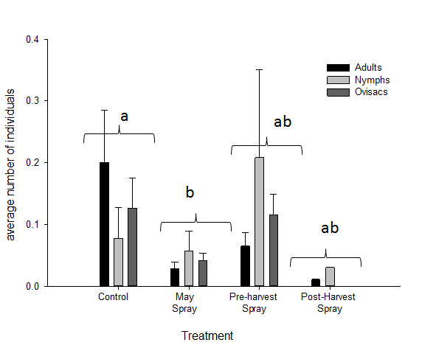

Fig. 1: Average number of nymphs, adults and ovisacs on vines treated in mid- late-May (farmer standard treatment), pre- harvest and post-harvest, and a no-spray control.

We also measured economic damage on five clusters on each vine using a 0–3 scale: 0 means no mealybug damage, 1 means honeydew present but the bunch is salvageable, 2 means honeydew and mealybugs present but at least part of the bunch is salvageable, and 3 means a total loss (Fig. 2). The economic damage of clusters took place from June through harvest in 2016 (we did not take similar measurement in 2017 because of the low mealybug densities).

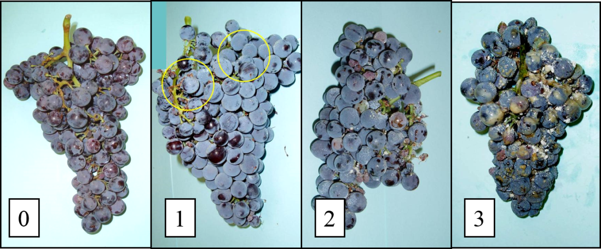

Fig 2. A visual rating of 0 to 3 cluster economic damage for mealybug infestation in the fruit clusters.

Results of cluster damage were similar to those of mealybug density. Data from wine grapes in Napa Valley and Lodi Woodbridge showed no difference among treatments using mid-May, July or pre-harvest Movento applications. However, mealybug densities were too low to make any strong statements. Note that all of the selected vineyards had mealybug populations that were considered to be economically damaging to the vineyard managers when the study began.

There were higher mealybug densities at some sites in the Fresno area, where we found the May application of Movento had less fruit damage compared to untreated, mid-July (pre-harvest) and post-harvest (the previous season) spray treatments (Chi Square = 65,659, *P* < 0.001).

In our two-year field bioassay studies, the low number of mealybugs found at the monitored sites and the low cluster damage recorded was a frustration with these trials. We suspect that the mealybug’s clumped distribution on the host plant necessitated a great number of samples to get an accurate estimate of population response, but there was also a repeated issue of grower overspray on the control plots that we suspect happened at some sites.

**Delayed dormant comparison.** In a second trial, we used a 25-year-old raisin field (*cv*. Thompson Seedless) in the Fresno area, to compare different spring applications with the May application of Movento® (Table 1). Applaud® (buprofezin, Nichino) is an insect growth regulator that is typically applied in season against early stage mealybugs. In this trial we tested Applaud as an alternative delayed-dormant spray to Lorsban-4E (chlorpyrifos, Dow Chemical). The insecticides were applied at different rates and timings (Table 1). Note that the insecticides have different modes of action, such that we expected combinations to provide additive control (Movento is classified in the group 23, Applaud is Group 16, and Lorsban is group 1B, by the Insecticide Resistance Action Committee, IRAC).

A standardized application method was used for each material so that surfactant and application rate would not be an influence. At each site, there were 15 replicates (individual vines) per treatment per vineyard, arranged in a complete randomized design.

Table 1. Schedule of spray treatments investigating novel insecticide combinations for a delayed dormant to spring application to control overwintering mealybugs. In all trials, Movento was applied at the full label rate (for a single application) of 8 oz per acre.

|  |  |
| --- | --- |
| Spray treatment | Insecticide, Application rate, and Application timing |
| 1 | Applaud, 12 fl oz, 1 March 2017 |
| 2 | Applaud, 24 fl oz, 1 March 2017 |
| 3 | Applaud, 12 fl oz, 22 March 2017 |
| 4 | Applaud, 24 fl oz, 22 March 2017 |
| 5 | Applaud, 12 fl oz, 22 March 2017 AND Movento, 4 May 2017 |
| 6 | Applaud, 24 fl oz, 22 March 2017 AND Movento, 4 May 2017 |
| 7 | Movento 8 fl oz, 4 May 2017 |
| 8 | Lorsban 4E, 4 pts, 1 March 2017 |
| 9 | Untreated control |

Results from the delayed dormant spray trial comparing Applaud applied at different times (and with or without a Movento spray in May) with the standard Lorsban delayed dormant treatment significant effect on the numbers of individuals found per vine sample (F = 6.258; df = 8,531; P < 0.001; Fig. 2). There was no difference between Applaud applied at 12 oz as a late dormant (22 March and the control (treatments 3 vs. 8); however, Applaud applied 1 March (treatments 1 and 2) was similar to the Lorsban treatment (8). As described above, Applaud applied just 3 weeks later (22 March) was similar to the control at the 12 oz per acre rate, but lower at the off-label 24 oz rate.

The three Movento treatments had the lowest counts, and the Movento treatments that included Applaud at 24 oz rate as a delayed dormant had the lowest counts (Fig. 2).



Fig. 4: Average number of mealybugs on vines treated different with different pesticides (Table 1) at different rates and at timings (samples were taken during a timed count).

**II. HPLC to follow the movement of systemic insecticides**

Data were presented in the previous report and the latest data has not yet been analyzed.

**III. Temperature development of vine mealybug.**

**Insect and vine cultures.** All experiments were conducted with *P. ficus* obtained from insectary cultures, originally established with mealybugs collected in vineyards located near Sanger, CA (Fresno Co.) and maintained at the University of California Kearney Agricultural Research and Extension Center, near Parlier, CA (Fresno Co.). Mealybugs were reared on butternut squash, *Cucurbita moschata* L., which was cleaned in a 0.5% bleach solution to reduce mold growth, and then triple rinsed. Each squash was inoculated with 5–10 gravid female mealybugs, which resulted in an initial infestation level of 600–1000 mealybugs. Cultures were held at 22 ± 2°C, with 12:12 (L:D) photoperiod.

The grape plants, *Vitis vinifera* L., were 2 yr old Thompson Seedless cv., originally obtained from cuttings from vines at the University of California Kearney Research and Extension Center, near Parlier, CA (Fresno Co.). Cuttings were rooted in 3.8 L pots, filled with a sandy loam soil and watered and fertilized throughout the experiment as needed.

**Temperature-dependent development.** The effect of constant rearing temperatures on *P. ficus* development time was determined at 12, 16.5, 19, 23, 26, 30 and 34°C. Temperature cabinets maintained temperatures at ± 1.5°C, as recorded by HOBO data recorders (Onset, Bourne, MA) placed in each cabinet. There was a light: dark regime of L16: D8, with grow lights used to maintain vine health; humidity was not controlled and ranged between 60–90%. To begin each trial, 7–10 adult *P. ficus* females, which were beginning to produce ovisacs, were placed on each vine, which was then held at 25°C for a 24 h inoculation period. After which, the vines were checked for freshly deposited eggs, still in the ovisac, and the adults and excess eggs were removed. In this manner, each plant was inoculated with 30–120 eggs. Barriers of petroleum jelly were added at the base of the vine to restrict mealybug movement off the vine.

Inoculated plants were then randomly assigned to temperature treatments. Thereafter, plants were checked every 1–2 d for mealybug development and survival. After 2 wk, this period was extended to 3–6 d, depending on the development rate at each temperature. Mealybug density was recorded by the following developmental stages: egg, first instar, second instar, third instar female (pre-oviposition), third instar male (prepupa), adult female (producing an ovisac), male pupae, ovisac with eggs, and adult male (male pupa with an emergence hole).

Towards the end of each generation, adult females were individually numbered for future identification (after the ovisac deposition begins, there is very little movement of adult females) and to record eggs per individual females. For each ovisac, deposited eggs were collected on each observation date and placed in a gelatin capsule, which was then returned to the respective temperature treatment for 30 d or until egg hatch was complete. After this period, egg production and the proportion of hatched eggs were recorded for each female.

**Statistical analyses**. Results are presented as means per temperature treatment (± SEM). Development times were estimated as the number of days spent in each life stage, based on peak densities for each life stage. As will be discussed later, individual development times were not collected because there was too much movement on the vine and the individual mealybugs could not be marked. Mortality rates are the number of individuals entering each development stage divided by the number of individuals dying in each stage. Adult male and female stages were excluded from calculations of the mortality rates as these stages concluded the lifecycle. Fecundity rates are the number of eggs produced per female, captured and isolated at the end of the development period for each tested temperature. Egg viability rates are the number of hatched eggs divided by the total (hatched and unhatched) number of eggs per female. For all analyses, mealybugs lost due to escape or injury were omitted.

**Results - temperature-dependent development.** *Planococcus ficus* completed developed from egg to adult (with ovisac) at temperatures from 16.5–30.0°C, but failed to complete development at the lowest (12°C) or highest (34°C) temperatures tested (Fig. 3). The estimated development times from egg to adult (based on the production of adults with ovisacs) were fit to the nonlinear model. There are a number of nonlinear models commonly used to describe temperature development (reviewed in Roy et al. 2002). We selected the Brière et al. (1999) temperature development rate model, which provided lower, optimal and upper temperature thresholds and is described as:



where *T* is the rearing temperature (°C), *T0* is the lower temperature threshold, *TL* is the lethal (upper) temperature threshold, and *a* and *b* are empirical constants. The optimum temperature (*Topt* ) is calculated as:



where *TL, TO*, *a*, and *b*, obtained from equation (1).

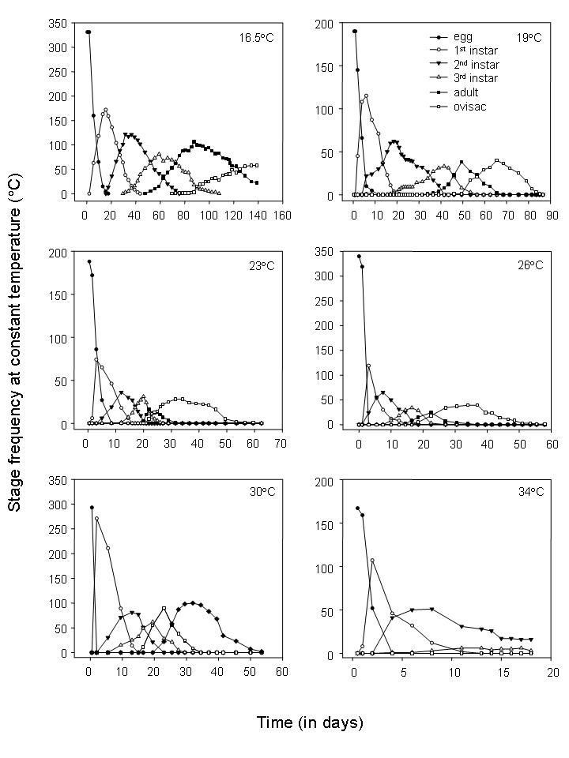

Figure 3. Development for each life stage of *Planococcus ficus* at six constant temperatures.

The low threshold temperature was also determined using simple linear regression (*r(T) = αT+β*) with data from temperature treatments 16.5 – 23°C, which most closely resembles a straight line. The development rate is a linear function of temperature, and *α* and *β* are regression parameters fitted to the data. The low development threshold is calculated as *TL* = -*α*/*β*, and the thermal constant (*k*) from birth to adult, in required degree-days (DD), is calculated as *k* = 1/*β* (Liu and Meng 1999).

Results show development times decreased as temperatures increased (Fig. 3), ranging from about 140 days (at 16.5°C) to about 25 days (at 30°C) (Fig. 4). The estimated lower and upper temperature thresholds for were 14.55 and 35.41°C, respectively, while the optimum developmental temperature was 26.93°C. Using linear regression with mid-range temperatures (19–30°C) a lower temperature threshold of 14.6°C was estimated (y=0.00362x - 0.053; F1,2 = 156.84; *P* < 0.0507; R2 =0.987). The thermal constant is 276.31 degree-days.



Fig. 4. *Planococcus ficus* stage development times at different temperatures. Development time defined as the number of days required for 50% of the population to move beyond a given stage). N1, N2, N3, and A1 refer to first, second, third instar nymphs and pre-reproductive adults, respectively. Most error bars are obscured by symbols. Estimates were not possible for some stages at some temperatures (12, 30, 34°C).

**Reproductive parameters.** The net reproduction rate (*Ro*) was greater than zero at all temperatures that permitted complete development (Table 2), indicating positive population growth. The maximum *Ro* (433.34) for was obtained from data collected at 26°C (Table 2). The lowest estimated *R*o (82.61) occurred at 16.5°C. The female: male ratio of offspring, which impacts *Ro* also varied among temperatures, ranging from 10.25: 1 at 19°C to 5.10: 1 at 16.5°C.

Mean generation times (*T*) values estimated for each of the trialed temperatures decreased with increasing temperatures with a gradual decrease in mean generation time as temperatures increased between 16 and 30°C (Table 2). The shortest generation time (*T*) was also recorded at this temperature. This decrease was more pronounced between 16, 19 and 23°C and reached a plateau between 23 and 30°C. The largest *T*-value was recorded at 16.5°C. These values decreased to 32.19 at 26°C after which there was a slight increase.

Intrinsic rate of natural increase(*rm*) values were positive at temperatures ranging from 16.5 to 30°C, indicating positive population growth. The lowest estimated *rm* value was 0.037 at 16.5°C; the highest was 0.26 at 26°C. At 30°C the *rm* values dropped to 0.195. The fitted model was y = (0.000000161) × x(x-(34.04632)) × ((15.8684)-x) ×exp(1/0.151912)) (*F* 1, 4=41.76; *P* = 0.11; R2 = 0.9864; Fig. 3). Using these *rm* values, the lower, upper, and optimal temperatures for population increase are estimated at 15.87, 34.05 and 26.47°C, respectively.

**Fecundity and egg viability.** Across all temperatures at which ovisacs were produced (16.5–30°C), average life time egg production was 220.8 ± 15.5 eggs per female. Temperature influenced egg production, which ranged from a maximum of 364.4 ± 0.8 eggs per female at 26°C to a minimum of 155.25 ± 0.1 eggs per female at 16.5°C (Table 2). There was a decrease in egg production at lower and higher temperatures, indicated by a good fit (R2 = 0.94) to the Briere et al. (1999) model modified for fecundity (Fig. 4). The lower, upper, and optimal temperatures for egg laying were determined at 11.59, 34.08, and 25.22°C, respectively. Egg viability was highest at 16.5°C, similar between 19 –26°C, and significantly lower at 30°C (Table 4; F4, 2185 = 383.49, *P* < 0.0001).

**Discussion**. We have worked with two entomologists that are very qualified to model data (Dr. Mark Sisterson and Dr. Mathew Daugherty). One aspect of this study that failed was our inability to tract the development time of individual mealybugs. With our design, we expected more uniform development times for each life stage at each of the tested temperatures. We suspect that feeding on different parts of the vine may have added to mixed development times. The end result is that we used the “average’ development based on peak population densities. This produced an informative figure showing life stage development and mortality; however, without being able to produce standard errors around each mean, we cannot complete a statistically accurate development model. For this reason, we have begun a simpler temperature development trial, counting only development from egg to ovisac.

**PUBLICATIONS AND PRESENTATIONS**

**Publications:**

No peer-reviewed publications to report.

Proceedings articles (2016-present).

Hochman Adler, V., Lutz, T. M., Hutchins, J. Cooper, M. L., and Daane, K. M. 2016. Identification and control of vine mealybug, pp. 6-11. In: *Proceedings, San Joaquin Valley Grape Seminar, January, 2016*. University of California Cooperative Extension and Allied Grape Growers. Easton, CA.

Daane, K. M., Hochman Adler, V., Lutz, T. M., Wilson, H., Hutchins, J., Cooper, M. L., Hogg, B. N., Blaisdell, K., Dervishian, G., Van Zyl, S., Kurtural, K., Chen, J., Oh, H., Fonseca-Espinoza, N., Oneto, R., Golino, D., and Almeida, R. 2016. Vine mealybug controls – investigating improvement to current control programs, pp 23-29. In: *Proceedings, Sonoma County Grape Day Seminar*, February 10, 2016. California Table Grape Commission. Fresno, CA.

Daane, K. M., Hochman Adler, V., Lutz, T. M., Wilson, H., Hutchins, J., Cooper, M. L., Hogg, B. N., Blaisdell, K., Dervishian, G., Van Zyl, S., Kurtural, K., Chen, J., Oh, H., Fonseca-Espinoza, N., Oneto, R., Golino, D., and Almeida, R. 2016. Vine mealybug controls – investigating improvement to current control programs, pp 23-29. In: *Proceedings, San Joaquin Valley Table Grape Seminar*, February 17, 2016. California Table Grape Commission. Fresno, CA.

Presentations (2016-present):

K.M. Daane: Identification and control of vine mealybug. *2016 San Joaquin Valley Grape Symposium*. Easton CA. Jan. 2016.

K.M. Daane: Mealybug research – from pesticide movement in the vine to their role as vectors of plant viruses. *Sonoma County Grape Day*. Santa Rosa. CA. Feb. 2016.

K.M. Daane: Vine mealybug controls – investigating improvement to current control programs. *San Joaquin Valley Table Grape Day*. Visalia. CA. Feb. 2016.

K.M. Daane: Update on mealybug controls – what works and what can be improved. Central Coast Wine Grape Seminar. Salinas. CA. Mar. 2016.

K.M. Daane: Improving insecticide controls for mealybugs – following the movement of translaminar insecticides in the vine mall and large bug pests UCCE Seminar: Vineyard Pests and Disease Management. San Luis Obispo, CA, Nov. 2016.

K.M. Daane: Improving vine mealybug winter and spring controls. 2016 Pierce’s Disease Research Symposium. San Diego, CA, Dec. 2016.

K.M. Daane: Mealybug pests in California vineyards – their role in the transmission of plant pathogens and their controls. Unified Wine and Fruit Outreach Day. Walla Walla, WA, Jan. 2017.

K.M. Daane: Using HPLC to follow the movement of a Movento through the vine to improve controls of vineyard mealybug pests. Bayer CropScience Tree Fruit and Vineyard Growers Meeting. Monterey, CA, Jan. 2017.

K.M. Daane: Mealybug controls as an example of the development of an IPM program (1 hr lecture). Integrated Pest Management class at West Hills College. Coalinga, CA. Feb. 2017.

K.M. Daane: Using HPLC to follow the movement of an insecticide through the vine. 65th Annual Lodi- Woodbridge Grape Day. Lodi, CA, Feb. 2017.

K.M. Daane: Insect pest management - grapes. Bayer Crop Science, 2017 Grape and Citrus Symposium. Monterey, CA, Mar. 2017.

K.M. Daane: Control tools for mealybugs and their impact on grape leafroll associated viruses. 2017 E&J Gallo Winery Mealybug, Leafroll and Insecticide Update Meeting. Fresno, CA, Mar. 2017.

K.M. Daane: Vine mealybug controls; using HPLC to follow the movement of a systemic insecticide through vine to optimize application. 101th Annual Meeting, Pacific Branch of the Entomological Society of America. Portland, OR. Apr. 2017. (Poster) (junior author with P Yang – lab employee, currently MSc Oregon State University).

K.M. Daane: Control tools for mealybugs and their impact on grape leafroll associated viruses. 2017 E&J Gallo Winery Mealybug, Leafroll and Insecticide Update Meeting. Lodi, CA, April. 2017 (same talk as #731).

K.M. Daane: Using HPLC to follow the movement of an insecticide through the vine. Spring 2017 Viticulture Program Team Meeting. Parlier, CA, Apr. 2017.

Strategies for managing mealybug vectors of leafroll disease. 2017 Grapevine Virus Meeting. Davis, CA, May 2017.

V. Hochman Adler: Improving vine mealybug winter and spring controls: following insecticide movement in the vine. Viticulture Research Roadshow. San Joaquin Valley Winegrowers Association, Fresno, CA. June. 2017

K.M. Daane: How to increase the presence and impact of mealybug natural enemies. Mealybug Field ID Day. Lodi Winegrape Commission. Lodi, CA, Aug. 2017.

K.M. Daane: Mealybug Pest Control: Issues Faced by Central Valley Growers. University of California, Grape Day 2017. Parlier, CA, Aug. 2017.

K.M. Daane: Organic and sustainable controls for vineyard mealybugs. CAPCA - Sustainable / Organic Production in the Southern San Joaquin Valley. Tulare, CA, Aug. 2017.

K.M. Daane: Best management practices for the monitoring and control of mealybug vectors of grape leafroll virus. Areawide Management of Mealybug Spread of Grapevine Leafroll Disease. Salinas, CA, Oct. 2017.

K.M. Daane: Best management practices for the monitoring and control of mealybug vectors of grape leafroll virus. Sustainable Ag Expo. San Luis Obispo, CA. Nov. 2017.

**RESEARCH RELEVANCE STATEMENT**

The vine mealybug has become one of the more important insect pests of California vineyards, threatening economic production and sustainable practices in this multi-billion-dollar state industry. This work has begun to better understand and optimize registered insecticides used to control the vine mealybug in the winter and spring periods, when the mealybug bug population is located primarily under the bark on the trunk and cordons. In the initial we selected vineyards in three regions and have taken spring through fall samples. We both applied treatments of Movento® and we monitored commercial spray applications in vineyards for different commodities (e.g., wine vs table grape) and with various management practices (e.g., trellis systems). We monitored mealybug densities but found little difference among the plots, in part because of the low mealybug populations. We collected approximately 6000 tissue samples at vineyards being used for the field bioassays, as well as from vineyards with unusual vine mealybug densities, or where we can manipulate spray application to test movement of key metabolites of Movento®. For analyses, we have developed protocols for tissue analysis using an HPLC, and verified that the procedure is accurate.

**LAY PERSON SUMMARY**

The vine mealybug has become one of the most important insect pests of California vineyards. Researchers, PCAs and farmers have developed relatively good controls that target exposed vine mealybugs – those on the leaves or canes. However, controlling the more protected mealybug population found under the bark of the trunk or on the roots has been more difficult. Our objectives are to improve pre- or post-harvest controls that target the winter-spring vine mealybug population and to better determine the spring emergence of vine mealybug crawlers to better time foliar applications. In 2016, research focused on bioassays (e.g., the number of live or dead mealybugs) and movement of Movento® - or more correctly its metabolites - in the vine, using high pressure liquid chromatograph methodology (HPLC).

**STATUS OF FUNDS**

Funds are being spent appropriately and are on schedule – as of September 2017, all funds have been spent on CDFA AGREEMENT 15-0427-SA from the 2015-2017 “field bioassay grant” (this grant should now be closed) and there remains only $45,000 from CDFA AGREEMENT 16-0556-SAFP from the 2016-2018 “HPLC to follow insecticide movement grant.”

**SUMMARY AND STATUS OF INTELLECTUAL PROPERTY ASSOCIATED WITH THE PROJECT**

There is no intellectual property associated with this project.

**LITERATURE CITED**

Bell, V. A., R. G. E. Bonfiglioli, J. T. S. Walker, P. L. Lo, J. F. Mackay, and S. E. McGregor. 2009. Grapevine leafroll associated virus 3 persistence in *Vitis vinifera* remnant roots. J Plant Pathol 91: 527-533.

Bentley, W. J., L. G. Varela, F. Zalom, R. J. Smith, A. H. Purcell, P. A. Phillips, D. R. Haviland, K. M. Daane, and M. C. Battany. 2014. Grape: pest management guidelines. University of California IPM Pest Management Guidelines: Grapes, Insects and Mites Publication 3448.

Briere, J. F., P. Pracros, A. Y. Le Roux, and J. S. Pierre. 1999. A novel rate model of temperature-dependent development for arthropods. Environ Entomol 28: 22-29.

Daane, K. M., W. J. Bentley, V. M. Walton, R. Malakar-Kuenen, J. G. Millar, C. A. Ingels, E. A. Weber, and C. Gispert. 2006. New controls investigated for vine mealybug. Calif Agric 60: 31-38.

Daane, K. M., W. J. Bentley, R. J. Smith, D. R. Haviland, E. Weber, C. Gispert, M. C. Battany, and Millar, J. G. 2013. *Planococcus* mealybugs (Vine mealybug), pp. 246-260. In L. Bettiga (ed.), Grape Pest Management, Publication 3343, 3rd ed. University of California, Division of Agriculture and Natural Resources, Oakland, CA.

Gutierrez, A. P., K. M. Daane, L. Ponti, V. M. Walton, and C. K. Ellis. 2008. Prospective evaluation of the biological control of vine mealybug: refuge effects and climate. J Appl Ecol 45: 524-536.

Prabhaker, N., C. Gispert, and S. J. Castle. 2012. Baseline susceptibility of *Planococcus ficus* (Hemiptera: Pseudococcidae) from California to select insecticides. J Econ Entomol 105: 1392-1400.