I: RNA-interference and control of the glassy-winged sharpshooter (Homalodisca vitripennis) and other leafhopper vectors of Xylella fastidiosa
II: Principal Investigator (PI): Bryce W. Falk, Professor, Department of Plant Pathology, University of California, One Shields Avenue, Davis, CA. 95616, 530-752-0302, bwfalk@ucdavis.edu
Co-Principal Investigator (Co-PI): Cristina Rosa, Postdoctoral Researcher, Department of Plant Pathology, University of California, One Shields Avenue, Davis, CA. 95616, 530-752-5218, crosa@ucdavis.edu
Cooperators:
Dr. Mysore R. Sudarshana, USDA-ARS, Department of Plant Pathology, One Shields Avenue, Davis, CA 95616, mrsudarshana@ucdavis.edu
Dr. Michael P. Parrella, Department of Entomology, Professor and Associate Dean, Department of Entomology, One Shields Avenue, University of California, Davis, CA 95616, 530-752-8473, mpparrella@ucdavis.edu
Dr. Drake Stenger, USDA ARS, 9611 S Riverbend Ave., Parlier, CA 93648-9757, (559) 596-2922, drake.stenger@ars.usda.gov
III: The specific objectives of our effort are:
- To identify RNAi-inducers capable of killing or reducing the survival and/or fecundity of Homalodisca vitripennis (GWSS) and other sharpshooter vectors of X. fastidiosa.
For this effort we utilized in vitro and in vivo delivery systems. We assessed RNAi effects in cultured H. vitripennis cells. We also screened dsRNAs in whole leafhoppers by injection, and we are optimizing dsRNA insect delivery by feeding in vitro.

Rearing H. vitripennis and other Pierce’s disease vectors. Eight colonies of GWSS originated from insects donated to us by Dr. R. Almeida, UCB. GWSS have now been reared continuously for two years at the Contained Research Facility of UC Davis in the BSL-3P area (Fig.1). GWSS colonies were kept in BugDorm tents containing two basil (Ocimum basilicum, L.) and one each of cotton (Gossypium hirsutum, L.) and cowpea (Vigna unguiculata L. Walp.) plants. Clean plants were introduced into BugDorms every 2 to 3 weeks. BugDorms were contained in growth chambers set at 24C, 70% humidity and 16 hours day light.

H. vitripennis cells. The GWSS cell line Z15 used in our experiments was provided by the Dr. Bruce Hammock laboratory (Kamita et al., 2005, GWSS cell line Z15). GWSS cells were reared as described by Kamita et al.

Choice of dsRNA inducers. Fourteen H. vitripennis nucleotide sequences available in GenBank were used to design gene specific primers and to generate cDNAs from GWSS cell line Z15. Corresponding sequences were amplified by RT-PCR, cloned and sequenced to confirm their identity. The lian 2 sequence, a non-LTR retrotransposon, was obtained with degenerate primers based on a GABA-A sequence from Graphocephala atropunctata, the blue-green sharpshooter. These sequences were cloned into the pGMTeasy vector, some of them after adding a T7 RNA polymerase promoter sequence on both ends between two unique restriction sites. Sequences containing the T7 promoter at both ends and linearized vectors were used for RNA polymerase-mediated in vitro transcription to generate specific dsRNAs (Ambion, dsRNA MegaScript).

DsRNAs corresponding to sequences for actin (a contractile protein found in muscle cells), arginine kinase (belonging to the family of phosphotransferases) lian 2 (a non-LTR retrotransposon) and sar1 (belonging to the small GTPase superfamily and SAR1 family, (involved in transport from the endoplasmic reticulum to the Golgi apparatus) were delivered via transfection into GWSS cells, and sar1 and actin dsRNAs were delivered via injection into GWSS insects.

Evaluation of RNAi effects in H. vitripennis cells and whole insects. Realtime RT-PCR primer/probe sets were designed and tested via real time RT-PCR assays of GWSS cell derived RNA (Pignatta et al., 2007). Experiments in GWSS insects were also evaluated by semi-quantitative RT-PCR. Northern blots of small (less than 200 nt) and large (greater than 200 nt) RNA fractions were optimized to assess the levels of corresponding mRNAs in transfected cells, and for the presence of siRNAs, hallmark of gene silencing.

³²P- labeled dsRNA infused in basil. ³²P- labeled dsRNAs were infused into basil cuttings, to follow the intake of dsRNAs, and to ascertain the integrity of dsRNAs in xylem tissues.

Nucleic acid infusion experiments. GWSS nymphs were placed on cotton, cowpea or basil stems infused with nucleic acids (DNA or dsRNA). Plants and nymphs were placed inside a cylindrical cage for two days and then removed, and the stems and sets of nymphs were tested by PCR for the presence of DNA or by real time RT-PCR to quantify the level of the target mRNA. Sets of nymphs were moved into separate cages containing fresh plants, and left them up to 3 weeks to observe their survival.
- To generate transgenic plants capable of expressing Homalodisca vitripennis deleterious interfering RNA molecules within their xylem.
Xylem specific promoter cloning. We chose to clone the xylem-specific promoter, EgCAD2 (Feuillet et al., 1995), as it has been used in several plants for specific activity in the plant xylem (including Arabidopsis, poplar, grapes and tobacco; Lauvergeat et al., 2002). Although most of the xylem tissue is dead, xylem parenchyma cells, primary and differentiating xylem cells are living. These authors suggested that transcriptional activation of this promoter is likely conserved among different higher plant species (Baghdady et al., 2006). We cloned the full length EgCAD2 xylem specific promoter from Eucalyptus gunii into pGEMTeasy, and we subcloned this promoter into the GUS containing plasmid AKK 1431, obtained from Govindarajulu Manjula, (C.G. Tylor lab Donald Danforth Plant Science Center, St. Louis). The EcGAD2-GUS cassette was excised and ligated into the PCB301 binary vector. Agrobacterium tumefaciens EHA105 bacteria were transformed with this plasmid. This was then evaluated in N. benthamiana, cowpea and cotton plants via Agrobacterium tumefaciens mediated transient expression assays. Histochemical GUS expression was evaluated following the protocol as found in Gittins et al. (2000).
Regeneration of transgenic plants. We have not yet begun to develop transgenic plants, however we are close. We will use effective dsRNA sequences identified from Objective 1 and the xylem specific promoter identified in Objective 2 to generate transgenic basil (Ocimum spp.) (Deschamps, C., and Simon, J., 2004) plants expressing dsRNAs, or their corresponding siRNAs, within the plant xylem. We have used basil plants as one of the plant species upon which we are rearing GWSS. Typically our GWSS rearing cages contain a mixture of basil, cowpea and cotton plants. These have worked well for our experiments. Alternatively, we could use cotton as it also exhibits most of the desired properties. We will also generate transgenic plants expressing the same dsRNAs under the control of the 35S promoter. For this effort we will engineer plant transformation constructs and generate transformed plants (via recharge) at the CAES Ralph M. Parsons plant transformation facility (http://ucdptf.ucdavis.edu/index.shtml).
3. To evaluate transgenic plants for their ability to induce RNAi effects vs. Homalodisca vitripennis and other sharpshooter vectors of X. fastidiosa.
Transgenic plants will be regenerated, and T₀ plants will be screened for transgenes, transgene mRNAs, dsRNAs and/or siRNAs as we have done for transgenic Carrizo citrange and N. benthamiana plants (Roy et al., 2006). We anticipate that the transgenic plants will yield dsRNAs because the opposite polarity, complementary sequences in the transgene transcripts will hybridize, giving a hairpin. We will test plants for the predicted full-length dsRNAs, but it seems more likely that dsRNAs will be processed by host responses to give short RNAs (siRNAs). As described in objective 1, we will also test for siRNAs by RNA hybridization. When we find plants that express desired siRNAs, we will carefully use xylem and phloem-enrichment (Zhao et al., 2000) and isolate RNAs to determine if expression is xylem-associated. Because we will generate transgenic plants using plasmids containing both the 35S promoter and the xylem-specific promoter, we can compare the tissue patterns of siRNA presence/accumulation, and use both types of plants for experiments described in objective 3. Insects then will be reared on the transgenic plants and evaluated for their phenotype (i.e. life span, macroscopic features) and for the accumulation of target mRNA via Real time RT-PCR and Northern blot, as described in Objective 1.
IV. SUMMARY OF MAJOR RESEARCH ACCOMPLISHMENTS AND RESULTS

Objective 1: RNAi in H. vitripennis and insects.
We found that RNAi effects could be induced in GWSS cells and whole insects after delivery of dsRNAs and siRNAs. This was shown by three methods: Real time RT-PCR, semiquantitative RT-PCR and Northern blot hybridization analysis. RNAi activity also was evident as shown by the reduction of target mRNAs in GWSS cells and insects, and by the appearance of siRNAs in cells (Fig. 2). The onset of RNAi was easily seen 72 hours post-transfection (hpt) or 72 hours post-injection (hpi). Both dsRNAs and siRNAs were effective triggers for RNAi, but the most effective RNAi inducer in cells in terms of reduction of target RNA was the actin dsRNA (see last years report).

We also demonstrated that double-stranded DNAs can be delivered to GWSS (and most likely other sharpshooters), by feeding them on stem cuttings immersed in a solution of the test DNA (Fig. 3). Furthermore, we showed that dsRNAs can be taken up by cuttings in a similar fashion, and it accumulates within the cuttings without evident degradation. Preliminary experiments on uptake of dsRNAs via feeding by GWSS nymphs, suggested that target mRNAs were reduced in insects and some dsRNA treatments shortened the insect life span. However, these were in initial experiments, more work using greater numbers of insects has to be done to confirm these results.

Objective 2: Xylem specific promoter cloning.
We used specific primers and PCR to amplify nucleotide sequences corresponding to the Eucalyptus gunnii xylem specific promoter, EgCAD2 (Feuillet et al., 1995). We collected leaf material from E. gunnii growing in the U. C. Davis arboretum. The EgCAD2 sequence was confirmed and the corresponding DNA was cloned into the PCB301 binary vector. The resulting plasmid was transformed into A. tumefaciens and used in transient assays on leaves of N. benthamiana plants to assess GUS activity. GUS expression driven by the xylem specific promoter was evident in leaves of N. benthamiana plants following agroinfiltration. Most of the GUS activity appeared to be restricted to the main vascular tissues (Fig. 4). This suggests that the EgCAD2 sequence is an active promoter. We are now subcloning cDNAs corresponding to the GWSS actin sequences described above (Objective 1) into the binary vector pCB301. These have been engineered such that, upon transcription, they will yield hairpin, double-stranded RNAs, similar to our previous work with Citrus tristeza virus (Roy et al., 2006). We will evaluate these constructs in transgenic basil plants during the upcoming year.

V. PUBLICATIONS OR REPORTS RESULTING FROM THE PROJECT

We are in process of preparing our first manuscript on our work from this effort. Our tentative title is: “RNA-interference in glassy-winged sharpshooter cells and whole insects, or, how to save grapevines and citrus from an insect vector of bacterial plant pathogens using a genetic (RNA based) insecticide.” We hope to submit this manuscript to the online journal, PLoS One.

VI. PRESENTATIONS ON RESEARCH

We gave three oral and one poster presentation of our work during this past year. These include a post and oral presentation at the PD-GWSS annual meeting in San Diego in December 2008. In addition, Dr. Rosa gave an oral presentation at the UC Davis Department of Plant Pathology annual retreat in September 2008, and B. Falk gave an oral presentation at the Lodi/woodbridge Winegrape Commission and Lodi District Grape Growers Association meeting on March 10, 2009.

VII. RESEARCH RELEVANCE STATEMENT

The objectives of our research effort are to investigate and develop new and effective, environmentally sound strategies for controlling the GWSS and other leafhopper vectors of X. fastidiosa. Our goal is to develop strategies that are effective and will provide control for PD of grapes, but also have flexibility for use in other important California crops. Of relevance to this proposal is that RNAi offers opportunities for targeting H. vitripennis via RNAi-based disruption of essential GWSS genes, thereby resulting in insect deleterious effects. Our work is relevant to the research recommendations of the PD/GWSS Scientific Summit and the National Academies’ National Research Council’s report including Categories 1 & 2 of the NAS PD research recommendations, specifically under recommendations 3.3, 3.5, 4.5 and 5.1.

VIII. LAY SUMMARY OF CURRENT YEAR'S RESULTS

We have demonstrated RNA interference (RNAi) effects in glassy-winged sharpshooter (GWSS) cells and whole insects after delivery of GWSS-specific dsRNAs, and other RNAi inducer molecules. We have determined that GWSS cells can be used to very rapidly and efficiently screen candidate gene silencing targets. For any RNAi strategy to have practical potential, it must be applicable to whole insects and not just knock down gene activity, but induce a negative phenotype. Therefore, we also investigated specific RNAi inducers in whole GWSS insects after delivery via intra-thoracic injection, and we evaluated an approach to give oral delivery. Intra-throacic injection showed that RNAi effects, as measured by target RNA levels, were induced in whole insects. We also were able to deliver double-stranded DNAs (dsDNAs, non RNAi inducers) by a simple cut stem infusion method. We then determined that dsRNAs (RNAi inducers) also can be taken up and transported in the xylem and we performed preliminary studies on whole GWSS by allowing them to feed on these plants. In the long term for RNAi to be successful we must have a way to deliver interfering RNAs into the plant xylem and thus have the “genetic insecticide” in position for uptake by xylem feeding sharpshooter vectors. To accomplish this we have constructed a xylem-specific promoter from Eucalyptus gunnii (cider gum). We are currently working to determine if this will be suitable for delivering interfering RNAs in plant xylem tissues. This study provides the evidence that RNAi might be useful as part of the overall strategy to control X. fastidiosa leafhopper species and to break the cycle between bacterial diseases and their hosts. Future work includes the identification of suitable RNAi targets, the production of transgenic plants expressing dsRNAs in their xylem and the study of the fate of ds/siRNA delivery in insects after feeding.

IX. STATUS OF FUNDS

We requested three years funding to support one postdoctoral scientist (Co-PI Rosa), a graduate student, an undergraduate intern, plus funds for standard benefits. We also requested funds for routine supplies, recharge facility recharge costs and limited travel. We were awarded two years of funding including $119,677 and $122,574 for years one and two, respectively. We are on track, spending wise, to use these funds as proposed in our original proposal budget.

X. SUMMARY AND STATUS OF INTELLECTUAL PROPERTY PRODUCED DURING THIS RESEARCH PROJECT

We will work with UC for managing any intellectual property or technologies that may arise from this effort. We submitted an overview of our work for evaluation by the UC Davis Technology Transfer team, they declined to pursue it at this time.
Funding agency: UC
References

Baghdady, A., Blervacq, A. –S., Jouanin, L., Grima-Pettenati, J., Sivadon, P., and Hawkins, S. 2006. Eucalyptus gunii CCR and CAD2 promoters are active in lignifying cells during primary and secondary xylem formation in Arabidopsis thaliana. Plant Physiology and Biochem. 44: 674 – 683.

Deschamps, C., and Simon, J. 2004. Agrobacterium tumefaciens-mediated transformation of Ocimum basiclicum and O. citriodorum. Plant Cell Reports 21:359 – 364.

Feuillett, C., Lauvergeat, V., Deswarte, C., Pilate, G., Boudet, A., and Grima-Pettenati, J. 1995. Tissue- and cell-specific expression of a cinnamyl alcohol dehydrogenase promoter in transgenic poplar plants. Plant Molecular Biol. 27: 651 – 667.

Gittins, J. R., Pellny, T. K., Hiles, E. R., Rosa, C., Biricolti, S., James, D. J. 2000. Transgene expression driven by heterologous ribulose-1, 5-bisphosphate carboxylase/oxygenase small-subunit gene promoters in the vegetative tissues of apple (Malus pumila mill.). Planta 210 (10): 232-240.

Kamita, S. G., Do, Z. N., Samra, A. I., Hagler, J. R. and Hammock, B. D. 2005. Characterization of cell lines developed from the glassy-winged sharpshooter, Homalodisca coagulata (Hemiptera: cicadellidae). In Vitro Cellular and Developmental Biology – Animals. 41: 149 – 153.

Lauvereat, V., Rech, P., Jauneau, A., Guez, C., Coutos-Thevenot, P., and Grima-Pettenati, J. 2002. The vascular expression pattern directed by the Eucalyptus gunnii cinnamyl alcohol dehydrogenase EgCAD2 promoter is conserved among woody and herbaceous plant species. Plant Molecular Biol. 50: 497 – 509.

Pignatta, D., Kumar, P., Turina, M., Dandekar, A. M., and Falk, B. W. 2007. Quantitative analysis of efficient endogenous gene silencing in Nicotiana benthamiana plants using Tomato bushy stunt virus vectors that retain the capsid protein gene. Molec. Plant Micorbe Interac. 20: 609 – 618.

Roy, G., Sudarshana, M. R., Ullman, D. E., Ding, S. W., Dandekar, A. M., and Falk, B. W. 2006. Chimeric cDNA sequences from Citrus tristeza virus confer RNA silencing-mediated resistance in transgenic Nicotiana benthamiana plants. Phytopathology 96: 819 – 827.

Zhao, C., Johnson, B. J., Kositsup, B., and Beers, E. P. 2000. Exploiting secondary growth in Arabidopsis: Construction of xylem and bark cDNA libraries and cloning of three xylem endopeptidases. Plant Physiol, 123: 1185-1196.

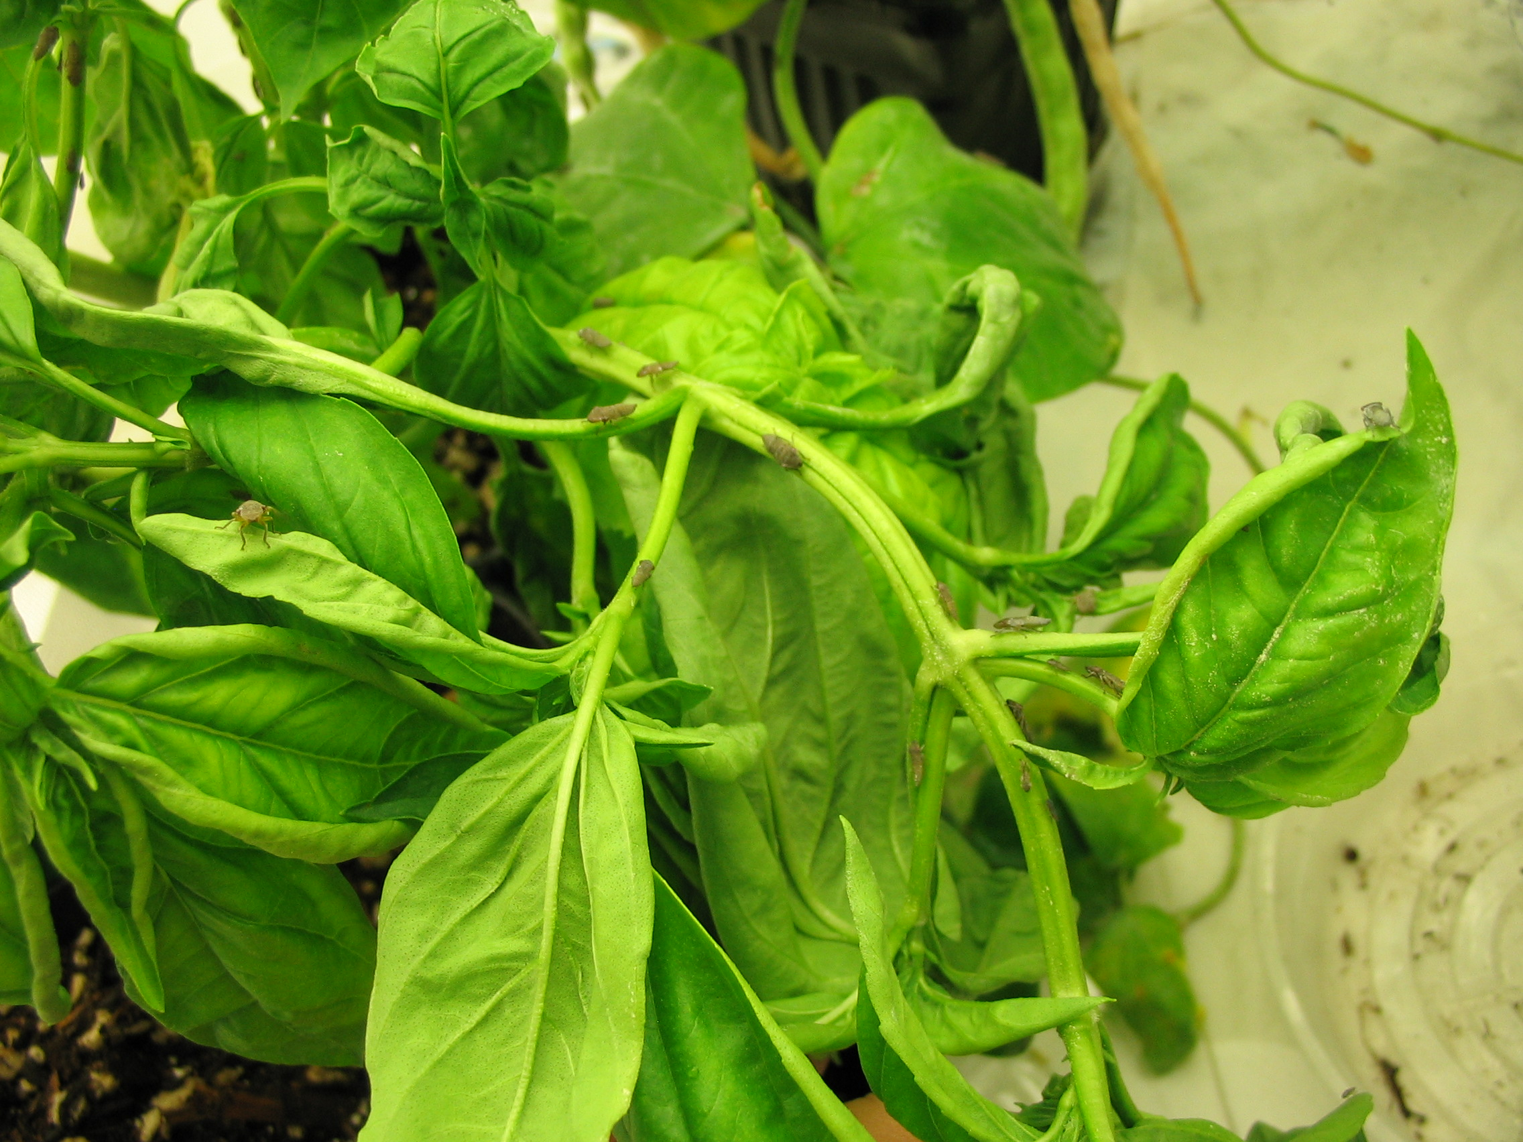
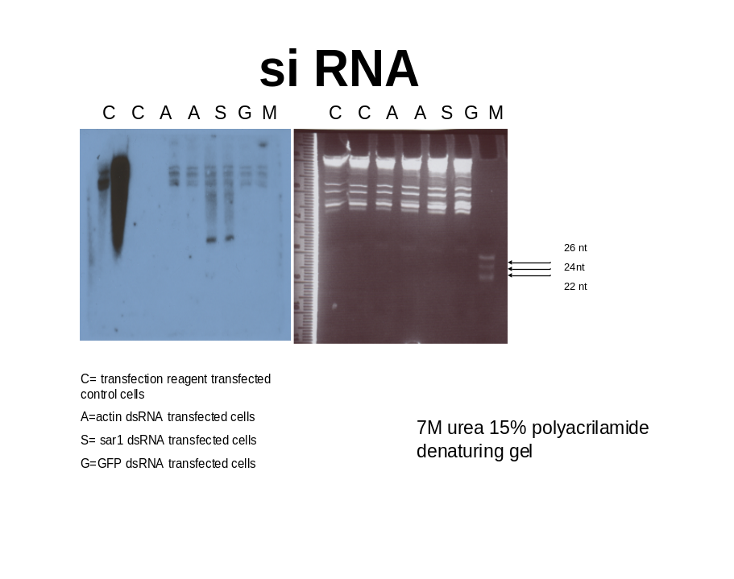
Fig 1. Picture of basil plant in BugDorm insect cage. Cages harbor GWSS colonies with nonsynchronized generations.

Figure 2. Actin dsRNA promotes actin small RNAs accumulation. Northern blot analysis of GWSS cell small RNAs. Cells were transfected with C transfection reagent, A actin dsRNA, S sar1 dsRNA , G GFP dsRNA and harvested 72 hpt. Large and small RNA fractions were extracted (Ambion PARIS) and 1 ug of the small fractions were electrophoresed on a 7M urea 15% polyacrylamide gel, and the gel was stained with ethidium bromide (right panel). RNA was transferred to a positively charged nylon membrane (GE) and UV crosslinked. The membrane was hybridized following standard procedure (Ambion). Negative sense actin RNA was radio-labeled, carbonated and used as probe. Si RNAs were visisble in actin dsRNA treated cells (A) and not in the controls (C, S and G) (left panel).

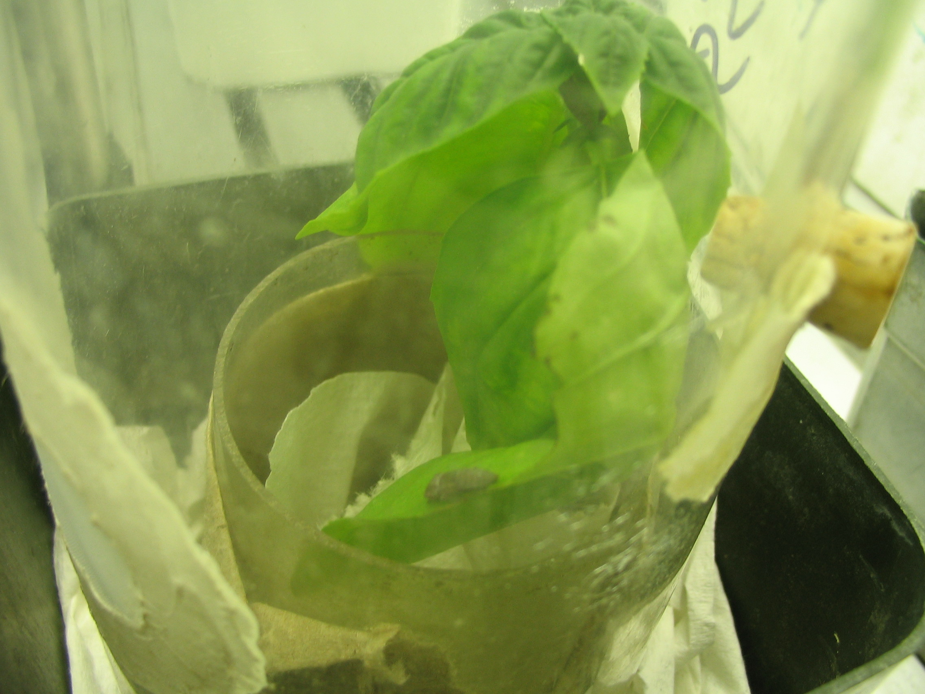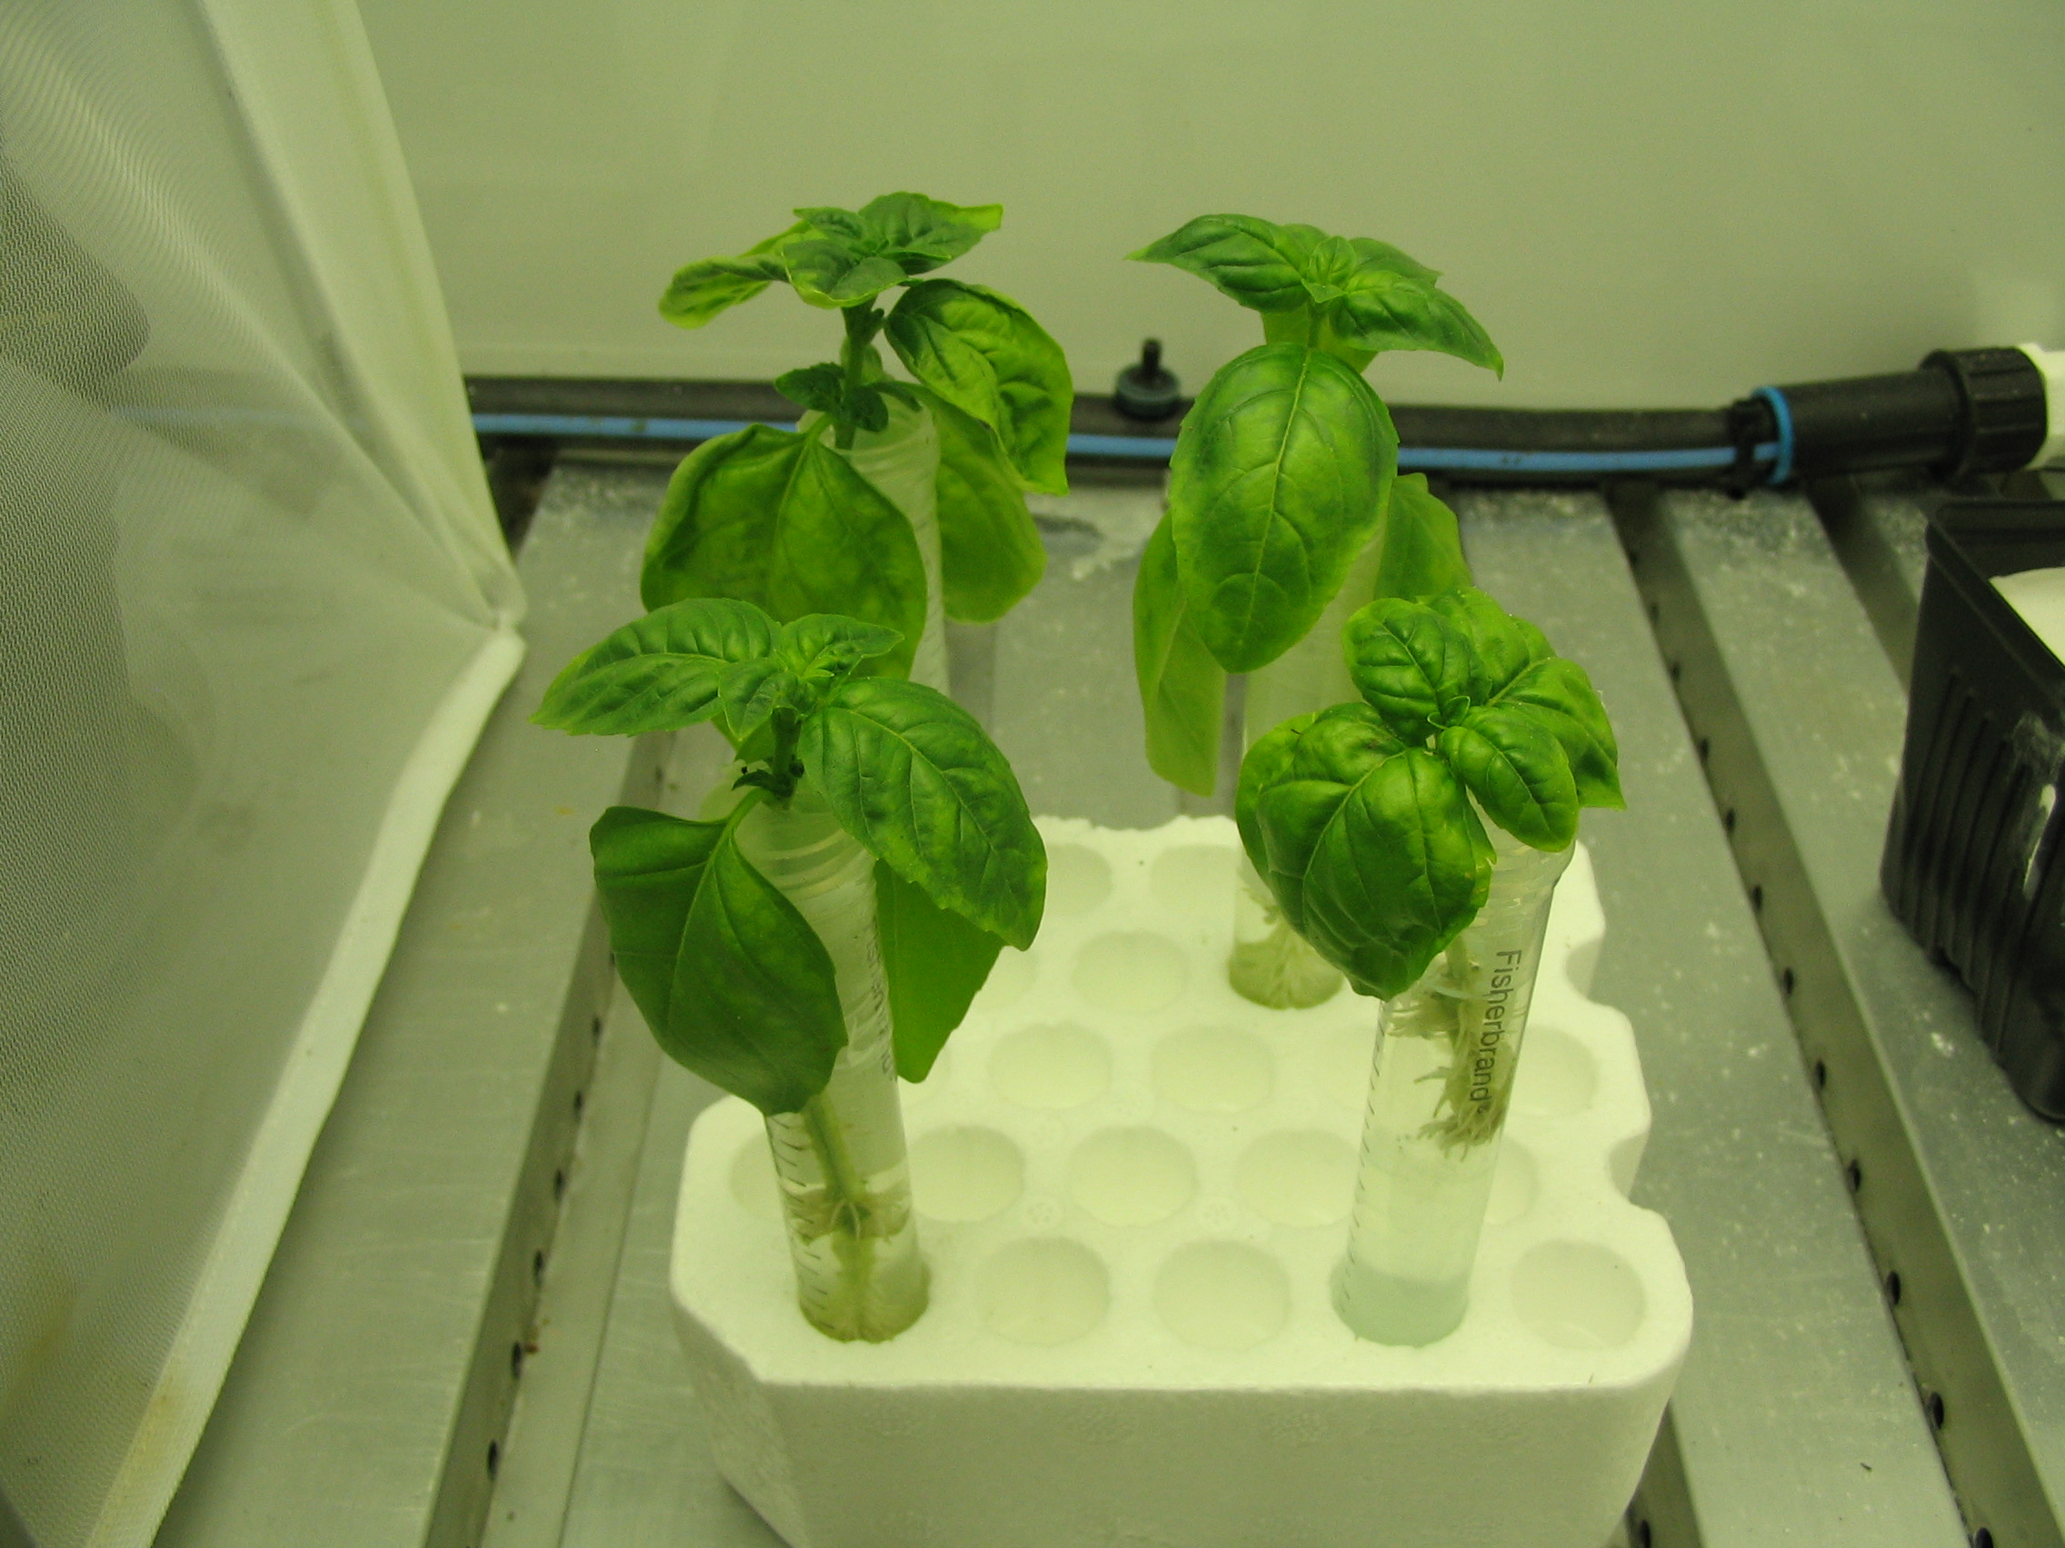
Fig 3. GWSS nymphs (in circle) were fed on young basil and/or cotton plants infused with solutions of exogenous dsDNA or dsRNAs for 48 hours. Plants and insects were tested by PCR for DNA presence and results are shown below.

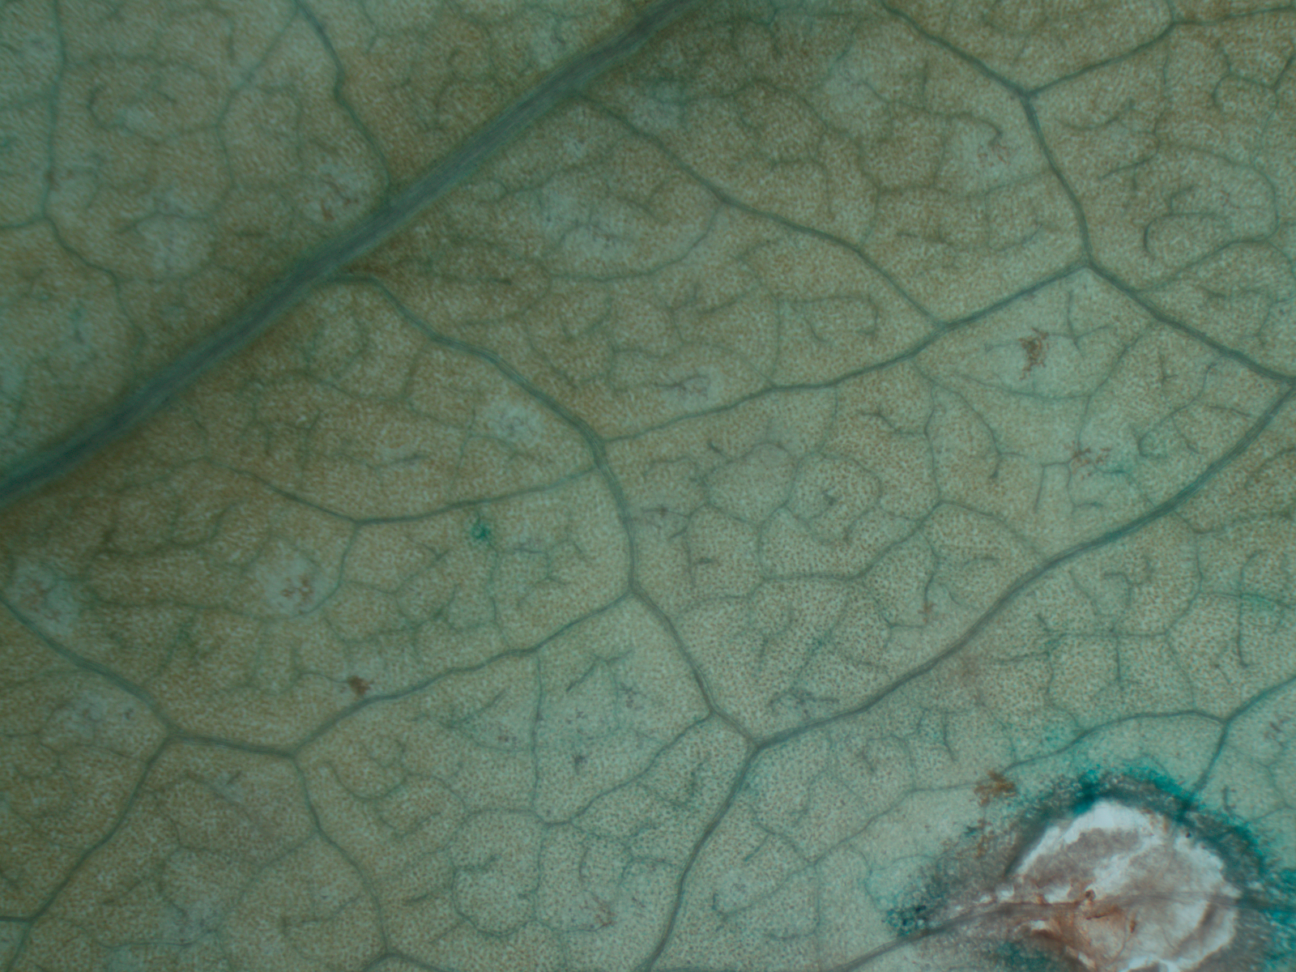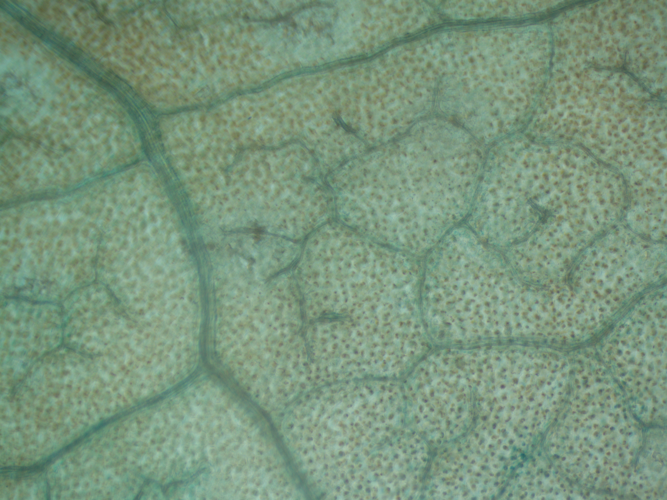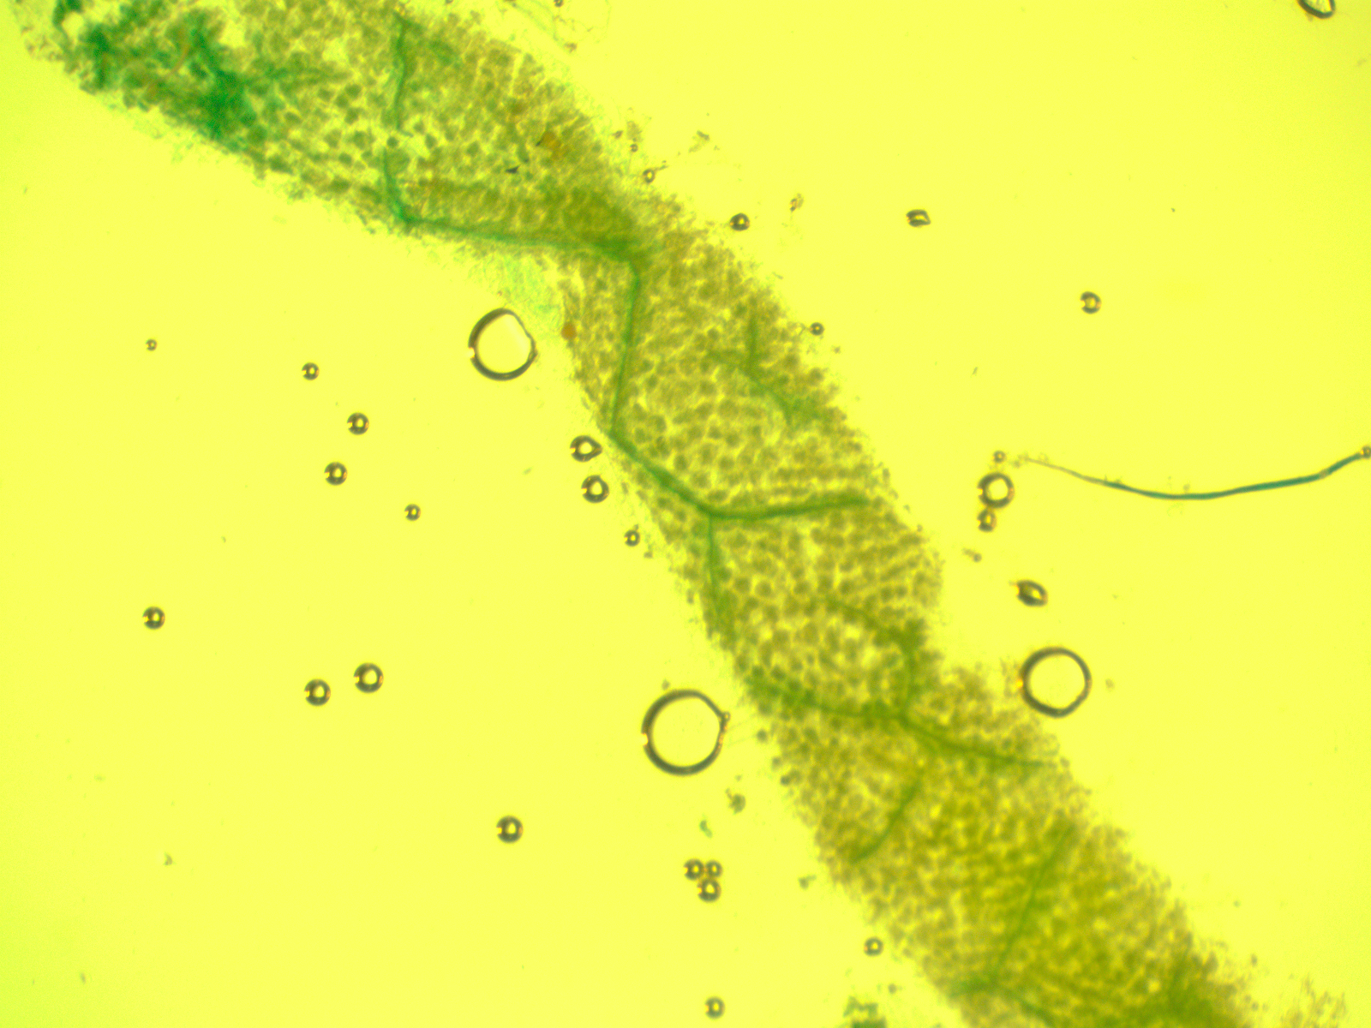
Figure 4. GUS expression in N. benthamiana leaves infiltrated with A. tumefaciens. GUS expression is especially associated with vascular tissue, as evident by the blue color developed in the veins of the agroinfiltrated leaf tissues.

