PROGRESS REPORT

I. Project title
Biology of the X. fastidiosa-vector interface

II. Principal Investigators and Cooperators
Rodrigo Almeida, Principal Investigator
Nabil Killiny, Researcher
Department of Environmental Science, Policy and Management
University of California, Berkeley, CA 94720

III. List of objectives and description of activities

- Characterization of chitin-binding proteins in the X. fastidiosa cell surface.
- Identification of molecules that disrupt X. fastidiosa adhesion.

IV. Summary of major research accomplishments and results for each objective
Previously, we have shown that different sugars could reduce the binding of cells to polysaccharides blotted on nitrocellulose membrane, those carbohydrates included N-acetylglucosamine, chitobiose and chitotriose, in addition to glucose. We showed also that those sugars interfered with X. fastidiosa attachment to the cuticle of sharpshooters vectors (Killiny & Almeida 2009). To move to and in vivo assay to better test approaches to disrupt the transmission of X. fastidiosa by vectors we would have establish an artificial diet system for transmission. Such a system would will permit us to control the delivery of cells and compounds to sharpshooters under various conditions. We and other groups have tried to develop this protocol, on and off, for 30 years. Here we report on our successful efforts to deliver transmissible X. fastidiosa cells to vectors. This is an essential component of our project, as now we can easily compare cells that are transmissible if grown on certain conditions with others that are not transmissible. In our last report we described the general idea of this protocol. We found that cells grown in a defined minimal medium supplied with pectin (XFM-pectin) are essential for the protocol to have high transmission rates if compared to XFM or XFM supplied with glucan. We showed that the complex PWG medium (Hill and Purcell 1995) is not suitable to carry out such transmission studies using artificial diet systems. We approached this question by comparing the 4 different media for phenotypic (including vector transmission), biochemical and molecular characteristics. This approach lead to a series of important findings that will be useful for this project, in addition to several other observations that will certainly be helpful to other research groups.

We found that cells grown in XFM media are different from those in PWG. X. fastidiosa cells grew approximately twice as fast on XFM-based media compared to PWG. These results are interesting, suggesting that although PWG is the most commonly used medium for growth of different X. fastidiosa strains, it either suppresses growth or does not provide adequate growth conditions as the much nutrient poorer XFM. We compared the number of planktonic versus attached cells grown in tissue culture tubes in these media. Both glucan and pectin induced cell adhesion, compared to the basal XFM medium. X. fastidiosa adhesion is mediated by a large number of surface proteins, such as pili and hemagglutinins. We quantified the amount of hemagglutinin proteins on cells grown in the four media. We have previously shown that these proteins are associated with vector transmission of X. fastidiosa to plants (Killiny & Almeida 2009). The results suggest that the proteins are produced at higher rates in cells grown on pectin and glucan compared to PWG and XFM. In addition, colony phenotype on these media was different on solid surfaces. On solid media, cells formed a uniform, glossy lawn on XFM-glucan and –pectin, when compared to individual colonies on PWG, which were more typical of X. fastidiosa. Colonies on XFM medium were intermediate among these treatments. These results suggest, among other things, that gum is up-regulated in XFM media.

We compared gene expression of multiple X. fastidiosa genes when cells are grown on different XFM-based media compared to PWG. It was clear that all these genes are repressed in PWG. In relation to XFM, however, hemagglutinins were up-regulated many fold, while other genes were also up-regulated but not as much. The type IV pilus gene pilY1 was down-regulated. These data suggest that carbohydrates induce a cell ‘adhesion’ phenotype and limit movement within plants; similarly to X. fastidiosa occurring in high cell density.

In order to better understand the changes to cells when grown on XFM-pectin, we carried out a gene expression microarray analysis for X. fastidiosa’s whole genome. Not surprisingly given the phenotypic changes observed, we found the presence of pectin induced many changes on the transcriptome of X. fastidiosa.
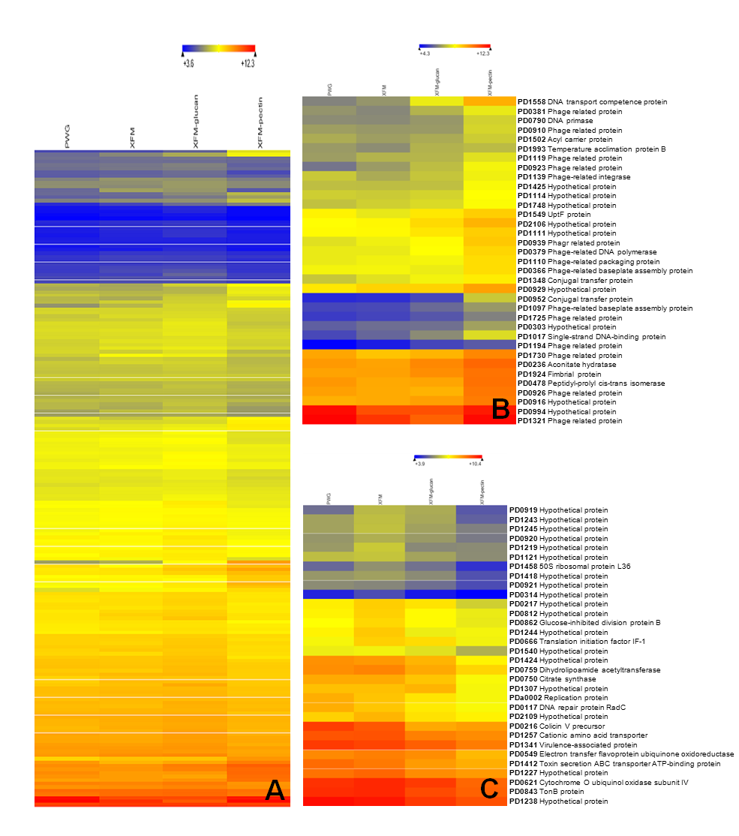

Microarray analysis for gene expression of cells grown in different media. (A) Hierarchical clustering analysis of microarray expression data for 187 genes found to be differentially regulated during growth in PWG, XFM, XFM-pectin, and XFM-glucan, respectively. (B) Up-regulated genes in the presence of pectin (C) Down-reglulated genes in the presence of pectin when compared to XFM. Note the gradient increasing or decreasing gradient of expression data are the average of 4 independent replicates of each treatment. The most intense red and blue colors correspond to increased or decreased expression values respectively. Genes having ratios of ≥ 1.6 or ≤ 0.6 fold for expression were selected as up-regulated or down-regulated respectively.

Finally, in vitro transmission tests using the artificial diet system described above, showed that transmission was above 90% efficient if cells were grown on XFM-pectin, while no transmission was observed on PWG. It is interesting to note a good correlation between the quantity of hemagglutinin on cells and vector transmission of X. fastidiosa using the in vitro system.

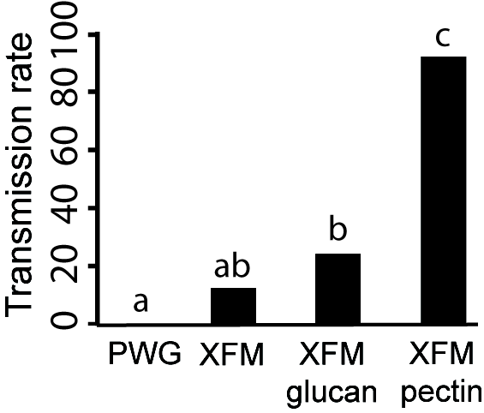

Pectin induction of X. fastidiosa vector transmission. Cells grown on different media were suspended in feeding medium and provided to 50 leafhoppers individually per treatment. Media with different letters on bars are statistically different (P< 0.05).

The main subunit of pectin is responsible for gene induction in X. fastidiosa.
We showed that pectin mediates the transmission of X. fastidiosa, but pectin is a very large and complex molecule. Thus, we also studied the effect of different subunits of pectin in the changes in phenotype and gene expression we observed. Pectin is primarily composed of galacturonic acid with rhamnose side chains; the ratio of these sugars is host plant species dependent (Cho et al 2001, Coutinho & Henrissant 1999). We tested the effect of rhamnose and galacturonic acid separately. And results are described in the following figure.
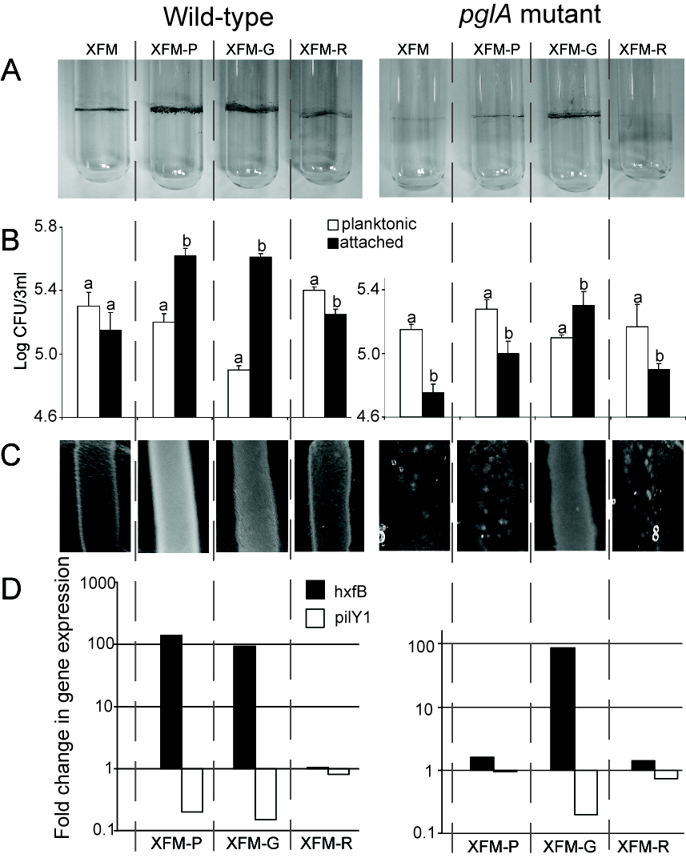

The main subunit of pectin is responsible for gene induction in X. fastidiosa. A) Biofilm formation at air/broth interface for the X. fastidiosa wild-type and polygalacturonase (pglA) mutant in four media; XFM, and XFM supplemented with -P(ectin), -G(alacturonate-Na) and -R(hamnose). B) Populations of planktonic versus glass-attached cells grown in four media, bars with the same letter are not different from each other within media treatments (t-test, P < 0.05); and C) visual aspect of bacterial lawns on solid media. D) Quantification of hxfB and pilY1 transcription under the same conditions for the wild-type and mutant; value of 1 indicates transcription level equal to cells grown in the basal medium XFM.

Taking together, it seems that galacturonic acid is the selective sugar for X. fastidiosa and it is the responsible of the change in phenotype and gene expression profiles. In order to confirm these results we used the pglA mutant, the mutant grow in the presence of galacturonic acid just like the wild type in the presence of pectin, which corroborates other observations that this sugar is responsible for the phenotypic changes we found.
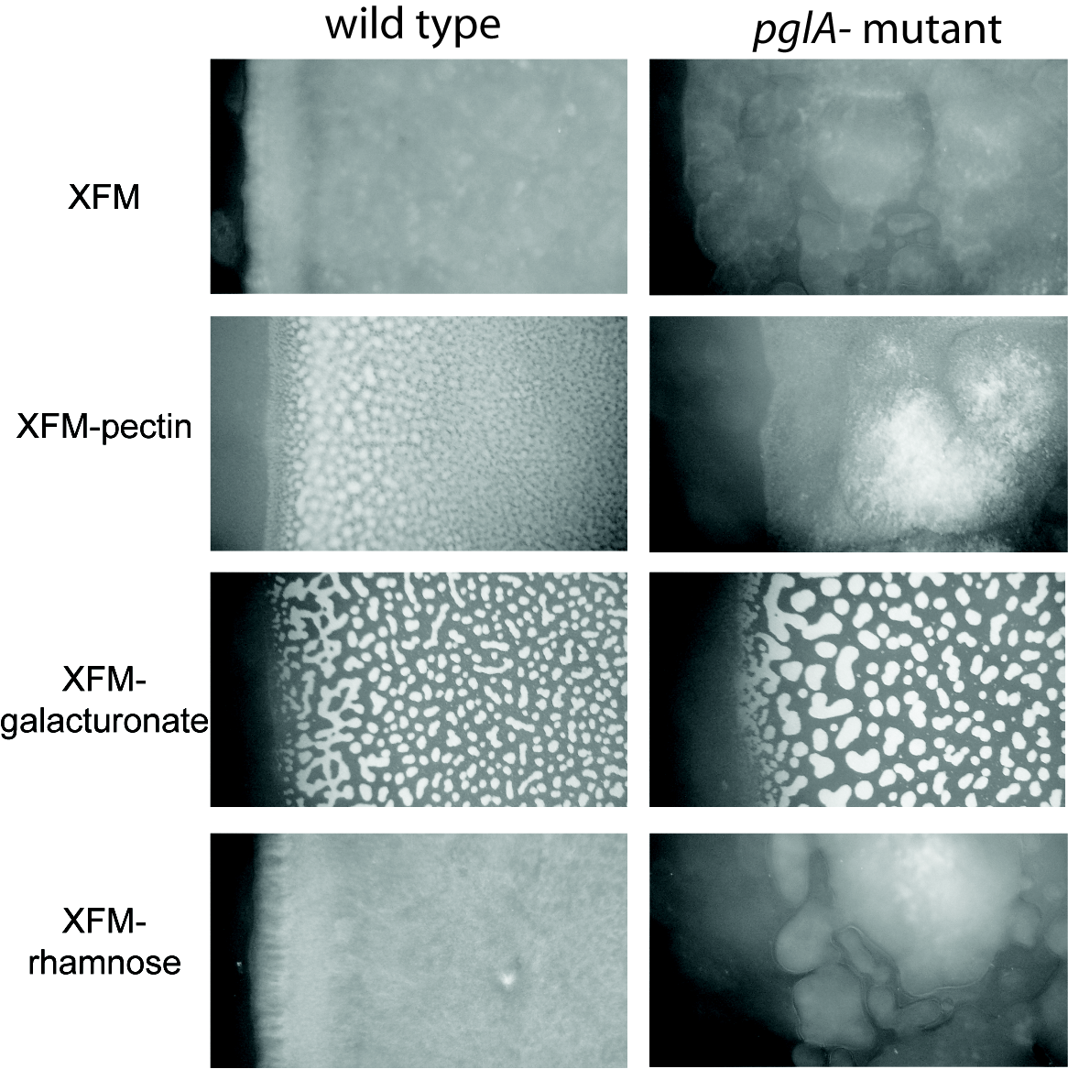

Phenotype of wild type and pglA mutant colonies on XFM media supplied with pectin or one of its major component. Pictures focus on the edge of plated cells for comparative purposes.. Images were taken using LEILKA M125 steromicroscope with 100X total magnification. Inoculums were adjusted to OD600 of 0.2 before plating on the media.

Ongoing research experiments
This summer we have already started the in vivo competition assays in order to block the transmission of X. fastidiosa to plants. In these experiments we used different substances as competitors. Description of these substances is listed in Table1. Previously we showed that it is possible to interrupt the attachment of cells to similar surfaces to insect cuticle using sugars (Killiny & Almeida 2009). On the other hand we demonstrated that the specific interactions is restricted in the early colonization through carbohydrate binding protein from X. fastidiosa cells that bind to polysaccharides on the foregut surface. Accordingly, the used substrates included different lectins exhibiting different affinities.

Table: 1 Carbohydrates and proteins used as competitors in the in vivo assay
Substance | Note
Galactose
Mannose
Glucose
N acetyglucoseamine
Chitobiose | Dimer of N-acetylglucosamine
Chititriose | Trimer of N-acetylglucosamine
Chitin | Linear chain of N-acetylglucosamine with beta 1,4 linkage
Colloidal chitin | acid-treated to be colloidal (stable suspension)
Chitosan | De-acetylated chitin (polymer of glucosamine)
Dextran | Complex α-1,6 and 1,4 glycosidic linkages between glucose
Cellulose | Linear chain of D-glucose with beta 1,4 linkage
Carboxymethy cellulose | Carboxymethyl group linked to the glucopyranose monomers to make up the cellulose backbone
Wheat germ agglutinin (WGA) | Affinity to N-acetylglucosamine (the core of N-glycosylation and the monomer of chitin)
Concanavain A (ConA) | Affinity to glucose and mannose residues
Peanut agglutinin (PNA) | Affinilty to galactose and N-acetylgalactosamine the core of O-glycosylation
Lentil lectin (LL) | Affinity to branched mannose with fucose
Bovine serum albumin (BSA) | Neutral protein
Ovalbumine (OVA) | Glycoprotein has affinity to mainly to glucose and mannose

V. Publications or reports resulting from the project
Almeida, R.P.P. and Killiny, N. 2008. Biology of the Xylella fastidiosa-vector interface. In: Proceedings of the 2008 Pierce’s Disease Research Symposium, San Diego, CA, Dec. 15-17. p 83-86.
Kiliny, N. and Almeida, R.P.P. 2009. Xylella fastidiosa afimbrial adhesins mediate cell transmission to plants by leafhopper vectors. Applied and Environmental Microbiology 75: 521-528.
Kiliny, N. and Almeida, R.P.P. 2009. Host structural carbohydrate induces vector transmission of a bacterial plant pathogen. Submitted.

VI. Presentations on research
None in this reporting period.

VII. Research relevance statement
This project focuses on X. fastidiosa-vector interactions and will test alternative approaches to block bacterial transmission by sharpshooters. In previous work we demonstrated the role of certain X. fastidiosa surface proteins in cell attachment to vectors and determined that certain molecules (polysaccharides) can block cell adhesion in vitro. Here we report on efforts to i) identify X. fastidiosa leafhopper-binding proteins and ii) test molecules that block cell adhesion to vectors. The long-term goal is to develop a disease control strategy that will specifically disrupt X. fastidiosa transmission without directly affecting vectors, pathogen, host plant or current vineyard management practices.

VIII. Lay summary of current year’s results
We developed and characterized an artificial diet system to deliver X. fastidiosa to leafhoppers without the requirement of infecting plants to serve as reservoirs. This technological advancement will permit the community to study how X. fastidiosa colonizes vectors in much more detail. In addition, our results will likely be useful to groups interested in how X. fastidiosa colonizes plants and causes disease, as we found that different media dramatically affect gene expression and the phenotype of this pathogen.

IX. Status of funds
Currently there are no funding problems for this project.

X. Summary and status of intellectual property produced during this research project
None expected.

