Isolation, characterization and genetic manipulation of Xylella fastidiosa hemagglutinin genes.

Principal Investigator: Bruce Kirkpatrick
Department of Plant Pathology
University of California, Davis
Ph (530) 752-2831
bckirkpatrick@ucdavis.edu

Cooperators: Tanja Voegel

Department of Plant Pathology

University of California, Davis
tmvoegel@ucdavis.edu

Sandra Uratsu Abhaya Dandekar
Dept. of Plant Science Dept. of Plant Science
University of California, Davis University of California, Davis
saratsu@ucdavis.edu amdandekar@ucdavis.edu

Objectives:
1a. Use antibodies we have prepared against a conserved, putative adhesion domain (AD2) that is present in both Xf hemagglutinins (HA) to determine the native size and location of Xf HA in cultured Xf cells and PD-affected grapevines.
b. Determine if these antibodies (Fab fragments) can prevent cell-cell clumping in liquid Xf cultures.
c. Prepare an affinity column using HA domain antibodies and isolate native Xf HAs from culture cells. Establish the identity of affinity purified, putative HAs by N-terminal sequencing.
d. Determine if native HAs and HA domain fusion proteins can bind to Xf cells.
e. Inject affinity purified HA proteins into rabbits and obtain HxfA and B specific-antibodies. Determine if HxfA and B specific antibodies can block cell-cell clumping of Xf grown in liquid medium.
2a. PCR-amplify, clone and express as fusion proteins, additional hypothetical adhesion domains of HxfA and B.
b. Prepare rabbit polyclonal antibodies against each HxfA/B domain fusion protein. Determine the native size and location of Xf HA in Xf cultured cells using AD1-3 and AD4 antibodies.
c. Determine if antibodies against various HxfA/B domain fusions can block cell-cell clumping of Xf grown in liquid medium.
3a. Transform grapevines and tobacco, an experimental host of Xf and an easily transformable plant (Francis et al., 2008), with Xf HA binding domains. Use antibodies prepared in Objective 2 to determine if Xf HA proteins can be found in tobacco xylem fluid.
b. Mechanically inoculate HA-transgenic grapevines and tobacco with wild type (wt) Xf cells. Compare disease progression and severity in transgenic tobacco with non-protected controls.
Results:

Objectives 1 and 2 are completed and results were reported previously (Proceedings, 2009 Pierce’s Disease Research Symposium. CDFA, Sacramento, CA).

Objective 3.
The generation of plasmid vectors for transformation of HA-expressing tobacco SR-1 and Thompson seedless grapevines, as well as the analysis of the transformed tobacco T₀ generation regarding the insertion of the T-DNA was reported previously (Proceedings, 2009 Pierce’s Disease Research Symposium. CDFA, Sacramento, CA). Here we report the generation of the T₂ tobacco generation and a preliminary pathogenicity assay that was performed on the T₁ tobacco generation.
Seeds from 10 plants per transformed line (lines 1-11 are transformed with pDU-pGIP-AD1-3, coding for the HA N-terminal domain containing the hemagglutination domain; lines A-K are transformed with pCAMBIA-pGIP-220, coding for the native 220kD HA protein we identified in earlier research) of the T₁ generation were harvested, surface sterilized and plated on ½ MSO medium containing the antibiotic according to the resistance gene on the T-DNA. The germination pattern of the resulting T₂ generation was analyzed. Lines that germinated with a rate of 100% are homozygous regarding the transgene. Fifteen germinated homozygous plantlets for each transgenic line were transferred into single pots, adjusted to the decreased humidity in the greenhouse and grown for 2 weeks. Plants were inoculated with 20µl of a 10⁸ cells/ml suspension of Xf Temecula GFP in 1 X PBS (Newman et al., 2003). We used the Temecula GFP strain in order to minimize contamination problems for subsequent isolation of the bacteria and to potentially perform localization studies of the bacteria in the plant xylem by confocal microscopy. Two replications were inoculated on January 11 and 12 and the plants will be ready for the isolation of the bacteria 2 months after inoculation.
We performed a preliminary pathogenicity assay on the tobacco T₁ generation that was available at the time. Six tobacco plants for lines 1 and 5 (transformed with pDU-pGIP-AD1-3), 6 plants for lines G and J (transformed with pCAMBIA-pGIP-220), and 10 wild type plants were inoculated with Xf wild type cells as described above. Eight weeks after inoculation, leaves at 25 cm above the point of inoculation (POI) were harvested and the bacterial population per gram of leaf tissue was determined. The results are summarized in Table 1.

Strain | CFU/g of tissue 25 cm above POI
wild type | 9.9 (+/- 7.3) x 10⁵
line 1 | 9.1 (+/- 16.2) x 10²
line 5 | 1.3 (+/- 1.5) x 10⁶
line G | 3.3 (+/- 8)
Line J | 2.5 (+/- 3.8) x 10³
Table 1: Bacterial populations at 25 cm above the POI of wild type and transformed tobacco lines 1, 5, G, and J at 8 weeks after inoculation. Bacterial populations are similar for wild type and line 5, whereas lines 1, G, and J have reduced quantities of bacteria.

There are significantly fewer Xf cells present at 25 cm above the POI in lines 1, G, and J when compared to wild type plants, indicating that both the expressed HA proteins AD1-3 and 220 might promote aggregation of the Xf cells at the POI and prevent movement of the cells upstream the plant xylem, hereby potentially preventing systemic colonization of the host plant. Only in line 5 bacteria could be isolated at 25 cm above the POI in levels similar to wild type plants, we conclude that this result is due to a position effect of the inserted transgene in the tobacco genome.
Ten weeks after inoculation, the tobacco plants were rated on a visual scale from 0 to 5 as previously described for grapes (Guilhabert and Kirkpatrick, 2005). The ratings are depicted in Figure 1, and symptoms of representative plants are shown in Figure 2.

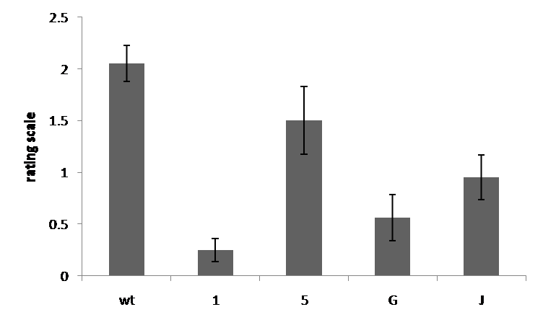
Figure 1: Ratings of Xf-inoculated tobacco lines wt, 1, 5, G and J on a scale of 0-5, ten weeks after inoculation. Line 5 shows symptom severity similar to wild type plants, whereas symptoms are reduced in lines 1, G, and J.

A
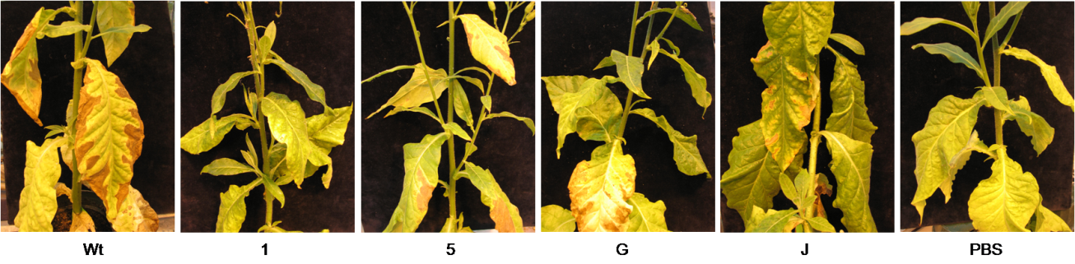

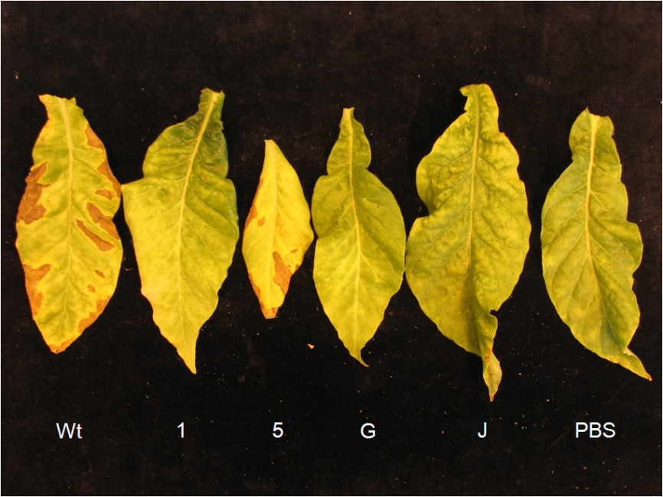
B
Figure 2: Foliar symptoms of HA-transgenic tobacco lines 1, 5, G and J, as well as wild type plants and PBS controls 10 weeks following mechanical inoculation with Xf. A: whole plant. B: single leaves.
A good correlation between the number of bacteria that were isolated from the inoculated tobacco plants and symptom severity was found. Lines 1, G, and J have reduced quantities of bacteria and also show fewer symptoms than wild type plants. These lines are very promising and may be considered moderately resistant to Xf. Line 5 has lower ratings than wild type plants, but a similar bacterial population at 25 cm above the POI and will not be further considered.
We hope to repeat our positive results in a more comprehensive pathogenicity assay with the T₂ tobacco generation as described above. Because we did not assess movement in the preliminary T₁ pathogenicity assay, we will sample the T₂ transgenic tobacco plants at the POI and 25 cm above the POI to determine if the inoculated Xf cells are inhibited in their movement through the stem, or if exposure to the expressed HA proteins leads to Xf cell death. Once we identify the most resistant tobacco lines, they will be assessed by Southern blot analysis to determine if there is a single insertion of the T-DNA, and by Western blot analysis with the anti-HA antibodies to determine if HA proteins are present in the xylem fluid of transformed plants. We anticipate receiving transformed Thompson seedless grapevines in spring, 2010. Abhaya Dandekar and Dave Gilchrist confirmed that it will likely be one full year from the time that we received transgenic grapevines from the transformation facility until we can determine if the grapevines possess any resistance against Xf following mechanical inoculation.

Publications:
Voegel T. M. Kirkpatrick B. C. (2006). Isolation and Characterization and Genetic Manipulation of Xylella fastidiosa Hemagglutinin Genes. Proceedings, 2006 Pierce’s Disease Research Symposium. California Department of Food and Agriculture, Sacramento, CA
Tanja M. Voegel and Bruce C. Kirkpatrick. 2006. Characterization of a putative Two-Partner-Secretion pathway protein in Xylella fastidiosa. Phytopathology 96:S119
T. M. VOEGEL and B. C. Kirkpatrick (2007). Xylella fastidiosa hemagglutinins: Identification of cell-cell binding domains and evaluation of their potential for producing Xf resistant transgenic plants. Phytopathology 97:S118
Voegel T. M. and Kirkpatrick B. C. (2007). Isolation, Characterization and Genetic Manipulation of Xylella fastidiosa Hemagglutinin Genes. Proceedings, 2007 Pierce’s Disease Research Symposium. California Department of Food and Agriculture, Sacramento, CA
Voegel T. M. and Kirkpatrick B. C. (2008). Isolation, Characterization and Genetic Manipulation of Xylella fastidiosa Hemagglutinin Genes. Proceedings, 2007 Pierce’s Disease Research Symposium. California Department of Food and Agriculture, Sacramento, CA
Tanja M. Voegel and Bruce C. Kirkpatrick (2008). A novel approach for generating Xylella fastidiosa resistant grapevines. Proceedings of the 2nd annual national viticulture research conference, Davis, CA.
Tanja Voegel, Jeremy Warren, Ayumi Matsumoto, Michele Igo, and Bruce Kirkpatrick (2010). Localization and Characterization of Xylella fastidiosa Hemagglutinin Adhesins. Microbiology (accepted).
Voegel TM and Kirkpatrick BC (2009). Identification of a novel two-partner secretion system in Xf. (in preparation).
Presentations on research:
Annual APS meeting, Quebec City, Canada, 2006
Pierce’s disease research symposium, San Diego, 2006
Annual APS meeting, San Diego, 2007
Pierce’s disease research symposium, San Diego, 2007
National viticulture research conference, Davis, 2008
Pierce’s disease research symposium, San Diego, 2008
Department of plant pathology retreat, Davis 2009
Pierce’s disease research symposium, San Diego, 2009

Research relevance:
Xf cell-cell attachment is an important virulence determinate in Pierce’s disease. Our previous research has shown that if 2 HA genes which we have named HxfA and HxfB are mutated Xf cells no longer clump in liquid medium and the mutants form dispersed “lawns” when plated on solid PD3 medium (Guilhabert and Kirkpatrick, 2005). Both of these mutants are hypervirulent when mechanically inoculated into grapevines, i.e. they colonize faster, cause more severe disease symptoms and kill vines faster than wt Xf. If either HxfA OR HxfB is individually knocked out there is no cell-cell attachment, which suggests that BOTH HA genes are needed for cell-cell attachment. It is clear that these proteins are very important determinants of pathogenicity and attachment in Xf/plant interactions. The Xf HAs essentially act as a “molecular glue” that is essential for cell-cell attachment and likely play a role in Xf attachment to xylem cell walls and contribute to the formation of Xf biofilms. Recent work reported by the Almeida lab has also shown the importance of HAs in vector transmission (Killiny and Almeida, 2009). Here we used the knowledge we gained about the basic biology of Xf HA proteins to generate transgenic HA-expressing tobacco and grapevines. Although we have not yet obtained the HA-transformed grapevines, our initial results with HA-expressing tobacco showed that these plants are at least moderately resistant to Xf. If our results are reproducible in grapevines our approach might provide a novel form of resistance against Pierce’s disease.

Summary in lay terms:
In earlier research we identified important portions of the Xf HA proteins that we thought to be necessary for the function of HAs. HA proteins mediate the formation of ‘cell clumps’ in Xf. We used these HA protein portions and generated transgenic tobacco and grapevine plants that produce these HA proteins in their xylem. Transgenic tobacco plants were inoculated with Xf and we could show that the transgenic plants had fewer numbers of Xf at 25 cm away from the point of inoculation and also showed fewer symptoms than non-transformed wild type plants. We speculate that the HA proteins bind to inoculated Xf cells and lead to the formation of ‘cell clumps’, thus preventing or slowing the movement of Xf cells away from the point of inoculation, resulting in healthy plants.

Status of funds: We have approximately $42,000 remaining on this grant which has a 6/30/10 end date. We will request a six month extension to spend the remaining funds, in order to fully test the transgenic grapevine which will take a significant amount of time to propagate and test in the greenhouse.

Summary and status of intellectual property:
Although Professor Alan Bennet presented an excellent talk on the intellectual property issues associated with transgenic plants at the 2007 PD/GWSS Conference, we believe it is important to evaluate the efficacy of this transgenic approach to mitigating PD using the same vectors that Aguero et al., 2005 used in their work with PGIPs. If the HA transgenic grapevines show some protection against Xf infection then the same genes can be subcloned into other plant transformation vectors if commercial application is desired. A provisional UC patent, Case No. 2004-572, “Engineering resistance to Pierce’s disease by expression of a Xylella fastidiosa HecA-like hemagglutinin gene” was submitted and accepted in April 2005. I view the submission of this patent as a mechanism to protect California grape growers from having to compete with other national or international interests from patenting a similar approach for developing resistance to PD.

References:
Guilhabert, M.R. and Kirpatrick B.C., 2005. Identification of Xylella fastidiosa avirulence genes: hemagglutinin adhesions contribute to X. fastidiosa biofilm maturation and colonization and attenuate virulence. Molecular Plant Microbe Interactions 18:856-868.

Killiny, N and Almeida R.P.P.,2009. Xylella fastidiosa Afimbrial Adhesins Mediate Cell Transmission to Plants by Leafhopper Vectors. Applied and Environmental Microbiology p. 521-528, Vol. 75, No.2
Newman, K.L., Almeida R.P.P., Purcell A.H., and Lindow S.E. 2003. Use of a Green Fluorescent Strain for Analysis of Xylella fastidiosa Colonization of Vitis vinifera. Applied and Environmental Microbiology, p. 7319-7327, Vol. 69, No. 12
Voegel, T.M. and Kirkpatrick, B.C. (2009). Isolation, Characterization and Genetic Manipulation of Xylella fastidiosa Hemagglutinin Genes. Proceedings, 2009 Pierce’s Disease Research Symposium. California Department of Food and Agriculture, Sacramento, CA.

