PROGRESS REPORT – February 2011

I. Project title
Which grape varietals are sources of Pierce’s disease spread? Decoupling resistance, tolerance and glassy-winged sharpshooter discrimination

II. Principal Investigator, Cooperator and Researcher
Rodrigo Almeida, Principal Investigator
Department of Environmental Science, Policy, and Management
University of California, Berkeley, CA 94720, e-mail: rodrigoalmeida@berkeley.edu
Matthew Daugherty, Cooperator
Department of Entomology
University of California, Riverside, CA 92521, e-mail: matt.daugherty@ucr.edu
Arash Rashed, Researcher
Department of Environmental Science, Policy, and Management
University of California, Berkeley, CA 94720, e-mail: arashed@berkeley.edu

III. List of objectives and description of activities
We proposed to quantify infection level, symptom severity, and vector transmission efficiency, in relation to its feeding behavior, in the vector-borne disease system of the pathogen Xylella fastidiosa (the etiological agent of Pierce’s disease in grapes) and the invasive Homalodisca vitripennis (the glassy-winged sharpshooter, GWSS). Our objectives were to:

1. measure the relative levels of susceptibility in several important California grapevine cultivars
2. measure GWSS discrimination against infected vines and X. fastidiosa transmission rate in different grape varietals
3. measure over-winter recovery from infection for different grape cultivars

Research activities to accomplish objectives are described together with a summary of major accomplishments, so that the rationale and outcome of studies are directly connected.

IV. Summary of research progress for each objective

Objective 1. Cultivar susceptibility
We addressed the first objective by performing two sets of experiments in 2009 and 2010. In 2009, 14 different commonly used red and white wine and table/raisin grapevine cultivars were mechanically needle-inoculated at the base of the main shoot with the STL strain of Xylella fastidiosa. Infection levels (bacterial populations) of the inoculated 2-month old cuttings were evaluated 8 and 12 weeks post-inoculation. We extracted DNA from petioles, collected +10 cm above the point of inoculation, using a robotic work station and Qiagen extraction kits. Cell numbers were estimated by quantitative PCR.
A significant variation was observed in among-cultivar infection levels. The existence of such variation was also reported from previous studies (e.g. Raju and Goheen 1981, Krivanek et al 2005, Baccari and Lindow 2011). The results of infection level comparisons have been presented in previous progress reports. In December 2010, we needle-inoculated 2-month old cuttings of another set of 10 different grapevine cultivars to evaluate their susceptibility. We quantified symptom severity (following Guilhabert and Kirkpatrick (2005)) in relation to bacterial infection level on weeks 8, 12, and 16, for each of the cultivars. Bacterial quantifications are now completed for the sampling weeks 8 and 12. Quantification of the infection levels on week 16 is a work currently in progress. Here we present the results of our infection level and symptom quantifications on the first two incubation times (week 8 and 12).
Our repeated measure analysis detected a significant among-cultivar variation in both infect level (F_{9,106} = 8.90, P < 0.001) and symptom severity (F_{9,106} = 8.99, P < 0.001) (Fig 1). The effect of incubation time on symptom severity differed across tested genotypes as reflected by the significant cultivar-by-incubation time interaction (F_{9,106} = 3.46, P < 0.001). However this effect on the level of infection was not statistically significant across cultivars (F_{9,106} = 1.04, P < 0.41).

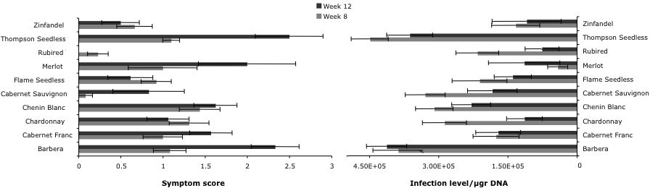
Figure 1. Infection level (right) and Pierce’s disease symptom severity (left) for the 10 evaluated grapevine cultivars. Error bars represent ±1 SE. The number of replicates per cultivar per incubation time ranged from 10 to 16. Exceptions were Merlot (n=4) and Zinfandel (n=6).

Separate regression models showed a lack of correlation between infection levels and symptom severity on week 8 (t = 0.41, P = 0.69). However, this correlation became significant on week 12 (t = 3.51, P = 0.007; Fig 2). Interestingly, we observed a consistent reduction of infection levels across the majority of our evaluated cultivars over the incubation period (Fig. 1). This observed trend was based on only two sampling dates and additional data from the week 16 would provide us with a clearer image of whether or not a real pattern exists. It is possible that older colonies following needle-inoculation die off through time, which would be reflected by our sampling design. To address this possibility our third sampling (week 16) was performed both at approximately +10 cm, and at about +70 cm from the point of inoculation (analyses in progress). The results of our winter experiment so far indicates that Thompson Seedless is the most susceptible cultivar Pierce’s disease among our 10 evaluated genotypes (followed by Barbera). Rubired has been the least susceptible genotype as it maintains both low symptoms and infection levels over time. Our final conclusion is pending on completion of bacterial quantifications for week 16 and a thorough data analysis.

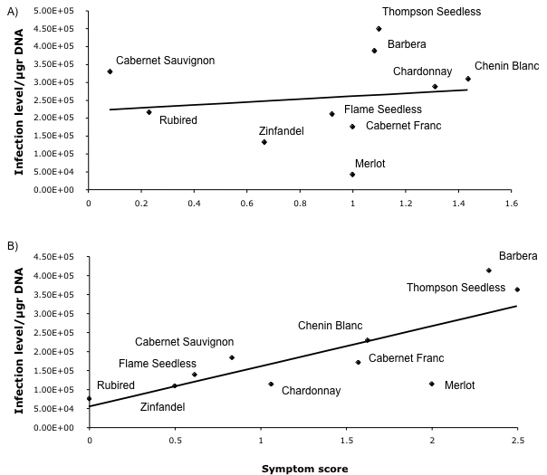
Figure 2: The relationship between bacterial populations and symptoms at 8 (A) and 12 (B) weeks after inoculation.

Upon completion of our analyses we will be able to provide an objective measure of susceptibility for each of the evaluated cultivars. One may define categories as (this is a tentative proposal, terminology and details may change):
Susceptible: Severe disease symptoms accompanied by high bacterial populations
Tolerant: Mild disease symptoms despite high bacterial populations in the infected host
Resistant: Mild disease symptoms and low bacterial populations in the infected host

However, there may not be a true distinction among these categories, especially since we know that all V. vinifera are susceptible to X. fastidiosa infection. As we have shown so far, we expect a continuum of high susceptibility to low susceptibility. Placing various cultivars along this continuous spectrum requires quantification of both symptoms and bacterial populations. We believe that this goal is achievable by the approach we have taken in this study.

Objective 2. Transmission and vector host-choice
No-choice transmission experiments
The results of our no-choice experiments, which investigated the transmission efficiency of X. fastidiosa by GWSS among 14 grapevine cultivars was presented in the Pierce’s disease proceeding report 2010.
In sum, no variation in X. fastidiosa transmission rate was detected among our evaluated cultivars (Wald X₁₃²= 8.55, P = 0.80). Likewise, transmission efficiency of GWSS was not affected by the incubation time (Wald X₁²= 1.42, P = 0.23; Fig 2) or by the infection level of the source plant (Wald X₁²= 0.03, P = 0.86). We recently revisited our data and noticed an interesting pattern in which GWSSs’ transmission efficiencies varies among red wine, white wine and table/raisin cultivars (Wald X₂² = 9.25, P = 0.010). More experiments with a wide range of cultivars are needed to evaluate the accuracy of this observed pattern.
In the summer 2010, we performed an additional transmission experiment. Seedlings of the three cultivars Cabernet Sauvignon, Pinot Noir, and Cabernet Franc were needle inoculated with the Temecula strain of X. fastidiosa. GWSS were caged on only two source plants (per cultivar) to eliminate variation in vectors’ degree of exposure to the pathogen. After 48hrs of acquisition period insects were caged individually on 20 healthy seedlings of the corresponding cultivar. Our previous results were confirmed, as there was no detectable variation in transmission efficiency of X. fastidiosa by GWSS among the three cultivars (X₂²=1.12, P = 0.57).

Choice experiments- response to Pierce’s disease symptoms
It has been previously reported that the sharpshooter vectors Dilobopterus costalimai and Oncometopia facialis (Hemiptera: Cicadellidae) discriminate against X. fastidiosa infected symptomatic plants (Marucci et al. 2005). In a series of experiments with artificially created symptoms (painted leaves) and field collected symptomatic cuttings we showed that GWSS similarly avoid to feed on symptomatic plants.
GWSS showed a significant preference to alight on green-painted grapes (sign-test: P = 0.038; n = 32 - previously reported). We also showed that sharpshooters do not select against infected grapes in the absence of symptoms (sign-test: P = 0.38; n = 32- details in the previous report). Our most recent pairwise choice experiment with field collected symptoms indicated that GWSS prefers asymptomatic plants compared to symptomatic grapevines (sign-test, P = 0.02, n = 24). This led us to the conclusion that visual signals are the primary cues used by GWSS to select a host plant. Olfaction (see Patt and Setamou 2007) may function following the initial landing on a host.
We also presented the results of our study on within-host site selection behavior GWSS in grapevines. The findings of that work and how they connect to X. fastidiosa transmission efficiency by vectors have been presented in detail (in previous reports) and are now published (Rashed et al 2011).

Objective 3. Over-winter recovery
Seedlings of the five cultivars Cabernet Franc, Zinfandel, Chardonnay, Cabernet Sauvignon and Pinot Noir were inoculated by Temecula strain of X. fastidiosa in August 2010. In November 2010, inoculated plants were placed on outdoor benches located at the Oxford Tract greenhouse facility of the University of California- Berkeley. Experiment is now in progress and we are expecting to evaluate the over-winter recovery rate by mid-May, with bacterial isolation (culturing).

Experiments were set to address all of our proposed objectives. To date, we accomplished majority of our objectives and the completion of this proposal is pending an ongoing an experiment (over-winter recovery) and finalizing quantitative PCR of about 400 remaining samples (which is expected to be done by the April 30th).

V. Publications or reports resulting from the project

Rashed A. and Almeida R.P.P. 2011. Background matching behaviour and pathogen acquisition: Feeding site preference does not predict the bacterial acquisition efficiency of vector species. Arthropod-Plant Interactions, in press.
Almeida, R.P.P. and Rashed, A. 2010. Evaluating variations in resistance and the glassy-winged sharpshooter transmission rate among grapevine cultivars. Pierce’s Disease Research Symposium Proceedings, pp 60-63.
Almeida R.P. P. and Rashed A. 2009. Which grape varietals are sources of Pierce’s disease spread? Decoupling resistance, tolerance, and glassy-winged sharpshooter discrimination. Pierce’s Disease Research Symposium Proceedings, pp 57-61.

VI. Presentations on research
Rashed A., Daugherty M.P., and Almeida R.P.P. 2010. Feeding behavior in sharpshooter leafhoppers (Hemiptera: Cicadellinae): Does within-host feeding site preference influence vector transmission efficiency? Entomological Society of America Annual Meeting. San Diego, CA, December 2010.
Daugherty M.P., Rashed A., Almeida R.P.P. 2010. Disease spread: interactive effects of vector preference and host resistance versus tolerance, joint talk, Entomological Society of America Annual Meeting. San Diego, CA, December 2010.
Rashed A. and Almeida R.P.P. 2010. How sharpshooter foraging behavior influences Xylella fastidiosa acquisition efficiency? Poster, Pierce’s Disease Research Symposium, Sacramento, CA, December 2010.
Rashed A. and Almeida R.P.P. 2010. Within-host feeding-site preference and acquisition efficiency in sharpshooter leafhoppers (Hemiptera: Cicadellidae). Poster, Center for Disease Vector Research Symposium, Riverside, CA, March 2010.
Almeida RPP. 2009. Xylella fastidiosa transmission: how did it become so complicated? Department of Entomology and Plant Pathology, Auburn University, Auburn, AL. April 6, 2009.
Almeida RPP. 2009. Xylella fastidiosa transmission by vectors – from molecules to models. Annual Meeting of the American Phytopathological Society, Portland, OR. August 1-5, 2009.
Almeida RPP. 2009. Xylella fastidiosa transmission and population ecology. I’institut National de la Recherché Agronomique, Bordeaux, France. September 7, 2009.
Almeida RPP. 2009. Xylella fastidiosa transmission and population ecology. I’institut National de la Recherché Agronomique, Montpellier, France. September 9, 2009.
Almeida RPP. 2009. Ecologia de Xylella fastidiosa. ESALQ/Universidade de Sao Paulo, Brazil. October 15, 2009.
Daugherty MP, Lopes JRS and Almeida RPP. 2009. Vector within-host feeding preference mediates transmission of a heterogeneously distributed pathogen. Annual Meeting of the Pacific Branch of the Entomological Society of America, San Diego, CA. March 31, 2009.
Rashed A, Kwan J and Almeida RPP. The relationship between color pattern and feeding behavior in three species of leafhoppers Entomological Society of America annual meeting, Indianapolis, IN, Dec 2009.
Rashed A and Almeida RPP. Which grape varietals are sources of Pierce’s disease spread? Decoupling resistance, tolerance, and glassy-winged sharpshooter discrimination. Poster, Pierce’s Disease Symposium, Sacramento, CA, Dec 2009.

VII. Research relevance statement
The GWSS is one of the important vectors of Xylella fastidiosa, which causes Pierce’s disease in grapevines. Grape cultivars differ in Pierce’s disease severity, which suggests differential susceptibility to the bacterial infection among genotypes. Providing an objective measure for the level of resistance among different cultivars is critical as it can affect patterns of pathogen spread by the GWSS. Tolerant cultivars (infected yet asymptomatic), in particular, may function as a source for X. fastidiosa because as we have shown vectors prefer to visit asymptomatic grapevines. We are evaluating the feasibility of using less susceptible Vitis vinifera cultivars to control Pierce’s disease spread by quantifying resistance, tolerance, and GWSS behavior for several important table/raisin and wine grape varietals. Upon completion of this research we can provide information to growers on the cultivars that may limit the rate of the pathogen spread among grapevines especially for the areas that are at high risk of Pierce’s disease.

VIII. Lay summary of current year’s results
We quantified bacterial populations (Xylella fastidiosa) and compared Pierce’s disease symptoms among several commonly used grape cultivars. Rubired appeared to be the most resistant cultivar to the infection. Thompson seedless and Barbera were the two cultivars that showed extensive Pierce’s disease symptoms. We are currently estimating bacterial populations of the petioles collected 16 weeks post-inoculation. Transmission rates of Xylella fastidiosa by the GWSS did not differ among the studied grape cultivars. Bacterial populations in source plants did not affect transmission efficiency of the vector. We showed that GWSS prefers to feed on asymptomatic plants - suggesting that asymptomatic infected grapevines (i.e. tolerant cultivars and/or plants at early stage of infection) could function as source for pathogen spread. Understanding vector feeding behavior and host choice combined with the plant response to pathogens will help contain disease spread in the field, and will be essential for the development of realistic epidemiological models and management practices.

IX. Status of funds
No present funding problems for this project. Project and funds will end this summer.

X. Summary and status of intellectual property produced during this research project
None expected.

