**I. Project Title: RNA-interference and control of the glassy-winged sharpshooter (*Homalodisca vitripennis*) and other leafhopper vectors of *Xylella fastidiosa***

**II. Principal Investigator (PI):** Bryce W. Falk, Professor, Department of Plant Pathology, University of California, One Shields Avenue, Davis, CA. 95616, 530-752-0302, [bwfalk@ucdavis.edu](mailto:bwfalk@ucdavis.edu)

**Co-Principal Investigator (Co-PI):** Cristina Rosa, Formerly Postdoctoral Researcher, Department of Plant Pathology, University of California, One Shields Avenue, Davis, CA. 95616, 530-752-5218, now, Research Scientist, Department of Entomology, Pennsylvania State University, State College, PA, [czr2@psu.edu](mailto:czr2@psu.edu)

**Cooperators:**

Dr. Michael P. Parrella, Department of Entomology, Professor, Department of Entomology, One Shields Avenue, University of California, Davis, CA 95616, 530-752-8473, [mpparrella@ucdavis.edu](mailto:mpparrella@ucdavis.edu)

Dr. Drake Stenger, USDA ARS, 9611 S Riverbend Ave., Parlier, CA 93648-9757, (559) 596-2922, [drake.stenger@ars.usda.gov](mailto:drake.stenger@ars.usda.gov)

Dr. Raja Sekhar Nandety, Postdoctoral Scientist, Department of Plant Pathology, University of California, Davis, CA 95616, (530) 752-5218, [nandety@ucdavis.edu](mailto:nandety@ucdavis.edu)

Dr. Shizuo George Kamita, Research Scientist, Department of Entomology, University of California, Davis, CA 95616, [sgkamita@ucdavis.edu](mailto:sgkamita@ucdavis.edu)

**III. List of objectives and description of activities conducted to accomplish each objective:**

The specific objectives of our effort are:

1. To generate and evaluate existing transgenic plants for their ability to generate RNAs capable of inducing RNAi effects in*Homalodisca vitripennis*.

2. To identify GWSS interfering RNAs for practical application.

a) To utilize transgenic *Arabidopsis thaliana* plants as efficient alternatives for identifying, delivering, and evaluating efficacious interfering RNAs.

b) To enhance production of interfering RNAs *in planta*.

c) To evaluate alternative strategies to deliver and screen high numbers of RNAi inducers in *Homalodisca vitripennis.*

**IV. Summary of major research accomplishments and results for each objective:**

We have made significant progress during this past one year and are in excellent position to complete most of our objectives during the upcoming year. We have published one refereed journal articles (Rosa et al., 2012) and have presented two symposium reports (Nandety et al., 2011) and (Falk et al., 2011). RNA interference applications are at the forefront for controlling insect pests and vectors, and our work here is very timely. Here we present our progress towards the development and application of an RNA interference (RNAi) based system aimed to target genes of the vector of *Xylella fastidiosa*, *Homalodisca vitripennis* or the Glassy-winged sharpshooter (GWSS). After demonstrating that RNAi induction in GWSS cells and insects is achievable, we began screening a large pool of candidate genes to find the best targets to control the survival of GWSS. These data were used to develop transgenic *Arabidopsis* and potato plants that express dsRNAs for the insect targets. We also made stable *Arabidopsis* transgenic plants that express GUS marker genes using 35S and a *Eucalyptus gunii* minimal xylem-specific promoter. While we were able to show the expression of GUS gene *in vivo* in the T2 transgenic plants, other transgenic plants are being evaluated for their ability to produce dsRNAs and will be tested against GWSS adult insects. Encouraged by our efforts to find effective targets, we adopted large scale sequencing of the GWSS transcriptome as well as the small RNA complement from GWSS adult insects. We were able to generate 35 million reads and nine million reads of the short read sequence data for transcriptomic and small RNA sequences in our initial run. We discovered some new findings in our sequence data which we are planning to publish shortly.

**RNAi in *H. vitripennis* cells and insects.** Initially, we used 14 GWSS Genbank cDNA sequences corresponding to known proteins in order to synthesize RNAi inducer molecules, dsRNAs. We then tested whether RNAi was inducible in GWSS cells and insects, and we were able to show that RNAi activity is inducible in GWSS [20]. Real time RT-PCR, semi quantitative RT-PCR, and Northern blot of small and large RNA fractions showed that RNAi was achieved in cells and insects injected with dsRNA where target mRNAs were partially degraded and specific siRNA, hallmarks of RNAi, were detected [20]. The inducibility of RNAi in the GWSS cells helped us design the following set of experiments.

**Generation of transgenic lines:** For the purpose of generating the *Arabidopsis* transgenic lines we used a different ecotype, Cape Verdi islands (C*vi*). Compared to Columbia (Col-0) it has larger leaves and presents more robust growth, and will be more appropriate in supporting insects of large size such as *H. vitripennis*. In order to generate dsRNAs that can target the insect, GWSS target sequences (Table 1) were cloned into a gateway-compatible binary vector pCB2004B (Figure 1). The target sequences were cloned in head to tail direction in the gateway vector with a non-homologous sequence between them. Upon transcription in transgenic plants, these constructs will yield double-stranded, hairpin RNAs of the desired sequence. The expression vectors carrying the insect target sequences of interest were first cloned into *E.coli* and *Agrobacterium tumefaciens* and they have been sequence verified. *A. tumefaciens* cultures carrying the sequences of interest were used to transform *A. thaliana Cvi* plantecotypes through the floral dip process. *Arabidopsis* T0 plants were screened for resistance against the selectable marker *BAR* gene, and we were able to confirm T1 transgenics. Further sets of transformation of *Arabidopsis* plants were underway to generate more independent transgenic lines for the GWSS target genes that had less than three independent transgenic lines. Also, efforts are underway to generate more transgenic lines for other target genes of GWSS that were not previously described. We are in the process of obtaining the homozygous transgenic *Arabidopsis* lines that will be used for screening against GWSS.



**Figure 1:** Diagrammatic representation of the vector pCB2004B used for generation of GWSS transgene constructs. The binary construct is designed to produce short hairpin between the sense and antisense target genes that will result in the production of small RNAs in the transgenic plants (*Arabidopsis* and potato plants).

We have used three of the constructs (Table 2) to transform potato plants. Transformation/regeneration was performed via recharge at the UC Davis Ralph M. Parsons plant transformation facility (<http://ucdptf.ucdavis.edu/>) and approximately ten independent transgenic lines were obtained for each of the constructs. We have performed screening of these transgenic potato plants for insert composition and have established the presence of a transgene similar to the procedure as described for *Arabidopsis* transgenic lines. The presence of chitin deacetilase transgene in the potatoes resulted in the production of small RNAs in those transgenic plants. In contrast to the approach with *A. thaliana*, we will vegetatively propagate the T0 plants and use them for RNAi experiments with GWSS. Potatoes are an excellent host plant for GWSS so we expect them to be very useful for our efforts here. We have characterized these plants to ensure that they contain the desired transgene(s) and for some, that they generate the desired siRNAs (Figure 2).



**IM M Tr T1 T2 T3 T4 T5 T6 T7**



**Figure 2**. Small RNA northern hybridization analysis of transgenic potato plants. Arrows indicate positions of GWSS anti-actin siRNAs. Lower intensity siRNA signals are present in many of the other lines.

**Table 1**: GWSS insect sequences used for cloning and generation of *Arabidopsis* transgenic lines.



In addition to the promoter effects of the GWSS target genes under the 35S promoter, we have started generating the constructs under a specific xylem promoter EgCAD2 was cloned from *Eucalyptus gunii*. The sequence was fused to the GUS reporter gene in the binary pCB301 vector. Then, GUS expression driven by the xylem specific promoter was accessed in a transient *Agrobacterium tumefaciens* assay in *N. benthamiana* plants. Upon staining for GUS activity, results showed that blue product was restricted to the main vascular tissues. This gives confidence in this promoter, which will now be used to attempt to express specific interfering RNAs in the xylem of transgenic plants. We have generated our initial set of transgenic plants in *Arabidopsis* which expresses the *GUS* gene under the xylem specific promoter, which we have tested in the T2 generation for the presence of transgene (Figure 3, left panel) and we were able to show the expression of GUS under a dissecting microscope (Figure 3, right panel).

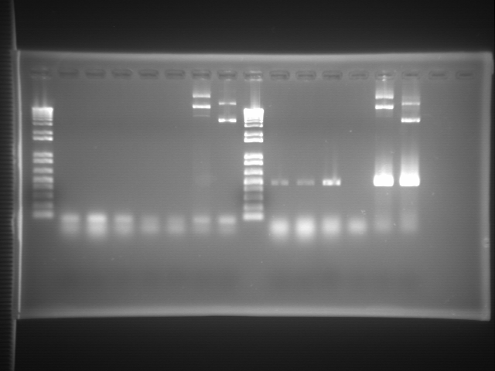

M E1 E2 E3 E4 C1 C2

**Figure. 3: M**: marker

**E1-E4:** samples from stable *Arabidopsis* transgenics containing ECAD promoter.

**C1-C2**: Plasmid samples (+ve controls)

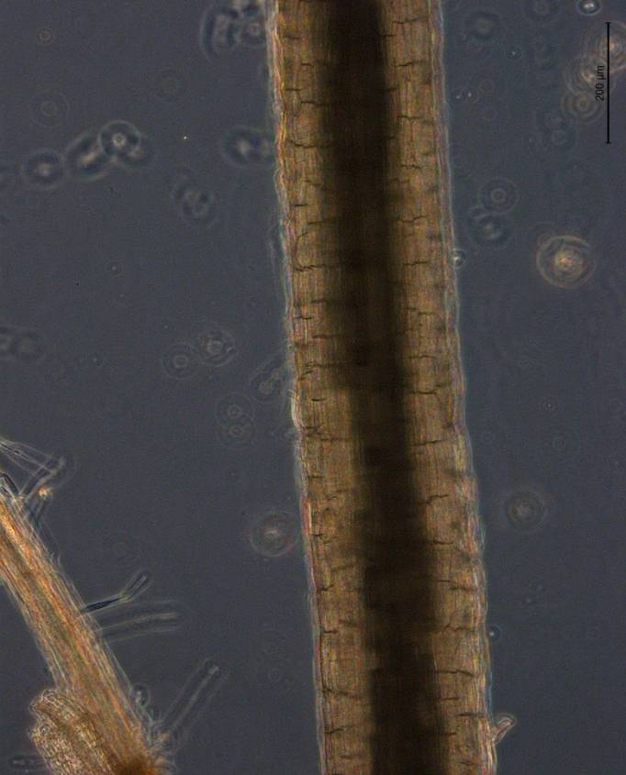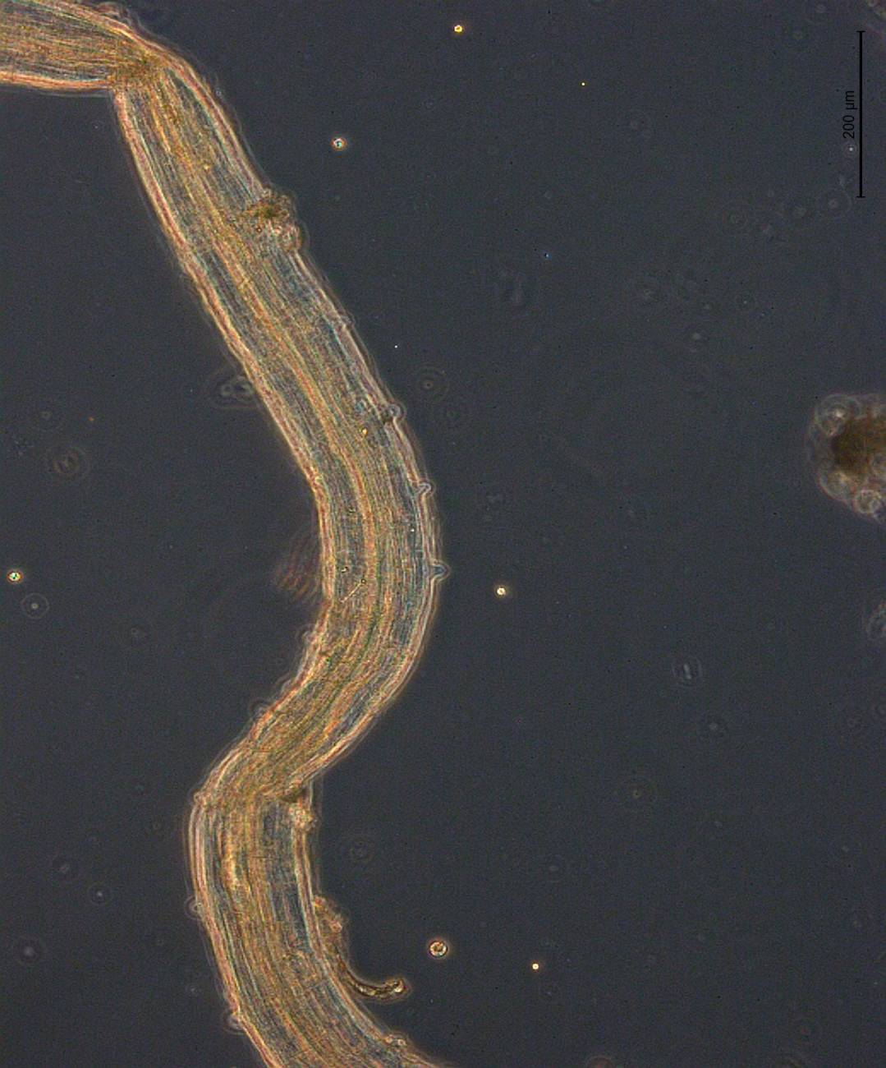

WT ECAD::GUS

**WT** - wild type *Arabidopsis* root tissue; **ECAD::GUS** - root sample from stable *Arabidopsis* transgenics containing GUS fusion to ECAD promoter; **X**-xylem. The roots are stained for GUS and observed under Zeiss dissecting microscope.

**X**

**Table 2**: GWSS insect sequences used for cloning and generation of potato transgenic lines in the variety Desiree.



**Feeding assays:**

In addition to the transgenic plant approaches, based on recent reports in the literature (Killiny and Almeida, 2009, PNAS 106:22416) and personal communications from other scientists, we have evaluated *in vitro* feeding approaches for GWSS (Figure 4). We have successfully tested different feeding methods and have confirmed thus far two highly efficient ways to feed GWSS. These feeding methods will allow for much more rapid screening of candidate sequences for their abilities to induce RNAi effects via oral acquisition. We have a number of candidate sequences which we are testing for RNAi. The candidate sequence targets are cloned into vectors suitable for *in vitro* transcription and the dsRNAs that are made as a result of *in vitro* transcription will be used through the standardized efficient feeding mechanisms we established. These included using basil infusion (basil stems directly inserted into dsRNA solutions) and basil hollow stem method (basil stems are cleared inside). We have used the basil infusion in the past and it offers some advantages as well as disadvantages. The new method we identified presents yet another method to efficiently feed GWSS with dsRNAs. We have tested the GFP PCR product through this new method in comparison to the established basil feeding method and were able to detect the GFP PCR product in equal proportions inside the GWSS insects (Figure 5). The only caveat to the second method, hollow stem method we identified was that the feeding was active from the second day forward as against the feeding behavior on the basil feeding method. We hope to rapidly screen target sequences without having to develop transgenic plants, thereby saving time and effort towards our ultimate goal.

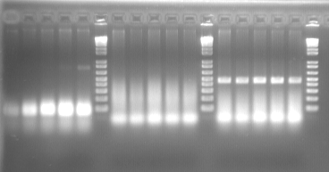

Ubiquitin

GFP

1 2 3 4 5

1 2 3 4 5

**Figure 4:** Comparison of three different feeding assays on GWSS insects. PCR amplification of GFP PCR product from the adult GWSS insects after they are fed with the GFP PCR product in either of the following forms: Tube feeding, Membrane feeding and Basil feeding. 1. Tube fed; 2-3 Membrane fed; 4-5: Basil fed

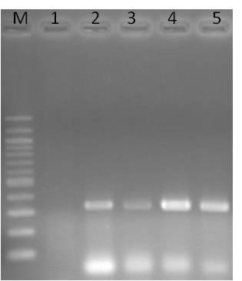

**Figure 5:** Comparison of two different efficient feeding mechanisms on GWSS insects. PCR amplification of GFP PCR product from the adult GWSS insects after they are fed with the GFP PCR product in either of the following forms, Basil feeding method or hollow-stem method. M: marker; 1: control; 2-3: Basil fed; 4-5: Hollow -stem method.

**Next Generation Sequencing of GWSS adult insects:**

The developmental regulation of insects through the use of small RNAs has been well studied. In our efforts to study the regulation of GWSS insect genes and identify RNAi targets, we took an alternate approach using high throughput parallel sequencing to identify the small RNAs from the GWSS insects. For our work, we noticed GWSS transcriptome data is lacking information for the identification of small RNA reads. To address this and identify the loci of the small RNAs that were originated from the short read sequencing, we sequenced the transcriptome of GWSS through the use of mRNA sequence methods as described in Figure 6. The sequencing of GWSS mRNA transcriptome was done through paired end sequencing on Illumina GA-II Platform. Both the mRNAseq library data and the small RNAseq library data were generated from the GWSS adult insects.

The sequencing reads from the transcriptomic data were assembled into scaffolds with a minimum size of 200 bases using Oases transcriptome assembler. We were able to assemble approximately 32.9Mb of the transcriptome across 47,265 loci and 52,708 transcripts. The average transcript length assembled was 624 nucleotides. Roughly 15 million of the total reads were found to be unique for the genome (Table 3) and 51% of the reads were incorporated into the assembly. The sequencing reads were then mapped back to the assembled transcripts with up to one mismatch. The reads that could not be mapped back to the reference assembly are being analyzed for the possible discovery of new viruses that may be infecting the GWSS insects. With the help of these sequencing reads, we aim to study the GWSS insect target genes and we hope to identify the small RNAs that target the GWSS target genes in a highly specific manner.

**Table 3**: Sequencing summary of the GWSS adult insect reads after the quality control



**Figure 6:** Sequencing methodology used for generation of transcriptomic data. Small RNA sequencing was done with Low molecular weight small RNA as starting material. Briefly after size selection, 5’ unique adapters are ligated followed by 3’ adapter ligations. The ligated molecules are used as templates for amplicon enrichment through RT-PCR. The sequencing is then done through one of the adapter primers or both in case of paired end read generation.

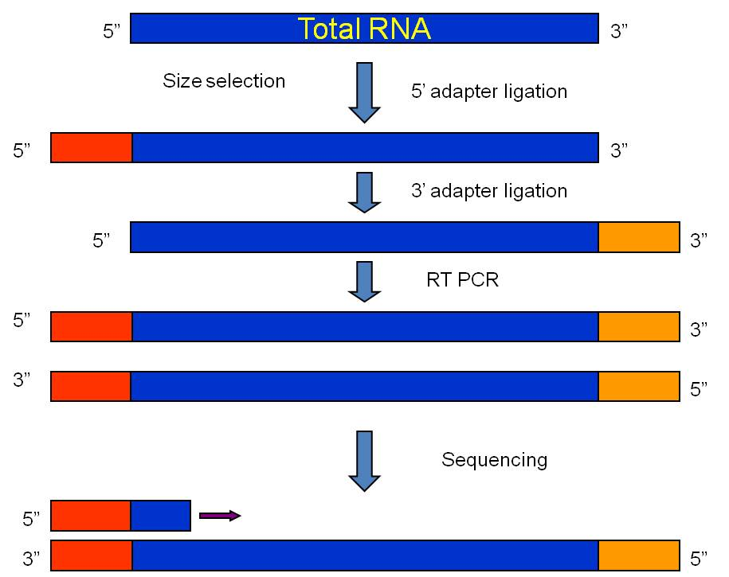

**V. Publications or reports resulting from the project:**

Rosa, C., Kamita, S. G., Dequine, H., Wuriyanghan, H., Lindbo, J. A., and Falk,

B. W. 2010. RNAi effects on actin mRNAs in *Homalodisca vitripennis* cells. J. RNAi Gene Silencing 6:361 – 366.

Rosa C, Kamita, S. G., and Falk, B. W. 2012. RNA-interference is induced in the glassy-winged sharpshooter Homalodisca vitripennis by actin dsRNA. *Pest management science* dec13 (online print available; DOI 10.1002/ps.3253).

Falk, B.W., Choi, S. H., Pitman, T. L., Nandety, R. S., Kamita, S. G.,  Bonning, B., Miller, W. A., Kroemer, J., Stenger, D., and Spear, A. Hemipteran-infecting viruses as tools for vector management.  December 13-15, 2011. Pierce’s Disease symposium, Sacramento, CA.

 Nandety R.S, Pitman T. L, Lin M, Kiss S, Song K and Falk, B.W. Next Generation sequencing and RNAi approaches for the control of Glassy winged Sharpshooters, December 13-15, 2011. Pierce’s Disease symposium, Sacramento, CA.

**VI. Presentations on research:**

Falk, B.W., Choi, S. H., Pitman, T. L., Nandety, R. S., Kamita, S. G.,  Bonning, B., Miller, W. A., Kroemer, J., Stenger, D., and Spear, A. Hemipteran-infecting viruses as tools for vector management.  December 13-15, 2011. Pierce’s Disease symposium, Sacramento, CA.

 Nandety R.S, Pitman T. L, Lin M, Kiss S, Song K and Falk, B.W. Next Generation sequencing and RNAi approaches for the control of Glassy winged Sharpshooters, December 13-15, 2011. Pierce’s Disease symposium, Sacramento, CA.

**VII. Research relevance statement:**

RNAi is a natural biological activity for controlling gene expression and anti-viral defense in a majority of eukaryotic organisms, including insects. The application of RNAi directed toward the control of different types of insect plant pests is becoming more feasible and promising. In our efforts, we were able to induce RNAi in *H. vitripennis* cells lines and whole insects, and are evaluating using transgenic plants as a means to initiate RNAi to help control the glassy winged sharpshooter and other leafhopper vectors of *Xylella fastidiosa*. RNAi is already used in commercial agriculture for plant virus control, and the many new publications demonstrating experimental successes with various plant-feeding insects suggest that RNAi could have a role in helping to manage Pierce’s Disease of grapevines.

**VIII. Lay persons summary of current year’s results:**

This work presents fundamental efforts towards understanding the feasibility of applying RNA interference (RNAi), to help combat Pierce’s Disease of grapevines. Pierce’s Disease is a significant threat to grape production in California and other parts of the U.S., and the causal agent, *Xylella fastidiosa*, a xylem-limited bacterium, also causes several other extremely important plant diseases worldwide. Our effort here does not directly target *Xylella fastidiosa*, but instead targets one of its most significant insect vectors, the Glassy-winged sharpshooter, *Homalodisca vitripennis*, and other sharpshooter vectors of *X. fastidiosa*.

We made our efforts focused this year on evaluating the transgenic plants for production of small RNAs that target the GWSS targets and have identified the lines in potatoes that can generate small RNAs which can target the GWSS targets. Potatoes and a model plant that we are using are much easier and faster to transform and regenerate than grapes, which can be readily fed to GWSS insects for oral acquisition of small RNAs that can target some of their genes. We also have made good progress toward developing an efficient, rapid non-plant-based delivery system. Apart from the above mentioned accomplishments, we have generated large scale genomic data for the identification of GWSS targets which will help us gear towards the control.

**IX. Status of funds:**

We were awarded two years funding to support one postdoctoral scientist (Dr. Raj Nandety is the lead postdoc on this project), a graduate student/part time technician, an undergraduate intern, plus funds for standard benefits. We also requested funds for routine supplies, recharge facility (Biosafety 3P Contained Research Facility) recharge costs and limited travel. We were awarded two years of funding including; $121,037 and $126,773 for years one and two, respectively. We are on track, spending wise, to use the funds as proposed in our original proposal budget, and anticipate that the funds requested for year two are appropriate for our project.

**X. Summary and status of intellectual property produced during the research project:**

We will work with UC for managing any intellectual property or technologies that may arise from this effort. We submitted an overview of our work for evaluation by the UC Davis Technology Transfer team, they declined to pursue it at this time.

**References cited.**

1. Davis, M.J., A.H. Purcell, and S.V. Thomson, *Pierce's disease of grapevines: isolation of the causal bacterium.* Science, 1978. **199**(4324): p. 75-7.

2. Myers, A.L., et al., *Pierce's Disease of Grapevines: Identification of the Primary Vectors in North Carolina.* Phytopathology, 2007. **97**(11): p. 1440-50.

3. Gordon, K.H.J. and P.M. Waterhouse, *RNAi for insect-proof plants.* Nature Biotechnology, 2007. **25**(11): p. 1231-1232.

4. Scharf, S.H.a.M., *Genetic pesticide developed in UF lab*, in *UF News*, U. News, Editor. 2008.

5. Meister, G. and T. Tuschl, *Mechanisms of gene silencing by double-stranded RNA.* Nature, 2004. **431**: p. 343-349.

6. Blandin, S., et al., *Reverse genetics in the mosquito Anopheles gambiae: targeted disruption of the Defensin gene.* EMBO, 2002. **3**(9): p. 852.

7. Blair, C.D., et al., *Rendering Mosquitoes Resistant to Arboviruses through RNA Interference.* MICROBE-AMERICAN SOCIETY FOR MICROBIOLOGY, 2006. **1**(10): p. 466.

8. Ciudad, L., M.D. Piulachs, and X. Belles, *Systemic RNAi of the cockroach vitellogenin receptor results in a phenotype similar to that of the Drosophila yolkless mutant.* FEBS J., 2006. **273**(2): p. 325-335.

9. Dzitoyeva, S., N. Dimitrijevic, and H. Manev, *Intra-abdominal injection of double-stranded RNA into anesthetized adult Drosophila triggers RNA interference in the central nervous system.* Molecular psychiatry, 2001. **6**(6): p. 665-670.

10. Rajagopal, R., et al., *Silencing of midgut aminopeptidase N of Spodoptera litura by double-stranded RNA establishes its role as Bacillus thuringiensis toxin receptor.* Journal of Biological Chemistry, 2002. **277**(49): p. 46849-46851.

11. Sim, C. and D.L. Denlinger, *A shut-down in expression of an insulin-like peptide, ILP-1, halts ovarian maturation during the overwintering diapause of the mosquito Culex pipiens.* Insect Molecular Biology, 2009. **18**(3): p. 325-332.

12. Mauricio R.V. Sant’Anna, B.A., Paul A. Bates, Rod J. Dillon, *Gene silencing in phlebotomine sand flies: Xanthine dehydrogenase knock down by dsRNA microinjections.* Insect Biochemistry and Molecular Biology **38**(6): p. 652-660.

13. Bettencourt, R., O. Terenius, and I. Faye, *<i>Hemolin</i> gene silencing by ds-RNA injected into Cecropia pupae is lethal to next generation embryos.* Insect Molecular Biology, 2002. **11**(3): p. 267-271.

14. Mutti, N.S., et al., *A protein from the salivary glands of the pea aphid, Acyrthosiphon pisum, is essential in feeding on a host plant.* Proceedings of the National Academy of Sciences. **105**(29): p. 9965.

15. Araujo, R.N., et al., *The role of salivary nitrophorins in the ingestion of blood by the triatomine bug Rhodnius prolixus (Reduviidae: Triatominae).* Insect Biochemistry and Molecular Biology, 2009. **39**(2): p. 83-89.

16. Cooper, D.M., C.M. Chamberlain, and C. Lowenberger, *Aedes FADD: A novel death domain-containing protein required for antibacterial immunity in the yellow fever mosquito, Aedes aegypti.* Insect Biochemistry and Molecular Biology, 2009. **39**(1): p. 47-54.

17. Murad Ghanim, S.K., Henryk Czosnek, *Tissue-specific gene silencing by RNA interference in the whitefly Bemisia tabaci (Gennadius).* Insect Biochemistry and Molecular Biology **37**(7): p. 732-738.

18. Mitchell Iii, R.D., et al., *Molecular characterization, tissue-specific expression and RNAi knockdown of the first vitellogenin receptor from a tick.* Insect Biochemistry and Molecular Biology, 2007. **37**(4): p. 375-388.

19. Arakane, Y., et al., *Analysis of functions of the chitin deacetylase gene family in Tribolium castaneum.* Insect Biochemistry and Molecular Biology. **39**(5-6): p. 355-365.

20. Rosa, C., et al., *RNAi effects on actin mRNAs in Homalodisca vitripennis cells.* J RNAi Gene Silencing, 2010. **6**(1): p. 361-6.

21. Rosa C, Kamita, S. G., and Falk, B. W. 2012. RNA-interference is induced in the glassy-winged sharpshooter Homalodisca vitripennis by actin dsRNA. *Pest management science* dec13 (online print available).

**Funding Agencies:** Funding for this project was provided by the USDA-funded University of California Pierce’s Disease Research Grants Program.