California Department of Food and Agriculture PD/GWSS
Progress Report
March 2013

Report title: Renewal Progress Report for CDFA Agreement Number 10-0277
Project Title: Molecular characterization of the putative Xylella fastidiosa resistance gene(s) from b43-17 (V. arizonica/candicans).

Principal Investigator and Cooperating Staff: M. Andrew Walker, Cecilia Agüero, and Summaira Riaz, Dept. of Viticulture & Enology, University of California, One Shields Ave., Davis, CA 95616-8749, awalker@ucdavis.edu, 530-752-0902

Cooperator: Abhaya M Dandekar, Dept. of Plant Sciences, University of California, One Shields Ave., Davis, CA 95616-8749, amdandekar@ucdavis.edu, 530- 752-7784

Reporting period: to March 2013

INTRODUCTION
New cultivars bred to resist Xylella fastidiosa infection and subsequent expression of PD symptoms will provide long-term sustainable control of PD. Disease resistant cultivars can be obtained by conventional breeding through the introgression of resistance from Native American species into elite vinifera wine and table grapes. Another approach is “cisgenesis” – the transformation of elite V. vinifera varieties with grape resistance genes and their native promoters, cloned from disease resistant American Vitis species. The cisgenic approach may have a more limited impact on the genome of the elite V. vinifera parent since single genes from the Vitis species genome would be added to the elite parent, thus limiting the impact on its fruit and wine quality while making it PD resistant. The cisgene approach in grapes is similar to the natural clonal variation that exists in many winegrape cultivars. This linkage-drag-free approach is attractive, and also allows the opportunity to stack additional resistance genes from other Vitis sources, even if these genes originate from the same chromosomal position in different species or accessions (Jacobsen and Hutten 2006). The physical mapping of the resistance region from V. arizonica/candicans b43-17, PdR1, allowed the identification of potential candidate resistance gene(s). Preliminary comparisons indicated that the PdR1 region contains multiple tandem repeats of Serine Threonine Protein Kinase with a LRR domain (STPK-LRR) gene family. This category of genes belongs to a group involved in plant resistance. Their defense mechanism is based on compounds involved in the recognition of microbe-associated molecular patterns (MAMP) like compounds, which initiate a defense response (Bent and Mackey 2007). In order to gain insight and to verify the function of resistance gene(s), cloning and functional characterization is required. In this report, we present the progress on the cloning and testing of five candidate resistance genes.

OBJECTIVES
- Cloning, structural analysis and gene annotation via comparison of the PdR1b locus to the susceptible Pinot noir genome sequence using the assembled sequence of the BAC clone H64J14.
- Expression studies of candidate genes.
- Development of alternative protocols for genetic transformation for the validation of gene constructs
- Agrobacterium-meditation transformation of the susceptible Vitis cultivars (Chardonnay and Thompson Seedless, and the rootstock St. George).
- Transformation of tobacco.

RESULTS
Genetic transformation for the validation of gene constructs / Development of alternative protocols. Once the gene constructs are completed, they must be tested to see if they contain the resistance genes. This is done by inserting the genes into a susceptible plant and testing to see if the insertion makes results in resistant plants. Currently the most widely used method for the production of transgenic/cisgenic grapes is based on Agrobacterium transformation followed by regeneration of plants from embryogenic callus. We have established cultures of pre-embryogenic callus derived from anthers of V. vinifera Thompson Seedless and Chardonnay and the rootstock V. rupestris St. George that have been used for transformation (Agüero et al. 2006).

PdR1b candidate genes were amplified using Phusion high-fidelity DNA polymerase (Finnzymes), cloned into pGEM-T easy vector (Promega) and sequenced at UC Davis Sequencing Facility. After sequence verification, genes were subcloned into binary vector pCambia 1303 (www.cambia.org) containing the 35S cauliflower mosaic virus promoter, the nopaline synthase terminator and an hptII-selectable marker gene (Figure 1). PdR1b.1 was also subcloned into binary vector pDU99.2215 containing an ntpII selectable marker gene. The resulting plasmids were transformed into disarmed A. tumefaciens EHA105 pCH32 by electroporation and used for transformation of Chardonnay, Thompson Seedless, and St. George.

pBR322ori
PdR1b
35S pro
nos poly-A
hptII
35S pro’
RB
Kan
35S poly-A
LB

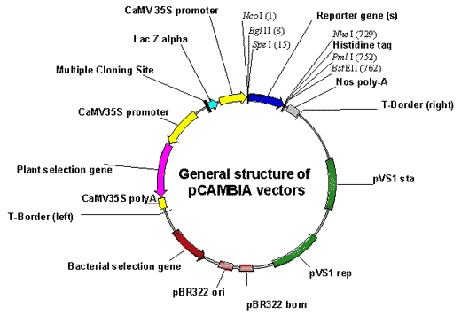

Figure 1. Schematic representation of binary plasmid

To speed the functional analysis, we have also transformed the tobacco variety SR1 which was recently demonstrated to be a susceptible host for X. fastidiosa and is much easier and quicker to transform and test (Francis et al. 2008). Transgenic tobacco plants carrying each candidate gene (9-10 independent lines per gene) have been produced at the UC Davis Transformation Facility and multiplied in vitro in our lab. Genomic DNA was isolated from plants of each line with DNeasy Plant Mini Kit (Qiagen). A primer that binds the CaMV 35S promoter and a primer that binds the coding region of each PdR1b candidate were used in combination for PCR amplification to verify the presence of the transgene. All candidate genes amplified successfully with exception of PdR1b.1 sublcloned into pDU99.2215.

Preliminary experiments have been conducted to establish the best screening method for tobacco. Pin prick inoculation of the stem resulted in the best procedure when compared with inoculations on the base of leaves, either through pin prick or incision. In our large-scale experiments, the fragility of tobacco leaves resulted in several inoculated leaves tearing before the experiment was ended, which made symptoms and ELISA results unreliable. However, pin prick inoculation of the stem required more time for symptoms to develop; as a consequence plants needed to be cut back every 4 weeks. Figure 2 shows a scheme of the methodology chosen. Plants are pin pricked inoculated two times, one week apart. Each time, 20 μl of a water suspension of the Beringer strain (OD600=0.25), are inoculated on the second or third node on both sides of the stem. Symptoms are scored on a 5-point scale and stem tissue above the cut is collected and analyzed through ELISA every 4 weeks.

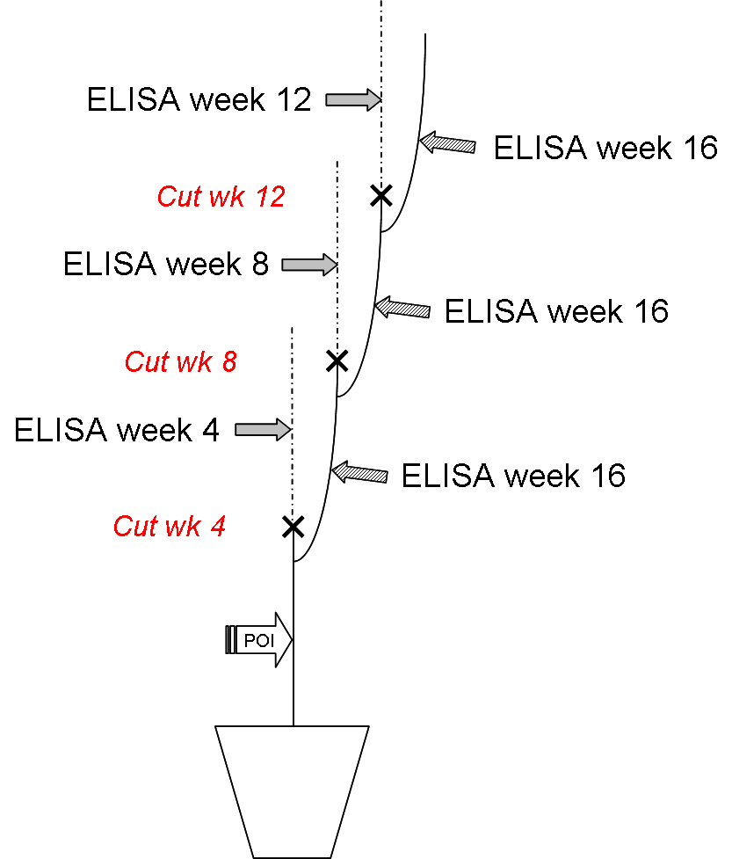

Figure 2
Transgenic tobacco plants have been acclimated to greenhouse conditions for testing against X. fastidiosa. They are tested in batches due to greenhouse space availability, each group including 5 replicants of 2-3 independent lines of 3 candidate genes. Two additional plants / line are inoculated with water. Untransformed plants are subjected to the same treatments. Preliminary results are shown in Figure 3 and 4.

Fig 3. PD symptoms in tobacco / Fig 4. Mean X. fastidiosa bacteria in 6 tobacco genotypes tested 12 weeks after inoculation. U is inoculated untransformed; H2O is inoculated with water.

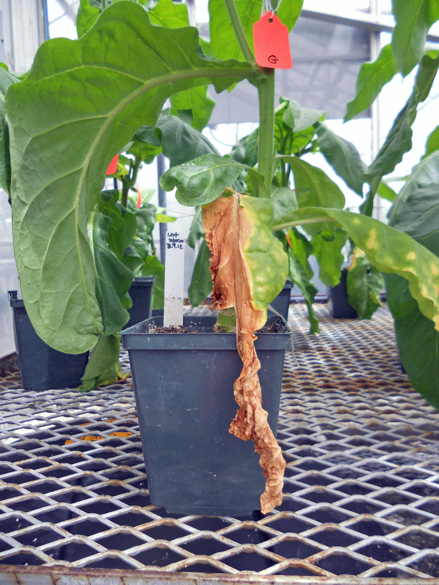

Embryogenic calli of Thompson Seedless, Chardonnay and St George transformed with the 5 candidate genes selected in medium with antibiotics have been subcultured to germination medium and are regenerating plants (Figure 5). The presence of the genes has been verified in some callus through PCR and will be tested again in plants. For each gene, we expect to produce, at least 10 independent lines that will be subsequently propagated clonally to 6 plants per line and tested under greenhouse conditions this summer. PD resistance analysis will be performed via ELISA screening, which is a routine technique in the Walker lab. All procedures of the ELISA screening are described in previous publications (Krivanek and Walker 2005). Table 1 shows the number of independent lines that have been obtained at present. Because, we have 20-40 independent lines growing in selection medium, we expect at least 10 independent lines per gene and genotype.
.

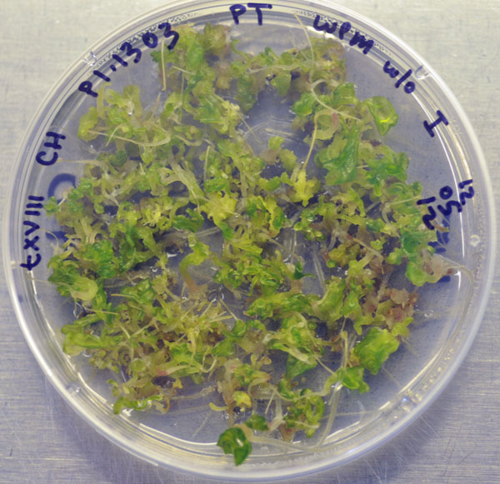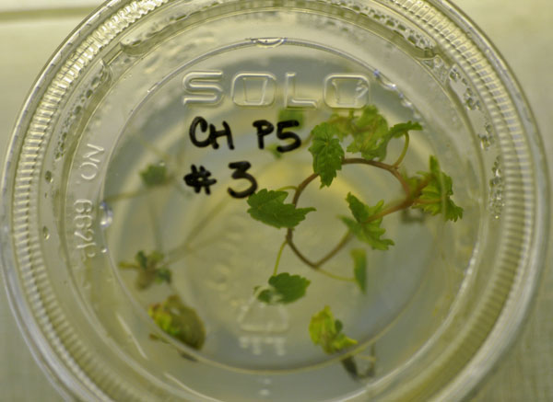

Figure 5. Chardonnay germinating embryos (left) and plantlet in vitro (right)

Table 1. Number of independent lines produced as of February 2013.

 | Chardonnay | Thompson Seedless | St George
P1 pDU 99.2215 | 4 | 0 | 0
P1 pCambia1303 | 5 | 0 | 11
P2 pCambia1303 | 0 | 0 | 0
P4 pCambia1303 | 4 | 0 | 1
P5 pCambia1303 | 4 | 1 | 0
P6 pCambia1303 | 2 | 6 | 1

Two alternative transformation techniques via organogenesis were tested to reduce the time needed to produce transgenic grapes. These methods have been developed in Thompson Seedless and are based on the use of meristematic bulks (MB) or etiolated meristems (EM) as explants for inoculation with A. tumefaciens (Mezzetti et al. 2002, Dutt et al. 2007). Transgenic plants of Thompson Seedless expressing GFP were produced in 3 months using MB while no plants were regenerated from EM. Based on these results, it was decided to focus on testing the production of St. George and Chardonnay MB, which was successful only with the latter.

Thompson Seedless and Chardonnay MB were inoculated with A. tumefaciens carrying PdR1b.4 in pCAMBIA 1303 using 3 initial levels of hygromicin: 5, 10 and 15 ug/ml. Hygromicin concentration was then increased gradually up to 25 ug/ml with each subculture. Since MB didn’t grow with any of the concentrations tested we are now assaying 0 ug/ml in the first step after inoculation followed by 2.5 ug/ml hygromicin.

Transformation of pre-embryogenic cultures or MB have been performed with A. tumefaciens EHA105 pCH32, carrying binary plasmids with PdR1b coding sequences. Overnight cultures of the bacteria in LB medium + antibiotics are diluted to 10⁸ cells·ml⁻¹ using liquid co-cultivation medium. Pre-embryogenic calli are placed on a sterile glassfiber filter (GFF) overlaid on co-cultivation medium. The Agrobacterium culture is poured over the callus and excess is blotted with sterile filter paper after 5 min. MB slices are dipped in bacteria suspension for 10 minutes. Pre-embryogenic callus or MB are then transferred onto fresh co- cultivation medium. After 48 h in the dark, MB or callus pieces, sub-divided into clumps of about 2 mm in diameter, are cultured on selection medium containing 100 ug/ml kanamycin or 0-15-25 ug/ml hygromicin for pre-embryogenic callus; or 0-2.5 ug/ml hygromicin for MB.

CONCLUSIONS
The last step in the characterization of a resistance gene is to verify that the isolated gene functions in a host plant. This process requires that the gene is transformed into a susceptible host and challenged by the disease agent. Agrobacterium-based transformation can be used with grape but initiating transformable and regenerable tissue is often a problem with grape. We have cloned 5 PdR1b candidate genes and used them in genetic transformation of tobacco and preembryogenic callus of Chardonnay, Thompson Seedless and St. George to produce transgenic plants for use in testing the PdR1b candidates. Plants of transformed tobacco with PdR1b.1, 2, 4, 5 and 6 have been obtained and are currently being tested against Xylella in the greenhouse. To reduce the time span for generating healthy transgenic plants we are also testing a method that employs organogenesis for Agrobacterium-mediated transformation. We also initiated total RNA extraction experiments to allow time course examinations of gene function from leaf and stem tissues. These were successfully completed and we are now ready to evaluate gene function over time in inoculated and un-inoculated plants of the PdR1 containing resistant selections F8909-08 and F8909-17, their resistant parent b43-17, their susceptible parent V. rupestris A. de Serres, and the susceptible control Chardonnay. These plants have been established in the greenhouse and will be inoculated later this summer.

PUBLICATIONS AND PRESENTATIONS
Abstracts
Agüero C.B., Riaz S., Hwang C-F, He R., Hu R., Bistue C., Walker M.A. Map-based cloning of Pierce’s disease and Xiphinema index resistance genes from Vitis arizonica. ASEV 63nd National Conference. Portland, Oregon, 6/18-22/2012.
Walker M.A., Riaz S., Agüero C., Bistue C. 2012 Molecular characterization of the putative Xylella fastidiosa resistance gene(s) from b43-17 (V. arizonica/candicans). Poster presentation Pierce’s Disease Research Symposium. Sacramento, 12/13-15/2012
Presentations
Breeding for pest and disease resistance. Ag Unlimited Annual Meeting, Napa, CA March 1, 2012.
Breeding resistant grapevines. Recent Advances in Viticulture and Enology, UC Davis, CA, March 15, 2012.
Current issues in grape diseases and pests. Wine Executive Program, UC Davis, CA, March 27, 2012.
Grape breeding for new rootstocks and winegrapes. University of Chihuahua, Mexico, March 29, 2012.
Advances in scion and rootstock breeding. Sonoma Vit Tech Group, Santa Rosa, CA, May 16, 2012.
Overview of the Walker grape breeding program. Board of Visitors and Fellows, UC Davis, May 18, 2012.
Breeding programs from around the world: what is their likely contribution. ASEV Alternative Varieties Symposium, Portland, OR, June 19, 2012.
Advances in scion and rootstock breeding. Coppola Grower Meeting, Healdsburg, CA, July 17, 2012.
Advances in rootstock and scion breeding. Roll Global Meeting, UC Davis, August 16, 2012.
Breeding new rootstocks and fruiting varieties. VEN 290 Seminar, UC Davis, November 2, 2012.
UC Davis grape breeding program. INIA Seminar, Santiago, Chile, December 13, 2012.

RESEARCH RELEVANCE
This research is focused on demonstrating whether PD resistance genes developed from genetic and physical mapping efforts function when transformed into susceptible host plants. These transformations are underway in tobacco (an easily used model system) and susceptible grape (Chardonnay, Thompson Seedless and St. George). These studies will lay the foundation to understanding how these resistance genes work, and may provide a tool to genetically engineer cisgenically resistant grapevines.

LAYPERSON SUMMARY
We maintain and characterize many populations while breeding PD resistant wine grapes, some of which have been used to develop genetic maps. These maps have been used to identify genetic markers that are tightly linked with PD resistance, which have allowed classical breeding to be greatly expedited through marker-assisted selection. Genetic maps allow the construction of physical maps to identify resistance genes (Riaz et al. 2008; Riaz et al. 2009). The physical map of the b43-17 resistance region allowed us to identify candidate genes responsible for PD resistance. Comparisons with plant genomes indicated that multiple tandem repeats of the disease resistance gene family Receptor-like proteins with LRRs domains were present in the resistance region. This category of genes is involved in the recognition of microbes and in the initiation of defense responses (Bent and Mackey 2007). We completed the cloning of five candidate genes: PdR1b.1, 2, 4, 5 and 6 and confirmed their sequence. We also developed embryogenic callus cultures of PD susceptible Chardonnay and Thompson Seedless and rootstock St. George for genetic transformation to verify candidate PD resistance gene function. PdR1b.1, 2, 4, 5 and 6 have been used in transformation of tobacco and grape. Tobacco plants transformed with PdR1b.1, 2, 4, 5 and 6 are currently being tested against Xylella in the greenhouse. Transformed embryogenic callus of grape are producing plants that are expected to be tested this summer. We are also testing another technique to speed the development of transgenic tissue from meristematic bulks that will allow PdR1 gene candidates to be tested in a much broader range of genotypes. The current transgenic grape plants were produced using the traditional procedure and we expect to test them this summer under greenhouse conditions.

Status of Funds: These funds are scheduled to be spent by the end of the grant.

Intellectual Property: The resistance genes identified in this research will be handled by PIPRA, UC Davis.

LITERATURE CITED

Agüero CB, Meredith CP, Dandekar AM (2006) Genetic transformation of Vitis vinifera L. cvs Thompson Seedless and Chardonnay with the pear PGIP and GFP encoding genes. Vitis 45:1-8
Bent AF and Mackey D (2007) Elicitors, effectors, and R genes: the new paradigm and a lifetime supply of questions. Ann. Rev. Phytopath. 45, 399–436
Dutt M, Li ZT, Dhekney SA, and Gray DJ (2007) Transgenic plants from shoot apical meristems of Vitis vinifera L. ‘Thompson seedless’ via Agrobacterium-mediated transformation. Plant Cell Rep. 26: 2101-2110
Francis M. Civerolo E.L., Bruening, G. (2008) Improved bioassay of Xylella fastidiosa using Nicotiana tabacum Cultivar SR1. Plant Disease 92:14-20.
Iandolino AB, Goes Da Silva F, Lim H, Choi H, Williams LE, and Cook DR (2004) High-quality RNA, cDNA, and derived EST libraries from grapevine (Vitis vinifera L.). Plant Molec. Biol. Rep. 22: 269-278.
Jacobsen J and Hutten R (2006) Stacking resistance genes in potato by cisgenesis instead of introgression breeding. In: N.U. Haase and A.J. Haverkort, Editors, Potato Developments in a Changing Europe, Wageningen Academic Publishers (2006), pp. 46–57
Mezzetti B, Pandolfini T, Navacchi O and Landi L (2002) Genetic transformation of Vitis vinifera via organogenesis, BMC Biotechnol. 2:18
The French-Italian Public Consortium for grapevine Genome Characterization (2007) The grapevine genome sequence suggests ancestral hexaploidization in major angiosperm phyla. Nature 449: 463-467
Riaz S, Tenscher AC, Rubin J, Graziani R, Pao SS and Walker MA (2008) Fine-scale genetic mapping of Pierce’s Disease resistance loci (PdR1a and PdR1b) and identification of major segregation distortion region along Chromosome 14 in grape. Theor. Appl. Genet. 117:671-681.
Riaz S, Tenscher AC, Graziani R, Krivanek AF, Walker MA (2009) Using marker assisted selection to breed for Pierce’s disease resistant grapes. Am. J. Enol. Viticult. 60:199-206.

