California Department of Food and Agriculture PD/GWSS

Progress Report

March 2013

Report title: Renewal Progress Report for CDFA Agreement Number 03-0282

Project Title: Genetic mapping of Xylella fastidiosa resistance gene(s) in grape germplasm from the southern United States.

Principal Investigator and Cooperating Staff: M. Andrew Walker and Summaira Riaz, Dept. of Viticulture & Enology, University of California, One Shields Ave., Davis, CA 95616-8749, awalker@ucdavis.edu, 530-752-0902

Reporting period: primarily October 2012 to March 2013

INTRODUCTION
This project provides the genetic support to enable our successful molecular breeding efforts (see companion PD breeding project). Identification, understanding and manipulation of novel sources of resistance are the foundation of a successful breeding program. We are exploring multiple genetic backgrounds for Pierce’s disease (PD) resistant grape breeding, developing and testing breeding populations via a greenhouse screen, carrying out genetic mapping of segregating populations to identify genomic regions that carry disease resistance genes, and developing physical sequence maps of resistance regions to identify and characterize grape resistance genes. We have initiated and completed mapping of a major PD resistance locus originating from V. arizonica/candicans b43-17, which is the basis of our PD breeding efforts. We are pursuing two other resistant V. arizonica forms: b42-26 V. arizonica/girdiana from Loreto, Baja California; and b40-14 V. arizonica from Chihuahua, Sonora. Although they are morphologically different than b43-17, they both posses strong resistance to PD and greatly suppress X. fastidiosa levels in stem tissue after greenhouse screening. Nine new populations were developed with five newly identified PD resistant plant material. The breeding part of the program produces and greenhouse screens the seedling populations. While the tightly linked genetic markers generated in these mapping efforts are being used to optimize and greatly accelerate the PD breeding program. These markers are essential to the successful introgression of resistance from multiple sources, and thus for the production of durably resistant grapevines. In response to recommendations from the CDFA-PD board and reviewer recommendations to broaden resistance, we have expanded the search for additional resistance sources by screening wide germplasm collected from different parts of US and Mexico. Initial greenhouse screen results indicate that we have twenty other accessions that possess strong PD resistance.

OBJECTIVES
- Fine scale mapping of additional QTL for PD resistance in the 04191 ((F2-7 x F8909-17) population (Completed)
- Greenhouse screen and genetically map PD resistance from other forms of V. arizonica: b42-26 (V. arizonica /girdiana) and b40-14 (V. arizonica).
- Evaluate V. germplasm collected from across the southwestern US to identify accessions with unique forms of PD resistance for grape breeding. Determine the inheritance of PD resistance from Muscadinia rotundifolia, develop new and exploit existing breeding populations to genetically map this resistance.
4. Complete the physical mapping of PdR1a and PdR1b and initiate the sequencing of BAC clones that carry PdR1a gene candidates.

RESULTS
Objective 1. A framework genetic map of the 04191 population (V. vinifera F2-7 x F8909-17) was developed to identify minor quantitative trait loci (QTL) contributing to PD resistance other than the PdR1a locus. A total of 139 SSR markers representing all 19 chromosomes were added to a set of 150 progeny. QTL analysis confirmed a major locus PdR1a on chromosome 14, and identified a minor QTL (PdR2) on chromosome 19. PdR2’s LOD score was 2.3 and it explains 7% of the phenotypic variation, which peaks at marker CB918037 (See previous report). This QTL is within a 10 cM interval – a relatively long genetic distance to be effective in marker assisted screening. To shorten the genetic distance between the markers, additional markers were developed and applied to the map. The positions of marker UDV023, CB918037, and VMC5e9 on the genome sequence are at 2,346,119, 2,974,668 and 4,182,806 bp, respectively. This provided us with 1.783 Mbp of sequence to develop 7 SSR primers in this region. Three of the seven tested primers gave clean amplifications with polymorphism for F8909-17 PD resistant parent. These markers were added to the population of 150 seedlings. We are in the process of completing the analysis. Identification of this minor QTL is important to further our understanding of how PD resistance works and allow us to understand genetic interactions among the major and minor resistance genes. In order to study the impact of minor QTL, we made two crosses with 04373-02 and 04373-22 and Pinot blanc. The goal is to discard all those plants that carry the PdR1a locus, greenhouse screen all other plants to test their level of resistance to PD and use these populations to study and verify the PdR2 region without interactions with the PdR1 locus. A total of 100 plants were screened with SSR markers and 43 plants were planted in the field in Spring 2012. These plants will be greenhouse screened in 2013.

Objective 2. A total of 918 SSR primers were tested, 763 amplified b42-26 DNA successfully, and 180 markers were polymorphic. The level of polymorphic markers is relatively low at 23%. We have not observed such a low level of polymorphism in any other genotype so far. Because the main focus of the work is to develop a genetic linkage map of the resistant parent, only markers that are polymorphic for b42-26 were used. We have completed 173 of polymorphic markers on the entire population of 239 progeny – an additional 48 markers since the previous report. A framework map with 125 markers was developed (See previous report for framework map of b42-26). The 125 markers grouped into 18 linkage groups; no marker was polymorphic for chromosome 6. For three linkage groups, markers were not mapped due to the large distance between them. A genetic map with 180 markers will be complete by the next reporting period. Our goal is to obtain an average distance between markers below 5 cM for QTL analysis.

Greenhouse screening was completed on 164 accessions, however results were not conclusive due to uneven greenhouse temperatures. We have observed that the severity of the greenhouse screen is much more pronounced in the hot summer months. For traits that segregate quantitatively, it is extremely important to obtain consistent phenotypic data. We are repeating the greenhouse screen for this population. For this purpose, we have made 4-5 reps of each seedling from green cuttings, and 160 genotypes and have been inoculated. ELISA sampling is scheduled for March 15, 2013.

A single dominant gene controls resistance to PD in V. arizonica b40-14. Two resistant siblings of this population were used to develop the 07388 (R8918-02 x V. vinifera) and 07744 (R8918-05 x V. vinifera) populations. 227 markers were polymorphic for one of the parents; 152 were analyzed on the entire set of 122 plants; a framework map of R8918-05 was produced with MAP QTL (4.0). PD resistance mapped only on chromosome 14 – the same chromosome where PdR1a and PdR1b mapped. PD resistance from b40-14 (which we have named PdR1c) maps in the same general region as PdR1a and PdR1bbetween flanking markers VVCh14-77 and VVIN64 and within 1.5 cM. The LOD threshold for the presence of this QTL was 33 and 82% of the phenotypic variation was explained (Fig. 2).
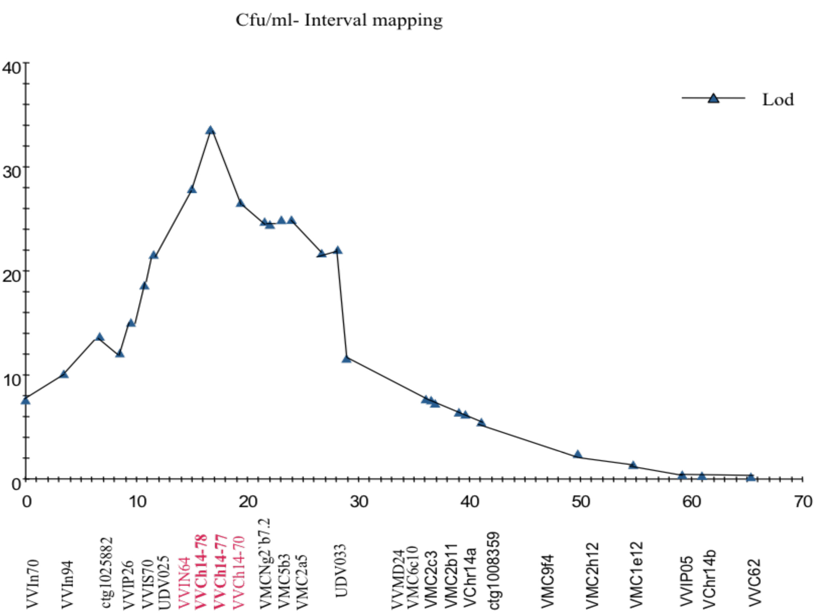

Fig. 1. Interval mapping of PdR1 indicating a peak at LDD 34.0 with a 95% confidence interval. The X-axis indicates the position of the markers; LOD values are plotted on the Y-axis.

Objective 3. Many V. species growing in the southeastern US are resistant to PD and have been used in breeding programs by grape breeders. For example, multiple accessions of V. champinii and the complex hybrid BD5-117 are known to have resistance to PD. It has been thought that southeastern germplasm co-evolved with X. fastidiosa and develop resistance to this disease. Our focus has been on 3 accessions of V. that Olmo collected in northern Mexico in 1960. These three accessions are complexes of multiple V. species and it is not known which particular species is controlling PD resistance. This point is confounded by the complete fertility among the V. species and the great number of hybrids that occur in the wild. It is extremely important for a breeding program to incorporate multiple unique resistance mechanisms, understand genetic diversity, and the mode of inheritance to facilitate decision making for resistance breeding. I have been expanding our southwest grape species collections and now have more than 250 accessions from PD infested areas in Texas, New Mexico, Arizona, Nevada and California. Previously, fifty-two accessions from across this geographic range (including the fifteen accessions from Mexico) were greenhouse screened. This screening found 22 other accessions with high resistance (See previous report).

To determine the inheritance and nature of resistance of the best forms, we made crosses in 2012 to develop breeding lines with five of the most resistant germplasm. ANU05 was collected from Mohave, AZ. The accession b41-13 and b40-29 are similar to b42-26. The accession b47-32 loosely groups with b43-17. Seeds of these populations are being processed for Spring 2013 planting. Nine different crosses produced over 1600 seeds and we are now planting small subsets from nine different crosses (Table 1). These will be tested with SSR markers to exclude off-type genotypes. True to cross seedlings will be transferred to the field and plants will be tested for PD resistance in Fall 2013 to determine the mode of inheritance of PD resistance from each resistant parent.

Table 1. Small subset of seedlings from nine different crosses.
Resistant parent | Susceptible parent
 | 08319-07 | 08319-29 | 08326-61 | Alicante Bouschet
ANU05 |  |  |  | 100
b40-29 | 15 | 19
b41-13 | 9 | 16
b46-43 | 16 | 100
b47-32 | 10 |  | 30
Total | 50 | 135 | 30 | 100

In order to better understand the nature of PD resistance and the genetic diversity and gene flow of grape species in the southern US and Mexico, we are examining a diverse collection of species from these areas. One of the objectives is to determine whether PD resistance from the Gulf states and southeastern US is similar to that of eastern coastal (and wet) Mexico. And whether this eastern resistance differs from PD resistance found in the southwestern US and central (and drier) Mexico. We are examining a collection of 159 accessions of these species, which includes Olmo’s Mexico collections (which he sampled across northern and central Mexico from the west to the east) (Table 2). We have added 88 accessions to the list since the October 2012 report. DNA was collected from all those genotypes and six V. vinifera accessions were added as outliers.

Table 2. List of germplasm under PD resistance and fingerprint analysis evaluation.
Accession name | Species ID | State/Country
A14 |  | AZ
A20 |  | AZ
C23-94 |  | AZ
SAZ 7 |  | San Rafael Valley, AZ
A1 |  | AZ
A28 |  | AZ
TXNM0812 | arizonica | NM
T10 | acerifolia/doaniana | TX
T13 | acerifolia | TX
Tx12-001 |  | TX
TX12-002 |  | TX
NM03-17SO1 | treleasei | NM
PS RUPESTRIS | rupestris | TX
TX9725 | rupestris | TX
TX9726 | rupestris | TX
ANU01 | arizonica | Clark, NV
ANU05 | arizonica | Mohave, AZ
ANU09 | arizonica | Washington, UT
ANU10 | arizonica | Washington, UT
ANU14 | arizonica | Washington, UT
ANU18 | arizonica | Washington, UT
ANU21 | arizonica | Washington, UT
ANU23 | arizonica/treleasei | Washington, UT
ANU25 | girdiana | Washington, UT
ANU28 | arizonica | Washington, UT
ANU42 | arizonica | Yavapai, AZ
ANU46 | arizonica | Gila, AZ
ANU48 | arizonica | Gila, AZ
ANU50 | arizonica | Gila, AZ
ANU51 | arizonica | Gila, AZ
ANU53 | arizonica | Gila, AZ
ANU56 | arizonica | Yavapai, AZ
ANU57 | arizonica | Yavapai, AZ
ANU67 | arizonica | Mohave, AZ
ANU71 | arizonica | Mohave, AZ
ANU77 | arizonica | Clark, NV
ANU78 | girdiana | Clark, NV
GC5 | arizonica | Coconino, AZ
GC6 | arizonica | Coconino, AZ
TXNM081 | arizonica | Ft. Davis, TX
T03-16 | arizonica | TX
SC11 | girdiana | Nye, NV
SC12 | girdiana | Inyo, CA
SC14 | girdiana | Inyo, CA
SC17 | girdiana | Kern, CA
SC23 | girdiana | Kern, CA
SC26 | girdiana | Kern, CA
SC30 | girdiana | Riverside, CA
SC36 | girdiana | San Diego, CA
SC38 | girdiana | San Diego, CA
SC39 | girdiana | San Diego, CA
SC50 | girdiana | San Diego, CA
SC52 | girdiana | San Diego, CA
T03-01SO2 | berlandieri | TX
T03-02SO1 | monticola | TX
T03-06SO2 | champinii | TX
T09 | doaniana | TX
T12 | acerifolia | TX
T40 | monticola or mont x ber | TX
T52 | aestivalis | TX
T65 | aestivalis | TX
T56 | candicans | TX
T66 | monticola | TX
TO3-15 | rupestris
TX9703 | champinii-like | TX
TX9714 | monticola hybrid (male) | TX
TX9720 | champinii | TX
TX9721 | champinii towards doaniana | TX
TXNM083 | berlandieri | Ft. Davis, Alpine. TX
TXNM085 | arizonica glabra | Big Bend Park, TX
SC42 | girdiana | San Diego, CA
V. nesbittiana |  | Mexico
V. nesbittiana |  | Mexico
V. simpsonii |  | Florida
V. vulpina |  | Louisiana
V. smalliania |  | Florida
V. bloodworthiana |  | Mexico
V. cinerea var. floridiana |  | Florida
V. cinerea var. floridiana |  | Florida
V. cinerea var. floridiana |  | Florida
V. cinerea var. floridiana |  | Florida
V. cinerea var. floridiana
V. arizonica |  | AZ
V. aestivalis |  | Florida
V. aestivalis |  | Florida
V. aestivalis |  | Florida
V. aestivalis |  | Florida
V. aestivalis |  | Shelby Co, TX
V. arizonica
V. aestivalis |  | San Augustine, TX
V. aestivalis |  | Anderson, TX
V. aestivalis |  | Florida
V. aestivalis |  | Florida
V. aestivalis |  | Florida
V. aestivalis |  | Waynesville, NC
V. aestivalis
V. aestivalis |  | Brevard, Florida
V. aestivalis |  | Florida
V. aestivalis |  | Florida
V. aestivalis |  | Florida
V. aestivalis |  | Florida
V. aestivalis |  | Florida
V. aestivalis |  | Florida
V. aestivalis |  | Florida
V. aestivalis |  | Florida
V. aestivalis |  | Florida
V. shuttleworthii |  | Inverness, central Florida
V. shuttleworthii |  | Florida
V. shuttleworthii |  | Florida
V. shuttleworthii (Haines City)
V. shuttleworthii (Kissimmee)
V. shuttleworthii |  | Brazil
V. shuttleworthii |  | Brazil
b40-14 | arizonica glabrous and brushy | Chihuahua, Mexico
b40-29 | arizonica brushy | Chihuahua, Mexico
b40-61 | arizonica | Hildalgo del Parral, Mexico
b41-13 | arizonica | Ciudad Maiz, Mexico
b41-23 | cinerea arizonica | Ciudad Maiz, Mexico
b42-26 | arizonica champinii | Loreto, Mexico
b42-55 | cinerea arizonica | Linares, Mexico
b43-17 | girdiana arizonica candicans | Monterrey, Mexico
b43-57 | arizonica champinii acerifolia girdiana | Monterrey, Mexico
b44-16 | cinerea small leaves | Nuevo Laredo, Mexico
b44-53 | cinerea arizonica | Nuevo Laredo, Mexico
b45-45 | cinerea champinii | Monterrey, Mexico
b46-43 | glabrous arizonica monticola | Big Bend, TX
b46-48 | glabrous arizonica monticola | Big Bend, TX
b47-28 | glabrous arizonica monticola | Big Bend, TX
b47-32 | glabrous arizonica monticola | Big Bend, TX
b47-5 | glabrous arizonica monticola | Big Bend, TX
b43-14 | acerifolia candicans champinii girdiana | Torreon, Mexico
b44-52 | cinerea small leaves | Nuevo Laredo, Mexico
b40-51 | cinerea | Chihuahua, Mexico
b45-28 | cinerea small leaves | Monterrey, Mexico
b45-53 | cinerea | Monterrey, Mexico
b45-63 | cinerea | Hildalgo, Mexico
b46-01 | cinerea large leaves | Hildalgo, Mexico
b45-26 | cinerea | Monterrey, Mexico
b47-27 | glabrous arizonica monticola | Big Bend, TX
b45-02 | cinerea small leaves | Monterrey, Mexico
b45-05 | cinerea | Monterrey, Mexico
b45-15 | cinerea | Monterrey, Mexico
b47-33 | glabrous arizonica monticola | Big Bend, TX
b43-12 | acerifolia candicans champinii girdiana | Torreon, Mexico
b40-13 | arizonica | Chihuahua, Mexico
b40-34 | arizonica cinerea | Chihuahua, Mexico
b40-50 | cinerea arizonica | Chihuahua, Mexico
b42-33 | cinerea arizonica | Linares, Mexico
b42-51 | cinerea arizonica small leaves | Linares, Mexico
b46-21 | cinerea | Hildalgo, Mexico
b44-11 | cinerea small leaves | Nuevo Laredo, Mexico
b44-21 | cinerea small leaves | Nuevo Laredo, Mexico
b44-22 | cinerea small leaves | Nuevo Laredo, Mexico
b44-44 | cinerea small leaves | Nuevo Laredo, Mexico
b43-15 | cinerea arizonica brushy | Monterrey, Mexico
b43-36 | acerifolia berlandieri | Monterrey, Mexico
b43-56 | acerifolia champinii (berlandieri too?) | Monterrey, Mexico
b47-06 | acerifolia candicans champinii girdiana | Big Bend, TX
b46-22 | cinerea champinii | Hildalgo, Mexico

A total of 22 SSR markers were selected for their polymorphism and coverage of all 19 grape chromosomes (Table 3). All amplified products were run on the ABI 3500 genetic analyzer and analyzed with the Gene Mapper program to obtain fingerprint profiles. Hierarchical clustering (Ward method) and Principal coordinate analysis were carried out with DARWIN software (version 5.0.158) to determine the number of groups. STRUCTURE V2.3.1 was used to infer the number of pseudo-populations or clusters with 22 markers.

Table 3. List of SSR markers used for fingerprint analysis of 165 selections.
Marker name | Dye label | Chromosome | Amplified product size range
VVIp60 | HEX | 1 | >300
VrZAG93 | NED | 2 | 180-240
APT3 | 6-FAM | 2 | 266-466
VVIb23 | 6-FAM | 2 | 250-320
VVMD28 | 6-FAM | 3 | 216-270
VVMD32 | NED | 4 | 240-280
VVMD27 | NED | 5 | 170-220
VrZAG79 | 6-FAM | 5 | 230-280
VVMD21 | 6-FAM | 6 | 240-260
VVMD31 | 6-FAM | 7 | 200
VVMD7 | NED | 7 | 220-270
VrZAG62 | HEX | 7 | 175-215
VMC1b11 | HEX | 8 | 150-190
VVIq52 | 6-FAM | 9 | 70-90
VVIv37 | 6-FAM | 10 | 140-180
VVS02 | 6-FAM | 11 | 120-170
VMC4f3.1 | HEX | 12 | 160-290
UDV124 | 6-FAM | 13 | 170-230
VVIP26 | HEX | 14 | 120-180
VVIv67 | HEX | 15 | 350-400
VVMD5 | 6-FAM | 16 | 210-290
VVIn73 | 6-FAM | 17 | 240-270
UDV108 | HEX | 18 | 200-276
VVIp31 | 6-FAM | 19 | 150-220

All three methods; hierarchical clustering (Ward method), principle coordinate analysis (PCA) and a model-based clustering method implemented in the program STRUCTURE revealed six groups for the 159 accessions after excluding 6 V. vinifera reference samples. Figure 2 presents the results of PCA with six distinct groups and Fig. 3 presents the groupings revealed with the STRUCTURE program. Most of the accessions from the Mexican species collections appear to be introgressive hybrids among V. arizonica, V. berlandieri, V. candicans (V. mustangensis), V. cinerea var. tomentosa, V. girdiana, and V. monticola. Strong resistance to PD occurs in V. arizonica/candicans, V. arizonica/girdiana, V. arizonica/monticola forms. PD resistance evaluations were completed only on a subset of these accessions. During the spring-summer 2013, all remaining accessions will be tested for resistance with the greenhouse screen and results will be available in Fall 2013. The goals of this study are to investigate the phylogeographic diversity of plant material collected from Gulf coast states and the southern US and determine relationships between species, PD resistance and the genetic control of that resistance, so that we can better understand the evolution of resistance and the range of resistance mechanisms and their control.

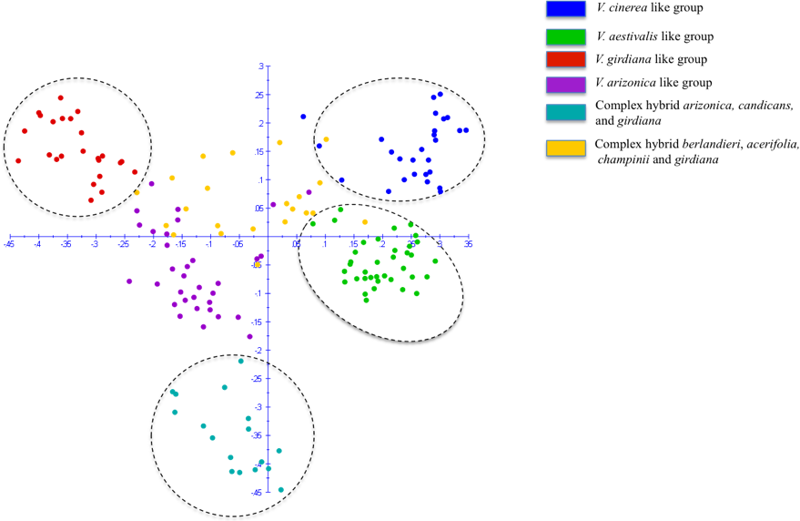

Fig. 2. Principle Coordinate Analysis constructed with genotypic data from 22 SSR markers on 159 accessions using DARWIN software. The axis 1 and 2 presents 10.09 and 5.65 percent of the variation, respectively

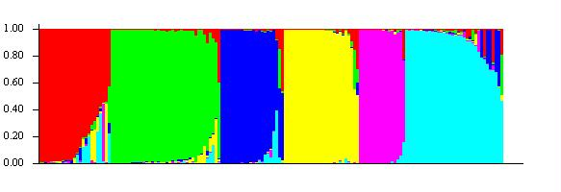

Fig. 3. Graphical presentation of the results obtained from STRUCTURE using K = 6.

Objective 4. We have used three categories of sequences (shotgun reads, fosmid reads and 454) to work on the BAC clone H69J14 that carries the PD resistance gene(s). From the assembly of this sequence, we identified 6 copies ranging from 2Kb to 3.1Kb in the resistance region. Copies 1 thru 4 are 97-99% similar and differ in size (potentially tandem repeats of one gene), they were up to 78% similar to the four copies of genes from the Pinot noir (PN40024) sequence. We utilized CENSOR software to screen query sequences against a reference collection of repeats to generate a report capable of classifying detected repeats. All four PN40024 genes carry DNA transposons as well as LTR retrotransposons indicating that the region is quite complex.

A detailed comprehensive comparison of the H69J14 clone sequence to the PN40024 sequence is not possible due to major re-arrangement of repetitive elements between the two genomes, and the presence of gaps in the contigs of the H69J14 BAC clone. We are in process of using FGS technology, which helps close these gaps. For this purpose, we identified three overlapping BAC sequences (H15B20, H69J14 and H64M16) that span about 450Kb of the physical sequence. Complete assembly of this region will allow a more precise comparison to susceptible PN40024, which will help identify differences in the expressed and non-expressed regions and help us identify the susceptible allele of the PdR1b gene. Results are expected within 2-3 months.

LAYPERSON SUMMARY
A major focus of this project is to broaden the genetic base of PD resistance by searching for and characterizing new forms of PD resistance. Previously, we reported on the screening of 52 accessions of grape species that were collected from across the southern US and northern Mexico. Greenhouse screening of these plants identified 20 new resistant accessions. We expanded this work to 159 accessions that were acquired from states along the Gulf of Mexico and utilized 22 SSR markers to develop fingerprint profiles for them. Analysis with two different programs revealed six major groups of species. The breeding program has used resistance from two of the groups, and resistance from the others has not been used. The goals of this study are to investigate the genetic and geographic diversity of plant material collected from Gulf coast states and South America, establish distinct genetic groups, carry out PD resistance evaluation via ELISA, and correlate the PD resistance to the defined groupings to better understand the evolution of PD resistance in grape. This germplasm screening provides opportunities to explore and identify resistance loci that may provide different resistance mechanisms allowing us to expand the genetic base of the PD resistance-breeding program. Without any prior knowledge of the recent genetic grouping study, crosses were made with five of the most resistant accessions in Spring 2012 and over 300 seedlings will be tested. To date, we have utilized 3 different genetic resources to identify PD resistance. Progress was made with b43-17 and b40-14 both of which carry a major, as well as a minor locus for PD resistance. Genetic mapping of these two different forms of V. arizonica have identified a PD resistance region on chromosome 14, which we termed PdR1. We have mapped two forms of PdR1 from V. arizonica/candicans b43-17, identified a minor gene on chromosome 19 (PdR2) and have mapped a third form, PdR1c, which originated from V. arizonica b40-14. Mapping of a multigenic source of PD resistance from V. arizonica/girdiana b42-26 continues – a total of 916 markers were tested, and 170 polymorphic markers (45 more since the previous report) have been added to the entire population of 239 seedlings. An initial genetic map was developed to assess the level of coverage on all 19 chromosomes. All markers were grouped and 15 linkage groups were established. The whole population is currently being screened for PD resistance due to the relatively high variation in ELISA values we encountered in previous tests. We have 4-5 reps of 160 plants with results expected in April 2013. Our focus is to refine the genetic map to get better coverage of all chromosomes, and obtain consistent greenhouse screen data in b42-26 background.

We plan to combine these multiple resistance sources in our breeding program to ensure broad and durable PD resistance. This project provides the genetic markers critical to the successful classical breeding of PD resistant wine, table and raisin grapes. Identification of markers for PdR1 has allowed us to reduce the seed-to-seed cycle to 2 years and produce selections that are PD resistant and 97% vinifera. These markers have also led to the identification of 6 genetic sequences that may house the PD resistance gene, and which are being tested to verify their function. These efforts will help us better understand how these genes function and could also lead to PD resistance genes from grape that would be available to genetically engineer PD resistance in V. vinifera cultivars.

PUBLICATIONS AND PRESENTATIONS

Abstracts
Agüero C.B., Riaz S., Hwang C-F, He R., Hu R., Bistue C., Walker M.A. Map-based cloning of Pierce’s disease and Xiphinema index resistance genes from V. arizonica. ASEV 63nd National Conference. Portland, Oregon, 6/18-22/2012.
Walker M.A., Riaz S., Agüero C., Bistue C. 2012 Molecular characterization of the putative Xylella fastidiosa resistance gene(s) from b43-17 (V. arizonica/candicans). Poster presentation Pierce’s Disease Research Symposium. Sacramento, 12/13-15/2012

Presentations
Breeding for pest and disease resistance. Ag Unlimited Annual Meeting, Napa, CA March 1, 2012.
Breeding resistant grapevines. Recent Advances in Viticulture and Enology, UC Davis, CA, March 15, 2012.
Current issues in grape diseases and pests. Wine Executive Program, UC Davis, CA, March 27, 2012.
Grape breeding for new rootstocks and winegrapes. University of Chihuahua, Mexico, March 29, 2012.
Advances in scion and rootstock breeding. Sonoma Vit Tech Group, Santa Rosa, CA, May 16, 2012.
Overview of the Walker grape breeding program. Board of Visitors and Fellows, UC Davis, May 18, 2012.
Breeding programs from around the world: what is their likely contribution. ASEV Alternative Varieties Symposium, Portland, OR, June 19, 2012.
Advances in scion and rootstock breeding. Coppola Grower Meeting, Healdsburg, CA, July 17, 2012.
Advances in rootstock and scion breeding. Roll Global Meeting, UC Davis, August 16, 2012.
Breeding new rootstocks and fruiting varieties. VEN 290 Seminar, UC Davis, November 2, 2012.
UC Davis grape breeding program. INIA Seminar, Santiago, Chile, December 13, 2012.

RESEARCH RELEVANCE
The goal of this research is to explore the genetics of resistance to PD and provide genetic support to our PD resistance breeding of wine, table and raisin grapes. We successfully mapped the resistance genes from a form of V. arizonica and used the linked markers to greatly expedite our breeding program. We are now searching for additional forms of PD resistance in other species from a variety of geographic locations across the southern States and Mexico, with the goal of combining resistance from several species together to ensure durable resistance.

Status of Funds: These funds are scheduled to be spent by the end of the grant.

Intellectual Property: PD resistant varieties will be released through the Office of Technology Transfer (Patent Office) of the University of California, Davis.

