Interim Progress Report for CDFA Agreement Number 12-0216-SA
Title of project: RNA-interference and control of the glassy-winged sharpshooter (Homalodisca vitripennis) and other leafhopper vectors of Xylella fastidiosa
Principal Investigator (PI): Dr. Bryce W. Falk, Professor, Department of Plant Pathology, University of California, One Shields Avenue, Davis, CA. 95616, 530-752-0302, bwfalk@ucdavis.edu
Cooperators: Dr. Raja Sekhar Nandety, Postdoctoral Researcher, Department of Plant Pathology, Univ. of California, One Shields Avenue, Davis, CA. 95616, 530-752-5218, nandety@ucdavis.edu
Tera Pitman, Staff Research Associate, Department of Plant Pathology, Univ. of California, One Shields Avenue, Davis, CA. 95616, 530-752-5218, tlpitman@ucdavis.edu

Dr. Kris Godfrey, Project Scientist and Director, UC Davis Biosafety 3P Contained Research Facility. U C Davis, Davis, CA 95616, 530-754-2104, kegodfrey@ucdavis.edu

Time period covered by report: July 1, 2012 – June 30, 2013

Introduction:
Our primary objective is to evaluate and demonstrate RNA interference (RNAi) activity against Homalodisca vitripennis or the Glassy-winged sharpshooter (GWSS). We envision that RNAi approaches can be part of long term strategies to help control GWSS and other sharpshooter vectors of Xylella fastidiosa, the causal agent of Pierce’s Disease of grapevines. We have made significant progress during the past few years and are in excellent position to complete most of our objectives during the upcoming year. We have published two new refereed journal articles (Nandety et al., 2013a; Kamita et al., 2013) and submitted a new manuscript (Nandety et al., 2013b). We have presented one new meeting abstract (Nandety et al., 2013) and are making excellent progress on our effort.
Here we present our progress towards the development and application of an RNA interference (RNAi) based system aimed to target genes of GWSS, the vector of X. fastidiosa. We have made stable Arabidopsis and potato transgenic plants using the constitutive, non tissue specific 35S promoter and a Eucalyptus gunii minimal xylem-specific promoter to control the spatial expression of candidate interfering RNAs. We showed expression of the GUS gene in vivo in the T2 transgenic Arabidopsis plants in the previous report, and within the past few months we were able to further test this concept in potato transgenic plants and demonstrate localized xylem expression. We also were able to show gene expression through the use of RT-PCR (above) and have evaluated potato plants transgenic to GWSS-Actin, GWSS-cuticle and GWSS-chitin deacetilase to produce dsRNAs (siRNAs) and down regulation of specific mRNA targets in GWSS adult insects. Encouraged by the results of GUS transgene expression in the xylem tissues of potato transgenic plants (spatial restriction of the transgene), we have also developed the transgene constructs to generate small RNAs specific for GWSS mRNA that are driven by xylem expressing, ECAD promoter. Since our update in March of 2013, we have also found effective targets from the large scale GWSS transcriptome sequencing project that we adopted. We have a well-built transcriptome data set for GWSS insects that covers 35Mb of the genome which we submitted recently for publication. In addition we have generated a profile map of transcriptome with the available small RNA data and micro RNA data which we will be submitting it shortly.
Objectives:
Objective 1. To assess the effectiveness of anti-GWSS transgenic plants against GWSS.
Objective 2. To identify optimal interfering RNA forms for use in transgenic plants.

Description of activities conducted and summary of results:
Objective 1. To assess the effectiveness of anti-GWSS transgenic plants against GWSS.
We performed feeding assays and assessed for RNAi effects on H. vitripennis (GWSS) using our transgenic potatoes, and the stem infusion dsRNA assays. Transgenic potato feeding assays, using the plants listed in Table 1, were done using 3rd- 4th instar nymphs (Fig. 1). Original cultivars of potatoes (non-transgenic) used to generate the transgenic lines were used as control plants. We placed cuttings of the potato plants in individual cages in a growth chamber, released five nymphs per cutting, and observed mortality for two weeks (Fig. 2). Higher mortality was observed in the nymphs that fed on cuticle and actin transgenic potato cuttings as compared to the controls. To determine if those observations were due to the effects of the transgene, we designed four day feeding assays. Using the same potato cutting experiment design as for the mortality study, we allowed five 3rd- 4th instar nymphs to feed on the cuttings for four days and then removed them from plants and dissected out the intestinal tracts of the nymphs. RNA was extracted from each sample, and cDNA generated from 500ng total RNA. Quantitative Real-Time PCR (qPCR) was then used to quantify relative expression of the genes targeted for down regulation, and was normalized with ubiquitin. Gene expression, expression SEM, and corrected expression SEM were generated by the Bio-Rad CFX Manager 3.0 software (Carlsbad, CA).
GWSS Targets
Potato Pedigree
Potato Variety
Selection Method
Chitin Deacetilase 102203 Kennebec Basta yes (shown previously)
Chitin Deacetilase 102203 Kennebec Basta yes (shown previously)
Actin 112064 Desiree Basta yes (Figure 3)
Cuticle 102203 Desiree Basta yes (Figure 2)
Table 1: GWSS insect sequences used for cloning and generation of potato transgenic lines.

Initial results indicated down-regulation of target mRNAs after four days of GWSS nymphs feeding on transgenic potatoes as compared to wild-type potatoes (Fig. 3). We have completed feeding experiments with five of the transgenic potatoes; two events each of chitin deacetilase and cuticle, and one of actin. We are currently growing more potato plants from tubers, including a transgenic plant control with green fluorescent protein (GFP) gene insert. Once plants reach appropriate size they will be used in GWSS feeding assays. Initial results are correlating with the mortality study; there is decreased expression of target mRNAs as compared to controls for cuticle and actin, but no significant difference for chitin deacetilase (Fig. 3). Statistical analyses were performed using SAS 4.0 (Cary, NC) with the general linear model and Bonferroni correction to determine significance.

In addition to the transgenic plant approaches, based on recent reports in the literature and personal communications from other scientists, we have evaluated in vitro feeding approaches for GWSS. We are utilizing basil stem cuttings in a feeding solution, as previously described, to introduce dsRNA to GWSS nymphs. We are currently evaluating the effects of dsRNA from the previously described actin, cuticle, and chitin deacetilase sequences have on GWSS nymphs, and whether the results are comparable to the transgenic potato feeding assays. If this method has similar treatment effects, we can utilize this method to more rapidly screen candidate sequences for RNAi approaches.

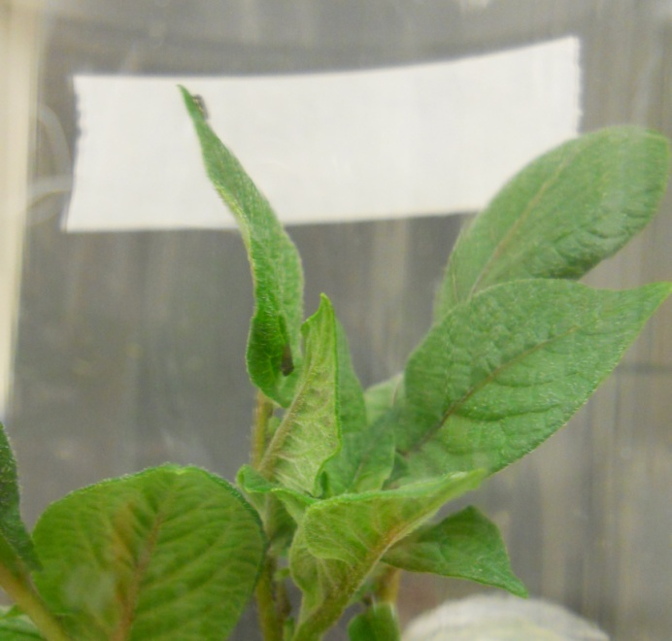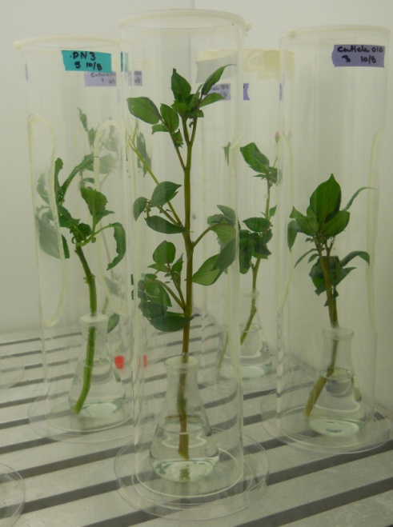
Figure 1. GWSS RNAi feeding assays on transgenic potato cuttings. At left shows stems in cylindrical cages, each containing 5 nymphs times 5 replications per treatment. Right shows a close up photo of a GWSS nymph feeding on upper potato foliage.

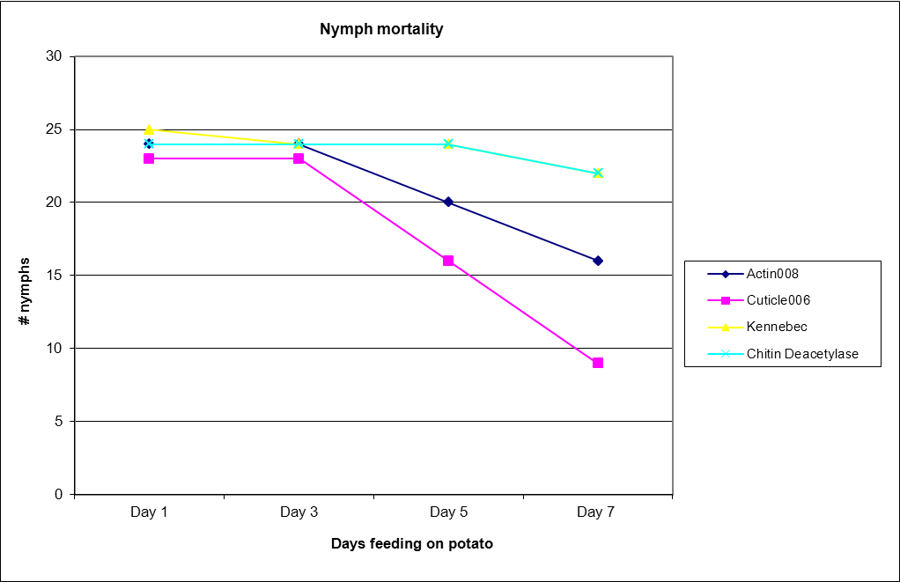
Figure 2. GWSS nymph mortality for seven days feeding on transgenic potato cuttings (Actin, Cuticle, Chitin Deacetilase) or wild-type control potato (Kennebec).

Biological Set | GWSS Gene Expression | Expression SEM | Corrected Expression SEM | Bon grouping
Actin feeding experiment
Actin 008 | 0.2811 | 0.10845 | 0.10858 | A
Kennebec | 1.1775 | 0.16806 | 0.16807 | B
Chitin Deacetilase feeding experiment
Desiree | 1.50313 | 0.06913 | 0.06928 | A
DN198443-004 | 2.63164 | 0.19496 | 0.19496 | B
DN198443-007 | 1 | 0.21406 | 0.21408 | AB
Cuticle feeding experiment
cuticle 002 | 0.41041 | 0.06841 | 0.06843 | A
cuticle 007 | 0.26919 | 0.05043 | 0.05058 | A
desiree | 1 | 0.11864 | 0.11864 | B
Figure 3. Statistical analysis of GWSS gene expression from intestinal tract RNA extracted after four day feeding experiments on transgenic potatoes expressing the indicated GWSS gene driven by the 35S promoter or wild type potatoes (α=0.05, D.F.=34).

Objective 2. To identify optimal interfering RNA forms for use in transgenic plants.
We have taken in vitro and in vivo approaches to identify optimal interfering RNAs. Since our update in March of 2013, we have attempted to identify additional effective RNA targets from the large scale GWSS transcriptome sequencing project that we adopted. We have a well-built transcriptome data set for GWSS insects that covers 35Mb of the genome which we submitted recently for publication (Nandety and Falk, 2013). In addition we have generated a profile map of transcriptome with the available small RNA data and micro RNA data. The latter will help identify optimal interfering RNA forms for future targeting of GWSS insects.
Sequencing of adult H. vitripennis small RNA libraries yielded 22,151,482 reads (Nandety et al., 2013a). Small RNA sequencing reads (43% of the total, ∼9.5 million) were mapped to an artificial build of the H. vitripennis transcriptome (Nandety and Falk, 2013 submitted). The sequencing reads were then mapped back to the assembled transcripts with up to one mismatch (Fig. 4). The reads that could not be mapped back to the reference assembly were analyzed for the virus discovery that resulted in the identification of Homalodisca coagulata virus-1 (HoCV-1) and Homalodisca reovirus (HoVRV) that infect the GWSS insects. With the help of these sequencing reads, we aim to study the GWSS insect target genes and we hope to identify the small RNAs that target the GWSS target genes in a highly specific manner.
The small RNA reads were further investigated for the presence of conserved micro RNAs (~22nt) that can be identified through bioinformatic analysis based on their size and folding patterns. In our analysis thus far, we have identified the conserved and putatively novel micro RNAs. We were able to validate few of the micro RNAs through stem loop Real time-PCR method (Fig. 5). The following data were analyzed using GWSS-miR1692 as standard. The expression among the tested candidate microRNAs was found highest for GWSS-miR171 followed by GWSS-miR71.
In our analysis thus far, we have identified a diversified expression pattern of micro RNAs from each other in adult GWSS insects. Further, we were also able to identify the differential expression in relevance to the tissues chosen (Fig. 5). The expression of microRNAs was found to be relatively higher for nymphs in comparison to Adult insects (Fig. 5). We were in the process of identifying novel microRNAs from the libraries we have generated.

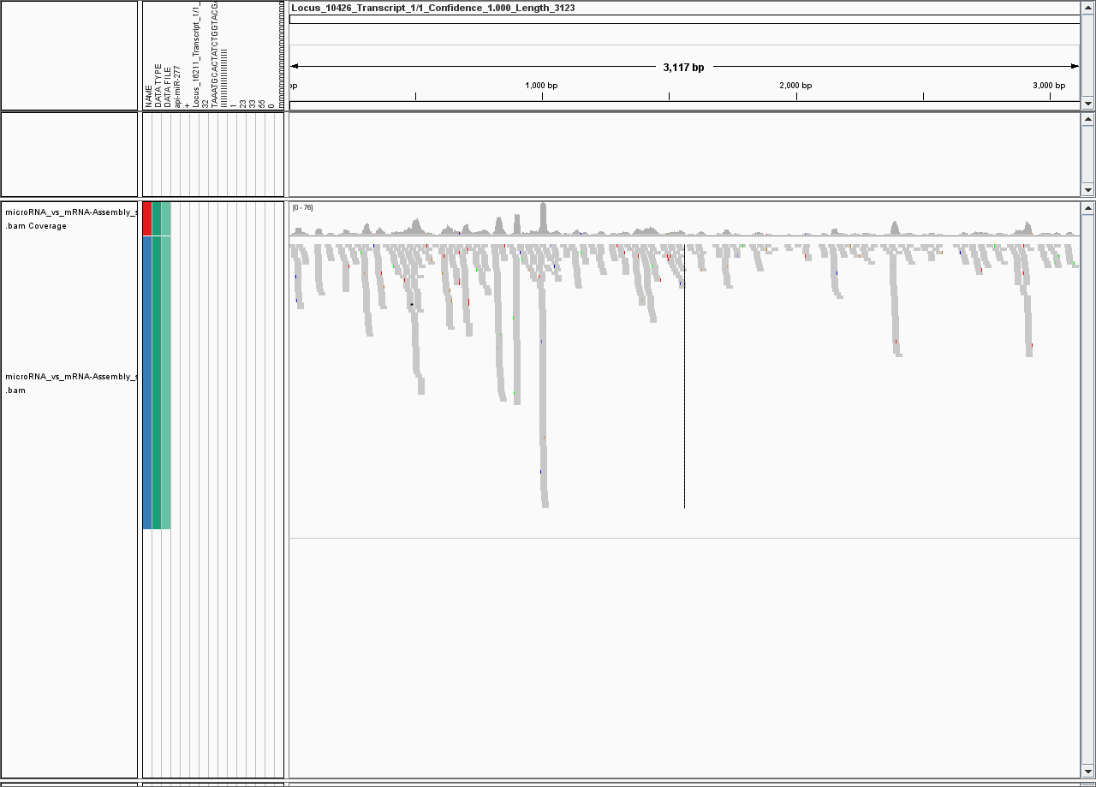
Figure 4. Snapshot profiling of one of the Homalodisca vitripennis transcripts (Locus_10426). A similar pattern of small RNA profiling was generated for all of the 52,000 transcript loci.

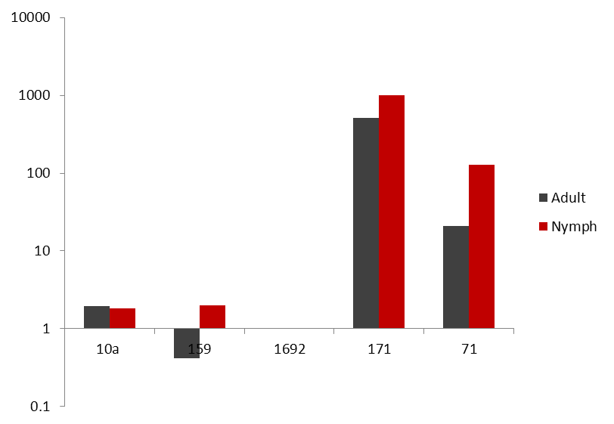

Figure 5. Validation of the initial set of Homalodisca vitripennis micro RNAs. The values on the X axis represent the list of microRNAs chosen for validation. Values on the Y axis represent the relative quantification of the microRNAs in a logarithmic scale.
GWSS-micro RNAs
Relative expression
Publications produced and pending, and presentations:
- Rosa C, Kamita, S. G., and Falk, B. W. 2012. RNA-interference is induced in the glassy-winged sharpshooter Homalodisca vitripennis by actin dsRNA. Pest management science Jul; 68 (7):995-1002.

- Raja Sekhar Nandety, Viacheslav Y. Fofanov, Heather Koshinsky, Drake C. Stenger and Bryce W. 2013. Small RNA populations for two unrelated viruses exhibit different biases in strand polarity and proximity to terminal sequences in the insect host Homalodisca vitripennis. Virology, 442:12-19.

- Shizuo G. Kamita, Grant H. Oshita, Peng Wang, Raja Sekhar Nandety Christophe Morisseau , Bryce W. Falk and Bruce D. Hammock. 2013. Characterization of Hovi-mEH1, a microsomal epoxide hydrolase from the glassy-winged sharpshooter Homalodisca vitripennis. Archives of Insect Biochemistry and Physiology, 83 (4):173-179.

- Raja Sekhar Nandety, Shizuo G Kamita, Bruce D Hammock and Bryce W Falk. Sequencing and de novo assembly of the transcriptome of the glassy-winged sharpshooter (Homalodisca vitripennis). Submitted.

- Raja Sekhar Nandety, Almas Shariff, Tera L Pitman and Bryce W Falk. Glassy Winged Sharpshooter Insect Genome Footprints Through Transcriptomic and Small RNA Sequence Profiling. Abstract presented at PAG conference, San Diego, CA, Jan 2013.

Research relevance: RNAi is a natural biological activity for controlling gene expression and anti-viral defense in a majority of eukaryotic organisms, including insects. The application of RNAi directed toward the control of different types of insect plant pests is becoming more feasible and promising. In our efforts, we were able to induce RNAi in H. vitripennis and evaluated initial transgenic plants as a means to initiate RNAi to help control the glassy winged sharpshooter and other leafhopper vectors of Xylella fastidiosa. RNAi is already used in commercial agriculture for plant virus control, and the many new publications demonstrating experimental successes with various plant-feeding insects suggest that RNAi could have a role in helping to manage Pierce’s Disease of grapevines.
Lay persons summary of current year’s results: This work presents fundamental efforts towards understanding the feasibility of applying RNA interference (RNAi), to help combat Pierce’s Disease of grapevines. Pierce’s Disease is a significant threat to grape production in California and other parts of the U.S., and the causal agent, Xylella fastidiosa, a xylem-limited bacterium, also causes several other extremely important plant diseases worldwide. Our effort here does not directly target Xylella fastidiosa, but instead targets one of its most significant insect vectors, the Glassy-winged sharpshooter, Homalodisca vitripennis, and other sharpshooter vectors of X. fastidiosa.
We focused our efforts this year on evaluating transgenic potato plants to evaluate their potential for inducing RNAi effects in H. vitripennis, and for identifying optimal RNAi inducer delivery systems. Potatoes are easier and faster to transform and regenerate than are grapes, and the glassy-winged sharpshooter feeds readily on these plants. We also generated large scale genomic data that were further analyzed for the identification of GWSS targets and the distribution and identity of GWSS small RNAs, which will help us gear towards the control.
Status of funds: All funds were spent for the 2012 – 2013 allocation.
Summary and status of intellectual property associated with the project: No intellectual property has developed so far.

Literature cited:
Kamita, S. G., Grant H. Oshita, Peng Wang, Raja Sekhar Nandety Christophe Morisseau, Bryce W. Falk and Bruce D. Hammock. 2013. Characterization of Hovi-mEH1, a microsomal epoxide hydrolase from the glassy-winged sharpshooter Homalodisca vitripennis. Archives of Insect Biochemistry and Physiology, 83 (4):173-179.

Nandety, Raja Sekhar, Viacheslav Y. Fofanov, Heather Koshinsky, Drake C. Stenger and Bryce W. 2013. Small RNA populations for two unrelated viruses exhibit different biases in strand polarity and proximity to terminal sequences in the insect host Homalodisca vitripennis. Virology, 442:12-19.

Rosa C, Kamita, S. G., and Falk, B. W. 2012. RNA-interference is induced in the glassy-winged sharpshooter Homalodisca vitripennis by actin dsRNA. . Pest management science Jul; 68 (7):995-1002.

Funding Agencies: Funding for this project was provided by the USDA-funded University of California Pierce’s Disease Research Grants Program.

