Project Title: Molecular breeding support for the development of PD resistant winegrapes.

Principal Investigator
M. Andrew Walker (PI)
Dept. Viticulture & Enology, University of California, Davis, CA 95616
awalker@ucdavis.edu
530-752-0902

Co-Principal Investigator
Dario Cantu, Assistant
Professor, Dept. Viticulture and Enology, University of California, Davis, CA 95616
dacantu@ucdavis.edu

Cooperating Staff
Dr. Summaira Riaz,
snriaz@ucdavis.edu
Dr. Cecilia Agüero,
cbaguero@ucdavis.edu
Dept. Viticulture and Enology, University of California, Davis, CA 95616
Reporting period: October 2014 to October 2015

ABSTRACT
This main objective of this project is to identify novel Pierce’s disease resistant germplasm, determine the inheritance of resistance, tag genomic regions and develop markers capable of facilitating and accelerating the breeding of resistant wine grapes. We have completed greenhouse-based PD resistance screening, genotyping (SSR and chloroplast markers) and population analysis of over 250 accessions and identified 20 new highly resistant accessions that were used to develop breeding populations in 2012 and 2013 and 2014. Breeding populations were marker tested to assure correct identity. Resistance loci were identified on genetic maps, markers were developed for breeding, and physical mapping was completed for b43-17 to clone and characterize resistance genes (PdR1a and PdR1b see earlier reports). The physical map of the PdR1c locus (from b40-14) is nearing completion and we are in carrying out comparative sequence analysis. We have also initiated the genetic mapping of a new and very resistant source, b46-43, and marker screening is in process. We are continuously developing and expanding breeding populations from new promising resistant lines. Upstream and downstream sequences as well as gene sequences of two candidate genes ORF14 and ORF18 from PdR1b were verified. A large scale multiple time point gene expression project was completed in the greenhouse and RNA extractions were completed for over 400 samples. The qPCR experiments were used to test the expression of candidate genes. Cultures to generate embryogenic callus of V. vinifera cvs. Chardonnay and Thompson Seedless and V. rupestris St. George are being maintained for use in transgenic experiments. Experiments to utilize the PdR1 resistance gene with native promoter are underway. These efforts will help us to identify candidate resistance genes by complementation and better understand how they function. They could also lead to PD resistance genes from grape that would be available to genetically engineer PD resistance into V. vinifera cultivars. This project provides the genetic markers critical to the successful classical breeding of PD resistant wine, table, and raisin grapes. Identification of markers for PdR1 allowed us to reduce the seed-to-seed cycle to 2 years and produce selections that are PD resistant and 97% vinifera.

Layperson Summary
We continue to identify and genetically characterize novel resistance sources from southwestern US and Mexican Vitis species collections; use genome sequence information to identify unique resistance genes; clone and characterize these resistance genes with native promoters; and develop resistance gene constructs prior to transforming them into susceptible V. vinifera grapes to test their function. Creating genetic maps with DNA markers allows us to identify and validate markers that could be used for marker-assisted selection and to incorporate (stack) multiple resistance genes into a single background to create more durably resistant varieties. Genetic mapping allow us to carry out map-based positional cloning and characterization of grape PD resistance genes under control of native promoters, which could be used to genetically engineer resistance into elite V. vinifera cultivars.

INTRODUCTION
A successful resistance-breeding program depends on germplasm to provide a wide genetic base for resistance. Identification, characterization and manipulation of novel sources of resistance are prerequisite for breeding. This evolved project continues to provide molecular support to the PD resistance grape breeding project – “Breeding Pierce’s disease resistant winegrapes” by acquiring and testing a wide range of resistant germplasm, tag resistance regions with markers by genetic mapping and then functionally characterizing the resistance genes from different backgrounds. In earlier versions of this project, genetic markers linked to X. fastidiosa resistance from b43-17 background were used to perform marker-assisted selection (MAS) to accelerate our PD resistant winegrape and the table and raisin grape breeding of David Ramming. Outcomes from the earlier two projects include genetic maps, and BAC (bacterial artificial chromosome) libraries of the highly resistant V. arizonica accessions, b43-17 and b40-14. A physical map of the PdR1 locus was completed and several candidate genes were identified. Five candidate genes were cloned and constructs were developed with 35S promoter to transform tobacco, Chardonnay, Thompson Seedless and St George.

The new merged project has five key objectives: to identify novel sources of PD resistance for use in broadening the genetic base of resistance; to accelerate marker discovery and the identification of new and unique resistance genes; to clone and characterize unique DNA sequences (promoters) that regulate the expression of candidate PD resistance grape genes cloned from the PdR1b locus; and to evaluate and compare lines transformed with native and 35S promoters. We have surveyed over 250 accessions of Vitis species growing in the southern US and Mexico to identify new PD resistant accessions. Analysis using population genetics methods allowed us to better understand gene flow among resistant species and their taxonomic and evolutionary relationships. PD resistance in southeastern Vitis spp. seems to be different than the resistance in Vitis from the southwest and Mexico. We have identified new PD resistant accessions that are genetically and phenotypically different, were collected from different geographic locations, and have different maternal inheritance. Breeding populations from new promising resistant lines were developed. These populations will be tested to study the inheritance of resistance. Then next generation sequencing will be used on the recently identified resistant accessions to expedite marker discovery and confirm that they are unique. Then genetic maps will be developed to identify genomic regions associated with resistance, and genetic markers will be used for the stacking of multiple resistance genes to breed winegrapes with durable PD resistance.

The identification and characterization of resistance genes and their regulatory sequences will help determine the basis of resistance/susceptibility in grape germplasm. In addition, these genes and their promoters can be employed in production of ‘cisgenic’ plants. Cisgenesis is the transformation of a host plant with its own genes and promoters (Holmes et al. 2013). Alternatively, other well characterized vinifera-based promoters; either constitutive (Li et al. 2012) or activated by X. fastidiosa (Gilchrist et al. 2007) could be utilized. Development of V. vinifera plants transformed with grape genes and grape promoters might mitigate concerns about transgenic crops harboring genetic elements derived from different organisms that cannot be crossed by natural means. Proven resistance gene constructs could be transformed into a broad array of elite V. vinifera cultivars.

Objectives
The specific objectives of this project are:
1. Provide genetic marker testing for mapping and breeding populations produced and maintained by the PD resistance-breeding program, including characterization of novel forms of resistance.
2. Complete a physical map of the PdR1c region from the b40-14 background and carry out comparative sequence analysis with b43-17 (PdR1a and b).
3. Employ whole genome (WG) sequencing (50X) of recently identified PD resistant accessions and a susceptible reference accession; use bioinformatics tools to identify resistance genes, perform comparative sequence analysis and develop SNP markers to be used for mapping.
4. Clone PdR1 genes with native promoters.
5. Compare the PD resistance of plants transformed with native vs. heterologous promoters.

Results and discussion
Objective 1. Provide genetic marker testing for mapping and breeding populations produced and maintained by the PD resistance breeding program, including characterization of novel forms of resistance.

Vitis species growing in Mexico and the southwestern USA have co-evolved with X. fastidiosa and developed natural resistance to the disease. We completed a survey of over 250 southwestern and northern Mexico Vitis, which included accessions collected from multiple collection trips from States bordering Mexico or that were previously collected from Mexico. Both SSR (simple sequence repeat) and chloroplast markers were used to evaluate genetic diversity and establish relationships with known sources of resistance currently being used in the breeding program (Riaz and Walker 2013). Some of these resistant forms may have different mechanisms of resistance that could add to the repertoire of resistance genes and loci available for the breeding program. A subset of this germplasm was greenhouse screened for PD resistance and preliminary results identified multiple new sources of resistance. Crosses were made with five new PD resistant V. arizonica accessions from the southwestern US and Mexico to develop small breeding populations. A subset of seeds from these crosses was germinated and greenhouse screened to characterize the inheritance of their PD resistance. Results indicated clear separation of progeny families into resistant, intermediate and susceptible groups, and identified an unprecedented level of resistance in b46-43 based on disease phenotype and ELISA (enzyme-linked immunosorbent assay) results. More crosses were made in 2013 with five additional resistant accessions: b41-13, b43-57, b47-32, SC36, and T03-16.

We have developed F1 and BC1 (backcross 1) breeding populations using two of the resistant accessions, b46-43 and T03-16, that are geographically unique, have different maternal origin, and are genetically diverse. Greenhouse testing of the F1 population was completed and BC1 populations are under testing. Genomic DNA was isolated from 177 seedlings in the BC1 population with the b46-43 background and marker testing on a small set of seedlings and parental DNA is in process. Our objective is to employ a limited mapping strategy by focusing mapping on linked chromosomes identified from the sub-population screening and then saturate with SSR markers that reside on those chromosomes. The identification of other genomic resistance regions is critically important, since it is not genetically possible to stack more than 2 chromosome 14 resistance sources.

In Spring 2015, we provided molecular support to the companion PD resistance wine grape breeding project by marker testing a total of 1,237 seedlings from 17 crosses to determine PD resistant and susceptible genotypes. Most of these crosses were designed to stack resistance from b42-26 and PdR1b as well as to develop advanced breeding lines with PdR1c (the b40-14 background).

Table 1 presents the breeding populations that were developed with new resistance sources (For details, see previous reports). In Spring 2015, we completed propagation of 4-5 replicates for the subset of crosses mentioned in Table 1. Plants from rooted green cutting were transferred to 2” pots first and then 4” pots to acclimatize to greenhouse conditions. These plants were inoculated with X. fastidiosa at the end of August and the results of the assay will be available in December.

Table 1. Crosses that are under greenhouse testing to determine the mode of inheritance of their resistance to Pierce’s disease
Cross ID | Female Name | Male Name | Seedlings tested
14-360 | F2-35 | DVIT 2236.2 (V. nesbittiana) | 90
14-367 | F2-35 | 12340-13 | 50
14-321 | Rosa Minna | 12305-55 | 28
14-308 | Rosa Minna | 12305-55 | 19
14-364 | Rosa Minna | A28 | 19
14-347 | Rosa Minna | A28 | 23
14-322 | Rosa Minna | 12305-56 | 15
14-313 | A14 | Colombard | 53
14-324 | F2-35 | 12305-56 | 47
14-340 | ANU71 | Grenache blanc | 38
14-303 | C23-94 | Nero d'Avola | 64
14-362 | F2-35 | ANU67 | 31
14-363 | F2-35 | SAZ 7 | 52
14-368 | F2-35 | 12340-14 | 35
14-336 | F2-35 | 12305-83 | 14
Total |  |  | 578

Objective 2. Complete a physical map of the PdR1c region from the b40-14 background and carry out comparative sequence analysis with b43-17 (PdR1a and b).

We have completed a genetic map and identified a major PD resistance locus, PdR1c, on chromosome 14 from the V. arizonica b40-14 background (see previous reports for details). PD resistance from b40-14 maps in the same region as PdR1a and PdR1b between flanking markers VVCh14-77 and VVIN64 and within 1.5 cM. The allelic comparison of SSR markers within the 20cM region including the PdR1c locus revealed that PdR1c locus is unique and sequences and genomic features are distinct from those in b43-17 (the sources or PdR1a and PdR1b). A total of 305 seedlings were also tested with markers to identify unique recombinants. We also developed new SSR markers using the b43-17 sequence generated in this study for comparative sequence analysis. Two of the SSR markers, SSR82-1b4 and ORF18-19-3 were tested on the combined set of recombinant plants (Table 2) to tighten the genetic window. We found four recombinants between Ch14-81 and VVIn64 on one side and one recombinant between the Ch14-77 and Ch14-27 markers. With the help of these markers we confined the PdR1c locus to 325 Kb based on the sequence of b43-17.
Table 2. Positioning of genetic markers in relationship to PD resistance in V. arizonica b40-14
Genotype | 14-29 | 14-27 | VVCh14-77 | SSR82-1b4 | ELISA  Results | ORF18 to 19-3 | 14-81 | VVIn64 | UDV025 | VVIp26
09367-35 | + | + | + | + | R | + | + | + | + | +
09367-37 | + | + | + | + | R | + | + | + | + | +
09367-38 | + | + | + | + | R | + | + | + | + | -
09367-41 | - | - | - | - | S | - | - | - | +
12325-78 | + | + | + | + | R | + | + | + | - | -
12326-18 | + | + | + | + | R | + | + | - | - | -
12327-54 | - | - | - | - | S | - | - | + | + | +
09367-26 | - | - | - | - | S | - | - | + | +
09367-30 | - | - | - | - | S | - | - | + | + | +
09367-07 | - | - | + | + | R | + | + | + | + | +
09367-12 | + | - | - | - | S | - | - | - | - | -
09367-40 | + | + | + | + | R | + | + | + | + | +
09367-43 | + | + | + | + | R | + | + | + | + | +

We developed a BAC library from b40-14 genomic DNA (see details in previous reports). BAC library screening was completed with probes that amplify a single amplicon of 600-650 bp using b40-14 genomic DNA. We identified 30 BAC clones by using two probes, Ch14-56 and Ch14-58. Six clones were positive with both probes. BAC clones that represent PdR1c were separated from the other haplotype based on the SSR markers that are polymorphic for the resistant selection b40-14. At the final stage, we selected two BAC clones VA29E9 and VA57F4 that overlap with each other, and are ~ 200Kb in size. The selected BAC clones were cultured to generate a large amount DNA, and purified DNA was sent to UCI genomics high through put facility for PAC BIO RS II sequencing (see previous report).

In order to expand the region beyond probe 14-58, we selected a third BAC clone that was positive with probe 14-58 and 14-59, isolated and purified the DNA and sent it for sequencing. The assembly of three BAC clones representing PdR1c locus is presented in Figure 1. The assembly consisted of two contigs with no over lap. Common probes between the PdR1c and PdR1b region were used to compare and align the sequences of two backgrounds in order to determine the region that is missing in the assembly of PdR1c locus. Based on the comparative analysis using sequence of PdR1b locus, we estimate that the gap between two assembled contigs is ~50-60 Kb in length. We are in process of identifying a fourth BAC that overlaps with the VA30F14 and VA57F4/VA29E9 assembly. We have designed new probes using the sequence of PdR1c region to test overlapping BACs. The current assembly contains a total of 363Kb of sequence, and a cluster of 18 resistance genes.

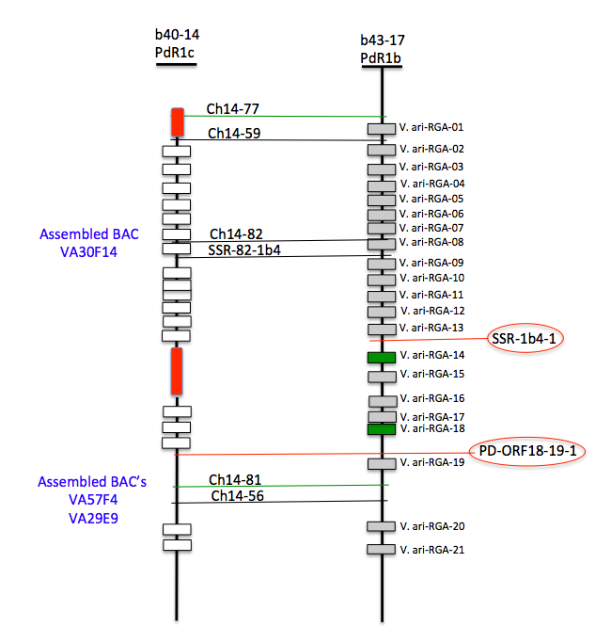
Figure 1. Sequence analysis of the PdR1b and PdR1c regions. The region between the two probes Ch14-59 and Ch14-56 was ~316 Kb in PdR1b (b43-17). In PdR1c, the assembled BAC VA30F14 consisted of 171Kb with a cluster of 13 resistance genes. The assembled BACs VA57F4-VA29E9 consisted of 192 Kb with five resistance genes. Two of the resistance genes are outside the genetic window with marker Ch14-81. The red regions represent the gaps in the assembly.

The assembly of H43-I23 from the b43-17 BAC library that represents the PdR1a haplotype (F8909-17) was also completed. The length of assembled sequence was 206Kb. Figure 2 provides details of the assembled region. The open reading frames (ORF) of the PdR1b region and the BAC clone H69J14 were used to make comparisons. There was complete homology between the over lapping BAC clone sequences that reflect two different haplotypes. The BAC clone H43I23 has ORF16 to ORF20 and all five ORFs have identical sequences to the PdR1b haplotype (Figure 2). Based on these results, we conclude that there is complete sequence homology between haplotype a, and b of the PdR1 locus; therefore cloning and functional characterization of genes from either haplotype will be sufficient for future work. Complete sequence homology also reflects that the parents of b43-17 must be closely related and may have a first-degree relationship and acquired resistance from shared parents. This also explains why we observed complete homozygosity of SSR markers for the PdR1 locus in the resistant accession b43-17.

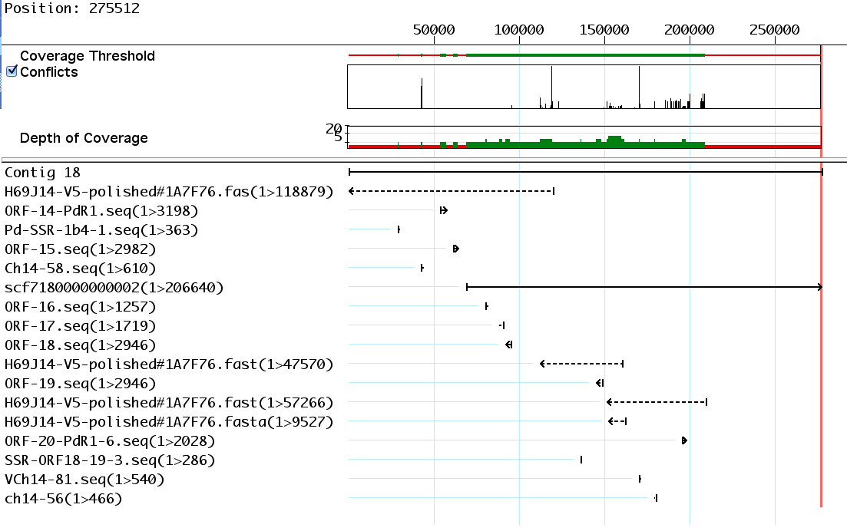

Figure 2. Assemblies of BAC clone reflecting the PdR1a haplotype.

Objective 3. Employ whole genome sequencing (WGS) (50X) of recently identified PD resistant accessions and a susceptible reference accession; use bioinformatics tools to identify resistance genes, perform comparative sequence analysis and develop SNP markers to be used for mapping.

The focus for WGS is on two new resistant accessions, b46-43 and T03-16. Both have been greenhouse tested to have very low bacterial levels in repeated screens. b46-43 is homozygous resistant to PD. Crosses to develop BC1 populations were made in 2014. We have extracted DNA from the F1 population to marker verify the integrity of the cross. Our approach of traditional bi-parental mapping populations has played an important role in gene discovery and understanding of PD resistance in North American Vitis species, and both bi-parental and multi-parental breeding populations remain the foundation of our breeding program. In this project, we want to combine the traditional SSR marker system with next generation sequencing using IIlumina HiSeq and MiSeq platforms to carry out SNP discovery and identification of SNP markers linked to resistance (Fig. 1). We will pursue the WGS approach only with those resistant lines for which we have strong greenhouse screen information, heritability of the PD resistance, and potential screening of the population using the limited mapping strategy. The BC1 populations with b46-43 and T03-16 background are under testing and will be ready for WGS approach in Winter 2015.

Objective 4. Cloning of PdR1 genes with native promoters.

We have completed assembly of a 604 Kb region of PdR1b with four BAC clones (see previous reports for details). We identified multiple ORFs (open reading frames) of the Leucine-Rich Repeat Receptor Kinase gene family that regulates a wide variety of functions in plants including stem cell maintenance, hormone perception, and defense and wounding response for both host as well as non-host specific defense. With the help of molecular markers, we have limited the genetic region that carries the five ORF to 82 Kb – these ORFs are associated with disease resistance and other plant functions described above (Figure 1). There are multiple ORF’s that are outside this genetic region and have 99% sequence similarity to the candidate genes. We have also acquired binary vectors pCLB1301NH and pCLB2301NK (Feechan et al. 2013) that have been optimized to carry large DNA sequences, thus allowing us to insert candidate genes plus surrounding sequences. Two ORFs V.ari-RGA14 and V.ari-RGA18, within the resistance region boundaries, are the most likely candidates for PdR1b. The other 3 sequences, V.ari-RGA15, 16 and 17 are shorter and contain a large number of transposable elements (TE).

In order to include native promoters and terminators in constructs for future genetic transformations, we have verified sequences upstream and downstream of V.ari-RGA14 and 18, the two most likely PdR1b candidates. Sequence verification for V.ari-RGA14 has been completed up to 3.75 kb in the upstream region and 1 kb in the downstream. Both RGA14 and 18 are very similar in the sequence profile with the exception that RGA-18 is 2946bp in size and lacks the first 252 bp of sequence that is part of RGA14. Functional analysis of the protein sequence of both RGA revealed that RGA-14 lacks a signal peptide in the initial part of the sequence. This was further verified by using 3’RACE (rapid amplification of cDNA ends) to specifically amplify RNA from grapevines transformed with V.ari-RGA14 under the 35s promoter. The results found that mature mRNA does not contain a signal peptide, necessary for proper membrane localization, at the beginning of the sequence.

We have also initiated a large experiment with resistant and susceptible plants using multiple replicates, and time points for control (mock or un-inoculated) and inoculated plants (see details in previous report). To date, we have completed RNA extractions from 450 samples in the above-mentioned experiment. We have also designed primers and determined primer efficiency for the gene expression studies for both RGA14 and RGA18. Two different primer pairs with an efficiency of greater than 90% were selected to carry out preliminary analysis with mock and inoculated samples of Chardonnay and F8909-17. Preliminary results with samples from six time points indicates that the expression level of both RGA14 and RGA18 in F8909-17 increases after day 8 in comparison to mock inoculated, peaks at day 23 and then decreases. Mock and inoculated susceptible Chardonnay did not show any expression. Gene expression analysis will be carried out on complete data sets when we have processed all the RNA samples.

Objective 5. Comparing the PD resistance of plants transformed with native vs. heterologous promoters.

We have established an Agrobacterium mediated transformation system followed by regeneration of plants from embryogenic callus. We have streamlined the protocol to established cultures of pre-embryogenic callus derived from anthers of V. vinifera Thompson Seedless (TS) and Chardonnay (CH) and the rootstock V. rupestris St. George (SG) (Agüero et al. 2006). In an earlier phase of this project, we have transformed these varieties with five candidate genes containing the 35S cauliflower mosaic virus promoter, the nopaline synthase terminator and an hptII-selectable marker gene (see previous reports for details). We completed testing 5 candidate genes, and the tansgenic plants did not confer PD resistance or tolerance. These results are in accordance with the latest assembly obtained using PAC BIO SRII system and 3 additional overlapping BAC clones. They show that only one of the sequences tested, V.ari-RGA14, lays within the more refined resistance region of 82 kb defined by the two recombinants we recently obtained. The technique of 3’RACE was used to amplify RNA from V.ari-RGA14 transformed grapevines and results showed that mature mRNA does not contain a signal peptide, necessary for proper membrane localization, at the beginning of the sequence.

In addition to embryogenic calli of Thompson Seedless (TS), Chardonnay (CH), and Vitis rupestris St. George (SG) available for transformation, we have developed meristematic bulks (MB) of these genotypes plus Cabernet Sauvignon and 101-14 Mgt for transformation via organogenesis (Figure 3). Slices of MB can regenerate

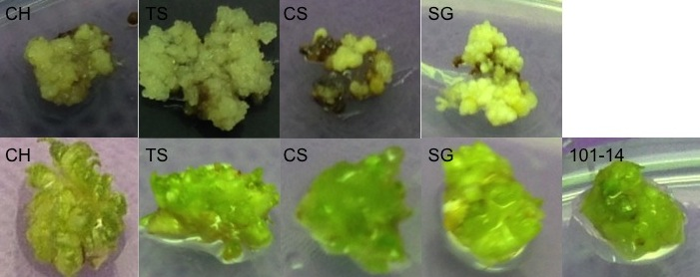

Figure 3. Embryogenic cultures (top) and meristematic bulks (bottom) of CH, TS, CS, SG and 101-14

transformed shoots in a shorter period of time than somatic embryos. We have tested different media and selective agents and established protocols for the initiation, maintenance and genetic transformation of MB from these 5 genotypes (Xie et al. in preparation). MB induction in non-vinifera genotypes is less efficient but still high, with about 80% of the explants producing MB after 3 subcultures in medium containing increasing concentrations of cytokinins. For this reason, we have also started the production of MB of PD susceptible genotypes selected from 04191 population, which are 50% vinifera, 25% b43-17 and 25% V. rupestris A. de Serres (as in original population used for PdR1b mapping). These genotypes can provide an additional genetic background for analysis of expression of PdR1 candidate genes.

In order to include native promoters and terminators in constructs for future genetic transformations, we have verified sequences upstream and downstream of V.ari-RGA14 and 18, the two strongest PdR1b candidates. Sequence verification has been completed up to 4-6 kb in the upstream region and 1 kb in the downstream region. In silico analysis of the upstream regions with PlantCare, a database of plant cis-acting regulatory elements has shown that upstream sequences contain several motifs related to drought and defense responses.

Transformations with Agrobacterium tumefaciens carrying binary plasmids pCLB1301NH and pCLB2301NK, will be used to clone PdR1b candidate genes and their regulatory regions. These plasmids have been designed to overcome stability problems associated with the presence of large genomic fragments (Feechman et al. 2013). They carry the hygromycin (pCLB1301NH) and kanamycin (pCLB2301NK) selectable marker genes, respectively. Both plasmids also carry mGFP5-ER as a reporter gene. We have transformed MB of TS, CH and SG with both plasmids to test the use of the hygromycin and kanamycin genes under the control of the NOS promoter in contrast with our previous results using the same genes under the control of the 35S promoter.

CONCLUSIONS
The genetic mapping with two new populations with b46-43 and T03-16 background is proceeding. These two accessions are geographically isolated from b43-17 and support the lowest levels of bacteria. The screening of F1 and BC1 populations with these two backgrounds in underway. Marker testing to identify polymorphic markers is initiated. The results from this work will allow us to use markers to facilitate stacking of these resistance sources with PdR1 from b43-17 – the incorporation of multiple resistance should make resistance more durable. We have completed the genetic mapping of PD resistance from b40-14 and named it PdR1c. This resistance source maps within the PdR1b locus, and may be an alternative gene within this complex replicated locus. We are physically mapping this gene to improve our understanding of the locus. Finally, we have been sequencing the PdR1 locus to better define the 2 candidate genes and prepare them for complementation tests. This effort is also identifying their promoters so that we can avoid the use of constitutive non-grape promoters like CaMV 35S.

Literature Cited

Agüero CB, Meredith CP, Dandekar AM (2006) Genetic transformation of Vitis vinifera L. cvs. Thompson Seedless and Chardonnay with the pear PGIP and GFP encoding genes. Vitis 45:1-8
Feechan, A., Anderson, C., Torregrosa, L., Jermakow, A., Mestre, P., Wiedemann-Merdinoglu, S., Merdinoglu, D., Walker, A. R., Cadle-Davidson, L., Reisch, B., Aubourg, S., Bentahar, N., Shrestha, B., Bouquet, A., Adam-Blondon, A.-F., Thomas, M. R. and Dry, I. B. (2013), Genetic dissection of a TIR-NB-LRR locus from the wild North American grapevine species Muscadinia rotundifolia identifies paralogous genes conferring resistance to major fungal and oomycete pathogens in cultivated grapevine. The Plant Journal, 76: 661–674. doi: 10.1111/tpj.12327
Gilchrist D., and Lincoln J. (2008) Functional testing and characterization of Pierce’s disease-induced promoters from grape. Proceedings of the Pierce's Disease Research Symposium.
Holmes IB, Wendt T, and Holm PB (2013) Intragenesis and cisgenesis as alternatives to transgenic crop development. Plant Biotech. J. 11:395–407
Li ZT, Kim KH, Jasinski JR, Creech MR, and Gray D. (2012) Large-scale characterization of promoters from grapevine (Vitis spp.) using quantitative anthocyanin and GUS assay systems. Plant Sci. 196:132-142
Riaz, S and M.A. Walker. 2013 Phylogeographic analysis of resistance to Pierce’s Disease in North American and Mexican species. 64th Annual Meeting of the American Society for Enology and Viticulture, Monterey, CA.

FUNDING AGENCY
Funding for this project was provided by the CDFA PD/GWSS Board. Additional support from the Louis P. Martini Endowed Chair in Viticulture is also gratefully acknowledged.

