California Department of Food and Agriculture PD/GWSS

Renewal Progress Report – March 2017

REPORT TITLE: Renewal Progress Report for CDFA Agreement Number 15-0425-SA

PROJECT TITLE: Breeding Pierce’s disease resistant winegrapes.

PRINCIPAL INVESTIGATOR AND COOPERATING STAFF: M. Andrew Walker and Alan Tenscher, Dept. of Viticulture & Enology, University of California, One Shields Ave., Davis, CA 95616-8749, awalker@ucdavis.edu, 530-752-0902

REPORTING PERIOD: primarily October 2016 to March 2017

INTRODUCTION
We continue to make rapid progress breeding Pierce’s disease (PD) resistant winegrapes. Aggressive vine training and selection for precocious flowering have allowed us to reduce the seed-to-seed cycle to two years. To further expedite breeding progress we are using marker-assisted selection (MAS) for the Pierce’s disease resistance locus, PdR1 to select resistant progeny as soon as seeds germinate. These two practices have greatly accelerated the breeding program and allowed us to produce four backcross generations with elite Vitis vinifera winegrape cultivars in 10 years. We have screened through about 2,000 progeny from the 2009, 2010, and 2011 crosses that are 97% V. vinifera with the PdR1b resistance gene from V. arizonica b43-17. Seedlings from these crosses continue to fruit and others are advancing to small scale wine trials. We select for fruit and vine quality and then move the best selections to greenhouse testing, where only those with the highest resistance to Xylella fastidiosa, after multiple greenhouse tests, are advanced to multi-vine wine testing at Davis and other test sites. The best of these will be advanced to field testing with commercial-scale wine production, the first of which was planted in Napa in June 2013. To date 19 scion and three PD resistant rootstocks have been advanced to FPS for certification. Stacking of PdR1b with b42-26 Pierce’s disease resistance has been advanced to the 92% V. vinifera level using MAS to confirm the presence of PdR1 as well as the recently discovered (see companion report) PD resistance locus on LG8 from b42-26, PdR2. Greenhouse screening is still used to select for advancement only genotypes with higher than usual levels of PD resistance. Other forms of V. arizonica are being studied and the resistance of some will be genetically mapped for future efforts to combine multiple resistance sources and ensure durable resistance. Pierce’s disease resistance from V. shuttleworthii and BD5-117 are also being pursued but progress is limited by their multigenic resistance and the absence of associated genetic markers. Very small scale wines from 94% and 97% V. vinifera PdR1b selections have been very good and have been received well at public tastings in Sacramento (California Association of Winegrape Growers; CAWG) and Santa Rosa (Sonoma Winegrape Commission), Napa Valley (Napa Valley Grape Growers and Winemakers Associations), Temecula (Temecula Valley Winegrape Growers and Vintners), and Healdsburg (Dry Creek Valley and Sonoma Grape Growers and Winemakers).

The Walker lab is uniquely poised to undertake this important breeding effort, having developed rapid screening techniques for Xylella fastidiosa resistance (Buzkan et al., 2003; Buzkan et al., 2005; Krivanek et al., 2005a 2005b; Krivanek and Walker, 2005; Baumgartel, 2009), and having unique and highly resistant Vitis rupestris x V. arizonica selections, as well as an extensive collection of southwestern grape species, which allows the introduction of extremely high levels of X. fastidiosa resistance into commercial grapes. We genetically mapped and identified what seems to be a single dominant gene for X. fastidiosa resistance in V. arizonica/candicans b43- 17 and named it PdR1. This resistance has been backcrossed through four generations to elite V. vinifera cultivars (BC4) and we now have 97% V. vinifera PD resistant material to select from. Individuals with the best fruit and vine characteristics are then tested for resistance to X. fastidiosa under our greenhouse screen. Only those with the highest levels of resistance are advanced to small-scale winemaking trials by grafting them onto resistant rootstocks and planting six to eight vine sets on commercial spacing and trellising at Pierce’s disease hot spots around California, where they continue to thrive. We have made wine from vines that are 94% V. vinifera level from the same resistance background for eight years and from the 97% V. vinifera level for six years. They have been very good and don’t have typical hybrid flaws (blue purple color and herbaceous aromas and taste) that were prevalent in red wines from the 87% V. vinifera level. There are two forms of PdR1 that descend from sibling progeny of b43-17 and they have different alleles of PdR1, designated PdR1a and PdR1b. Screening results reported previously showed no significant difference in resistance levels in genotypes with either one or both alleles. We have narrowed our focus to PdR1b but retain a number of selections at various backcross (BC) levels with PdR1a in the event that there is an as yet unknown X. fastidiosa strain-related resistance associated with the PdR1 alleles. We also identified a PD resistance locus PdR1c from V. arizonica b40-14 (PdR1c) that maps to the same region of Chromosome 14 as PdR1 from b43-17. In the absence of an understanding of gene function and given the very disparate origins of the b43-17 and b40-14 resistance sources, differences in preliminary DNA sequence data between them, and differences in their PD symptom expressions, we have continued to advance the PdR1c line as a future breeding resource. Our companion research project is pursuing the genetic basis of these differences between PdR1b and PdR1c. In 2005, we started a PD resistant breeding line from another Mexican accession, b42-26. Markers linked to this resistance proved elusive but strong resistance was observable in our greenhouse screens as we advanced through the backcross levels. In 2011, we started stacking resistance from PdR1b with that of b42-26 using marker-assisted selection (MAS) to select for PdR1b and a higher than usual resistance in our greenhouse screen to move the b42-26 resistance forward. Late last year our companion project identified the location of a significant PD resistance locus from b42-26 on LG8, which we have called PdR2. Three years ago, in 2014, we advanced our PdR1 x PdR2 line to the 92% vinifera level and last spring made crosses to advance it to the 96% vinifera level. MAS was used to advance only genotypes with both PdR1b and PdR2 for the first time on these crosses. The resistance from southeastern United States (SEUS) species is being advanced in other lines. However, the resistance in these latter lines is complex (controlled by multiple genes) and markers have not yet been developed to expedite breeding. The breeding effort with alternative resistance sources and the complexing of these resistances is being done to broaden X. fastidiosa resistance and address X. fastidiosa’s potential to overcome resistance.

OBJECTIVES
- Identify unique sources of PD resistance with a focus on accessions collected from the southwestern United States and northern Mexico. Develop F1 and BC1 populations from the most promising new sources of resistance. Evaluate the inheritance of resistance and utilize populations from the most resistant sources to create mapping populations.

- Provide support to the companion mapping/genetics program by establishing and maintaining mapping populations, and using the greenhouse screen to evaluate populations and selections for PD resistance.

- Develop advanced lines of PD resistant winegrapes from unique resistance sources through four backcross generations to elite V. vinifera cultivars. Evaluate and select on fruit quality traits such as color, tannin content, flavor, and productivity. Complete wine and fruit sensory analysis of advanced selections.

- Utilize marker-assisted selection (MAS) to stack (combine) different resistance loci from the BC4 generation with advanced selections containing PdR1. Screen for genotypes with combined resistances, to produce new PD resistant grapes with multiple sources of PD resistance and high quality fruit and wine.

DESCRIPTION OF ACTIVITIES

Objective 1. Identify unique sources of PD resistance with a focus on accessions collected from the southwestern United States and northern Mexico. Develop F1 and BC1 populations from the most promising new sources of resistance. Evaluate the inheritance of resistance and utilize populations from the most resistant sources to create mapping populations.

Objective 2. Provide support to the companion mapping/genetics program by establishing and maintaining mapping populations, and using the greenhouse screen to evaluate populations and selections for PD resistance.

To date over 293 wild accessions have been tested for PD resistance with the greenhouse screen, most of which were collected from the southwestern United States and Mexico (SWUS). Our goal is to identify accessions with the most unique PD resistance mechanisms. To do so we evaluate the genetic diversity of these accessions and test them for genetic markers from chromosome 14 (where PdR1 resides) to ensure that we are choosing genetically diverse resistance sources for population development and greenhouse screening efforts. Over the last three years, 15 of the most unique accessions were used to develop F1 populations with V. vinifera to investigate the inheritance of PD resistance in their F1 progeny and the degree to which they resist X. fastidiosa. We have reported previously the surprising result from our companion PD mapping project that most of the resistance lines we have explored from the southwestern US have PD resistance associated with chromosome 14, the same region as our primary resistance line PdR1b. From that same project we identified PdR2 on chromosome 8 from b42-26. PdR2 resistance although significant, generally doesn’t confer as strong a resistance as PdR1. Preliminary results indicate that most of the non-PdR1 resistance sources appear to also have at least some of their resistance derived from chromosome (Ch) 8. Until we better understand the nature of Ch8 PD resistance and explore additional resistance loci in these lines, it is important to continue advancing multiple sources of Ch8 resistance. We are part way through our yearly seed germination season. All seeds have been planted and seedlings are emerging. In Table 1 we detail crosses made in 2016 to advance lines that preliminary screening indicates are not located on Ch14 and give estimates for the number of seedlings expected and those healthy enough to be DNA tested either for trueness to type or for Ch8 markers. Crosses in Group 1a created progeny to expand existing F1 mapping populations from the ANU67, b41-13 and T03-16 sources (all accessions from southwestern Vitis species). The location of PD resistance from ANU67 is not yet determined, resistance from the latter two, at least in part, resistance appears to be associated with Ch8. Some of the progeny from these F1 lines exhibited strong resistance, but few highly resistant progeny were detected in the T03-16 line. Crosses in Group 1b were made to examine whether complete PD resistance in this line could be recovered through a full sib crossing in the F1 generation. Two elite F1 individuals from the b41-13 line and the three of the most resistant F1 genotypes in the T03-16 line were backcrossed to the indicated elite vinifera parents (Group 1c) to create new breeding lines at the BC1 level. We are not sure why we are seeing poor germination in 1c, which involves the T03-16 line. We also observed poor germination in 2 of the 3 crosses to ANU67 in 1a. They all share F2-25 as the female but similar crosses with the former germinated normally as did an identical cross in the latter. Until we know more about resistance from the Ch8 lines, will continue to advance them separately. Ultimately they could be combined either individually or in combination with the b42-26 PdR2 line to enhance and broaden PD resistance in our main PdR1b resistance crosses.

Table 1. 2016 Crosses made to expand new PD mapping populations and advance breeding lines to the next backcross level.
Group | Cross PDR Source | % vinifera | vinifera Parents/ Grandparents | # Crosses | Act. # Seeds | Est # Seedlings Produced | Est # Seedlings Tested True to Type or MAS
1a | ANU67 | 50% | F2-35 | 1 | 890 | 253 | 175
 | b41-13 | 50% | F2-35 | 1 | 1147 | 624 | 395
 | T 03-16 | 50% | Palomino | 1 | 47 | 42 | 35
1b | T 03-16 | 50% | Palomino | 3 | 160 | 130 | 95
1c | b41-13 | 75% | Rosa Minna, Primitivo/F2-35 | 2 | 550 | 357 | 250
 | T03-16 | 75% | F2-35/Palomino | 3 | 338 | 31 | 25

Table 2 provides a list of the PD greenhouse screens analyzed, initiated and/or completed over the reporting period. Recombinants from 2014 crosses in the PdR1b line were tested in Group 2a to further refine its genomic location and results were provided to our companion mapping project. In the same screen we tested 127 genotypes in the 92% PdR1b x b42-26 stack group, 66 for the first time. This screen was only of low-moderate severity and although this can be sufficient for mapping, is usually insufficient for advancing parental candidates in breeding lines. Retesting of these was undertaken in 2g. Group 2b tests or retests F1 genotypes in the T03-16 and b41-13 lines – our focus now for alternatives to Ch14 PD resistance. We also retested genotypes used as parents in 2016 crosses to confirm high levels of PD resistance. Group 2c continues our screening of 92% PdR1b x b42-26 stack group by testing 93 genotypes for the second or third time to assure resistance. We are making strong progress evaluating the important PdR1b x b42-26 stacking group. In 2d we are testing 50 genotypes in an alternative PdR1b x b42-26 line at the 93% vinifera level. Also being tested are 98 genotypes employing various combinations of PD and powdery mildew (PM) resistance from crosses made in 2015. These include PdR1b either alone or with b42-26 resistance and the Ren1, Ren4 and Run1 PM resistance loci. The main focus of 2e is to refine resistance in the b42-26 line primarily around Ch8. Similarly, we are retesting 8 genotypes in the b46-43 line that had anomalous greenhouse screen results relative to their Ch14 markers. Promising parents for breeding in novel PDR lines including b40-14, b46-43, and ANU5 are also being retested as are untested remnants of our BD5-117 lines. As well as testing additional PDxPM crosses in 2f, we are testing 20 accessions of V. berlanderi for the first time to assess PD resistance in this Texas native species. Cuttings for the screen outlined in 3g have been taken to keep our screens uninterrupted during the period from budbreak to a couple weeks after the end of bloom when propagation by green cuttings is unreliable. Screening will focus on the b47-32 V. arizonica-monticola line to identify if resistance is unique or segregates with either Ch8 or Ch14 markers.

Table 2. Greenhouse PD screens analyzed, completed and/or initiated during the reporting period. Projected dates are in italics.
Group | Test Groups | No. of Genotypes | Inoculation Date | ELISA Sample Date | PD Resistance Source(s)
2a | SRs 2014 Recombinants, PdR1bxb42-26 Stack 2nd tests | 170 | 8/11/2016 | 11/10/2016 | PdR1b,b42-26
2b | T03-16,b41-13,2016 parents | 259 | 9/13/2016 | 12/13/2016 | b41-13, b42-26,PdR1b, T03-16
2c | PdR1b x b42-26 stack & recent promising | 115 | 10/11/2016 | 1/10/2017 | PdR1b, b40-14, b42-26
2d | 2015 PD & PD-PM Crosses | 155 | 1/5/2017 | 4/6/2017 | PdR1b, b42-26
2e | b42-26 BC1 & BC2 locus refinement, 2014 Cross highly rated; b46-43, BD5-117 | 262 | 3/14/2017 | 6/13/2017 | b42-26, b46-43, BD5-117
2f | Addn PDxPM HW & V. berlanderi | 113 | 4/8/2017 | 7/1/2017 | PdR1b, b42-26, berl
2g | b47-32 & low severity screen retests | 170 | 6/10/2017 | 9/9/2017 | PdR1b, b42-26, b47-32

As part of the trial in 2b above, we conducted a small experiment using 4 plants each of two of our standard 88% vinifera PdR1b biocontrol genotypes. Genotype U0505-01 is used as our resistance standard to determine whether the other test genotypes are statistically resistant, while the performance of the more intermediately resistant U0505-35 helps determine the severity of the screen. The goals were to determine the range of Xf titer in our typical sample region of 30 cm above the point of inoculation (POI), how widely the titer varies in the upper region of the plant, and to see if there was a correlation of the typical PD symptoms with Xf titer. Similar work had been done early in the identification of the PdR1 locus but hadn’t been conducted in a vinifera background nor at this relatively high backcross level. This was a moderate to high severity screen, ideal for selecting advanced breeding genotypes and lasted our typical 13 weeks from inoculation to sampling. Sample locations and numbers and Xf titer ranges are reported in Table 3. A typical U0505-35 genotype as well as relative sample locations can be seen in Figure 1. Note the green islands on the stem and the leaf scorch typical of PD infection. Statistical analysis showed no correlation of Xf titer with sample location, PD symptoms, or distance from point of inoculation (POI). There was a weak correlation between titer and node number above the POI, but an examination of the scatter (not shown) suggested that this was a statistical artifact. The only consistent variable, and this was highly significant, was the genotype. There were no interactions among the parameters. That genotype was the only significant factor, continues to validate the strength of our screening method in identifying PD resistant selections. It is important to note that for breeding purposes, we select for advancement only genotypes significantly more resistant than U0505-01, that consistently show even lower Xf titers (mostly below the detection threshold) and even more minimal PD symptom expression.

Table 3. X. fastidiosa titer ranges by genotype and aample location
Genotype | Sample Location | Minimum cfu/ml | Maximum cfu/ml | # Samples
U0505-01 | POI+30 to 45 cm | 10,000 | 609,000 | 13
U0505-01 | POI+~60 cm | 10,000 | 164,000 | 6
U0505-35 | POI+30 to 45 cm | 161,000 | 2,375,000 | 13
U0505-35 | POI+~60 cm | 96,000 | 3,600,000 | 6

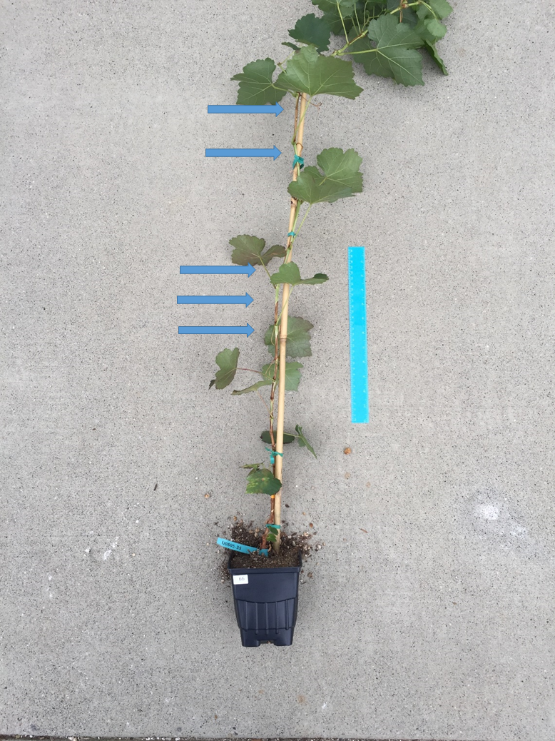
Figure 1. A typical U0505-35 genotype at the end of the greenhouse screen. Blue arrows show sample locations. The blue ruler is 30 cm long.

Objective 3. Develop advanced lines of PD resistant winegrapes from unique resistance sources through four backcross generations to elite V. vinifera cultivars. Evaluate and select on fruit quality traits such as color, tannin content, flavor, and productivity. Complete wine and fruit sensory analysis of advanced selections.

We continue to present our PD resistant wines at the 94% and 97% V. vinifera levels to grower and vintner groups. Some of these tastings are at the University of California, Davis with industry and student tasters, and others are at various industry gatherings with single event attendance exceeding 200 people. Overall, wines from our new PD resistant varieties have been very well received. On October 20, 2016 the first tasting to evaluate the 2016 vintage wines from our new PD resistant varieties was held at UC Davis. This was a production tasting to determine which lots and what quantities of each to bottle. Attendance was limited to the UC Davis winemakers, their student helper and the authors. All wines were produced from grapes grown in Davis. For the whites, 4 of 5 had average scores better than Chardonnay and all finished ahead of the standard PD resistant control, Blanc du Bois. We have continued to evaluate various 97% vinifera white selections to advance to multi-vine testing. The lot designated Emerging White Blend is made from a blend of single vine quantities of 5 candidates, two of which are already at FPS. The third place ranking of this lot among the white PD selections and its finish ahead of Chardonnay offers promise of more white selections to come. Last spring we planted multi-vine copies and we plan to make our first batches of wine from the individual selections this fall. Among the reds, 3 lots from the PD selections finished with average scores ahead of Cabernet Sauvignon. For the first time this year we made wine from 03182-084, a 75% vinifera selection with resistance based on the SEUS resistance from BD5-117. It was a controversial wine and on average didn’t do that well. As the wine ages and/or the vines mature, wine quality may improve. Also new this year, we evaluated the addition of two different oak adjuncts to one of our larger red lots, 09330-07. Both treatments, designated B and V respectively, were preferred to the control and were two of the 3 most preferred wines. We plan to present them to professional tasters along with the rest of the bottled wines later this spring. Results of the tasting and those selections now bottled (all but those highlighted in yellow) are presented in Table 4.

Table 4. Results of a preliminary tasting of 2016 vintage wines tasted 10/20/16 at UC Davis. The wines were rated on a hedonic quality scale from 1 = poor to 5 = v. good.
Wine Name | % vinifera | Color | Average Score | Max Score | Min Score | 10/20/16 Consensus Descriptors: color; aroma; flavor-texture
07370-084 | 94% | W | 3.3 | 5 | 1 | Slightly cloudy, pale straw; floral, peach, melon; fruity, dough, nice acidity, balanced.
09314-102 | 97% | W | 3.6 | 4 | 3 | Clear, med-pale straw; tropical, rich, ripe, touch earthy; soft, warm, slightly phenolic.
09338-016 | 97% | W | 2.9 | 4 | 1.5 | Slightly cloudy, pale straw; grassy, green, vinous, slightly floral; citrus rind, light, tart.
10302-178 | 97% | W | 3.7 | 5 | 2 | Clear, med yellow; apple, spicy, exotic; clean, subdued flavors, ok acidity, med body.
Blanc du Bois | 66% | W | 2.6 | 4 | 1 | Clear, pale; floral, rose, muscat; simple slightly bitter, slightly phenolic balanced.
Chardonnay | 100% | W | 3.2 | 4 | 2.5 | Clear, med yellow; apple-pear, slightly green; oily, rounded, short.
Emerging White Blend | 97% | W | 3.5 | 5 | 2 | Clear, med yellow; floral, mango, pineapple, banana; muscat, warm, balanced, slightly bitter.
03182-084 | 75% | R | 2.8 | 5 | 1 | Med- red, fig, dried prune, chocolate, spicy; relatively mature, vs mousey, subdued fruit, savory, soft.
07355-075 | 94% | R | 2.6 | 4 | 1 | Dark red; grapey, red fruit, touch apple; mousey, warm, soft, slightly bitter.
09330-07 | 97% | R | 3.5 | 4 | 3 | Dark red-purple; vs reduced, dark fruit, grapey, raspberry, cola; fruit, full, balanced, slightly phenolic.
09330-07 B | 97% | R | 4.2 | 5 | 3 | Dark red-purple; toasty oak, vanilla, diminished fruit; caramel, savory, warm, rounder tannins.
09330-07 V | 97% | R | 4.1 | 4.5 | 4 | Dark red-purple; woody, vs toasty, meaty, diminished fruit; red fruit, woody, warm, slightly bitter.
09331-047 | 97% | R | 3.5 | 4 | 2.5 | Dark- red-purple; red fruit, spice, slight reduction; fruity, candy, slightly thin, warm.
09331-103 | 97% | R | 4.0 | 5 | 3 | Med+ - Dark- red; Zin-like, strawberry, raspberry; bright & fruity, balanced acidity & astringency.
09331-133 | 97% | R | 3.7 | 5 | 3 | Dark- red; grapey, slightly cloying, figs, cherry; cherry, vs veg, warm, soft, good balance, obvious tannins.
09331-160 | 97% | R | 3.8 | 5 | 3 | Med- red; cherry, strawberry, slightly candied, Beaujolais, warm region pinot; light, simple, rounded.
09333-111 | 97% | R | 2.7 | 4 | 2 | Med- red; strong veg, bell pepper; veg, some red fruit, hot, thin, tannic.
09333-358 | 97% | R | 2.6 | 5 | 1 | Lt+ red-brown; simple, slightly veg, cooked; simple, light, strange, hot, thin.
09333-370 | 97% | R | 3.4 | 4.5 | 2 | Med+ red; dark fruit, grapey, meaty; jammy, soft, rustic.
09356-235 | 97% | R | 4.2 | 5 | 3 | Dark red-purple; dark fruit, spice, slightly jammy; dark red fruit, big, rich, chewy, tannic.
Cab Sauv BKII | 100% | R | 3.6 | 4.5 | 2 | Dark- red; simple red fruit, slightly stale vitamin, slightly tomato; subdued fruit, warm, light tannin.
Cab Sauv BKVII | 100% | R | 3.7 | 4.5 | 2 | Dark- red; non-descript red fruit, perhaps berry, slight veg; subdued fruit, warm, light tannin.
Lenoir | 50% | R | 2.7 | 4 | 1 | Dark red-brown; odd, raisined, rustic, spice; cherry, VA, hollow, thin.

Objective 4. Utilize marker-assisted selection (MAS) to stack (combine) different resistance loci from the BC4 generation with advanced selections containing PdR1. Screen for genotypes with combined resistances, to produce new PD resistant grapes with multiple sources of PD resistance and high quality fruit and wine.

Our 2016 breeding crosses (Table 1 and 5) expand on our 2015 efforts with increased numbers and focus on parents with superior horticultural and fruit quality traits. The numbers of relevant crosses were significantly impacted by the identification of PdR2. In the spring resistant parents were selected based on their PdR1b status and the greenhouse results from testing summarized in Table 5a and 5c and then refined late this fall using pre-plant MAS testing of the parents for the presence of Ch8 resistance. Crosses made in Table 5a represent backcrosses to elite vinifera wine varieties to various parents from crossings of PdR1b x b42-26 lines at the 92% vinifera level. The number of relevant crosses was reduced by 5 and the number of seeds planted fell by 1,743 saving significant time and labor. These 96% vinifera PdR1b x b42-26 progeny will serve as baseline populations to later quantify the value of double stacking minor factors of the b42-26 resistance. Table 5b presents intercrosses among the most resistant progeny to further evaluate compatibility and resistance in this effort to stack (combine) different resistance sources. Here the relevant cross count went from 17 to 12 and seeds needing planting fell by 4,114. The next step in our stacking efforts will be to take the most resistant progeny from these crosses, now homozygeous at both PdR1b and PdR2 and enriched in minor b43-17 and b42-26 resistance factors and, similar to what we did last year in Table 5a, cross the most promising and resistant of these elite selections to create populations that are 96% vinifera. All progeny would then have both PdR1b and PdR2 and all should be highly PD resistant. The most promising selections would then be advanced to Foundation Plant Services (FPS) for certification and eventual release as the next iteration of our PD resistant winegrape breeding efforts. Table 5c presents the first crossing of elite PdR1b types to parents with 3 powdery mildew (PM) resistance loci to evaluate possible segregation distortion between these combinations of resistance loci. Table 5d attempted to make similar crosses although at a lower percent vinifera level, but became irrelevant when the parents were found not to have PdR2. These crosses were created to confirm the functionality of combining 2 PD resistance loci with 3 PM resistance loci and will be repeated this spring now that markers are known. To increase the percentage of progeny with PdR1b, we cross either to a parent homozygous at PdR1b or cross with parents that both carry PdR1b (Tables 5e, f, g). Similarly we accomplish the same increase in vinifera percentage of progeny with PM resistance markers however again at a slightly lower vinifera level as shown in Tables 5f and 5g. Once again, relevant cross and seed numbers were reduced through MAS testing the parents for Ch8 resistance after crosses were made and before germination.

Table 5. PD crosses made in 2016 with percent vinifera, most recent elite vinifera parent and number of seeds produced. The PD resistance in PdR1b originated b43-17 a Monterrey, Mexico V. arizonica/candicans; b42-26 (V. arizonica/girdiana) has a multigenic form of PD resistance from Loreto, Baja California. Ren1, Ren4 and Run1 are powdery mildew (PM) resistance loci from V. vinifera, V. romanetii, and M. rotundifolia, respectively.
Cross PDR Type | Cross PM Type | % vinifera | vinifera Parents/ Grandparents or …/most recent vinifera parents
5a. PdR1bxb42-26 | none | 96% | Chardonnay, Cabernet Sauvignon, F2-35, Primitivo/Chardonnay, Zinfandel
5b. PdR1bxb42-26 | none | 92% | Zinfandel, Chardonnay
5c. PdR1b | Ren1,Ren4,Run1 | 96% | Zinfandel/F2-35
5d. PdR1bxb42-26 | Ren1,Ren4,Run1 | 92% | .../Grenache, Zinfandel
5e. PdR1b^2xb42-26 | Ren1,Ren4 | 94% | .../F2-35,Grenache, Zinfandel
5f. PdR1b^2xb42-26 | (Ren1,Ren4)^2 | 90% | .../F2-35,Karadzhandal, Zinfandel
5g. (PdR1bxb42-26)^2 | (Ren1,Ren4)^2 | 90% | .../F2-35,Grenache, Zinfandel

Table 5. Continued.
Cross PDR Type | # Crosses | # Seeds | # seedlings | # MAS Tested
5a. PdR1bxb42-26 | 4 | 797 | 515 | 270
5b. PdR1bxb42-26 | 12 | 3,255 | 1,778 | 985
5c. PdR1b | 1 | 136 | 32 | 25
5d. PdR1bxb42-26 | 0 | 0 | 0 | 0
5e. PdR1b^2xb42-26 | 2 | 463 | 152 | 135
5f. PdR1b^2xb42-26 | 1 | 294 | 64 | 55
5g. (PdR1bxb42-26)^2 | 2 | 595 | 152 | 125

CONCLUSIONS
We continue to make rapid progress breeding PD resistant winegrapes through aggressive vine training, marker-assisted selection, and our rapid greenhouse screen procedures. These practices have allowed us to produce four backcross generations with elite V. vinifera winegrape cultivars in 10 years. We have screened through thousands of seedlings that are 97% V. vinifera with the PdR1b resistance gene from V. arizonica b43-17. We select for fruit and vine quality and then move the best to greenhouse testing, where only those with the highest resistance to X. fastidiosa, after multiple greenhouse tests, are advanced to multi-vine wine testing at Davis and in Pierce’s disease hot spots around California. The best of these are being planted in vineyards at 50 to 1,000 vine trials with enough fruit for commercial scale winemaking Figure 2. We have sent 19 advanced winegrape selections to 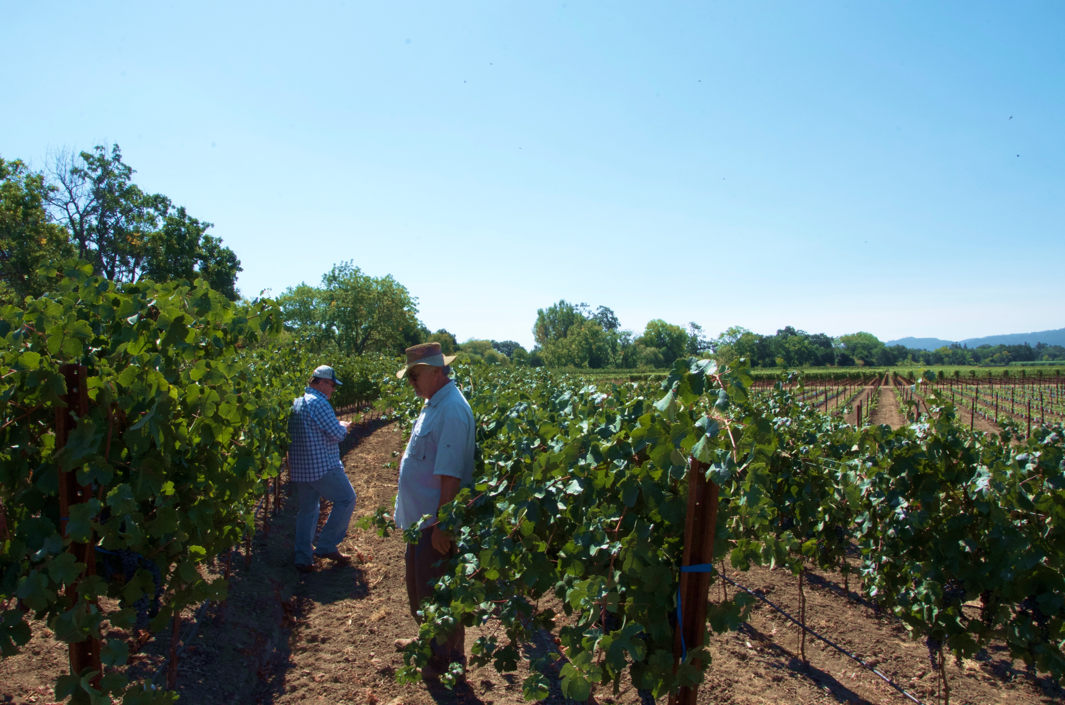
Figure 2. 94% v. vinifera PD resistant winegrape selection 07355-075 planted along the Napa River near St. Helena, CA.

FPS over the past four winters to begin the certification and release process. Three PD resistant rootstocks were
also sent to FPS for certification. The first selections have cleared certification from Foundation Plant Services and we are currently working through the UC patent and release process. We have also identified PD resistance on chromosome (Ch) 8 from V. arizonica-girdiana accession b42-26 and designated it PdR2. Numerous selections with PdR1b and PdR2 combined together at the 92% vinifera level have been greenhouse screened and used in crosses to increase the percentage of vinifera. Pierce’s disease resistance from V. shuttleworthii and BD5-117 is also being pursued, but progress and effort is limited because their resistance is controlled by multiple genes without effective resistance markers. Other forms of V. arizonica are being studied and the resistance of some will be genetically mapped for future efforts to combine multiple resistance sources and ensure durable resistance. Very small-scale wines from 94% and 97% V. vinifera PdR1b selections have been very good, and have been received well at tastings in the campus winery and at public tastings throughout California.

REFERENCES CITED
Baumgartel, J.E. 2009. Optimizing screening technology for breeding Pierce’s disease resistant Vitis. M.S. Thesis. University of California, Davis.
Buzkan, N., A.F. Krivanek, A. Eskalen and M.A. Walker. 2003. Improvements in sample preparation and polymerase chain reaction detection techniques for Xylella fastidiosa in grapevine tissue. Am. J. Enol. Vitic. 54:307-312.
Buzkan, N., L. Kocsis and M.A. Walker. 2005. Detection of Xylella fastidiosa from resistant and susceptible grapevine by tissue sectioning and membrane entrapment immunofluorescence. Microbiol. Res. 160:225-231.
Krivanek, A.F., J.F. Stevenson and M.A. Walker. 2005a. Development and comparison of symptom indices for quantifying grapevine resistance to Pierce’s disease. Phytopathology 95:36-43.
Krivanek, A.F. and M.A. Walker. 2005. Vitis resistance to Pierce’s disease is characterized by differential Xylella fastidiosa populations in stems and leaves. Phytopathology 95:44-52.
Krivanek, A.F., T.R. Famula, A. Tenscher and M.A. Walker. 2005b. Inheritance of resistance to Xylella fastidiosa within a Vitis rupestris x Vitis arizonica hybrid population. Theor, Appl. Genet. 111:110-119.
Krivanek, A.F., S. Riaz and M.A. Walker. 2006. The identification of PdR1, a primary resistance gene to Pierce’s disease in Vitis. Theor. Appl. Genet. 112:1125-1131.

PUBLICATIONS RELATED TO WINEGRAPE BREEDING
Xie, X., C.B. Agüero, Y. Wang and M.A. Walker. 2015. In vitro induction of tetraploids in Vitis X Muscadinia hybrids. Plant Cell, Tissue & Organ Culture DOI 10.1007/s11240-016-1023-4.
Peressotti, E., C. Dolzani, L. Poles, E. Banchi, M. Stefanini, F. Salamini, R. Velasco, S. Vezzulli, S. Riaz, M.A. Walker, B.I. Reisch, W.E. Van de Weg, M.C.A.M. Bink. 2015. A first pedigree-based analysis (PBA) approach for the dissection of disease resistance traits in grapevine hybrids. Acta Horticulturae 1082:113-121.
Feechan, A., M. Kocsis, S. Riaz, W. Zhang, D.M. Godoury, M.A. Walker, I.B. Dry, B. Reisch and L. Cadle-Davidson. 2015. Strategies for RUN1 deployment using RUN2 and REN2 to manage grapevine powdery mildew informed by studies of race-specificity. Phytopathology 105:1104-1113.
Walker, M.A. 2015. The Genus Vitis, Its Species and Its Rootstocks. IN: Compendium of Grape Diseases, Disorders, and Pests, 2nd Edition, Ed. W.F. Wilcox, W.D Gubler and J.K. Uyemoto et al. APS.
Amrine, K.C.H, B. Blanco-Ulate, S. Riaz, D. Pap, L. Jones, R. Figueroa-Baoderas M.A. Walker and Cantu, D. 2015. Comparative transcriptomics of Central Asian Vitis vinifera accessions reveals distinct defense strategies against powdery mildew. Horticultural Research 2: Article number: 15037 (2015) doi:10.1038/hortres.2015.37
Dangl, G.S., M.L. Mendum, J. Yang, M.A. Walker and J.E. Preece. 2015. Hybridization of cultivated Vitis vinifera with wild V. californica and V. girdiana in California. Ecology and Evolution 5:5671-5684.
Viana, A.P., M.D.V. de Resende, S. Riaz and M.A. Walker. 2016. Genome selection in fruit breeding: application to table grapes. Scientia Agricola 73:142-149.
Pap, D., S. Riaz, I.B. Dry, A. Jermakow, A.C. Tenscher, D. Cantu, R. Olah and M.A. Walker. 2016. Identification of two novel powdery mildew resistance loci, Ren6 and Ren7, from the wild Chinese grape species Vitis piasezkii. BMC Plant Biology (In Press)
Xie, X., C.B. Agüero, Y. Wang and M.A. Walker. 2016. Genetic transformation of grape varieties and rootstocks via organogenesis. Plant, Cell, Tissue and Organ Culture (In Press)
He, Rr; Jiao Wu; Yali Zhang; Shaoli Liu; Chaoxia Wang; Andrew M. Walker; Jiang Lu. 2016 Overexpression of a thaumatin-like protein gene from Vitis amurensis improves downy mildew resistance in Vitis vinifera grapevine. Protoplasma DOI: 10.1007/s00709-016-1047-y (In press)

PRESENTATIONS

Talks at Grower Meetings (Extension/Outreach) April 2016 to February 2017

PD resistant winegrape breeding and tasting, Silverado Vineyards meeting, Napa, CA April 4

PD resistant winegrape breeding. Talk and discussion with John Dyson and Williams Salem staff, UC Davis, April 13

PD resistant winegrape breeding and tasting for California Association of Winegrape Growers, Sacramento, CA Apr 18

Breeding PD resistant winegrapes. Temecula Grape Day, Temecula, CA Apr 21

Breeding PD resistant winegrapes. Alan Tenscher presenting to the AVF Board in Livermore, Apr 29

Breeding PD resistant winegrapes. Talk and tasting for Napa winemakers and viticulturists, UC Davis, May 4

Winegrape breeding at UC Davis. Vintage Nursery Open House, Wasco, CA May 18

Winegrape breeding at UC Davis. International Cabernet Sauvignon Conference, Pine Ridge Winery, Napa, CA June 22 2016

Grape breeding Daniel Roberts Growers group, Santa Rosa, CA July 22
Grape breeding at UCD. Chilean table grape growers association, UCD Oct 3
Grape breeding above and below ground. Cal Poly San Luis Obispo, CA Oct 6

Grape breeding update. CDFA Industry Advisory Board, UC Davis, Nov 1.

PD resistant wines – lecture and tasting. Sacramento Private School Auction Prize, with Darrel Corti. UCD, Nov. 13

Breeding PD Resistant Winegrapes. Texas A&M, Driftwood, TX, Nov, 18

What are the next steps for the PD resistant wine grape breeding program? Vineyard Health Seminar, UCD, Nov. 29

PD Breeding program update. FPS Annual Meeting, UCD, Dec. 1

Progress in the Grape Breeding Program, Recent Advances in Viticulture and Enology, UCD, Dec. 9

Classical and molecular breeding to combat PD. CDFA PD / GWSS Board Annual Meeting, San Diego, CA, Dec. 13

Updates on Salt and Drought Resistant Rootstock Breeding. San Joaquin Valley Grape Day, Fresno, CA Jan 11, 2017

The origin of grapes and grape breeding. 3rd Intl Symposium on Viticulture, Hermosillo, MX Jan 27

Origin of grapes and grape breeding. Daniel Roberts Grower Group Meeting, Santa Rosa, CA Jan 30

Presentations at Scientific Meeting
Xiaoqing Xie, Cecilia B. Agüero, Yuejin Wang , M. Andrew Walker. Optimizing the genetic transformation of grape fruiting and rootstock cultivars. 2016 ASEV National Meeting, Monterey, CA June 29.
Karla Huerta, Summaira Riaz, Alan Tenscher and M Andrew Walker. Characterization of Pierce’s disease resistance in germplasm collected from the southwestern US and Mexico. 2016 ASEV National Meeting, Monterey, CA June 29.
Summaira Riaz, Dániel Pap, Alan Tenscher and M. Andrew Walker. Molecular strategies to stack powdery mildew resistance from multiple backgrounds in a grape breeding program. 2016 ASEV National Meeting, Monterey, CA June 29.

RESEARCH RELEVANCE
The goal of this research is two-fold: to produce PD resistant winegrapes that can be used in PD hot spots in California and across the southern US, and to provide breeding, maintenance and screening support for our gene characterization and genetic mapping efforts. We have 16 winegrape selections at Foundation Plant Services and we are preparing their release to nurseries and then to growers.

Layperson Summary
One of the most reliable and sustainable solutions to plant pathogen problems is to create resistant plants. We use a traditional plant breeding technique called backcrossing to bring PD resistance from wild grape species into a diverse selection of elite winegrape backgrounds. We identified the an area on a chromosome that carries a very strong source of PD resistance from a grape species native to Mexico and the southwestern United States (Vitis arizonica). Because we were able to locate this resistance gene/region, which we named PdR1, we have been able to use marker-assisted selection (MAS) to screen for DNA regions associated with PdR1 allowing us to select resistant progeny shortly after seeds germinate. MAS and aggressive growing of the selected seedling vines have allowed us to produce new PD resistant high quality winegrape selections that are more than 97% V. vinifera in only 10 years. We have evaluated thousands of resistant seedlings for horticultural traits and fruit quality. The best of these are advanced to greenhouse testing, where only those with the highest resistance to Xylella fastidiosa, after multiple greenhouse tests, are advanced to multi-vine wine testing at Davis and at PD hot spots around California. The best of these are advanced to field plots where commercial-scale wines can be produced. We have sent 16 advanced selections to Foundation Plant Services (FPS) over the past four winters to begin the certification and release process. Three PD resistant rootstocks were also sent to FPS for certification. Other wild grape species are being studied and the resistance of some will be genetically characterized for future efforts to combine multiple resistance sources and ensure durable PD resistance. Very small-scale wines made from our advanced PdR1 selections have been very good, and have been received well at professional tastings throughout California.

Status of Funds: These funds are schedule to be spent by the end of the grant.

Intellectual Property: PD resistant varieties will be released through the Office of Technology Transfer (Patent Office) of the University of California, Davis.

FUNDING AGENCY
Funding for this project was provided by the CDFA PD/GWSS Board. Additional support from the Louise Rossi Endowed Chair in Viticulture is also gratefully acknowledged.

ACKNOWLEGEMENTS
We thank Gordon Burns of ETS Labs in St. Helena, CA for continued support with grape berry chemical analysis and Ken Freeze of Brown and Miller for help arranging and coordinating the industry tastings.

