California Department of Food and Agriculture PD/GWSS

Progress Report — March 2017

Report Title: Interim Progress Report for CDFA Project 14-0137-SA

Project Title: Molecular breeding support for the development of Pierce’s disease resistant winegrapes.

PRINCIPAL INVESTIGATOR
M. Andrew Walker (PI), Dept. Viticulture & Enology, University of California, One Shields Ave., Davis, CA 95616 awalker@ucdavis,edu, 530-752-0902

COLLABORATOR

Dario Cantu, Associate Professor, Dept. Viticulture and Enology, UC Davis

COOPERATING STAFF

Dr. Summaira Riaz, Staff Researcher Associate IV, Dept. Viticulture and Enology, UC Davis
Dr. Cecilia Agüero, Associate Specialist, Dept. Viticulture and Enology, UC Davis

Reporting period: March 2016 to March 2017

INTRODUCTION
This project continues to provide molecular support to the PD resistance grape breeding project – “Breeding Pierce’s disease resistant winegrapes” by acquiring and testing a wide range of resistant germplasm, associating resistance regions with markers developed by genetic mapping and then functionally characterizing the resistance genes from different backgrounds. In earlier versions of this project, genetic markers linked to X. fastidiosa resistance from the b43-17 and b40-14 background were used to perform marker-assisted selection (MAS) to accelerate our PD resistant winegrape project and the table and raisin grape breeding of David Ramming. Outcomes from the earlier two projects include genetic maps, and BAC (bacterial artificial chromosome) libraries of the highly resistant V. arizonica accessions, b43-17 and b40-14. We have also identified a different resistance locus, PdR2, in a V. arizonica form from Loreto, Baja California (b42-26) that resides chromosome (Ch) 8. A physical map of the PdR1 locus was completed for b43-17 and b40-14, and several candidate genes were identified. Two candidate genes were cloned and constructs were developed with native grape promoters for transformation efforts.

The current molecular breeding support project has five key objectives: to identify novel sources of PD resistance for use in broadening the genetic base of PD resistance; to accelerate marker discovery and the identification of new and unique resistance genes; to clone and characterize unique DNA sequences (promoters) that regulate the expression of candidate PD resistant grape genes cloned from the PdR1b locus; and to evaluate and compare lines transformed with PdR1 constructs with native and 35S promoters. We have surveyed over 250 accessions of Vitis species growing in the southern US and Mexico in an effort to identify new PD resistant accessions. Analysis using population genetics tools allowed us to better understand gene flow among resistant species and their taxonomic and evolutionary relationships. PD resistance in the southeastern US Vitis species seems to be different than the resistance in Vitis from the southwest US and Mexico. We have identified new PD resistant accessions that are genetically and phenotypically different, were collected from different geographic locations, and have different maternal inheritance. Breeding populations from new promising resistant lines have been developed. These populations will be tested to study the inheritance of resistance. Genetic maps will be developed to identify genomic regions associated with resistance, and genetic markers will be used to enable stacking of multiple resistance genes and breeding of winegrapes with durable PD resistance.

Twenty resistant accessions were identified from screening of more than 250 accessions of germplasm collected from the Mexico and southwestern USA. Markers were used to determine their diversity and relationship to each other. Resistant accessions were used to develop small breeding populations from 2012 to 2015. More than 700 seedlings from breeding populations were marker tested to ensure correct parentage and identity. We used a limited mapping strategy by utilizing markers from Ch14 in conjunction with greenhouse screen data of small breeding populations to determine if resistance to PD is different from the previously identified locus PdR1. Two new unique resistance sources (T03-16 and b41-13) were identified as having a different resistance region than Ch14. More crosses were made in Spring 2016 to expand these breeding populations for map-based identification of genomic regions that contribute to resistance. Physical mapping was completed for b43-17 to clone and characterize resistance genes (PdR1a and PdR1b see earlier reports). The physical map of the PdR1c locus (from b40-14) is also now complete. We are continuously developing and expanding breeding populations from new promising resistant lines.

The identification and characterization of resistance genes and their regulatory sequences will help determine the basis of resistance/susceptibility in grape germplasm. In addition, these genes and their promoters could be employed in production of ‘cisgenic’ plants. Cisgenesis is the transformation of a host plant with its own genes and promoters (Holmes et al. 2013). Alternatively, other well characterized vinifera-based promoters; either constitutive (Li et al. 2012) or activated by X. fastidiosa (Gilchrist et al. 2007) could be utilized. Development of V. vinifera plants transformed with our PD resistance genes and grape promoters might work more effectively and allow us to better understand PdR1’s function.

Upstream and downstream sequences as well as gene sequences of two candidate genes, ORF14 and ORF18, from PdR1b were verified and constructs were developed. Transformation experiments with the PdR1 resistance gene with a native grape promoter were completed with ORF18 and transgenic lines are being developed and maintained for later resistance verification. A large scale multiple time point gene expression project was completed in the greenhouse and RNA extractions were completed for over 400 samples. We used qPCR to test the expression of candidate genes. Embryogenic callus cultures of V. vinifera cvs. Chardonnay and Thompson Seedless and V. rupestris St. George are being maintained. These efforts will help us to identify candidate resistance genes by complementation and better understand how they function.

Objectives
1. Provide genetic marker testing for mapping and breeding populations produced and maintained by the PD resistance-breeding program, including characterization of novel forms of resistance.
2. Complete a physical map of the PdR1c region from the b40-14 background and carry out comparative sequence analysis with b43-17 (PdR1a and b).
3. Employ whole genome (WGS) sequencing (50X) of recently identified PD resistant accessions and a susceptible reference accession; use bioinformatics tools to identify resistance genes, perform comparative sequence analysis and develop SNP markers to be used for mapping.
4. Clone PdR1 genes with native promoters.
5. Compare the PD resistance of plants transformed with native vs. heterologous promoters.

description of activities
Objective 1. Provide genetic marker testing for mapping and breeding populations produced and maintained by the PD resistance-breeding program, including characterization of novel forms of resistance.

The development of resistant varieties requires the combination of multiple genetic sources of resistance (stackoing) to assure a broader and long-lasting resistance. We completed greenhouse testing of over 250 southwestern and northern Mexico Vitis, which included accessions collected from multiple collection trips from States bordering Mexico and others that were previously collected from Mexico by Olmo. Both SSR (simple sequence repeat) and chloroplast markers were used to establish relationships with known sources of resistance currently being used in the breeding program (Riaz and Walker 2013). We identified 20 highly resistant accessions and 15 accessions were selected to develop small breeding populations. In Spring 2016, we extracted DNA from the 704 individuals obtained from breeding populations that were also greenhouse screened. We carried out a limited mapping strategy by utilizing markers from chromosome (Ch) 14 that are linked to the PdR1 locus (See previous reports for details of the PdR1 locus). This strategy allowed us to identify resistance sources whose resistance is similar to PdR1 and those that are different among the newly identified accessions. We selected 12 SSR markers that flanked a 3.5 Mb region around PdR1 locus (Figure 1a). The PdR1 locus is located between markers Pd82-1b4 and ORF18-19-03. The genotypic data of all resistance accessions with 22 markers from 19 chromosomes was used to analyze how genetically distinct the resistant accessions were from each other (Figure 1b).

Based on the polymorphic markers for each breeding population, a genetic map was created to determine the relative marker order and then QTL analysis for each population was carried out. We were able to identify two accessions that were resistant to PD but none of the markers from Ch14 showed any association to the resistance indicating that a distinctive resistance resides on a different chromosome and that is likely different from the PdR1 locus.

A) B)
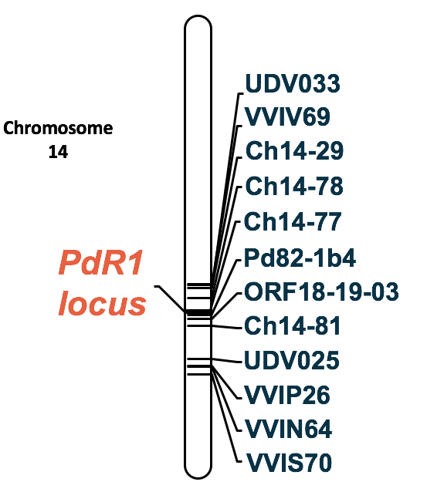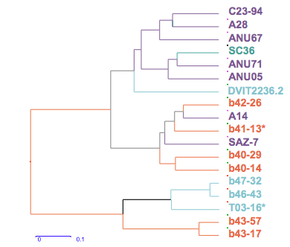

Figure 1. (A) 12 SSR markers that flank 3.5 Mb region on Chromosome 14. The PdR1 locus resides between markers Pd82-1b4 and ORF18-19-03. (B) Dendrogram shows genetic relationship between resistant accessions; asterisks show PD resistant accessions with different source of resistance. Purple: accessions from AZ; Green: accessions from CA; Blue: accessions from Mexico; Orange: accessions from TX.

Accession T03-16 from the Big Bend region in Texas and b41-13 from Tamaulipas state in Mexico are strong candidates that do not possess PdR1. Figure 2 shows the location of all resistant accessions tested so far in this study. These accessions have great potential for use in the PD grapevine breeding program. In order to proceed and to identify the genomic regions in these two accessions, crosses were made in Spring 2016 to expand the size of populations. In four backgrounds, we were not able to determine if resistance is different than PdR1 due to the small population size (Table 1). We plan to expand the number of individuals in those backgrounds, greenhouse test them for PD resistance and carry out analysis next year to determine the presence or absence of PdR1. These results will get us one step closer to finding an alternative mechanism of PD resistance that we can use in our breeding program.

We have also identified a new locus PdR2 in the V. arizonica/girdiana b42-26 background. To create a genetic map of the F1 population 05347 (F2-35 x b42-26), we expanded the population to 352 seedling plants and tested more than 1,000 markers. The level of polymorphism in b42-26 is very low owing to its isolation and possibly inbred genetic background. The genetic map was developed with 163 markers grouped to 17 chromosomes. Chromosome 10 and 19 were not represented. We carried out analysis with this map and identified resistance on Ch8, which was also verified on the basis of linked alleles in the pBC1 and pBC2 populations. The resistance locus is called PdR2 and it resides between markers FAM82 and VMC 7h2. In Spring 2017, we will employ closely linked markers to assist the breeding program with the use of MAS to stack the PdR1b and PdR2 loci together. We are also testing more markers from Ch 10 and 19 to get complete representation of the genome for the final genetic map and QTL analysis. The manuscript will be ready for submission in Summer 2017.

Table 1. Resistant accessions used for the 23 breeding populations. Resistant accessions with a different source of resistance are marked as Not 14 in last column. Accessions marked as Ch14 possess the PdR1 locus. Accessions marked as ND could not be determined due to small population size and less informative markers.

Resistance source | Species description | Populations tested | Number of Screened Genotypes | Results of Limited mapping strategy
ANU5 | V. girdiana | 12-314 | 60 | CH14
b40-29 | V. arizonica, brushy | 12-340, 12-341, 14-367, 14-368 | 29 | CH14
b46-43 | V. arizonica, glabrous with V. monticola | 12-305, 14-308, 14-321, 14-322, 14-324, 14-336 | 159 | CH14
b41-13 | V. arizonica-mustangensis and champinii hybrid, red stem with hairy leaves | 13-355 | 47 | Not 14
b47-32 | V. arizonica glabrous with monticola, small clusters, red stem | 13-344 | 13 | ND
SC36 | V. girdiana | 13-348 | 35 | CH14
T03-16 | V. arizonica glabrous | 13-336 | 62 | Not 14
A14 | V. arizonica | 14-313 | 25 | ND
A28 | V. arizonica | 14-347, 14-364 | 42 | CH14
ANU67 | V. arizonica glabrous | 14-362 | 28 | ND
ANU71 | V. arizonica-riparia hybrid | 14-340 | 30 | ND
C23-94 | V. arizonica glabrous and brushy | 14-303 | 44 | CH14
DVIT 2236.2 | V. cinerea like, long cordate leaves, short wide teeth, small flower cluster | 14-360 | 30 | CH14
SAZ 7 | V. arizonica | 14-363 | 52 | CH14

In Spring 2016, we also provided molecular support to the companion PD resistance winegrape breeding project by marker testing a total of 745 seedlings from 6 crosses to identify resistant and susceptible genotypes. An additional group of 1,400 more genotypes were tested for the presence of combined resistance. The objective was to stack resistance from PdR1b as well as to develop advanced breeding lines with PdR1c (from the b40-14 background) and add resistance from b42-26 into those lines.

Objective 2. Complete a physical map of the PdR1c region from the b40-14 background and carry out comparative sequence analysis with b43-17 (PdR1a and b).

The SSR-based framework genetic map of V. arizonica b40-14 was completed. Greenhouse ELISA screen data was used to carry out QTL (quantitative trait locus) analysis and a major PD resistance locus, PdR1c, was identified on Ch14 (see previous reports for details). PD resistance from b40-14 maps between flanking markers VVCh14-77 and VVIN64 within a 1.5 cM interval. The genomic location of the PdR1c locus is similar to the PdR1a and PdR1b loci. An additional 305 seedlings were marker tested to identify unique recombinants using new SSR markers developed from the b43-17 sequence (Table 2) to narrow the genetic mapping distance. Four recombinants were identified between Ch14-81 and VVIn64, and one recombinant between the Ch14-77 and Ch14-27 markers. The new markers position the PdR1c locus to a 325 Kb (kilobase) region based on the sequence of b43-17.

A BAC (bacterial artificial chromosome) library from b40-14 genomic DNA (see details in previous reports) was screened and 30 BAC clones were identified with two probes, Ch14-56 and Ch14-58. BAC clones that represent PdR1c were separated from the other haplotype and two BAC clones VA29E9 and VA57F4 were selected. The DNA of the selected BAC clones was sequenced using PAC BIO RS II (see previous report).

A third BAC clone was sequenced to expand the region beyond the probe Ch14-58. The previous assembly consisted of two contigs with no overlap. Common probes between the PdR1c and PdR1b region were used to align the sequences in order to determine length of the gap in the assembly. A fourth BAC clone that overlaps with the VA30F14 and VA57F4/VA29E9 assembly was selected based on use of the new probes. Sequencing of this BAC clone was completed. New probes were designed using the sequence of PdR1c region to test for overlapping BACs. The assembly of four BAC clones is presented in Figure 2a and 2b represent the sequence analysis of PdR1b and PdR1c region. A manuscript entitled “The genetic and physical map of PD resistance locus, PdR1c” is in preparation

Figure 2. A) BAC library was developed from genomic DNA of b40-14 and screened with probes. Four over lapping clones were selected for sequencing the complete region. B) The sequences of four BAC clones were assembled and full-length open reading frames were identified. Sequences were compared with the reference genome and checked for synteny in that region.

A)
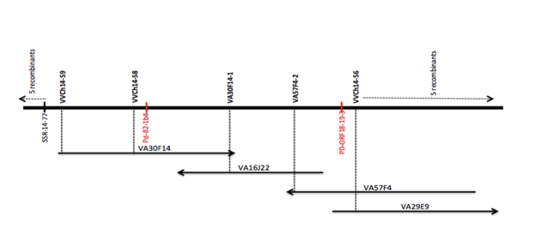

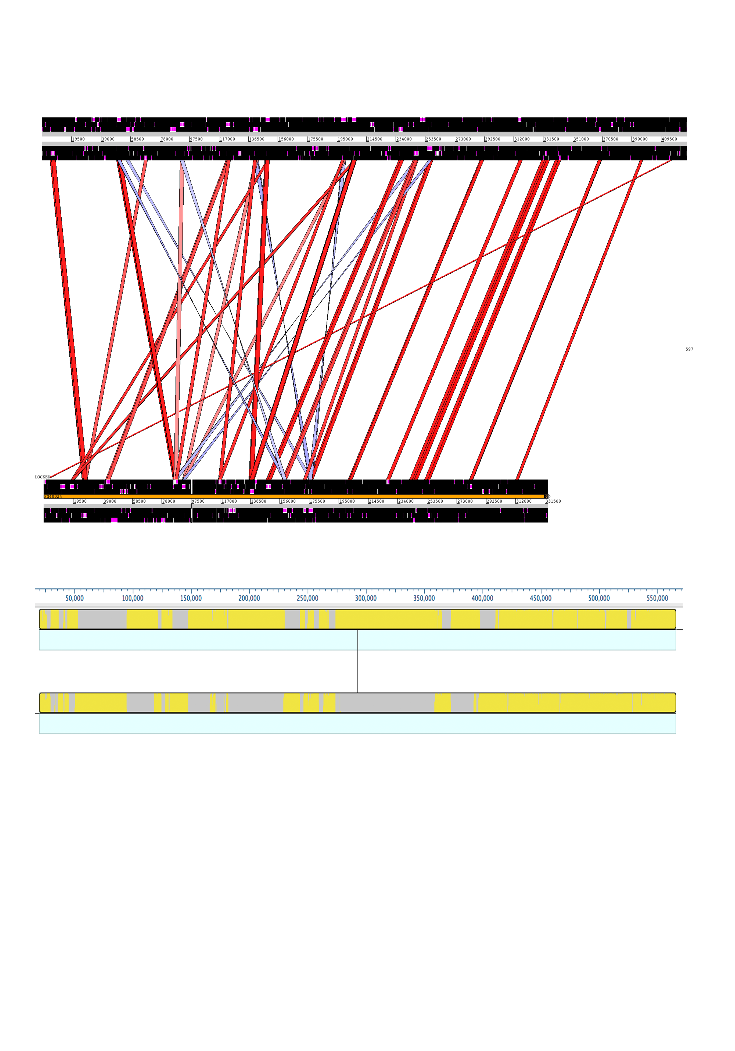
B)

The assembly of H43-I23 from the b43-17 BAC library that represents the PdR1a haplotype (F8909-17) was also completed. The length of assembled sequence was 206Kb. The open reading frames (ORF) of the PdR1b region and the BAC clone H69J14 were used to make comparisons. There was complete homology between the over lapping BAC clone sequences that reflect two different haplotypes. The BAC clone H43I23 has ORF16 to ORF20 and all five ORFs have identical sequences to the PdR1b haplotype. Based on these results, we conclude that there is complete sequence homology between haplotype a, and b of the PdR1 locus; therefore cloning and functional characterization of genes from any one haplotype will be sufficient for future work. Complete sequence homology also reflects that the parents of b43-17 must be closely related and may have a first-degree relationship and acquired resistance from shared parents. This also explains why we observed complete homozygosity of SSR markers for the PdR1 locus in the resistant accession b43-17.

Objective 3. Employ whole genome sequencing (WGS) (50X) of recently identified PD resistant accessions and a susceptible reference accession; use bioinformatics tools to identify resistance genes, perform comparative sequence analysis and develop SNP markers to be used for mapping.

In this proposal and as detailed in previous reports, we have proposed to use WGS to genetically map two new resistant accessions, b46-43 and T03-16, which have very strong X. fastidiosa resistance in repeated greenhouse screens. Next generation sequencing using IIlumina HiSeq and MiSeq platforms to carry out SNP discovery and identification of SNP markers linked to resistance would only be used with those resistant lines for which we have strong greenhouse screen information, information on the heritability of their PD resistance, and the potential to screen the population using a limited mapping strategy.

The V. arizonica accession b46-43 is homozygous resistant to PD. Multiple crosses to V. vinifera were made to develop BC1 populations in 2014 and 2015. Breeding populations were tested with markers to verify the integrity of the crosses. Greenhouse screening of the BC1 populations with b46-43 and other resistant sources was completed (see companion project report) and results were used in conjunction with markers from the chromosome 14 to evaluate the correlations between markers and resistance. Preliminary results indicate that there is a major PD resistance locus on chromosome 14. However, our breeding program has already identified two other accessions that have a major PD resistance locus on this chromosome. In order to optimize the development of broadly resistant PD winegrapes, we need to use PD resistance sources that map to different regions so that we have the greatest chance of stacking resistance genes from multiple and diverse sources. Test results suggest that b46-43 is not a unique source of PD resistance since it maps to the same location as PdR1, although it does have very strong resistance to X. fastidiosa. In the light of these results, we will not pursue WGS to map in the b46-43 background.

We completed the map of only chromosome 14 for the BC1 mapping population, completed screening in the greenhouse for 121 seedling plants. QTL analysis results indicated that locus explains only ~42% phenotypic variation indicating that there might be another locus on a different chromosome (Fig. 3)
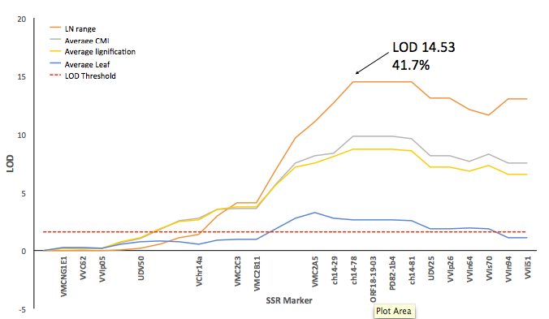
Fig. 3. QTL analysis results of interval mapping of the pBC1 14399 population for Ch14. The arrow represents the maximum LOD for marker ch14-78 and the percent-explained variation for PD resistance. Red dotted line is LOD threshold for significant QTL call. All mapped markers are on the x-axis

Figure 4 presents the correlation of different phenotypic parameters we have used to screen the pBC1 population. We are currently repeating the greenhouse screen and expanding the mapping effort to develop a framework map of all chromosomes to identify any other genomic region that contribute to the resistance.
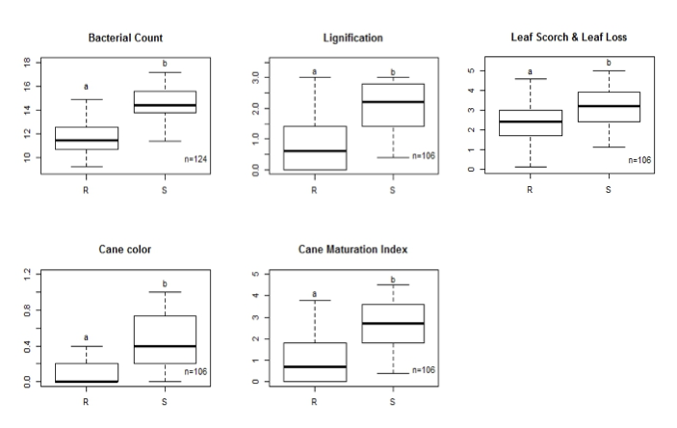

Fig. 4. Comparison between resistant (R) and susceptible (S) genotypes in each measured phenotypic parameter. Significant differences with Tukey’s test are indicated with letters a and b. The letter ‘n’ denotes the number of genotypes screened.

Objective 4. Cloning of PdR1 genes with native promoters.

The physical map of PdR1b using four BAC clones covers 604Kb (see previous reports for details). Multiple ORFs of the Leucine-Rich Repeat Receptor Kinase gene family were identified. These genes regulate a wide range of functions in plants including defense and wounding responses for both host as well as non-host specific defense. The physical distance is limited to the 82 Kb – with 5 ORFs associated with disease resistance and other plant functions described above. The main challenge is the high sequence similarity of the ORFs that are present outside the genetic window to the candidate ORFs.

We have acquired optimized binary vectors pCLB1301NH and pCLB2301NK (Feechan et al. 2013), which are capable of carrying large DNA sequences, thus allowing us to insert the candidate genes plus surrounding sequences. Two ORFs V.ari-RGA14 and V.ari-RGA18, within the resistance region boundaries, are the most likely candidates for PdR1b. The other 3 sequences, V.ari-RGA15, 16 and 17 are shorter and contain a large number of transposable elements (TE).

We have verified upstream and downstream sequences of V.ari-RGA14 and 18, two more likely PdR1b candidates. Both RGA14 and 18 (resistance gene analogs) have a very similar sequence profile with the exception that RGA-18 is 2946bp in size and lacks the first 252 bp of sequence that is part of RGA14. Functional analysis of the protein sequence of both RGAs revealed that RGA-14 lacks a signal peptide in the initial part of the sequence. This result was verified using 3’RACE (rapid amplification of cDNA ends) to specifically amplify RNA from grapevines transformed with V.ari-RGA14 under the 35S promoter. The results found that mature mRNA does not contain a signal peptide, necessary for proper membrane localization, at the beginning of the sequence thus leaving RGA-18 as the strongest candidate. Sequence verification for RGA14 and RGA18 and flanking sequences was completed and fragments that contain the entire coding region plus ∼3 kb upstream and ∼1 kb downstream sequences were synthesized and cloned into pCLB2301NK at Genewiz, Inc. The new plasmids, called pCLB2301NK-14 and pCLB2301NK-18, were verified by restriction analysis in our lab (Figure 5). Besides the corresponding 7 kb fragment, containing RGA14 or RGA18, these plasmids contain a 35S:mGFP5-ER reporter cassette and a kanamycin-selectable marker gene with the NOS promoter.

(a) (b) (c)
1 2 3 4 5 6 7
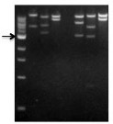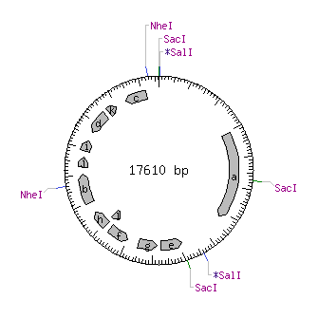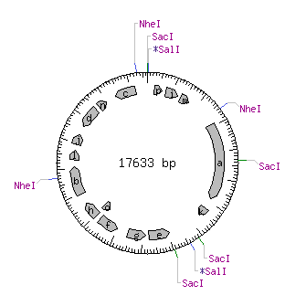

Figure 5. (a) Restriction analysis of plasmids pCLB2301NK-14 (lanes 2, 3, 4) and pCLB2301NK-18 (lanes 5, 6, 7) after digestion with Nhe1 (lanes 2, 5), Sac1 (lanes 3, 6) and Sal1 (lanes 4, 7). Gel image includes a 1kb ladder (lane 1) with the 3 kb fragment having increased intensity to serve as a reference band. The results on the gel match the predicted sizes inferred from the plasmid information; (b) pCLB2301NK-14 restriction map; (c) pCLB2301NK-18 restriction map.

We carried out sequence verification of genotypes U0505-22 and U0505-01, which are being used as biocontrols in our greenhouse screenings. These genotypes were originally selected for the presence of PdR1b markers in our breeding program. However, U0505-22 displays PD susceptibility despite being positive for the markers, which then offers the opportunity to explore the changes that could explain this behavior at the DNA level. Presently, we are focused on RGA-18 and RGA-14 sequence verification including the promoter region. Our first results were not conclusive, since direct sequencing of non-cloned PCR fragments, using primers originally designed for sequence verification of RGA14 and RGA18, produced mixed signals. Consequently, we designed new primers to produce approx. 3 kb fragments that include sequences upstream and downstream of RGA-14 or RGA-18 in order to increase the specificity of the amplification and facilitate cloning by reducing the number of fragments to 2 per gene. Preliminary results obtained with U0505-22 have shown the amplification of fragments of the predicted size but with sequences that differ from RGA14 and RGA18 in several bases.

A large experiment with resistant and susceptible plants using multiple replicates, and time points for control (un-inoculated) and inoculated plants (see details in previous report) was completed. To date, we have completed RNA extractions from 450 samples in the above-mentioned experiment. We have also designed primers and determined primer efficiency for gene expression studies with both RGA14 and RGA18. Two different primer pairs with efficiency of greater than 90% were selected to carry out preliminary analysis with un-inoculated and inoculated samples of Chardonnay and F8909-17 (source of PdR1). Preliminary results with samples from six time points indicates that the expression level of both RGA14 and RGA18 in F8909-17 increases after day 8 in comparison to un-inoculated, peaks at day 23 and then decreases. Un-inoculated and inoculated susceptible Chardonnay did not show any expression. Gene expression and cDNA sequence analysis is underway.

Objective 5. Comparing the PD resistance of plants transformed with native vs. heterologous promoters.

We have established an Agrobacterium mediated transformation system followed by regeneration of plants from embryogenic callus. We have streamlined the protocol and have established cultures of pre-embryogenic callus derived from anthers of V. vinifera Thompson Seedless (TS), Cabernet Sauvignon, Chardonnay (CH) and the rootstock V. rupestris St. George (SG) (Agüero et al. 2006). In an earlier phase of this project, we transformed these varieties with five candidate genes containing the 35S cauliflower mosaic virus promoter, the nopaline synthase terminator and an hptII-selectable marker gene (see previous reports for details). We completed testing and found that the transgenic plants did not confer PD resistance or tolerance. These results are in accordance with the latest assembly obtained using PAC BIO SRII system and 3 additional overlapping BAC clones. They show that only one of the sequences tested, V.ari-RGA14, lays within the more refined resistance region of 82 kb defined by the two recombinants we recently obtained. The 3’RACE technique was used to amplify RNA from V.ari-RGA14 transformed grapevines and results showed that mature mRNA did not contain the signal peptide, necessary for proper membrane localization, at the beginning of the sequence.

In addition to the embryogenic calli of Thompson Seedless (TS), Chardonnay (CH), Cabernet Sauvignon (CS) and Vitis rupestris St. George (SG) we have available for transformation, we developed meristematic bulks (MB) of these genotypes plus 101-14 Mgt for transformation via organogenesis (Figure 6). Slices of MB can regenerate transformed shoots in a much shorter period of time than somatic embryos. We have tested different media and selective agents and established protocols for the initiation, maintenance and genetic transformation of MB from these 5 genotypes (Xie et al. 2016). MB induction in non-vinifera genotypes is less efficient but still high, with about 80% of the explants producing MB after 3 subcultures in medium containing increasing concentrations of cytokinins.

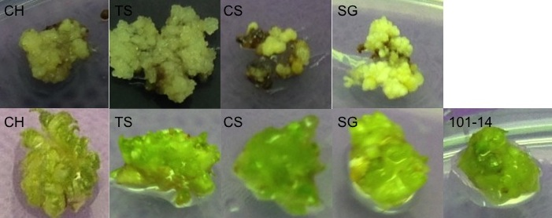

Figure 6. Embryogenic cultures (top) and meristematic bulks (bottom) of CH, TS, CS, SG and 101-14

In order to include native promoters and terminators in constructs for future genetic transformations, we have verified sequences upstream and downstream of V.ari-RGA14 and 18, the two most likely PdR1b candidates. Sequence verification has been completed up to 4-6 kb in the upstream region and 1 kb in the downstream region. In silico analysis of the upstream regions with PlantCare, a database of plant cis-acting regulatory elements has shown that upstream sequences contain several motifs related to drought and defense responses.

Previous transformations with Agrobacterium tumefaciens carrying binary plasmids that contain hygromycin (pCLB1301NH) or kanamycin (pCLB2301NK) selectable marker genes showed that both antibiotics are effective selection agents for embryogenic calli. However, MB regeneration has mainly occurred in selection with kanamycin, confirming our previous observation that MB are highly sensitive to hygromicin. Thus, pCLB2301NK was chosen to carry RGA14 and RGA18 expanded sequences and named pCLB2301NK-14 and pCLB2301NK-18 thereafter.

Agrobacterium tumefaciens strain EHA 105 pC32 was chemically transformed with pCLB2301NK-14 or pCLB2301NK-18 and subsequently used to transform embryogenic calli of V. vinifera cvs. Chardonnay, Thompson Seedless and St. George rootstock. Transformation experiments with pCLB2301NK-18 and pCLB2301NK-14 were initiated in March and July 2016 respectively, after synthesis and cloning was completed. In addition, Agrobacterium was used to transform meristematic bulks (MB) produced from the same genotypes. Table 2 shows the number of independent lines regenerated up to date, while Figure 7-e shows the most advanced cultures growing in greenhouse.

Table 2. Number of embryogenic calli (EC) and meristematic bulks (MB) inoculated with Agrobacterium carrying pCLB2301NK-18
Genotype | Explant | # Explants
Chardonnay | EC | 994
T. Seedless | EC | 603
St. George | EC | 692
Chardonnay | MB | 40
T. Seedless | MB | 80
St. George | MB | 70

We have also started the production of MB of PD susceptible genotypes selected from the 04-191 population, which are 50% vinifera, 25% b43-17 and 25% V. rupestris A. de Serres (as in the original population used for PdR1b mapping). These genotypes can provide an additional genetic background for analysis of expression of PdR1 candidate genes. Two of these genotypes, designated 29-42 and 47-50 exhibited great potential for the development of MB (Figure 7) and transformation experiments with Agrobacterium have been initiated.

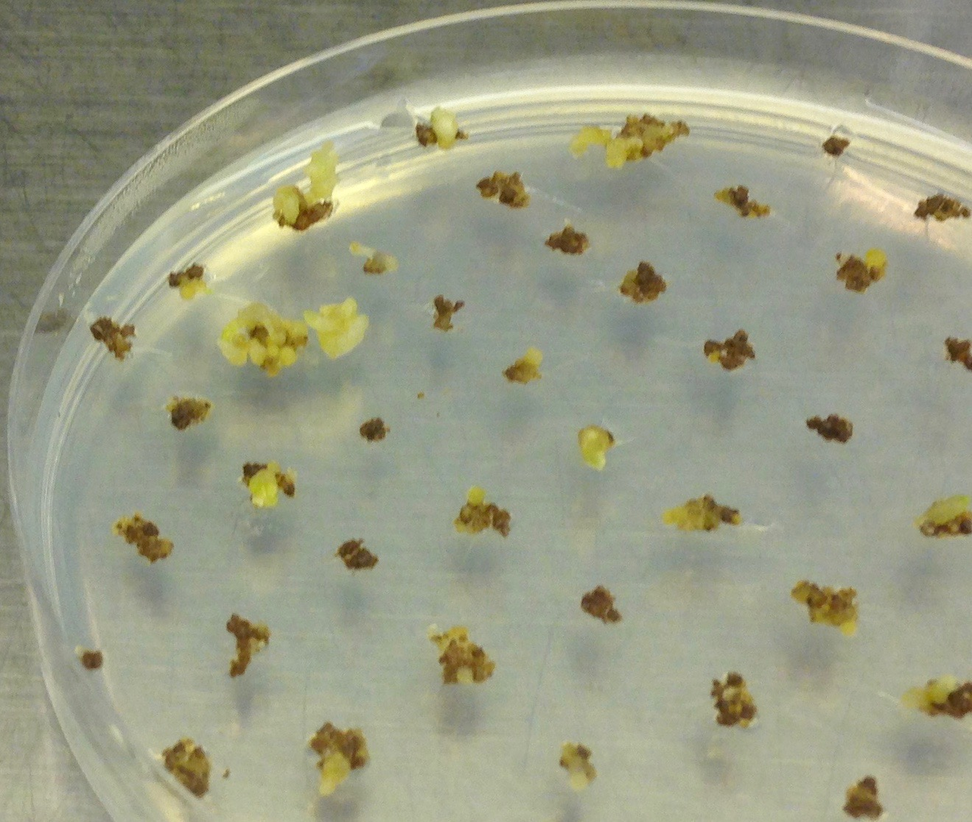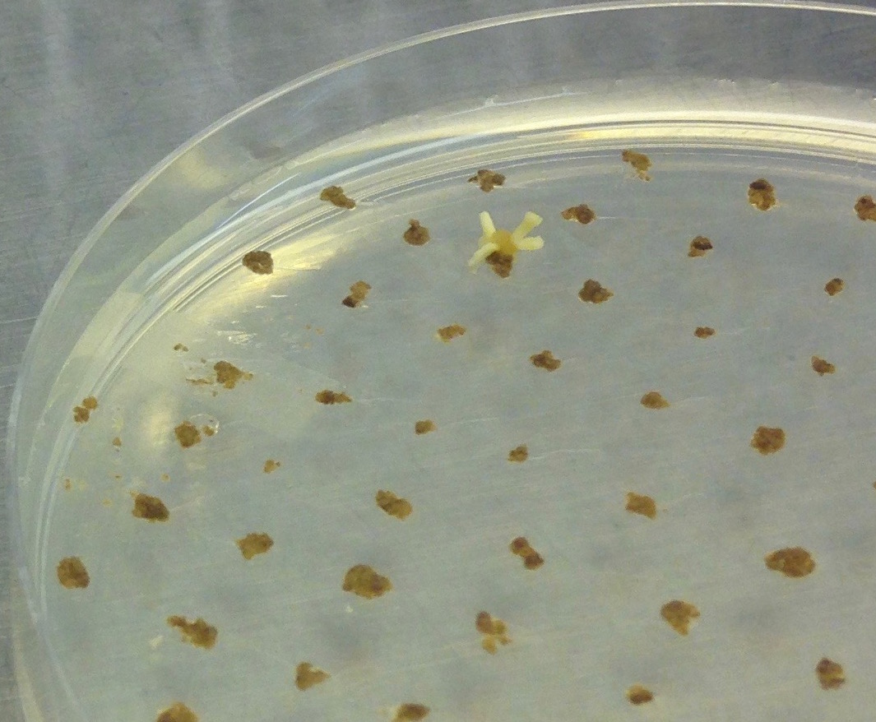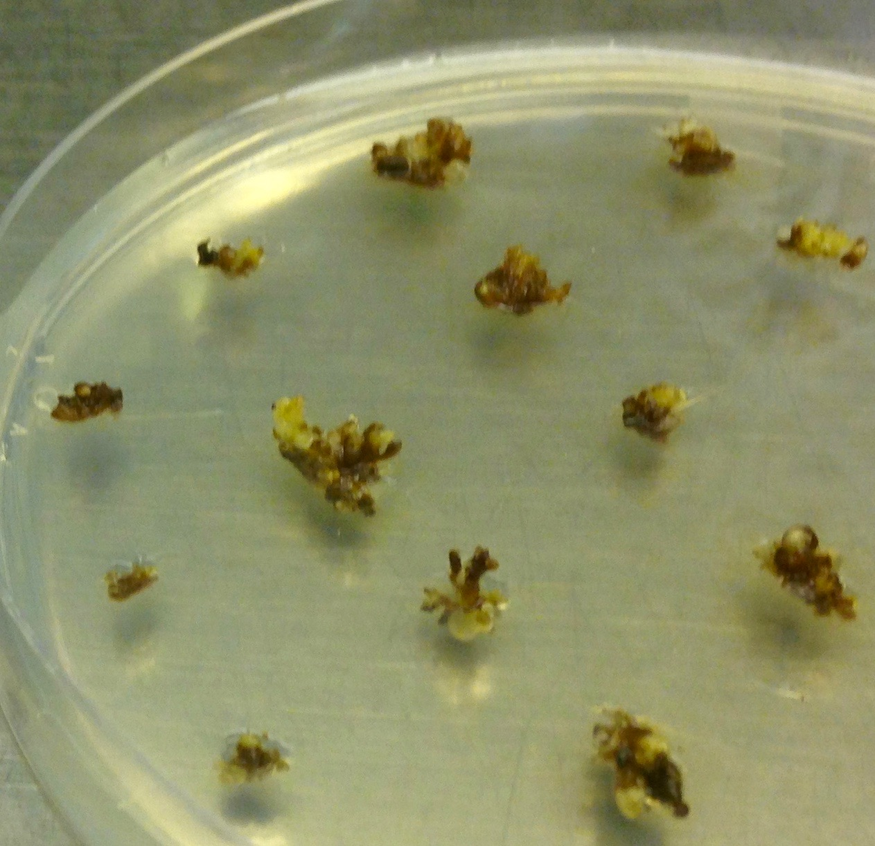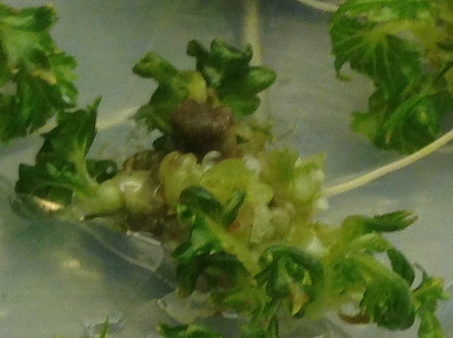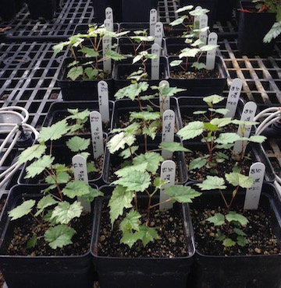
a b c d e
Figure 7. Embryo regeneration from embryogenic callus in (a) Thompson Seedless and (b) St. George. Shoot regeneration from meristematic bulks in (c) St. George. Meristematic bulk development in (d) genotype 47-50 from the 04191 population. First independent lines transplanted into the greenhouse (e).

CONCLUSIONS
We completed greenhouse screening, marker testing and QTL analysis of breeding populations from 15 new resistance sources including b46-43 and T03-16. We identified T03-16 and b41-13 as possessing resistance on a different region than chromosome (ch) 14. Crosses were made to expand these breeding populations for framework map development in order to identify other genomic regions. Our primary goal is to identify new sources of resistance whose resistance region is not on ch14 so we can facilitate stacking of these resistance sources with PdR1 from b43-17, since the incorporation of multiple resistances should make resistance more durable. We have also identified new resistance locus PdR2 from b42-26 background and closely linked markers are being utilized from MAS to stack resistance loci from different backgrounds. We have completed the genetic and physical mapping of PD resistance from b40-14. This resistance source maps within the PdR1b locus, but it may be an alternative gene within this complex replicated locus. Finally, we verified the sequence of two candidate genes from the PdR1b locus, completed transformations with ORF18 and ORF14 and multiplying obtained transgenic lines for complementation tests in the greenhouse scheduled to start in June. This effort is also identifying the promoters of these genes so that we can avoid the use of constitutive non-grape promoters like CaMV 35S.

PUBLICATIONS RELATED TO WINEGRAPE BREEDING
Xie, X., C.B. Agüero, Y. Wang and M.A. Walker. 2015. In vitro induction of tetraploids in Vitis X Muscadinia hybrids. Plant Cell, Tissue & Organ Culture DOI 10.1007/s11240-016-1023-4.
Peressotti, E., C. Dolzani, L. Poles, E. Banchi, M. Stefanini, F. Salamini, R. Velasco, S. Vezzulli, S. Riaz, M.A. Walker, B.I. Reisch, W.E. Van de Weg, M.C.A.M. Bink. 2015. A first pedigree-based analysis (PBA) approach for the dissection of disease resistance traits in grapevine hybrids. Acta Horticulturae 1082:113-121.
Feechan, A., M. Kocsis, S. Riaz, W. Zhang, D.M. Godoury, M.A. Walker, I.B. Dry, B. Reisch and L. Cadle-Davidson. 2015. Strategies for RUN1 deployment using RUN2 and REN2 to manage grapevine powdery mildew informed by studies of race-specificity. Phytopathology 105:1104-1113.
Walker, M.A. 2015. The Genus Vitis, Its Species and Its Rootstocks. IN: Compendium of Grape Diseases, Disorders, and Pests, 2nd Edition, Ed. W.F. Wilcox, W.D Gubler and J.K. Uyemoto et al. APS.
Amrine, K.C.H, B. Blanco-Ulate, S. Riaz, D. Pap, L. Jones, R. Figueroa-Baoderas M.A. Walker and Cantu, D. 2015. Comparative transcriptomics of Central Asian Vitis vinifera accessions reveals distinct defense strategies against powdery mildew. Horticultural Research 2: Article number: 15037 (2015) doi:10.1038/hortres.2015.37
Dangl, G.S., M.L. Mendum, J. Yang, M.A. Walker and J.E. Preece. 2015. Hybridization of cultivated Vitis vinifera with wild V. californica and V. girdiana in California. Ecology and Evolution 5:5671-5684.
Viana, A.P., M.D.V. de Resende, S. Riaz and M.A. Walker. 2016. Genome selection in fruit breeding: application to table grapes. Scientia Agricola 73:142-149.
Pap, D., S. Riaz, I.B. Dry, A. Jermakow, A.C. Tenscher, D. Cantu, R. Olah and M.A. Walker. 2016. Identification of two novel powdery mildew resistance loci, Ren6 and Ren7, from the wild Chinese grape species Vitis piasezkii. BMC Plant Biology (In Press)
Xie, X., C.B. Agüero, Y. Wang and M.A. Walker. 2016. Genetic transformation of grape varieties and rootstocks via organogenesis. Plant, Cell, Tissue and Organ Culture (In Press)
He, Rr; Jiao Wu; Yali Zhang; Shaoli Liu; Chaoxia Wang; Andrew M. Walker; Jiang Lu. 2016 Overexpression of a thaumatin-like protein gene from Vitis amurensis improves downy mildew resistance in Vitis vinifera grapevine. Protoplasma DOI: 10.1007/s00709-016-1047-y (In press)

PRESENTATIONS

Talks at Grower Meetings (Extension/Outreach) April 2016 to February 2017

PD resistant winegrape breeding and tasting, Silverado Vineyards meeting, Napa, CA April 4

PD resistant winegrape breeding. Talk and discussion with John Dyson and Williams Salem staff, UC Davis, April 13

PD resistant winegrape breeding and tasting for California Association of Winegrape Growers, Sacramento, CA Apr 18

Breeding PD resistant winegrapes. Temecula Grape Day, Temecula, CA Apr 21

Breeding PD resistant winegrapes. Alan Tenscher presenting to the AVF Board in Livermore, Apr 29

Breeding PD resistant winegrapes. Talk and tasting for Napa winemakers and viticulturists, UC Davis, May 4

Winegrape breeding at UC Davis. Vintage Nursery Open House, Wasco, CA May 18

Winegrape breeding at UC Davis. International Cabernet Sauvignon Conference, Pine Ridge Winery, Napa, CA June 22 2016

Grape breeding Daniel Roberts Growers group, Santa Rosa, CA July 22
Grape breeding at UCD. Chilean table grape growers association, UCD Oct 3
Grape breeding above and below ground. Cal Poly San Luis Obispo, CA Oct 6

Grape breeding update. CDFA Industry Advisory Board, UC Davis, Nov 1.

PD resistant wines – lecture and tasting. Sacramento Private School Auction Prize, with Darrel Corti. UCD, Nov. 13

Breeding PD Resistant Winegrapes. Texas A&M, Driftwood, TX, Nov, 18

What are the next steps for the PD resistant wine grape breeding program? Vineyard Health Seminar, UCD, Nov. 29

PD Breeding program update. FPS Annual Meeting, UCD, Dec. 1

Progress in the Grape Breeding Program, Recent Advances in Viticulture and Enology, UCD, Dec. 9

Classical and molecular breeding to combat PD. CDFA PD / GWSS Board Annual Meeting, San Diego, CA, Dec. 13

Updates on Salt and Drought Resistant Rootstock Breeding. San Joaquin Valley Grape Day, Fresno, CA Jan 11, 2017

The origin of grapes and grape breeding. 3rd Intl Symposium on Viticulture, Hermosillo, MX Jan 27

Origin of grapes and grape breeding. Daniel Roberts Grower Group Meeting, Santa Rosa, CA Jan 30

Presentations at Scientific Meetings
Xiaoqing Xie, Cecilia B. Agüero, Yuejin Wang , M. Andrew Walker. Optimizing the genetic transformation of grape fruiting and rootstock cultivars. 2016 ASEV National Meeting, Monterey, CA June 29.
Karla Huerta, Summaira Riaz, Alan Tenscher and M Andrew Walker. Characterization of Pierce’s disease resistance in germplasm collected from the southwestern US and Mexico. 2016 ASEV National Meeting, Monterey, CA June 29.
Summaira Riaz, Dániel Pap, Alan Tenscher and M. Andrew Walker. Molecular strategies to stack powdery mildew resistance from multiple backgrounds in a grape breeding program. 2016 ASEV National Meeting, Monterey, CA June 29.

RESEARCH RELEVANCE
The goal of this research is to understand the genetics of PD resistance and provide genetic support to our PD resistance breeding of wine grapes. We successfully mapped the resistance genes from a form of V. arizonica and used the linked markers to greatly expedite our breeding program. We are now searching for additional forms of PD resistance in other species from a variety of geographic locations across the southern US and Mexico, with the goal of combining resistance from several species together to ensure durable resistance

Layperson Summary
We continue to identify and genetically characterize novel PD resistance sources from southwestern US and Mexican Vitis species collections. We create genetic maps that associate regions of chromosomes with PD resistance. These regions (markers) are used to expedite screening for resistance since they can be used to test seedlings for resistance as soon as they sprout. We are developing these markers for different sources of resistance so that we can combine multiple resistance forms and therefore produce offspring with more durable resistance. These markers also allow us to identify resistance genes and engineer them into susceptible grapes; which we are doing to better understand the genes and the resistance.

Status of Funds: These funds are schedule to be spent by the end of the grant.

Intellectual Property: PD resistant varieties will be released through the Office of Technology Transfer (Patent Office) of the University of California, Davis.

Literature Cited

Agüero CB, Meredith CP, Dandekar AM (2006) Genetic transformation of Vitis vinifera L. cvs. Thompson Seedless and Chardonnay with the pear PGIP and GFP encoding genes. Vitis 45:1-8
Feechan, A., Anderson, C., Torregrosa, L., Jermakow, A., Mestre, P., Wiedemann-Merdinoglu, S., Merdinoglu, D., Walker, A. R., Cadle-Davidson, L., Reisch, B., Aubourg, S., Bentahar, N., Shrestha, B., Bouquet, A., Adam-Blondon, A.-F., Thomas, M. R. and Dry, I. B. (2013) Genetic dissection of a TIR-NB-LRR locus from the wild North American grapevine species Muscadinia rotundifolia identifies paralogous genes conferring resistance to major fungal and oomycete pathogens in cultivated grapevine. The Plant Journal, 76: 661–674. doi: 10.1111/tpj.12327
Gilchrist D., and Lincoln J. (2008) Functional testing and characterization of Pierce’s disease-induced promoters from grape. Proceedings of the Pierce's Disease Research Symposium.
Holmes IB, Wendt T, and Holm PB (2013) Intragenesis and cisgenesis as alternatives to transgenic crop development. Plant Biotech. J. 11:395–407
Li ZT, Kim KH, Jasinski JR, Creech MR, and Gray D. (2012) Large-scale characterization of promoters from grapevine (Vitis spp.) using quantitative anthocyanin and GUS assay systems. Plant Sci. 196:132-142
Riaz, S and M.A. Walker. 2013 Phylogeographic analysis of resistance to Pierce’s Disease in North American and Mexican species. 64th Annual Meeting of the American Society for Enology and Viticulture, Monterey, CA.

FUNDING AGENCY
Funding for this project was provided by the CDFA PD/GWSS Board. Additional support from the Louise Rossi Endowed Chair in Viticulture supporting work with grape species is also gratefully acknowledged.

